Command Reference: WriteWellHistoricalPumpingTSMonthlyToStateMod()

Write well historical pumping time series (monthly) to a StateMod file

StateCU and StateMod Command
Version 3.09.01, 2010-01-27

The WriteWellHistoricalPumpingTSMonthlyToStateMod() command writes well historical pumping time series (monthly) to a StateMod time series file. The following dialog is used to edit the command and illustrates the syntax of the command.

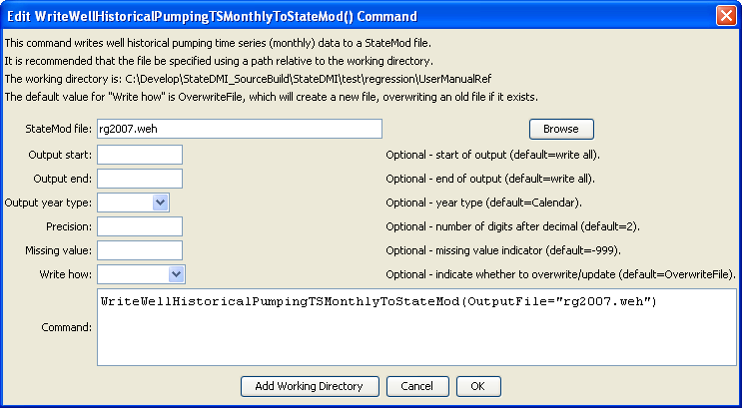
WriteWellHistoricalPumpingTSMonthlyToStateMod
WriteWellHistoricalPumpingTSMonthlyToStateMod() Command Editor

The command syntax is as follows:

WriteWellHistoricalPumpingTSMonthlyToStateMod(Parameter=Value,…)

Command Parameters

Parameter | Description | Default
OutputFile | The name of the output file to write, surrounded by double quotes. | None – must be specified.
OutputStart | The start date to write, using format YYYY-MM or MM/YYYY. | Full period will be written.
OutputEnd | The end date to write, using format YYYY-MM or MM/YYYY. | Full period will be written.
OutputYearType | The output year type to write, one of:  - Calendar – January to December.  - NovToOct – November to October.  - Water – October to September. | Calendar, or the value set by the previous SetOutputYearType() command.
Precision | The number of digits after the decimal to write. | 2
MissingValue | The value to write for missing data. | -999
WriteHow | OverwriteFile if the file should be overwritten or UpdateFile if the file should be updated, resulting in the previous header being carried forward. | OverwriteFile

