Command Reference: WriteWellRightsToList()

Write well rights data to a delimited file

StateCU and StateMod Command
Version 3.09.00, 2010-01-25

The WriteWellRightsToList() command writes well rights data to a delimited file.

The following dialog is used to edit the command and illustrates the syntax of the command.

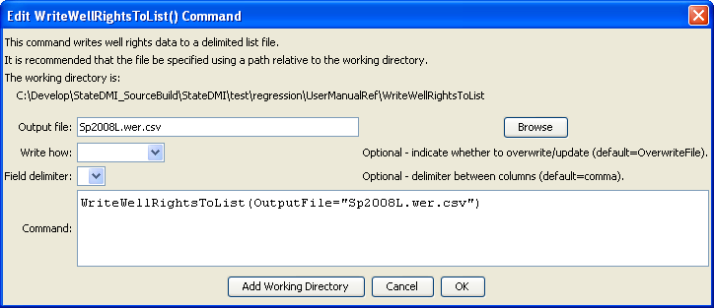
WriteWellRightsToList
WriteWellRightsToList() Command Editor

The command syntax is as follows:

WriteWellRightsToList(Parameter=Value,…)

Command Parameters

Parameter | Description | Default
OutputFile | The name of the output file to write, surrounded by double quotes. | None – must be specified.
WriteHow | OverwriteFile if the file should be overwritten or UpdateFile if the file should be updated, resulting in the previous header being carried forward. | OverwriteFile
Delimiter | The delimiter character to use between columns. | Comma

The following example illustrates how to create a list of well rights from a list of stations:

ReadWellStationsFromList(ListFile="test.lst")
ReadWellRightsFromHydroBase(ID="*")
WriteWellRightsToList(OutputFile="rights.lst")

