Command Reference: WriteWellRightsToStateMod()

Write well rights data to a StateMod file

StateMod Command
Version 3.09.00, 2010-01-25

The WriteWellRightsToStateMod() command writes well rights to a StateMod well rights file. The current in-memory rights are written. See also the MergeWellRights() and AggregateWellRights() commands.

The following dialog is used to edit the command and illustrates the syntax of the command.

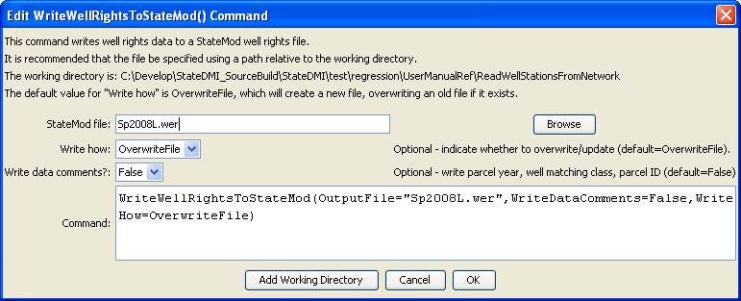
WriteWellRightsToStateMod
WriteWellRightsToStateMod() Command Editor

The command syntax is as follows:

WriteWellRightsToStateMod(Parameter=Value,…)

Command Parameters

Parameter | Description | Default
OutputFile | The name of the output file to write, surrounded by double quotes. | None – must be specified.
WriteHow | OverwriteFile if the file should be overwritten or UpdateFile if the file should be updated, resulting in the previous header being carried forward. | OverwriteFile
WriteData  Comments | Write comments to the right of normal data, including the parcel year, parcel/well matching class, and parcel ID. This information is necessary to fill irrigation practice and crop pattern time series with well water rights. Typically, a “_NotMerged.wer” well right file is written and then merged and possibly aggregated rights files are written. | False
An excerpt from a well rights file with data comments is shown below:

#> ID Name Struct Admin # Decree On/Off PYr--Cls--PID
#>---------eb----------------------eb----------eb--------------eb------eb------exb--exb--exb----e
2005001 W0006 WELL NO 01 200812 31592.00000 2.34 1936 1936 1 3107
2005001 W0006 WELL NO 01 200812 38836.00000 1.23 1956 1936 1 3107
2005001 W0006 WELL NO 01 200812 31592.00000 2.34 1936 1998 2 11016
2005001 W0006 WELL NO 01 200812 31592.00000 1.15 1936 2002 5 20902
2005001 W0006 WELL NO 01 200812 38836.00000 0.61 1956 2002 5 20902
…

The following example command file illustrates how well rights can be defined, sorted, checked, and written to a StateMod file:

# Well Rights File (*.wer)
StartLog(LogFile="Sp2008L_WER.log")
# _________________________________________________________
# Step 1 - Read all structures
ReadWellStationsFromNetwork(InputFile="..\Network\Sp2008L.net")
# _________________________________________________________
# Step 2 - define diversion and d&w aggregates and demand systems
SetWellAggregateFromList(ListFile="..\Sp2008L_SWAgg.csv",PartType=Ditch,IDCol=1,
NameCol=2,PartIDsCol=3,PartsListedHow=InColumn,IfNotFound=Warn)
SetWellSystemFromList(ListFile="..\Sp2008L_DivSys_DDH.csv",PartType=Ditch,IDCol=1,
NameCol=2,PartIDsCol=3,PartsListedHow=InRow,IfNotFound=Warn)
#
SetWellAggregateFromList(ListFile="Sp2008L_AugRchWell_Aggregates.csv",PartType=Well,
IDCol=1,PartIDsCol=2,PartsListedHow=InRow)
# _________________________________________________________
# Step 3- Set Well aggregates (GW Only lands)
# rrb Same as provided by LRE as Sp_GWAgg_xxxx.csv except non WD 01 and 64 removed
SetWellSystemFromList(ListFile="..\Sp2008L_GWAgg_1956.csv",Year=1956,Div=1,
PartType=Parcel,IDCol=1,PartIDsCol=2,PartsListedHow=InColumn)
SetWellSystemFromList(ListFile="..\Sp2008L_GWAgg_1976.csv",Year=1976,Div=1,
PartType=Parcel,IDCol=1,PartIDsCol=2,PartsListedHow=InColumn)
SetWellSystemFromList(ListFile="..\Sp2008L_GWAgg_1987.csv",Year=1987,Div=1,
PartType=Parcel,IDCol=1,PartIDsCol=2,PartsListedHow=InColumn)
SetWellSystemFromList(ListFile="..\Sp2008L_GWAgg_2001.csv",Year=2001,Div=1,
PartType=Parcel,IDCol=1,PartIDsCol=2,PartsListedHow=InColumn)
SetWellSystemFromList(ListFile="..\Sp2008L_GWAgg_2005.csv",Year=2005,Div=1,
PartType=Parcel,IDCol=1,PartIDsCol=2,PartsListedHow=InColumn)
# _________________________________________________________
# Step 4 - Read Augmentation and Recharge Well Aggregate Parts
SetWellAggregateFromList(ListFile="Sp2008L_AugRchWell_Aggregates.csv",PartType=Well,
IDCol=1,PartIDsCol=2,PartsListedHow=InRow,PartIDsColMax=25,IfNotFound=Ignore)
SetWellAggregateFromList(ListFile="Sp2008L_AlternatePoint_Aggregates.csv",PartType=Well,
IDCol=1,PartIDsCol=2,PartsListedHow=InRow,PartIDsColMax=1,IfNotFound=Ignore)
# _________________________________________________________
# Step 5 - Read rights from HydroBase
ReadWellRightsFromHydroBase(ID="*",IDFormat="HydroBaseID",Year="1956,1976,1987,2001,2005",
Div="1",DefaultAppropriationDate="1950-01-01",DefineRightHow=RightIfAvailable,
ReadWellRights=True,UseApex=True,OnOffDefault=AppropriationDate)
# _________________________________________________________
# Step 6 - Sort and Write
# Write Data Comments="True" provides output used for subsequent cds & ipy acreage filling
# Write Data Comments="False" provides merged file used for seting ipy max pumping
SortWellRights(Order=LocationIDAscending,Order2=IDAscending)
# _________________________________________________________
WriteWellRightsToStateMod(OutputFile="Sp2008L_NotMerged.wer",WriteDataComments=True)
MergeWellRights(OutputFile="..\StateMod\Historic\Sp2008L.wer")
SortWellRights(Order=LocationIDAscending,Order2=IDAscending)
# _________________________________________________________
WriteWellRightsToStateMod(OutputFile="Sp2008L.wer",WriteDataComments=False,WriteHow=OverwriteFile)
# Check the well rights
CheckWellRights(ID="*")
WriteCheckFile(OutputFile="Sp2008L.wer.check.html",Title="Well Rights Check File")

