Command Reference: WriteWellStationsToStateMod()

Write well stations data to a StateMod file

StateCU StateMod Command
Version 3.09.01, 2010-01-27

The WriteWellStationsToStateMod() command writes well stations that have been defined to a StateMod well stations file. The following dialog is used to edit the command and illustrates the syntax of the command.

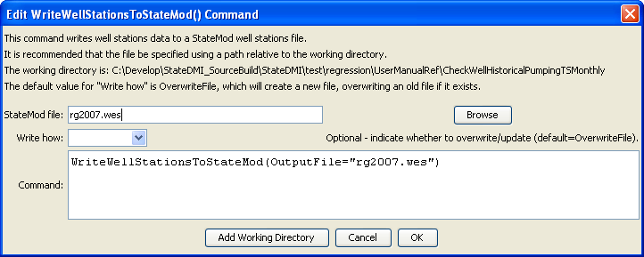
WriteWellStationsToStateMod
WriteWellStationsToStateMod() Command Editor

The command syntax is as follows:

WriteWellStationsToStateMod(Parameter=Value,…)

Command Parameters

Parameter | Description | Default
OutputFile | The name of the output file to write, surrounded by double quotes. | None – must be specified.
WriteHow | OverwriteFile if the file should be overwritten or UpdateFile if the file should be updated, resulting in the previous header being carried forward. | OverwriteFile

