Appendix: StateDMI Installation and Configuration
Version 03.09.01, 2010-02-15

1. Overview

This appendix describes how to install StateDMI in the CDSS (Colorado's Decision Support Systems) environment. CDSS consists of the HydroBase database, modeling, and data viewing/editing software. StateDMI can be used within this system to process data from the HydroBase database, CDSS model files, and other files.

2. Installing StateDMI as Part of CDSS

Standard locations of StateDMI software files are as follows. Files are normally installed on Windows on the C: drive but can be installed in a shared location on a server.

\CDSS\StateDMI-Version |  | Top-level install directory.
bin\ |  | Software directory for StateDMI.bat file and Java JAR files.
batik*.jar |  | Scalable Vector Graphics (SVG) output packages.
Blowfish*.jar |  | Used for encryption/security.
cdss.domain*.jar |  | CDSS components.
HydroBaseDMI*.jar |  | State of Colorado HydroBase database interface package.
jcommon.jar, jfreechart.jar |  | Plotting package.
jsr173_1.0_api.jar,  libXMLJava.jar |  | XML support.
jython.jar |  | Jython support.
sqljdbc4.jar |  | Microsoft SQL Server packages.
RTi_Common*.jar |  | Riverside Technology, inc. supporting packages.
SatmonSysDMI*.jar |  | State of Colorado Satellite Monitoring System package.
shellcon.exe |  | Executable program used to read from the Windows registry (e.g., to determine the default web browser and list available ODBC data source names). – PHASING OUT.
StateDMI.exe |  | Executable program to run StateDMI using the JRE software.
StateDMI.l4j.ini |  | Configuration file for StateDMI.exe launcher.
StateDMI*.jar |  | StateDMI program components.
StateMod*.jar |  | State of Colorado’s StateMod and StateCU model packages.
TSCommandProcessor*.jar |  | Time series command processor package.
doc\StateDMI\UserManual\ |  | Main documentation directory for StateDMI.
StateDMI.pdf |  | StateDMI documentation as PDF.
jre*\ |  | Java Runtime Environment (JRE) used by StateDMI.
logs\ |  | Directory for StateDMI log files (should be writable).
system\ |  | Directory for system files.
CDSS.cfg |  | CDSS configuration file for HydroBase database connection.
DATAUNIT |  | Data units file.
StateDMI.cfg |  | Configuration file to modify StateDMI defaults (under development).

3. Installing StateDMI

Use the following instructions to install StateDMI using the StateDMI_CDSS_Version_Setup.exe installer program, for example if StateDMI software was downloaded from the CDSS web site (http://cdss.state.co.us):

- Run the StateDMI_CDSS_Version_Setup.exe file by selecting from Windows Explorer, the Start…Run… menu, or from a command shell. The setup filename will include a version number (e.g., StateDMI_CDSS_03.09.01_Setup.exe).

You must be logged into the computer using an account with administrator privileges. If you have administrative privileges, the following welcome will be displayed, and the installation can continue:

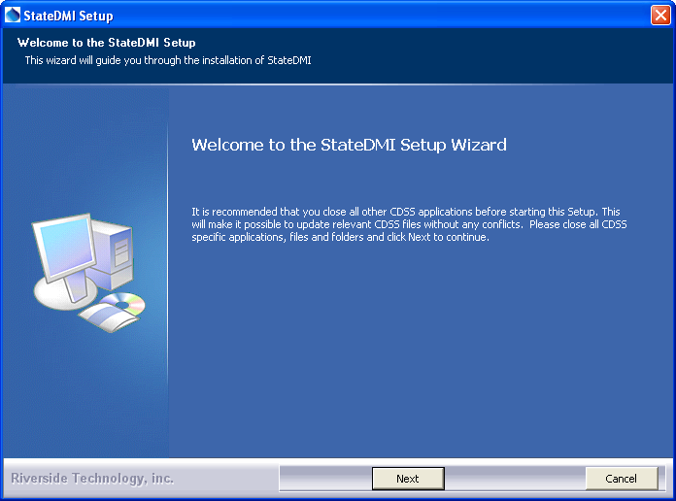
Install_Welcome

Press Next to continue with the installation.
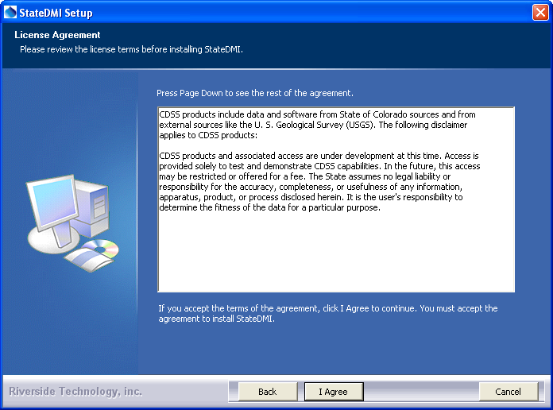
Install_Disclaimer

StateDMI is distributed with CDSS with no license restrictions. However the disclaimer must be acknowledged. Press I Agree to continue with the installation.

- Several components can be selected for the install as shown in the following dialog. Position the mouse over a component to see its description.

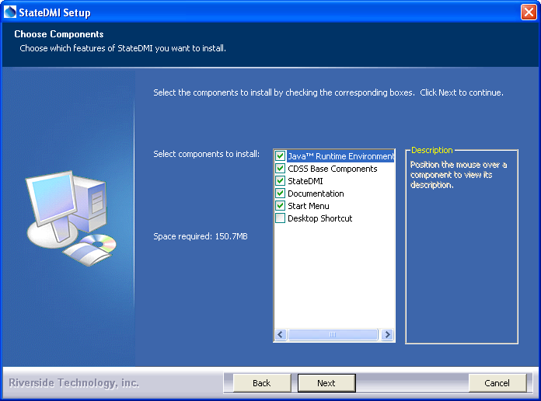
Install_SelectComponents

Select the components to install and press Next.

- The following dialog is then shown and is used to select the installation location for StateDMI. Multiple versions of StateDMI can be installed and there are no dependencies between the versions. It is recommenced that the default install location shown is used.

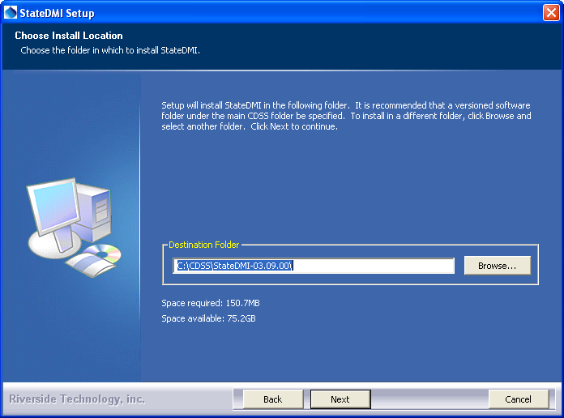
Install_SelectFolder

After selecting the install location, press Next.

Note that this location will be saved as a Windows registry setting (HKEY_LOCAL_MACHINE\Software\State of Colorado\StateDMI-Version\Path) to allow future updates to check for and default to the same install location, and to allow the standard software uninstall procedure to work correctly.

- The following dialog will be shown to select the menu for the software:

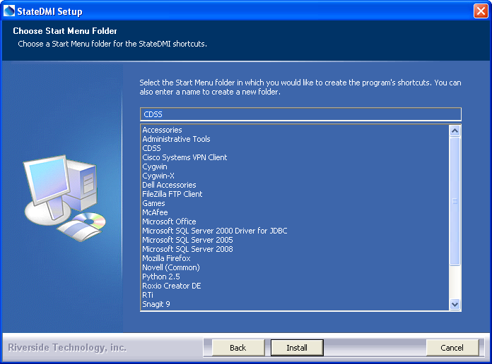
Install_StartMenuFolder

After selecting the folder, press Install.

- The following dialog will show the progress of the installation:

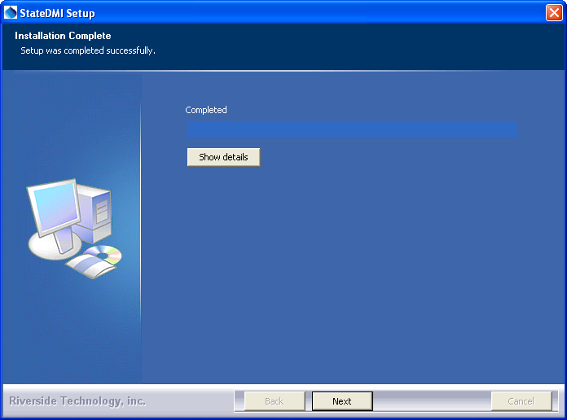
Install_Complete

Press Show details to see the files that were installed or press Next to continue.

- If the CDSS Base Components were selected for install (the default), the following dialog will be displayed:

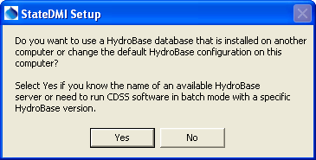
Install_HydroBaseQuestion

StateDMI and other CDSS software can utilize HydroBase running on the local computer as well as other computers. Press Yes if HydroBase has been installed on another computer in the network environment and may be used by the software (then continue to the next step). Otherwise, press No (skip to step 8).

- The following dialog allows additional HydroBase servers to be specified for use by CDSS software (the example below configures CDSS software to list the dwrappsdb HydroBase server in choices and defaults to HydroBase on the local computer):

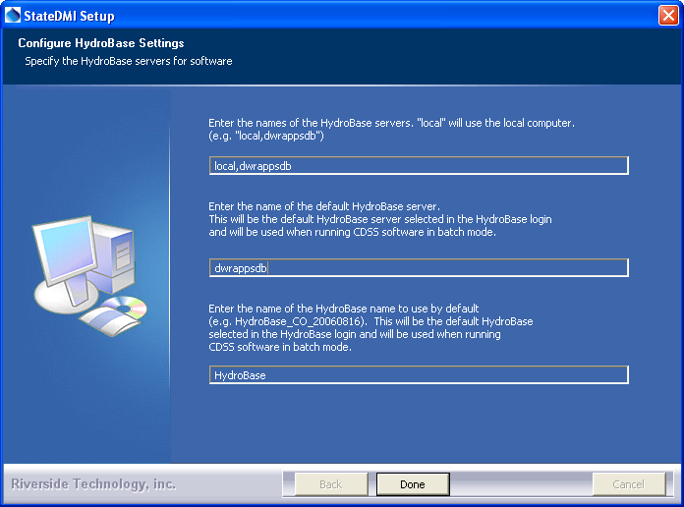
Install_HydroBaseConfiguration

After entering the name of a HydroBase server and the default server to use, press Done.

- The following dialog will then be shown asking whether the StateDMI software should be run:

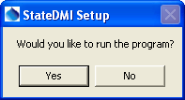
Install_RunStateDMIQuestion

Press Yes to run the software or No to exit the installation procedure.

3.1 StateDMI Configuration Files

StateDMI requires minimal configuration after installation. This section describes StateDMI configuration files that can be customized for a system.

3.1.1 Data Units File

The system\DATAUNIT file under the main installation directory contains data unit information that defines conversions and output precision. In most cases the default file can be used but additional units may need to be added for a user's needs (in this case please notify the developers so the units can be added to the default file distributed with installations). Currently, the data units file is the only source for units information – in the future units may be determined from the various input sources.

3.1.2 CDSS Configuration File

By default, StateDMI will automatically look for HydroBase databases on the current (local) machine and the State servers. State server databases are typically only accessible to State of Colorado computers. If SQL Server HydroBase versions have been installed on a different machine, the \CDSS\StateDMI-Version\system\CDSS.cfg file can be used to indicate the database servers. An example of the configuration file is as follows:

[HydroBase]

ServerNames="ServerName,local"
DefaultServerName="ServerName"
DefaultDatabaseName="HydroBase_CO_20080730"

The CDSS configuration properties are described in the following table:

CDSS HydroBase Database Configuration Properties

Property | Description | Default
ServerNames | A comma-separated list of server names to list in the HydroBase login dialog. | The state server is listed.
Default  ServerName | The default HydroBase server name to use. This allows the HydroBase login dialog to preselect a default that applies to most users in the system. | greenmtn.  state.co.us
Default  DatabaseName | The default HydroBase database name to use. This allows the HydroBase login dialog to preselect a default that applies to most users in the system.
Database  Engine | Reserved for internal use.
DatabaseName | The database name to use for the initial connection. This overrides the default server.
Database  Server | The server name to use for the initial connection. This overrides the default server.
SystemLogin | Reserved for internal use.
SystemPassword | Reserved for internal use.
UserLogin | Reserved for internal use.

4. Uninstalling StateDMI Software

To uninstall StateDMI software, select CDSS…Uninstall…StateDMI-Version from the Start menu and confirm the uninstall. User data will remain installed.

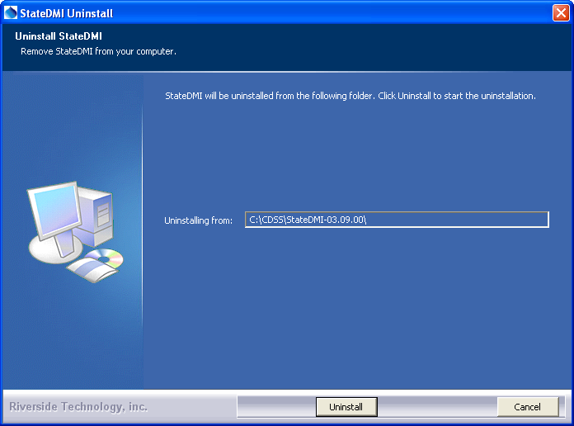
Uninstall_Confirmation

Press Uninstall to uninstall the software.

The following dialog shows the status of the uninstall.

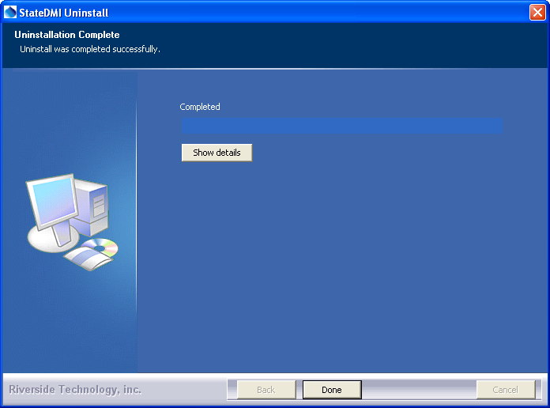
Uninstall_Complete

Press Show details to see the list of files that were removed. Press Done to exit the uninstall.

