StateDMI

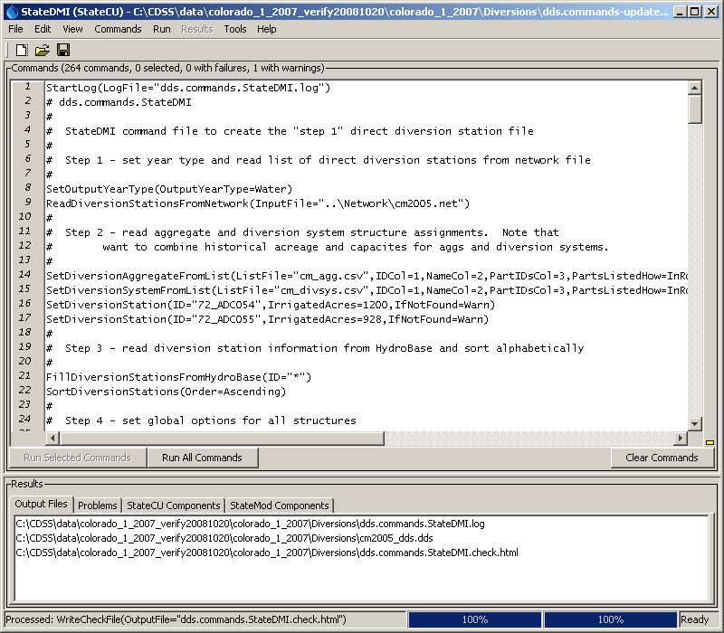

Colorado Department of Natural Resources

Colorado Water Conservation Board

Division of Water Resources

*Developed by:*



**Version 4.05.00, 2016-10-05**

This page is intentionally blank.

This document is formatted for double-sided printing.

Cover graphic is Main_cover.