Command Reference: ReadCULocationsFromList()

Read CU Locations data from a list file

StateCU Command

Version 4.00.00, 2016-05-19

The ReadCULocationsFromList() command reads a list of CU Locations from a delimited list file and defines CU Locations in memory. The CU Locations can then be manipulated and output with other commands. The identifier column is required.

The following dialog is used to edit the command and illustrates the syntax of the command.

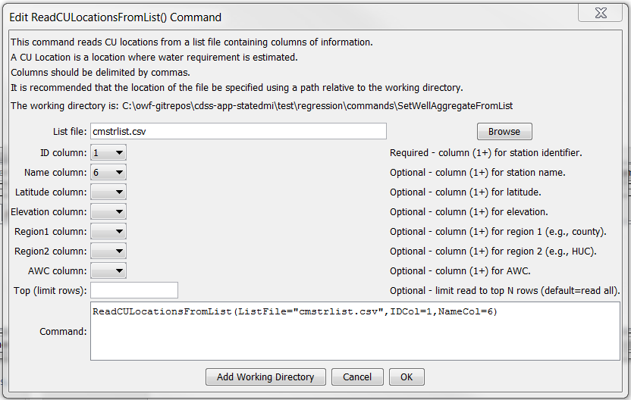

ReadCULocationsFromList

ReadCULocationsFromList() Command Editor

The command syntax is as follows:

ReadCULocationsFromList(Parameter=Value,…)

Command Parameters

|  |  |  |
| --- | --- | --- |
| Parameter | Description | Default |
| ListFile | The name of the list file to be read. | None – must be specified. |
| IDCol | The column number (1+) containing the CU Location identifiers. | None – must be specified. |
| NameCol | The column number (1+) containing the CU Location name. | The name will be initialized to blank. |
| LatitudeCol | The column number (1+) containing the CU Location latitude. | The latitude will be missing. |
| ElevationCol | The column number (1+) containing the CU Location elevation. | The elevation will be missing. |
| Region1Col | The column number (1+) containing the CU Location Region1. | The region1 will be initialized to blank. |
| Region2Col | The column number (1+) containing the CU Location Region2. | The region2 will be initialized to blank. |
| AWCCol | The column number (1+) containing the CU Location AWC. | The AWC will be missing. |
| Top | Specify a number of rows to read, useful during testing. | Read all rows. |

At a minimum, the list file must contain a column with CU Location identifiers. Lines starting with the # character are treated as comments. If the first line’s values are surrounded by double quotes, the line is assumed to indicate column headings.

A sample list file is shown below:

|  |
| --- |
| #wdid,lat,long,county,huc,name,ceff,fleff,speff,gmode,awc  360645,39.84,-106.35,SUMMIT,14010002,GUTHRIE THOMAS DITCH,1,0.6,0.8,2,0.08  360649,39.78,-106.18,SUMMIT,14010002,HAMILTON DAVIDSON DITCH,1,0.6,0.8,2,0.08  360660,39.8,-106.16,SUMMIT,14010002,HIGH MILLER DITCH,1,0.6,0.8,2,0.12  360662,39.97,-106.38,SUMMIT,14010002,HOAGLAND CANAL,1,0.6,0.8,2,0.12  360671,39.74,-106.13,SUMMIT,14010002,INDEPENDENT BLUE DITCH,1,0.6,0.8,2,0.13  360687,39.77,-106.18,SUMMIT,14010002,KIRKWOOD DITCH,1,0.6,0.8,2,0.08  360709,40.01,-106.38,GRAND,14010002,LOBACK DITCH,1,0.6,0.8,2,0.09  360725,39.82,-106.25,SUMMIT,14010002,MARY DITCH,1,0.6,0.8,2,0.08  360728,39.83,-106.25,SUMMIT,14010002,MAT NO 1 DITCH,1,0.6,0.8,2,0.08 |