Command Reference: ReadWellStationsFromList()

Read well stations data from a list file

StateMod Command

Version 4.00.00, 2016-05-19

The ReadWellStationsFromList() command reads a list of well stations from a delimited list file and defines well stations in memory. The well stations can then be manipulated and output with other commands. Reading from a list is more general than reading from a StateMod file.

The following dialog is used to edit the command and illustrates the syntax of the command.

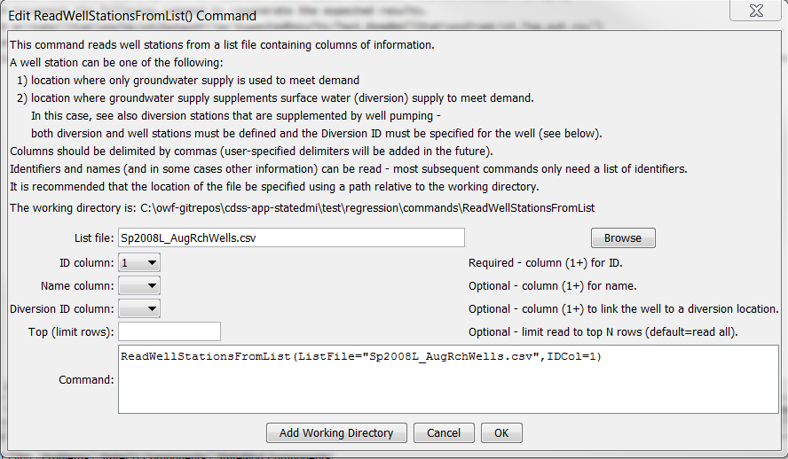

ReadWellStationsFromList

ReadWellStationsFromList() Command Editor

The command syntax is as follows:

ReadWellStationsFromList(Parameter=Value,…)

Command Parameters

|  |  |  |
| --- | --- | --- |
| Parameter | Description | Default |
| ListFile | The name of the list file to be read. | None – must be specified. |
| IDCol | The column number (1+) containing the well station identifiers. | None – must be specified. |
| NameCol | The column number (1+) containing the well station names. | None – optional (name will be initialized to blank). |
| DiversionIDCol | The column number (1+) containing the diversion identifiers associated with the well stations. This is needed in some cases to determine when a location is a diversion with supplemental well supply, for example, when processing well rights. | None – optional (diversion ID will be initialized to blank). |
| Top | Specify the number of rows to read, useful for testing. | Read all rows. |

At a minimum, the list file must contain a column with well station identifiers. Lines starting with the # character are treated as comments. If the first line’s values are surrounded by double quotes, the line is assumed to indicate column headings.

A sample list file is shown below:

|  |
| --- |
| #  # sp2007L_AugRchWells.csv  # _______________________________________________________  #  # rrb Augmentation and recharge wells from SmOpr  # SmOpr  # State of Colorado  # Version: 1.00  # Last revision date: 2006/10/27  #  # rrb 2008/10/08 count = 17 + 4 21  # _______________________________________________________  #  0102522_AuW ,"RIVERSIDE AUG ",' ', ' ', ' ', ' ', ' ','NA'  0102528_AuW ,"FT MORGAN CNL AUG PLAN ",' ', ' ', ' ', ' ', ' ','NA'  0102529_AuW ,"UPPER PLATTE BEAVER AUG ",' ', ' ', ' ', ' ', ' ','NA'  0102535_ReW ,"LOWER PLATTE BEAVER AUG ",' ', ' ', ' ', ' ', ' ','NA'  0102535_AuW ,"LOWER PLATTE BEAVER AUG ",' ', ' ', ' ', ' ', ' ','NA'  6402015_ReW ,"TAMARAK ",' ', ' ', ' ', ' ', ' ','NA'  6402027_ReW ,"OVERLAND ",' ', ' ', ' ', ' ', ' ','NA'  6402518_AuW ,"HARMONY Aug Well ",' ', ' ', ' ', ' ', ' ','NA'  6402519_ReW ,"DINSDALE AUG ",' ', ' ', ' ', ' ', ' ','NA'  … |