Command Reference: SetWellAggregate ()

Set well aggregate parts

StateCU and StateMod Command

Version 4.00.00, 2016-05-19

The SetWellAggregate() command sets well aggregate part identifier data for a well (a CU Location that corresponds to a location with well supply, or StateMod well station). Well aggregates are specified using a list of part identifiers as follows:

* Part type is Ditch – the collection includes wells that are associated with a list of ditches, identified using ditch water district identifiers (WDIDs). The list of ditches is used for the full period.
* Part type is Parcel – the collection includes wells that are associated with a list of parcels. The division and year must be specified in the command because well to parcel relationships are determined for specific years.
* Part type is Well – the collection includes wells identified by well WDID or well permit “receipt”. Receipts should be specified with a leading P: (e.g., P:1234567A) in which case the leading P: will be stripped and the remainder used for the receipt during processing. The internal part ID type will be set to WDID or Receipt, as appropriate.

To facilitate processing, it is often best to use list files to specific aggregates (see SetWellAggregateFromList()). Aggregates by convention have their water rights grouped into classes – to represent all water rights at a location, use a system (see the similar System commands). See also the StateDMI Introduction chapter, which provides additional information about aggregates and other modeling conventions. Aggregate information should be specified after well locations are defined and before their use in other processing, such as reading data from HydroBase.

The following dialog is used to edit the command and illustrates the syntax of the command.

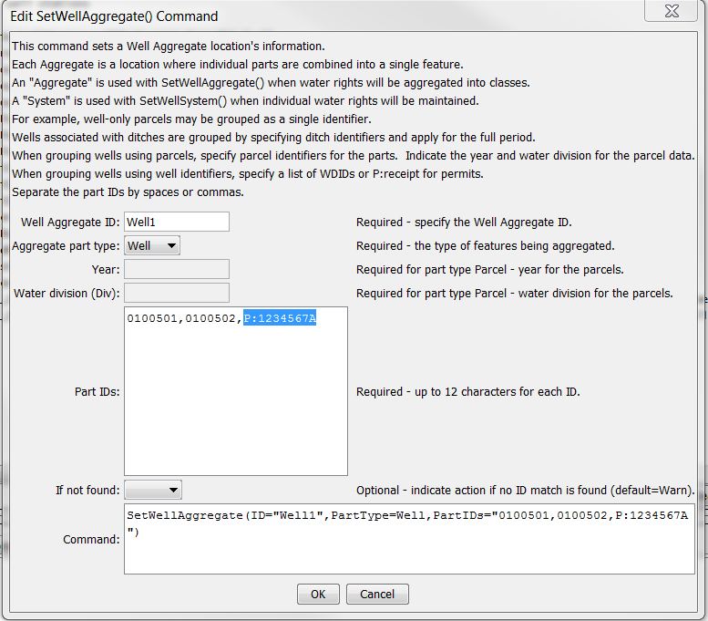

SetWellAggregate

SetWellAggregate() Command Editor

The command syntax is as follows:

SetWellAggregate(Parameter=Value,…)

Command Parameters

| Parameter | Description | Default |
| --- | --- | --- |
| ID | The well identifier to associate with the collection of individual wells. | None – must be specified. |
| PartType | Indicate the type of features being aggregated and specified by PartIDs, one of:   * Ditch – the PartIDs (ditch WDIDs) indicate ditch service areas supplemented by wells. * Parcel – the PartIDs (parcel numbers from GIS processing) indicate parcels irrigated by wells, with no surface water supply. * Well – the PartIDs indicate wells (WDIDs or permit receipts), with no surface water supply. Include P: at the start of receipt identifiers. | None – must be specified. |
| Year | The year defining the parcels. | Required when PartType is Parcel because parcel identifiers from well matching are specific to the data year. |
| Div | Water division for the parcels in the aggregate. | Required when PartType is Parcel because parcels require the division. |
| PartIDs | The list of part identifiers to comprise the aggregate. See the PartType description above. | None – must be specified. |
| IfNotFound | Used for error handling, one of the following:   * Fail – generate a failure message if the identifier is not matched * Ignore – ignore (don’t add and don’t generate a message) if the identifier is not matched * Warn – generate a warning message if the identifier is not matched | Warn |

This page is intentionally blank.