Command Reference: SetWellSystemFromList()

Set well system parts from data in a list file

StateCU and StateMod Command

Version 4.00.00, 2016-05-19

The SetWellSystemFromList() command sets well system part identifier data for a well (a CU Location that corresponds to a location with well supply, or StateMod well station). Well systems are specified using a list of part identifiers as follows:

* Part type is Ditch – the collection includes wells that are associated with a list of ditches, identified using ditch water district identifiers (WDIDs). The list of ditches is used for the full period.
* Part type is Parcel – the collection includes wells that are associated with a list of parcels. The division and year must be specified in the command because well to parcel relationships are determined for specific years.
* Part type is Well – the collection includes wells identified by well WDID or well permit receipt. The PartIdTypeColumn parameter must be specified to indicate the part ID type.

To facilitate processing, the list of parts is specified in a delimited list file. Systems by convention have their water rights fully represented in output – to aggregate water rights at a location, use an aggregate (see the similar Aggregate commands). See also the StateDMI Introduction chapter, which provides additional information about systems and other modeling conventions. System information should be specified after well locations are defined and before their use in other processing, such as reading data from HydroBase.

The following dialog is used to edit the command and illustrates the syntax of the command.

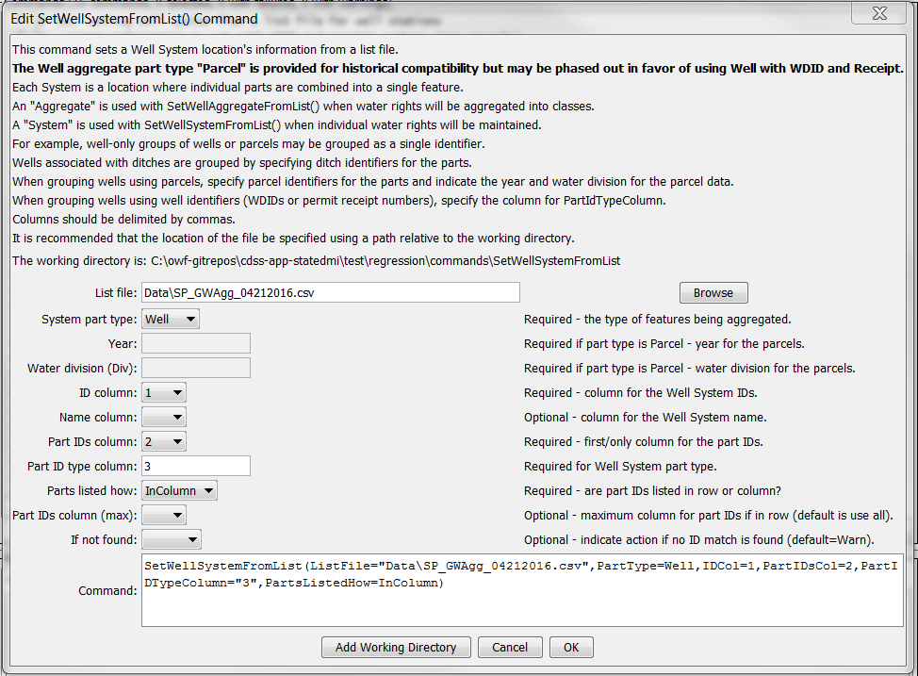

SetWellSystemFromList

SetWellSystemFromList() Command Editor

The command syntax is as follows:

SetWellSystemFromList(Parameter=Value,…)

Command Parameters

| Parameter | Description | Default |
| --- | --- | --- |
| ListFile | The name of the input file to read, surrounded by double quotes. | None – must be specified. |
| PartType | Indicate the type of features being aggregated and specified by PartIDs, one of:   * Ditch – the PartIDs (ditch WDIDs) indicate ditch service areas supplemented by wells. * Parcel – the PartIDs (parcel numbers from GIS processing) indicate parcels irrigated by wells, with no surface water supply. * Well – the PartIDs indicate wells (WDIDs and permit receipt), with no surface water supply. | None – must be specified. |
| Year | The year defining the parcels. | Required when PartType is Parcel because parcel identifiers from well matching are specific to the data year. |
| Div | Water division for the parcels in the system. | Required when PartType is Parcel because parcels require the division. |
| IDCol | The column number (1+) containing the well system identifiers. | None – must be specified. |
| NameCol | The column number (1+) containing the well system name. | None – optional (name will remain as before). |
| PartIDsCol | The column number (1+) for the first column having part identifiers. | None – must be specified. |
| PartIdTypeColumn | The column number (1+) or name for the column having part ID type. Recognized values in the column cells are WDID to indicate water district identifier and Receipt indicating a well permit receipt. Values are not case-sensitive. | Required when specifying system using Well part type. |
| PartsListedHow | If InRow, it is expected that all parts defining a system are listed in the same row. If InColumn, it is expected that the parts defining a system are listed one per row, with multiple rows defining the full system (PartIDsColMax is ignored in this case). | None – must be specified. |
| PartIDsColMax | The column number (1+) for the last column having part identifiers. Use if extra columns on the right need to be excluded from the list. | Use all available non-blank columns starting with PartIDsCol. |
| IfNotFound | Used for error handling, one of the following:   * Fail – generate a failure message if the aggregate identifier is not matched * Ignore – ignore (don’t add and don’t generate a message) if the aggregate identifier is not matched * Warn – generate a warning message if the aggregate identifier is not matched | Warn |

The following example illustrates a list file is used with PartType=Parcel and PartsListedHow=InColumn:

|  |
| --- |
| "UZONES","PARCEL"  20URF0,16831  20URF0,16832  20URF0,16834  …  20URF0,18606  20URF24,10295  20URF24,10318  … |

The following example illustrates a list file is used with PartType=Ditch and PartsListedHow=InColumn, with the name being provided in column 2:

|  |
| --- |
| # System_ID/Agg_Name/WDID  01_ADP037,South Platte River below Kersey Co North 2,0100643  01_ADP037,South Platte River below Kersey Co North 2,0100644  01_ADP037,South Platte River below Kersey Co North 2,0100835  01_ADP037,South Platte River below Kersey Co North 2,0104486 |

The following example illustrates a list file for PartType=Well and PartsListedHow=InColumn, with the part ID type specified in column 2, and part ID type in column 3:

|  |
| --- |
| # List file created by intersecting the well coverages (that are included in the CDSS  # irrigated acreage GDB) with the GW Aggregate Coverage,  # removing duplicates, and limiting the list to only wells tied to a GW only irrigated  # parcel in any of the acreage snapshots.  # Files/versions used include:  # HydroBase_CO_20160407  # SPDSS GIS Coverages 3/30/2016  # Aggregate_03_2008.shp  #GWID,WELL_ID,ID_TYPE  01_AWP022,0000072A,RECEIPT  01_AWP022,0000218A,RECEIPT  01_AWP012,0003643,RECEIPT  01_AWP022,0004850C,RECEIPT  03_AWP001,0013828,RECEIPT  01_AWP003,0105001,WDID  01_AWP003,0105003,WDID  01_AWP002,0105005,WDID  01_AWP002,0105006,WDID  01_AWP027,0105012,WDID |