Command Reference: WriteCULocationsToList()

Write CU Locations data to a delimited file

StateCU Command

Version 4.00.00, 2016-05-17

The WriteCULocationsToList() command writes CU Locations data to a delimited file. The command uses the specified filename to determine the names of several files to write, as shown below:

* cm2006.csv – name specified with OutputFile parameter, used for main CU Location data
* cm2006_ClimateStations.csv – list of climate stations for the CU Location
* cm2006_Collections.csv – list of collection data (aggregate and systems parts) for the CU Location

The following dialog is used to edit the command and illustrates the syntax of the command.

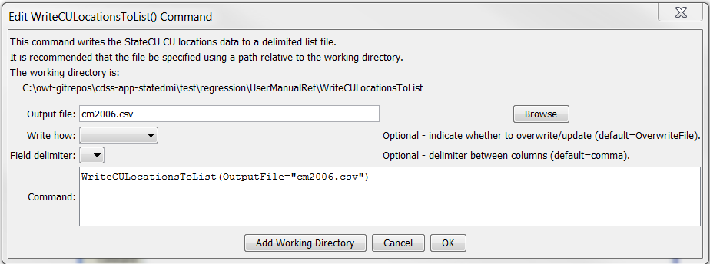

WriteCULocationsToList

WriteCULocationsToList() Command Editor

The command syntax is as follows:

WriteCULocationsToList(Parameter=Value,…)

Command Parameters

|  |  |  |
| --- | --- | --- |
| Parameter | Description | Default |
| OutputFile | The name of the output file to write, surrounded by double quotes. | None – must be specified. |
| WriteHow | OverwriteFile if the file should be overwritten or UpdateFile if the file should be updated, resulting in the previous header being carried forward. | OverwriteFile |
| Delimiter | The delimiter character to use between columns. | Comma |

The following example illustrates how to process CU Locations data from HydroBase, starting with a list of station identifiers, and creating a full list of data:

|  |
| --- |
| ReadCULocationsFromList(ListFile="list.csv")  FillCULocationsFromHydroBase(ID="*",CULocType="Structure",Region1Type="County",Region2Type="HUC")  WriteCULocationsToList(OutputFile="test2.lst") |