Command Reference: WriteWellStationsToList()

Write well station data to a delimited file

StateMod Command

Version 4.00.00, 2016-05-17

The WriteWellStationsToList() command writes well stations data to a delimited file. In addition to the main station file, files with suffixes _Collections, _Depletions, and _ReturnFlows are written, containing secondary station information.

The following dialog is used to edit the command and illustrates the syntax of the command.

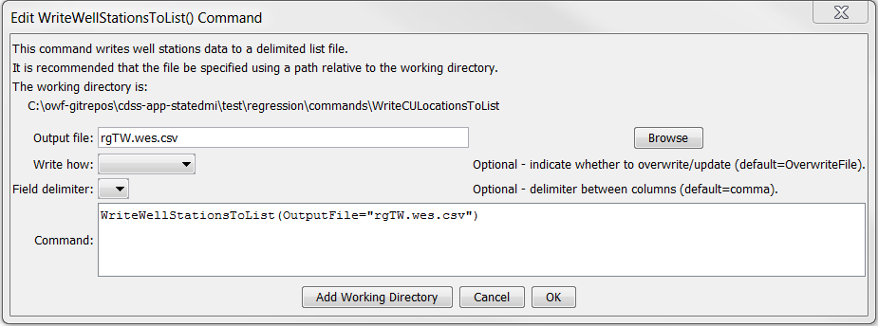

WriteWellStationsToList

WriteWellStationsToList() Command Editor

The command syntax is as follows:

WriteWellStationsToList(Parameter=Value,…)

Command Parameters

|  |  |  |
| --- | --- | --- |
| Parameter | Description | Default |
| OutputFile | The name of the output file to write, surrounded by double quotes. | None – must be specified. |
| WriteHow | OverwriteFile if the file should be overwritten or UpdateFile if the file should be updated, resulting in the previous header being carried forward. | OverwriteFile |
| Delimiter | The delimiter character to use between columns. | Comma |

The following example illustrates how to create a list of well stations from a network file:

|  |
| --- |
| ReadWellStationsFromNetwork(InputFile="rgtw.net")  WriteWellStationsToList(OutputFile="rgtw.wes.csv") |