

3.0 Model Description
The State of Colorado's Stream Simulation Model (StateMod) is capable of simulating stream diversions, instream demands, well pumping, reservoir operations and river flows on a monthly or daily basis for any stream system using user specified data. To facilitate this simulation, the river basin is divided into a series of river nodes which generally represent gauging stations, river confluences, diversion structures and reservoirs. Accounting is performed on a water right basis while reporting is performed by structure and each river node. The following sections are available in this chapter:
- 3.1 Stream Flow Allocation
- 3.2 System Operation
- 3.3 Model Application
- 3.4 Daily Operations
- 3.5 Variable Efficiency
- 3.6 Demands
- 3.7 Soil Moisture Accounting
- 3.8 Wells
- 3.9 Plans

3.1 Stream Flow Allocation
StateMod allocates water to a diversion, instream flow, or reservoir based upon physically available river flow, legally available flow (priority), decreed right, delivery capacity, and demand. Demand is an input to StateMod, but is typically estimated outside the model to reflect historical or future demands associated with agricultural, municipal, and industrial water needs. As a well may pump water from ground water storage, StateMod allocates water to a well using the same constraints described previously except it is not limited to physical availability of flow in the river. If current or future depletions caused by wells exceed the available flow, the water supply is identified as coming from ground water storage.
The water allocation scheme used in the current version of StateMod is the Modified Direct Solution Algorithm (MDSA) (Bennett, Ray R., December 2000). The MDSA is an enhancement to the Direct Solution Algorithm (DSA) that recognizes the impact of a diversion's return flows even when they occur in the same month or day that they were diverted. The enhancement associated with the MDSA allows water use efficiencies to vary up to a user specified maximum and account for soil moisture contents. The MDSA eliminates the need to iterate between time steps unless reservoir operations or return flows that do not accrue to a downstream node make new water available to the system.
Following is an abbreviated description of the stream allocation scheme, graphics depicting a simplified version of this approach follow:
- Water availability is determined at each river node to include both native inflows and return flows accruing from a prior time step.
- The most senior direct, instream, storage, well or operational water right is identified.
- Diversions are estimated to be the minimum of the decreed water right, structure capacity, demand, and available flow in the river. For a direct flow or reservoir right, the available flow in the river is the minimum of the diverting or downstream node plus any of the diverting right’s return flow to that node at the current time step. For an instream right, the available flow in the river is the flow at each river node within the instream reach. For a well, pumping is not constrained by the available flow in the river since pumping may deplete ground water storage.
- Downstream flows are adjusted to reflect the senior diversion and its return flows.
- Return flows for future time periods are determined and stored.
- Well depletions for future time periods are determined and stored.
- The process is repeated by priority for each successive direct, instream, storage, well and operational water right.
- If new water is introduced to the system from a reservoir's operation or return flows accrue to a non-downstream node, the model reoperates the current time step and the process is repeated beginning with the most senior direct, instream, storage or operational right.
- The process is repeated for each month or day of the study period.
StateMod allocates water by priority, therefore if the administration numbers of two water rights are the same, their relative priority is set by StateMod based on the order it is read within a file and between data files as follows: instream flows, reservoirs, diversions, operating rights, and wells. It is recommended that the user review the list of water rights as read by StateMod in the water rights summary (*.xwr) file and overwrite administration numbers as appropriate to trigger based on actual operations. The user can generate a water rights summary (*.xwr) file by running the Report Option 4 – Water Rights List.

StateMod Simulation Step 1
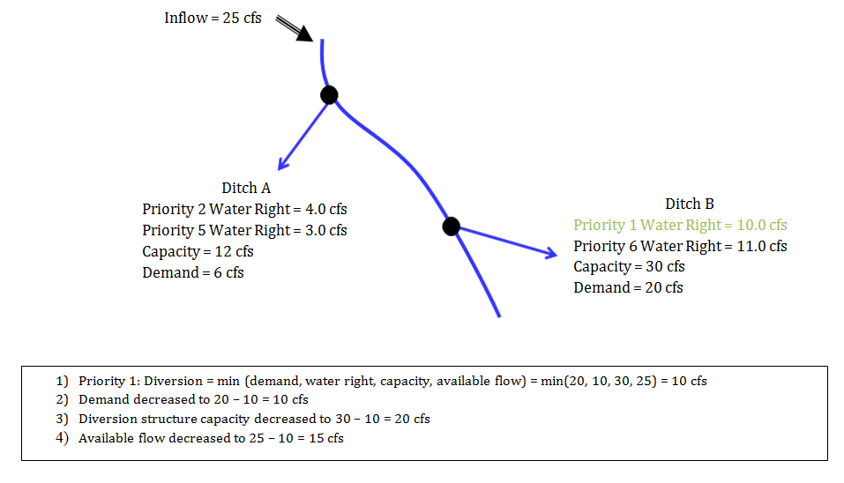
StateMod Simulation Step 2
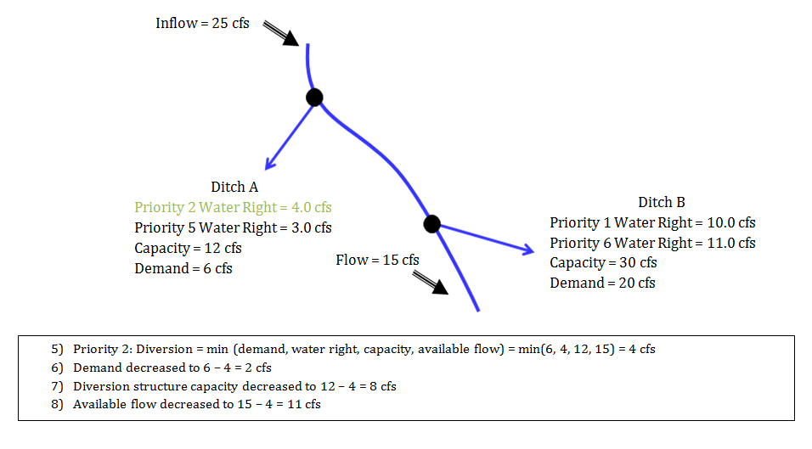
StateMod Simulation Step 3
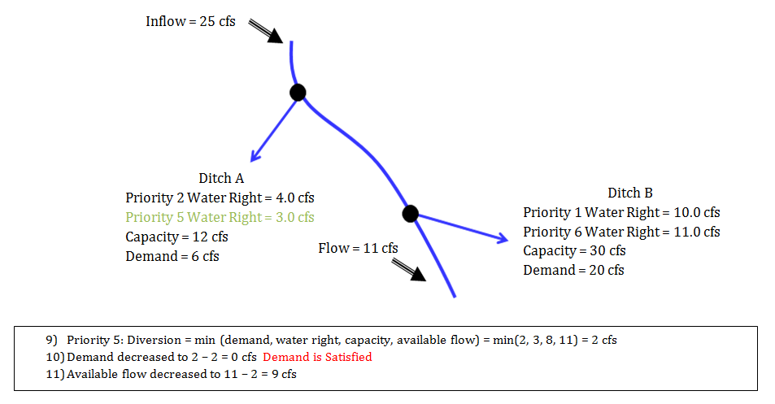
StateMod Simulation Step 4
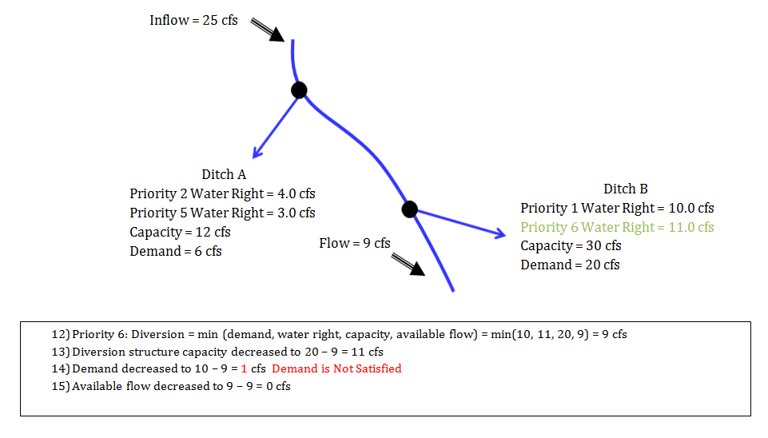
StateMod Simulation Step 5
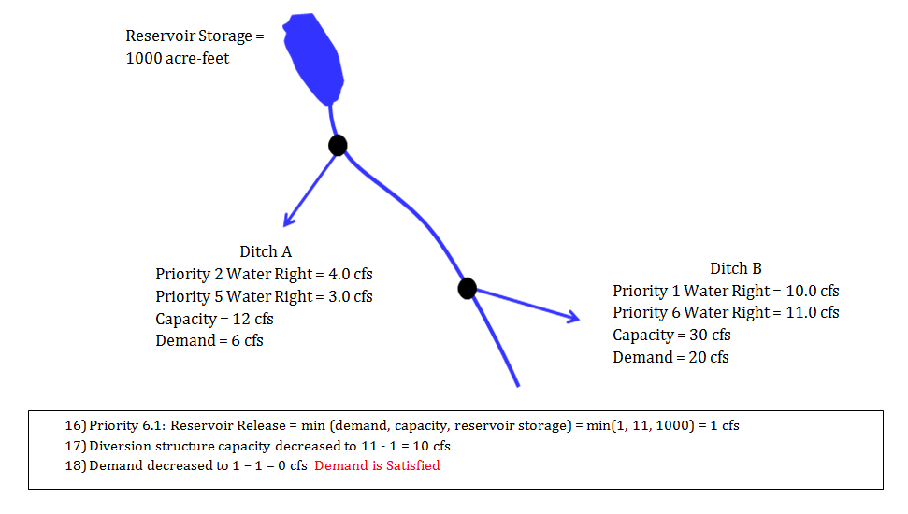

3.2 System Operations
System operations describe how direct, instream, well and storage rights interact with a water right owner's preferences. Reservoirs store water based on physically available river flow, legally available flow (priority), decreed right, storage capacity, demand, and operating rules. A balance is computed which accounts for the inflows and outflows from a reservoir including natural inflow, pumped inflow, controlled releases, spills, net evaporation and seepage. Downstream river flows associated with a reservoir storage or release are adjusted using the same water allocation procedure outlined in the previous section.
Water is released from a reservoir to satisfy an owner's demand, exchange agreement, augmentation requirement, hydropower goals, or target storage values. Reservoirs may have one or more ownership accounts and may be located on the main channel or off-channel. Standard operating policies associated with most river basins have been implemented in StateMod, as described in Section 4 and Section 7.
System operations, diversion return flows to non-downstream river nodes, and well pumping return flows have the potential to add additional water to a river which might be available to a senior water right. For example, when a reservoir releases water to meet a target storage level, additional water may become available to a senior downstream right. Similarly, if a ditch returns water to a neighboring non-downstream tributary, those return flows may be used by a senior ditch on that tributary. Finally when the return flow associated with well pumping exceeds its depletion to the river, additional water may become available to a senior downstream right. When such a system operation, non-downstream return flow or net accretion occurs, the model automatically re-evaluates (re-operates) all water rights in priority in order that senior rights may benefit from the additional water supply. The following are noted:
- When "new water" becomes available because of a system operation, non-downstream return flow or net accretion, the model automatically re-operates all water rights in priority in order that senior rights may benefit from the additional water supply.
- The user can control the number of iterations by adjusting the control (*.ctl) file reoperation variable (ireopx). This variable allows the user to turn off the reoperation capability or specify a volume before reoperation occurs. Both of these activities can impact results but may be an efficient method of operation if the user is interested in testing a new structure or feature and performance is an issue.
- If the user wants to force a reoperation at a specific administration date, a type 12 operating rule can be specified.

3.3 Model Application
This section describes the procedure for applying the river and system operations previously described. Model input files used to drive the model are described in Section 4.
StateMod is structured to perform one of 4 interrelated activities:

Base Flows (Natural Flows)

Simulate

Report

Data Check
The Base Flow Module creates a set of "base streamflows" or “natural flows” which have the impact of historical diversions, return flows, well pumping, and reservoir storage, release, evaporation and seepage removed. The generation of a "base streamflow" sequence is necessary for a basin planning model in order to analyze a "What If" scenario which includes a proposed water right or operating strategy that may impact historic river operations. This module may be executed by the user to develop a "natural streamflow" sequence if all impacts of man are removed or a "base streamflow" sequence if only selected impacts of man are removed. When the user selects to generate a "base streamflow" rather than a "natural streamflow" sequence, they are implicitly assuming the historic diversion and reservoir operation impacts which are left in the gage will not change significantly under a What If scenario. By including this component within the model, data preparation requirements are reduced significantly and future simulated return flow patterns are, where appropriate, consistent with the base or natural streamflow generation. Note, the base flow module may be executed with missing streamflow data (specified by -999) to allow man’s impact to be removed prior to filling missing data gaps using a technique such as regression.
The Simulate Module operates the river based on user specified water rights and operating criteria. It begins by reading data that is constant over time such as the river network, reservoir structures, diversion structures, instream flow structures, well structures and water rights. Time varying data such as streamflow, demands, and climate data are read. Then for every simulation time step, direct, instream, storage, well and operational rights are simulated from the most senior to junior priority. At the end of each month, results are printed for each river node to a direct access binary file. If a simulation only option is chosen, then the program is complete and detailed reports may be obtained through the Report module. If a simulation plus report option is chosen, then at the end of the simulation period, the binary file is read to produce detailed monthly or daily results in a tabular form for each diversion, instream flow, well structure, reservoir, and gage as follows:
Monthly Model Output
- File *.xdd containing detailed monthly diversion and instream flow results
- File *.xre containing detailed monthly reservoir results
- File *.xwe containing detailed monthly well structure results
- File *.xir containing detailed monthly instream flow reach results
- File *.xop containing detailed monthly operational right results
- File *.xss containing detailed monthly structure results
- File *.xpl containing detailed monthly plan structure results
- File *.xca containing call information at the end of a time step
- File *.xrp containing replacement reservoir data
Daily Model Output
- File *.xdy containing detailed daily diversion and instream flow results
- File *.xry containing detailed daily reservoir results
- File *.xwy containing detailed daily well structure results
Note the detailed diversion and instream file (*.xdd) includes information for each river node. Therefore, data associated with the river at every structure, stream gage, confluence, etc. is included. The other standard reports include additional information for a particular structure type or operational activity. For example, the reservoir summary report includes data for each reservoir account while the instream flow report includes data for each node within an instream flow reach.
The Report Module reads the direct access, binary file generated by the simulate module to produce user specified reports and files which may be imported to a number of common spreadsheet packages such as Excel for graphing. Following are the standard reports available:
Monthly Model Reports
- Diversion Summary (*.xdd)
- Reservoir Summary (*.xre)
- Operational Right Summary (*.xop)
- Instream Flow Summary (*.xir)
- Well Summary (*.xwe)
- Plan Summary (*.xpl)
- Binary Data File (*.xbn)
- Water Balance (*.xwb)
- Water Rights List (*.xwr)
- Graph Data for Diversions and Gages (*.xdg)
- Graph for Well Structures (*.xwg)
- Graph Data for Reservoirs (*.xrg)
- Supply (total diversion), shortage and consumptive use summaries (*.xsu, *.xsh, *.xcu)
Daily Mode Reports
- Diversion Summary (*.xdy)
- Reservoir Summary (*.xry)
- Well Summary (*.xwy)
The Data Check Module echoes the streamflow and diversion data, prints a comprehensive list of all water rights sorted by priority, tabulates input data for simplified reporting, and performs selected data checks of the input files including:
- Stream network is properly connected
- Return flows return to a stream node
- Return flow delay tables total 100% (including loss)
- Distribution of return flows to river nodes or losses equals 100%
- Wells have both a return flow and depletion table
- Water rights are assigned to a structure or operation
- Structures have a water right
- Demands are assigned to a structure
- Structures have a demand or operation
- Reservoir area/capacity tables increase
- Operational rights are properly specified
- Time varying data files (streamflow, demands, precipitation, etc.) have data for the selected study period and year type [Calendar Year (January through December), Water Year (October through September), or Irrigation Year (November through October)].

3.4 Daily Operations
StateMod can operate on a monthly or daily time step. See Section 7 for additional discussion on how to add daily capability to a monthly model. For simplicity StateMod estimates every February has 28 days, therefore any daily data provided for February 29 in a leap year is ignored. The daily capability can be implemented directly or by building upon a monthly model. Constructing a monthly model first is recommended for the following reasons:
- The most difficult part of developing a basin model is understanding the system. By first developing a monthly model, the system operation can be investigated without burdening the user with the volume of information ultimately required for a daily model.
- A daily model is typically developed to be able to simulate large and small flow events that occur within a monthly time step. Therefore, although daily streamflow data will be required, the user may want to estimate some of the other terms required for a daily analysis, such as diversion demands or reservoir targets, using a simplified approach. The ability to supply a simple distribution method to estimate daily data includes the following options:
  - Divide a monthly estimate by the number of days in a month or
  - Set daily data to a monthly average or
  - Use another gages daily distribution or
  - Use a pattern developed by connecting the midpoints of monthly data (common for demand data) or
  - Use a pattern developed by connecting the endpoints of monthly data (common for reservoir data).
- Daily baseflows may be developed directly as daily data or estimated from monthly baseflow estimates.
- For the case where a structure has both daily and monthly data which do not equal, the distribution method described above specifies which controls. This approach provides maximum flexibility to assign daily data.
- The routing of daily streamflows is accounted for by the gain and loss term that results from the base (natural) stream flows estimated by or provided to the model.
- Routing of reservoir releases are estimated to occur instantaneously in StateMod. The routing of reservoir releases is not included because 1. StateMod is a primarily a planning model, 2. The additional detail required to properly implement reservoir releases with a travel time component is not justified since the system would have to include some kind of forecasting to know a reservoir release is required before a reservoir demand occurs and 3. The volume of water potentially delivered early by ignoring a reservoir's travel time is offset by the potential over release that occurs after the demand is satisfied.

3.5 Variable Efficiency
StateMod allows water use efficiency to vary from 0 to a user specified maximum value. See Section 7 for additional discussion on how to implement variable efficiency in a model. The following are noted:
- Variable efficiency uses the Modified Direct Solution Algorithm (Bennett, Ray R., December 2000).
- Variable efficiency requires consumptive water requirement data be provided for every diversion and well only structure by year. If not provided, it is estimated from the average efficiency data provided in the diversion and well station (*.dds and *.wes) files and demand data.
- Variable efficiency for wells may include a value for both flood and sprinkler applications if the acres served by sprinklers are provided.
- Variable efficiency operations may include soil moisture accounting although it is not required.
- Variable efficiency capability applies to all direct diversion, well pumping and carrier to diversion structure operations.
- Variable efficiency capability does not apply to reservoir releases. These operating rules continue to use the average efficiency data provided in the diversion station file (*.dds) to determine the structure’s demand from the reservoir.

3.6 Demands
StateMod provides several methods to simulate structure demands. The selection of a demand approach is relatively simple for a system with surface water only. However for a system with both surface and ground water selecting an appropriate demand approach can be critical because diversions, wells and reservoir data often have different water use efficiencies. The following are noted:
- Demand data may be provided at the supply point (includes inefficient water use) or as a consumptive requirement (includes no inefficient water use). When demands are provided as a consumptive requirement, the model adjusts the demand on-the-fly to include the inefficiencies associated with the water supply source (surface diversion or well) being simulated.
- Demand data can be provided for diversions and wells separately or as a single value that may be served from surface or ground water supplies. The ability to separate or combine demands based on source allows the flexibility to perform both historic and calculated calibration.
- Demands that can be served by both surface and ground water may be simulated using a Maximum Demand Approach. This approach allows a structure to divert surface water up to their decreed amount and limits ground water pumping to the consumptive requirement. This approach allows a user to divert surface water that may result in a relatively low water use efficiency but use ground water, as needed, at a relatively high efficiency.

Soil Moisture Accounting
The State Model has the ability to include soil moisture as a water supply. See Section 7 for additional discussion on how to implement soil moisture accounting. The soil moisture capacity is calculated as follows:
SM = D * A * C
SM = Soil Moisture
D = Soil Depth - average soil depth provided for all structures in the control (*.ctl) file
A = Area - data provided by structure in the annual time series (*.ipy) file
C = Soil Moisture Capacity - data provided by structure in the soil parameter (*.par) file or in the consumptive use structure (*.str) file
- The Soil Moisture option allows water to be stored in the soil zone up to its capacity and the diverting structures (direct diversion or well) efficiency.
- StateMod initializes the soil moisture reservoir contents to be 50% of the soil moisture capacity.
- If the irrigated area of a structure is reduced from one year to the next and the resulting soil moisture capacity is exceeded any water in excess of the capacity is estimated to be a loss attributed to that structure.
- The Soil Moisture option requires the variable efficiency option (see Section 3.5) be used.
- In a simulation mode, the Soil Moisture option uses an operating rule to specify an administration date that controls when water is available to be taken out of the soil zone to satisfy a consumptive (not total) demand. In order to represent water use when historic diversions are provided as a demand this operating rule allows water to be taken out of the soil zone when a structure's consumptive irrigation water requirement exists even if the user has specified the structures demand to be zero.
- In the baseflow mode, the Soil Moisture option takes water out of the soil zone to satisfy a consumptive (not total) demand after surface water and well water use occurs. In order to represent water use in baseflow mode, water can be taken out of the soil zone when a structure's consumptive irrigation water requirement exists even if the user has specified the structures diversion and pumping to be zero.

3.8 Wells
The StateMod model allows ground water pumping via wells to be modeled. See Section 7 for more information on how to model well operations. The following are noted:
- Wells are generally operated within StateMod either as an aggregate of wells and their associated water rights tied to a well structure or as supplemental well water rights tied to a surface water diversion structure.
- If a well structure is not tied to a surface water diversion structure then well demands are provided in the well demand file.
- If a well structure is tied to a surface water diversion structure, then demands may be provided and treated in several ways as specified by the control variable icondem.
- Wells may increase the water supply available at the river at a given time step if well return flows exceed the stream depletion. StateMod checks for such a condition and reoperates to allow senior ditches to benefit from the additional water supply.
- Wells may require two or more delay patterns to represent the delay associated with return flows and depletions. The data for both types of delays are specified in the delay table input file. Note when the sum of return flows to the river is less than 100%, the balance is treated as a loss. Similarly when the sum of depletions to the river is less than 100%, the balance is treated as salvage.
- Wells may cause river flows to go negative when their estimated depletion to the river exceeds the streamflow. StateMod treats such an occurrence as an indication that pumping impacts have depleted ground water storage rather than the stream flow. Under such a case, StateMod allows the pumping to occur and accounts for the source of water as originating from ground water storage. This water is presented in the diversion summary output under the column titled "From/To GW Stor" for each river node and for the whole basin in the water budget report (*.xwb). Note the quantity of water supplied by ground water storage in a simulation time period is taken out of the stream the next time period before any water allocation occurs. The control file variable iwell allows the repayment of this water to be limited to a maximum amount to represent stream / ground water systems that are disconnected. Also, since data for this term is generally not observed, baseflow calculations may be influenced by this lack of data.
- Well information for supplemental wells is presented in four columns of the diversion summary (*.dds) file. The column titled "From Well" describes the total amount of water pumped and made available to a diversion. The column titled "Well Depletion" represents the impact of a previous months pumping on the river. The column titled "To/From GW Stor" was described above. The column titled "River by Well" represents the impact of the current months pumping on the river. The "Well Depletion" and "River by Well" data are separated because the impact of a previous months pumping on the river influences the water supply available to all users before any diversions occur while the impact of the current months pumping impacts water rights that are junior to the well only. In general, the columns titled "Well Depletion" and "River by Well" include the impact of all well pumping on the river at any given point in the river.

3.9 Plans
StateMod uses plan structures to model complex operations, such a reusable supplies, recharge supply and augmentation demands, terms and conditions, changed water rights, out-of-priority plans, and imports. The specific operation desired by the user is defined by the type of plan structure used, the associated plan input files, and the array of operating rules required to operate the plan structure. See Section 7 for additional discussion on how to model plan structures and operations.
Eleven plan types are currently available; note that Plan Types 5 and 6 are intentionally omitted as they are no longer functional in StateMod:
- Type 1 - T&C Plan is used to store a future obligation associated with the transfer of water from one structure to another. For example, a water right transfer might require historical return flows be maintained as part of the transfer. When a T&C plan is specified, StateMod calculates the obligation for the time step it occurs and all associated future time steps. Future returns and/or depletions are estimated using the same delay information specified for the source structure or in the operating rule that includes the T&C plan.
- Type 2 - Well Augmentation Plan is used to store a future obligation to return water to the river (augment) when a well depletes the river out of priority. When a Well Augmentation Plan is specified, StateMod calculates the current and future obligation for the time step it occurs and all associated future time steps. Future returns and/or depletions are estimated using the same delay information specified for the source well structure.
- Type 3 - Reservoir Reuse Plan is used to store a reusable water supply associated with a reservoir. As the reuse plan represents water stored in the reservoir, any unused water can be carried over in the plan to the next time step.
- Type 4 - Non-Reservoir (Diversion) Reuse Plan is used to store a reusable water supply associated with a diversion. As the reuse plan is associated with a diversion, any unused water must be spilled since it cannot be carried over to the next month.
- Type 7 - Transmountain Import Plan is used to account for imported water which, in many cases, may be used to extinction. The return flows generated from deliveries from a Type 7 plan are typically stored in Type 3 or Type 4 Reuse Plans. See the “How to Model Imports” section for more information on this plan type and import operations.
- Type 8 - Recharge Plan is used to store a water supply that originated from reservoir, recharge area, or canal seepage. The water supply from this plan is typically used to meet a well augmentation demand generated in a Type 2 plan. The return to the river is controlled by a unit response table therefore it accrues to the river as a supply even if it is not assigned to a demand.
- Type 9 - Out of Priority Plan is used to store a future obligation associated with water that is diverted out of priority. These plans are typically used to represent out-of-priority diversions to storage pursuant to the upstream storage statute (e.g. Blue River decree diversions by Denver and Colorado Springs).
- Type 10 - Special Well Augmentation Plan is used to store the depletion associated with a well that is not required to be augmented. Examples include pumping in a designated basin or pumping by a well which has been decreed to be non-tributary (i.e. “coffin wells”). A special augmentation plan is typically used to demonstrate that every well in the model is assigned to an augmentation plan even if some wells are not required to augment their depletions.
- Type 11 - Accounting Plan is used to “temporarily” divert water in priority which may subsequently be used at a later point in the priority system or by a number of other structures. Note this plan type was historically used for changed water rights, however due to the complexity of those operations, Plan Type 13 was developed exclusively for those operations. The Type 11 plan is still used in special operations such as the South Platte Compact.
- Type 12 - Release Limit Plan is used to limit the cumulative supply from multiple sources to monthly and annual values. This plan is typically included in a series of other operating rules to limit the total amount of diversions or reservoir releases to a user-specified monthly or annual amount.
- Type 13 – Changed Water Rights Plan is a specific type of accounting plan that is used to handle changed water right operations, allowing water to be “temporarily diverted” in priority, split to other Type 13 plans if the changed right has more than one owner, then released at a later priority to meet demands.
The following are noted:
- Section 4 describes the physical data associated with a plan which includes its ID, name and location in the stream network.
- Water accounted for in various reuse plans be used as a source for many other operating rules.
- If a plan is not specified as a part of an operating rule or well water right, StateMod warns the user but assumes there are no terms and conditions to be imposed.
- Total demand and supply associate with a plan are reported as part of the standard stream node output (*.xdd) under the plan ID and appropriate location in the network.
- Detailed reporting of a plan is provided in a standard plan output file (*.xpl).
- Reservoir reuse plans are used to account for reusable water associated with an account in a reservoir. Reservoir reuse plans can be located anywhere in the network but are typically located adjacent to the associated reservoir. Reusable water supplies can be accounted for by assigning a reservoir reuse plan as part of an operating rule.
- Non-reservoir reuse plans are located on the stream network where the water is physically located.
- Terms and conditions (T&C) plans are located on the stream network at the most upstream location(s) where the terms and conditions of a water transfer are to be implemented (e.g. if a term and condition of a transfer requires a diversion leave historic return flows at the transfer location, then the plan should be located just downstream of the transfer location). Return flow obligations associated with a term and condition are a function of how much water gets transferred. Therefore when a terms and conditions (T&C) plan is specified, StateMod calculates the obligation on-the-fly for the month it occurs and all associated future months. Future return flow and/or depletion percentages and patterns may be specified to equal the same values as the source structure or the plan itself. The terms and conditions are defined within the operating rule.
- Well augmentation plans should be located on the stream network at the most upstream location(s) where the lagged pumping depletions affect the river. The lagged river depletions associated with operating a well water right out-of-priority represents the demands for a well augmentation plan. The timing pattern of depletions from pumping are included in the unit response table (monthly - *urm; daily - *.urd). Lagged river depletions associated with well pumping are a function of how much pumped water is simulated. When a well augmentation plan is specified, StateMod calculates the lagged river depletion on-the-fly the month it occurs and all associated future months. Operating rules can be used to satisfy this demand when a well is in priority or from other water supplies, including accretions from recharge diversions (Recharge Plan).
- Accretions associated with recharge water rights diverted from the river to recharge sites can be represented in Recharge Plans. Recharge plans are located on the stream network at the location(s) where the lagged river accretions associated with recharge diversions have been separately estimated to occur. The timing pattern of accretions from recharge diversions is included in the unit response table (monthly - *urm; daily - *.urd). Lagged river accretions associated with recharge diversions are a function of how much recharge diversion is simulated. When a recharge plan is specified, StateMod calculates the lagged river depletion on-the-fly the month it occurs and all associated future months. Operating rules can be used to supply the calculated accretions to meet other demands (e.g. well augmentation plan demands).
- Out-of-Priority plans are used to represent out-of-priority diversions to storage pursuant to the upstream storage statute (e.g. Blue River decree diversions by Denver and Colorado Springs). Accounting for replacement requirements associated with upstream storage statute operations are specified within the operating rule. Operating rules can be used to satisfy this demand when from other water supplies.
- Release limit plans are currently implemented for representing monthly and annual limits to reservoir releases (e.g. Green Mountain Reservoir HUP pool releases to Senate Document 80 beneficiaries).
- Special Well Augmentation Plans are used to represent lagged well depletions to the river system for wells that are considered not tributary to the river system (i.e. Coffin wells and designated basin wells). The timing pattern of depletions from pumping are included in the unit response table (monthly - *urm; daily - *.urd). Lagged depletions associated with well pumping are a function of how much pumped water is simulated. When a special well augmentation plan is specified, StateMod calculates the lagged depletion on-the-fly the month it occurs and all associated future months.

cdss.state.co.us
Last updated: March, 2016

