StateMod Graphical User Interface (StateMod GUI)

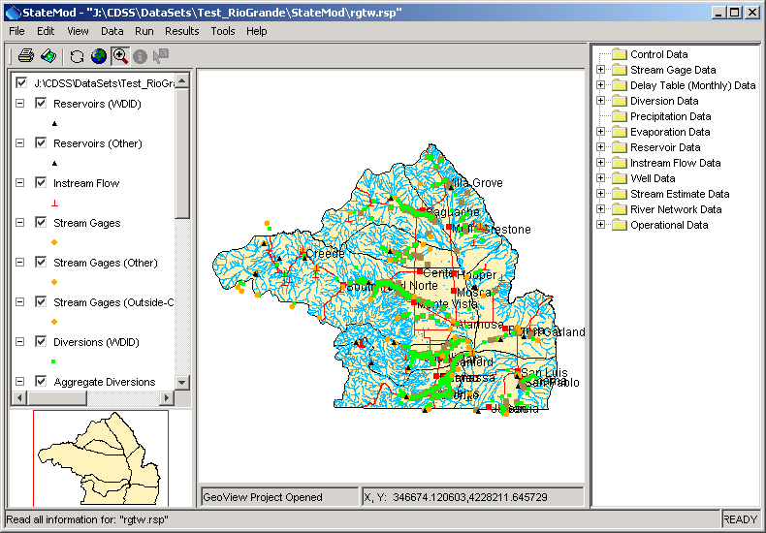

Colorado Department of Natural Resources
Colorado Water Conservation Board
Division of Water Resources

Developed by:

 | Riverside Technology, inc.

Version 07.04.00, 2013-04-17

This page is intentionally blank.

This document is formatted for two-sided printing.

