3 Getting Started
Version 07.04.00, 2013-04-18

This chapter provides an overview of the StateMod GUI. Additional chapters provide more detail about specific features.

3.1 Starting the StateMod GUI

The StateMod GUI is a Java application and therefore is run using the Java Runtime Environment (JRE). The StateMod GUI can be started from the CDSS…StateModGUI-Version start menu or a shortcut on the desktop (if configured during installation), where Version is similar to 07.04.00.

3.2 Main Interface

The StateMod GUI, when initially opened, appears as shown in the following figure:

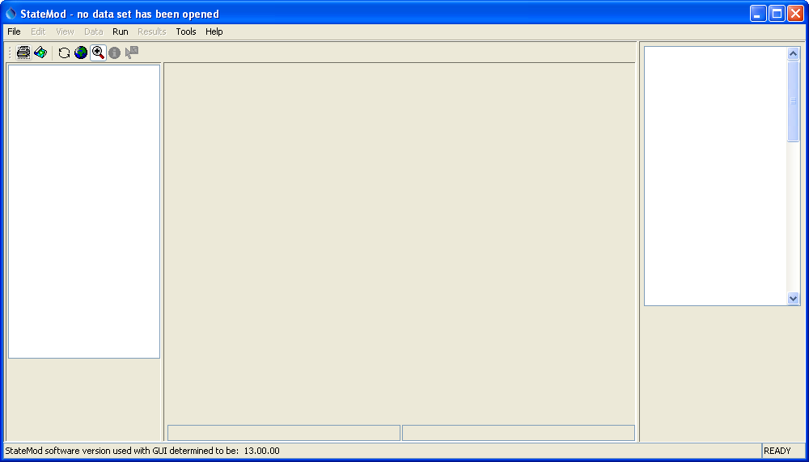
Main0
StateMod GUI Main Interface after Startup

The GUI depends on the StateMod software to generate output and it must know the StateMod version to properly interpret some data. Consequently, at startup the GUI runs the StateMod –version option. The StateMod version is displayed in the bottom of the main window and also can be displayed using Help…About StateMod/StateMod GUI.
The StateMod executable that is used by the GUI is configured using the Tools…Options menu as shown in the following figure, and there is flexibility to specify a StateMod executable that is stored with each data set (this is safest to ensure that the data set is published with the StateMod software that was used to run it). The StateMod version is important because some file formats have changed over time and there is not information in the file itself to indicate the version.

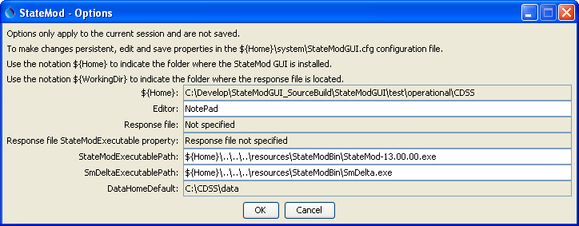
Tools_Options
StateMod GUI Configuration Options

The first step to using the StateMod GUI is to open a StateMod data set by selecting a response file for the data set. Section 3.3 – File Menu provides more information about this step. The above figure illustrates how the DataHomeDefault configuration property can be used to control the initial folder shown by the GUI when opening a data set.

Many of the examples in this documentation use a version of the State of Colorado’s Colorado River data set, which is saved in the doc\Training\data_cm2009 folder under the StateMod GUI installation. This folder can be copied to a working folder in order to ensure that the original version distributed with the software remains unchanged (as an archive in case the original needs to be retrieved).

Warning: Not all StateMod data sets have been defined to integrate completely with the StateMod GUI. Common issues are:

- Response files do not indicate locations of GIS files or network. The following response file excerpt illustrates needed information:

#----------------------
# Used by the StateMod GUI but not by StateMod the model...
Network = ..\network\cm2009.net
GeographicInformation = cm2009.gvp
# Would like to use the following but StateMod does not support (generates error)
# Instead, use ${WorkingDir} in StateMod GUI configuration file
#StateModExecutable = ..\Bin\StateMod-13.00.00.exe
# ... end StateMod GUI items
#----------------------

- GIS files are not completely configured:
  - GIS files (shapefiles or CSV files for point data) are not distributed with dataset
  - Geographic information file (also referred to as GeoView Project, *.gvp) is not provided or is improperly configured
  - Adding stations in the GUI does not result in GIS files being updated (this is a desirable enhancement – see Chapter 8 for discussion of map features)
- StateMod development has occurred and the GUI has not been updated consistently

The above issues need to be addressed in a more uniform fashion for all StateMod data sets.

After a response file has been selected and a data set has loaded, the main interface will appear similar to the following figure. Note that the location of the response file that was selected is shown in the window title and is set as the WorkingDir property mentioned in the StateMod GUI configuration file mentioned above.

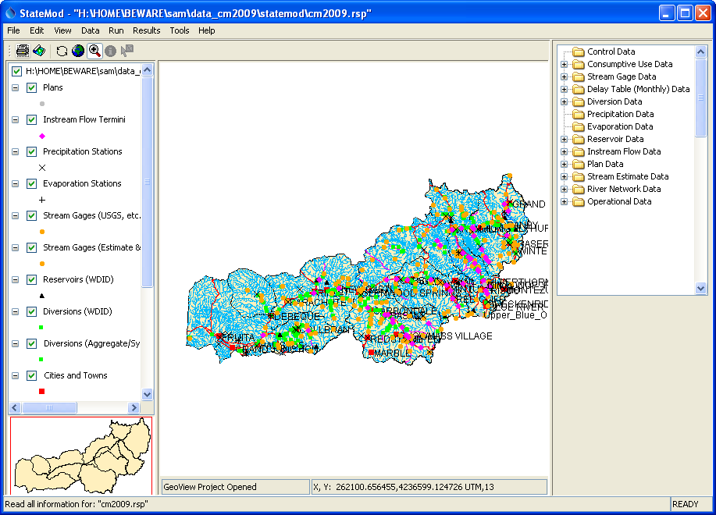
MainMap0
StateMod GUI Main Interface After Opening a Data Set

A map will be shown if a GeoView Project (*.gvp) file is referenced in the response file. See Appendix – Configuring Spatial Data for the StateMod GUI for more information. The main interface window for the StateMod GUI has several components.

Title Bar (top) | The title bar indicates the response file for the data set and whether any data have been modified.
Menu Bar (below title) | The menu bar at the top of the interface contains the menus for each of the major windows available within the interface. Each menu is discussed in the following sections.
Map Display | The map display area occupies most of the main interface and displays spatial data. General features of the mapping tool are described in the GeoView Mapping Tools Appendix. See Chapter 8 – Using the Map for more information about using the map tools within the StateMod GUI. The left side of the map display lists layers that are shown in the main map. An overview map is shown in the lower-left corner of the interface. Buttons above the layer list and map allow the map to be printed, saved as an image, and provide additional functionality.  If Zoom mode is selected (), a box can be drawn on the main map to zoom into a smaller area. A box can also be drawn on the overview map, which will show the visible extent of the main map.  If Info mode is selected (), drawing a box on the map with the mouse will print basic geographic information about the selected features.  If Select mode is selected () and a layer is selected in the layer list, clicking on a single feature will display the data window for that feature. Only one feature can be selected (a box cannot be used). For example, use Select mode to select a diversion from the map.
Data Set Tree (right of map) | The data set tree displays the primary component groups for the data set. The groups can be expanded to show the data items for each group.  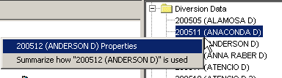  DataSet_Tree  Data Set Tree Illustrating Display Tools  Right clicking on an item displays a popup menu. Selecting Properties results in the main display window for the data component being shown (see Chapter 5 – Viewing and Editing Data).  Selecting Summarize displays a summary of how the component is used (this feature has not been fully implemented):  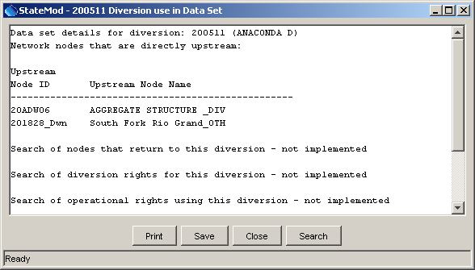  DataSet_Tree_Summary  Summary of How a Model Node is Used  It is envisioned that this feature will be enhanced in the future to facilitate modeling.
Status Message Area (bottom) | Important instructional and feedback messages are displayed in the status message area at the bottom of the main interface. These messages are also printed to the StateMod GUI log file.

The following sections describe the StateMod GUI menus, which are enabled as appropriate.

3.3 File Menu – Open and Save Data Sets

The following choices are available from the File menu (note that some choices are disabled until a data set has been opened):

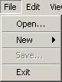
Menu_File

The menu choices are discussed in more detail below.

3.3.1 File…Open Menu

The File…Open menu is used to open an existing StateMod data set by selecting a StateMod response (.rsp) file, which lists the files in a StateMod data set. The file selector starts from the current working directory, the folder specified by the DataHomeDefault configuration property, or the last folder that has been accessed.

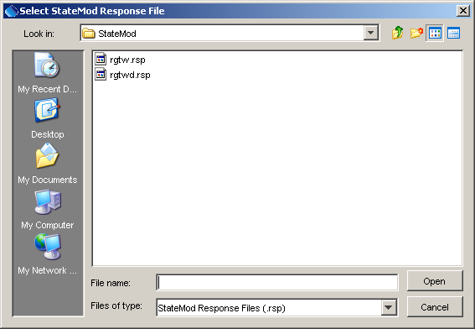
MenuFileOpen

Selecting a response file begins a process to read of all the StateMod data files for the data set. Errors reading any file may result in a warning dialog and that file may not be able to be viewed or edited by the GUI.

Once the StateMod GUI completes processing all input files, the map is displayed in the main interface if a GeoView project has been specified in the response file. The StateMod GUI filters spatial data so that only features that match identifiers in StateMod files are displayed. See the Configuring Spatial Data for the StateMod GUI Appendix for more information preparing spatial data for the StateMod GUI.
The model network file (*.net) is used by the StateMod GUI to represent the model node network as a diagram. This file is not directly used by the StateMod software but is key to StateDMI data processing and to visualizing the model network. StateMod does use a river network file (*.rin), which is compatible with the *.net file. Older StateMod data sets and response files do not include the network file (*.net). If the network file (*.net) is not listed in the response file, the following dialog will be shown at startup:

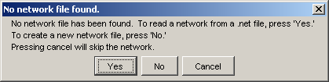
File_Open_NetworkWarning
Network File Warning

At this point, the network file (*.net) can be be added to the data set and will be displayed. Subsequently opening the data set will not display the warning. Chapter 4 – The Model Network provides more information about creating and modifying the model network.

3.3.2 File…New - Create a New Network or Data Set

The File…New menu allows the creation of a new data set or network. It is highly recommended that the StateMod GUI not be used to create new data sets and instead that a data-centered approach is used involving StateDMI, TSTool, or equivalent software. Although access to the State of Colorado’s HydroBase database provides the most functionality with StateDMI, the software also can use comma-separated-value (CSV) files to provide input for processing. TSTool is a general tool that processes data from many sources. Using the StateMod GUI to edit a new data set has the following limitations (also see the Release Notes):

- Not all interactive editing features in the StateMod GUI are completely functional, for example due to StateMod model enhancements that have not been implemented in the GUI.
- The GUI does not include functionality to annotate edited model files. Consequently, tracking of edits does not occur.
- The manual effort necessary to interactively input data will be much more than if using the automated processing provided by StateDMI and TSTool.

Nevertheless, the following sections describe how to create a new data set in the GUI.

Creating a New Data Set

Use the File…New…Data Set menu to initialize a new data set, as follows:

- Start the StateMod GUI without loading a data set.
- Select File…New…Data Set to open a new data set and provide initial information:

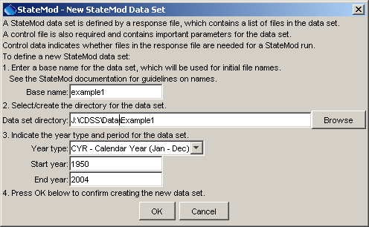
Menu_File_New_DataSet1
Providing Information to Initialize a New Data Set

The data set directory must already exist.

- Initial data set files will be created as indicated in the following confirmation dialog:

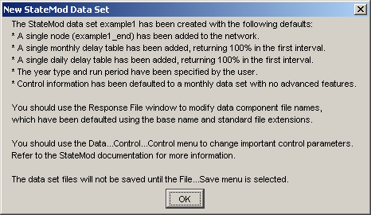
Menu_File_New_DataSet2
Confirmation of New Data Set

- The response file contents are displayed as shown in the following figure:

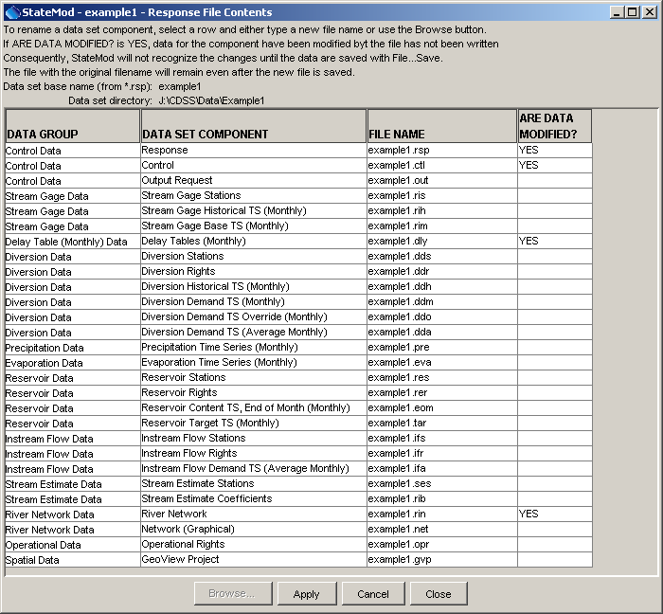
Menu_File_New_DataSet3
Initial Response File Contents for New Data Set

The file names should be modified as appropriate and then press Apply. Pressing Cancel will cancel creation of the new data set. Pressing Close apply any changes and close the window. The initial files can be saved with File…Save.
- Additional data can then be added/modified using other display windows and consequently saved with File…Save. If no additional data are added for data components, the files will be written with headers but no data records.
- Because the model network (*.rin) requires special setup attention

Creating a New Network

Use the File…New…Network to create a new network (*.net) file. This is needed when creating a new data set (do after the steps described above) or may be needed because an older StateMod data set does not include a network file. See Chapter 4 – The Model Network for more information. This feature is currently disabled pending software enhancements. Instead, use the network editor in the StateDMI software to create a new network, and use a data-centered approach to create StateMod files based on that network.

3.3.3 Save Data Files

The File…Save menu displays the following dialog, which indicates the StateMod files that need to be written due to user edits:

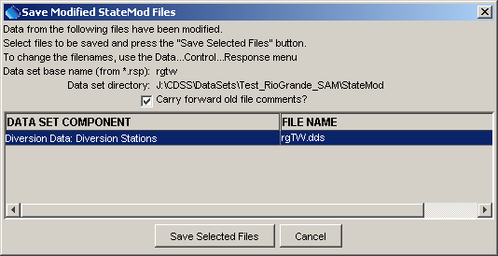
Menu_File_Save

Only StateMod files that need to be updated are listed and by default all listed files are selected. Only the selected files will be written. Use the Shift key to select a range of items and the Ctrl keys to toggle an item on and off. Selecting the Cancel button will result in no files being written.

The Carry forward old file comments checkbox, if selected, will carry forward previous file header comments (e.g., from StateDMI, TSTool, or other software), allowing the full modification history of the file to be recorded.

The above dialog is automatically displayed if you try to run StateMod from the StateMod GUI and data have been modified in memory but have not been saved to files.

3.3.4 File…Exit

The File…Exit menu exits the StateMod GUI, first asking for confirmation. If data files have been modified, an option to save the files will be provided. The X in the StateMod GUI menu bar is equivalent to File…Exit.

There is a known issue that sometimes the GUI thinks that files have been modified when the user has not actually made any changes, resulting from the GUI updating file formats or in some cases not understanding newer file formats. This issue needs to be resolved with more development resources.

3.4 Edit Menu – Add and Delete Model Data

The following choices are available from the Edit menu (note that some choices are disabled until a data set has been opened) and provides capabilities to modify a StateMod data set.

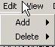
Menu_Edit

These menus are used for adding new model nodes or related data components and are discussed in Chapter 4 – The Model Network.

Once model nodes have been added, the Data menu can be used to view and modify the data components (see Chapter 5 – Viewing and Editing Data).

It is highly recommended that the StateMod GUI not be used to edit data sets and instead that a data-centered approach is used involving StateDMI, TSTool, or equivalent software. See the discussion above under creating a new data set and the Release Notes.

3.5 View Menu – Enable/Disable Display Features

The following choices are available from the View menu (note that some choices are disabled until a data set has been opened):

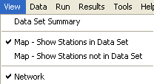
Menu_View

The following sections discuss each menu.

3.5.1 Displaying a Data Set Summary

The View…Data Set Summary menu displays a summary of the basin:

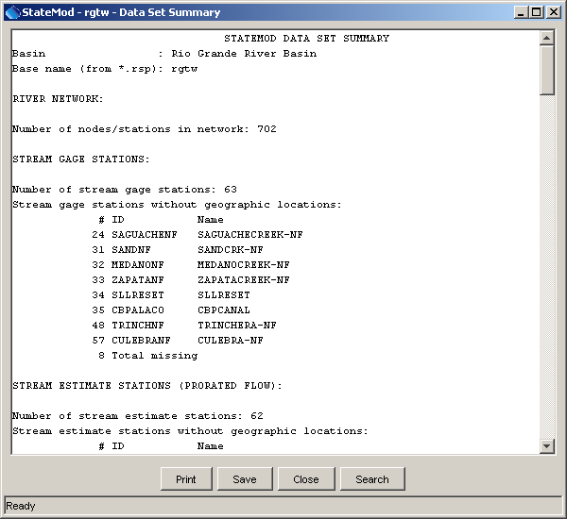
Menu_View_DataSetSummary
Data Set Summary

This information is useful for evaluating the complexity of the network. It is envisioned that this summary will be enhanced to include information to help configure and troubleshoot data sets. The above example illustrates how the summary can be used to identify stations that are not included in the spatial data layers.

3.5.2 View the Map with Stations in the Data Set

The View…Map – Show Stations in Data Set menu displays the map (read from information in the *.gvp), if spatial data have been configured for the data set. See the Configuring Spatial Data for the StateMod GUI appendix and Chapter 8 – Using the Map for more information about the map interface. This menu option is by default turned on and displays stations that match data set locations.

3.5.3 View the Map with Stations Not in the Data Set

The View…Map – Show Stations not in Data Set menu causes the map to display stations that are not in the data set. This is useful to show additional spatial data that are available in map layers but which are not currently included in the data set (or at least have identifiers that don’t match the data set).

3.5.4 View the Model Network

The View…Network menu displays the model network (read from *.net), if a network is available for the data set. See Chapter 4 – The Model Network for more information about using the network tools.

3.6 Data Menu – View and Edit Data

The following choices are available from the Data menu (note that some choices are disabled until a data set has been opened):

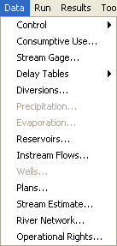
Menu_Data

These menus are used to display the main windows for primary data components. These displays allow viewing or modifying existing stations and other data (see Chapter 5 – Viewing and Editing Data). To add or delete data, use the Edit menu, as discussed in Chapter 4 – The Model Network.

3.7 Run Menu – Run StateMod

The following choices are available from the Run menu (note that some choices are disabled until a data set has been opened):

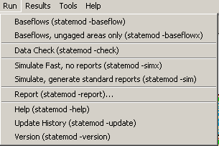
Menu_Run

These menus are used to run StateMod software and related utility software. See Chapter 6 – Running StateMod for more information.

3.8 Results Menu – View StateMod Results

The following choices are available from the Results menu (note that some choices are disabled until a data set has been opened):

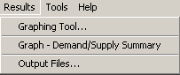
Menu_Results

These menus are used to view StateMod results. See Chapter 7 – Viewing StateMod Results for more information.

3.9 Tools Menu

The following choices are available from the Tools menu (note that some choices are disabled until a data set has been opened):

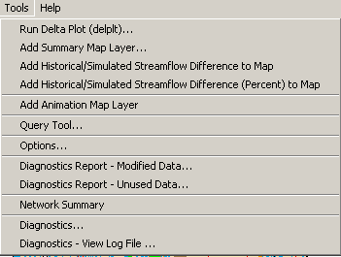
Menu_Tools

Tools provide various useful features and are described in Chapter 9 – Tools.

3.10 Help Menu

The following choices are available from the Help menu:

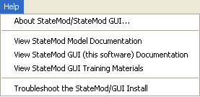
Menu_Help

The Help…About StateMod/StateMod GUI menu displays the software version for the StateMod GUI, the StateMod model version that was used for development, and the StateMod model version that has been detected by the StateMod GUI at run time.

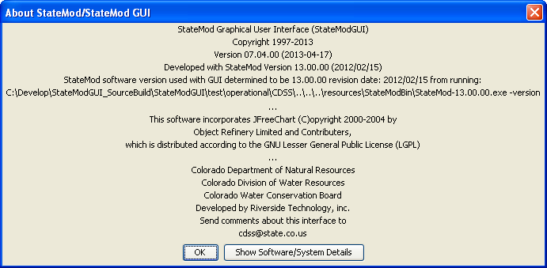
Menu_Help_About

Use the software version information when reporting problems or suggesting enhancements.

