4 The Model Network – Adding and Deleting Data
Version 06.03.02, 2006-03-04

It is recommended that modelers use a data-centered approach to creating data sets, for example using the StateDMI and TSTool software within the State of Colorado’s Decision Support Systems. This will ensure that creation of data sets is automated, repeatable, and transparent. The following are known limitations when editing data using the StateMod GUI (see also the Release Notes):

- The GUI is not current with the StateMod model features.
- Modeling conventions have not been defined to ensure that spatial data locations are defined for all model data.
- The GUI does not track edits. Consequently regenerating the files using an automated approach will lose manual edits.

The model network describes the connectivity between stations. Because other data are associated with stations, the network is a key component in organizing and navigating a data set. This chapter presents an overview of the network and describes how data can be added to or deleted from the network. Once data have been added, the data viewing and editing windows described in Chapter 5 – Data Viewing and Editing can be used. The following information is most useful to someone who is going to make changes to the model network.

4.1 Model Network Overview

The model network consists of the following information:

- A list of model nodes of various data types (e.g., diversions, reservoirs, stream gages).
- Connectivity information that indicates the downstream nodes for each node (it is implied that river networks collect but do not diverge).
- Information about area and precipitation above flow locations, for use in prorating known flows to estimated streamflow locations.
- Node coordinates, annotations, and symbol properties, to allow the network to be drawn in schematic fashion.

Although the StateMod river network file contains river node identifiers and downstream information, it does not contain some of the other information listed above. Consequently, the StateMod GUI uses an XML network file (*.net) that is compatible with, and in addition to the StateMod river network file (*.rin).

The coordinates in the model network data allow a schematic representation of the network to be created. These coordinates normally do not correspond to geographical coordinates.

The StateDMI documentation provides a full description of the network file and is not duplicated here. The following sections focus on creating and modifying the model network within the StateMod GUI. StateDMI also allows creation and editing of the network and should be used to edit the network when an automated process is being used to create other data files from the network file. The StateMod GUI should be used to edit the network if an automated process is NOT being used (e.g., to make minor changes to create a scenario or when tools like StateDMI are not available).

The model network for a StateMod basin model typically consists of a single end node to which all streams in the basin drain. Upstream of the end node is a branching stream network, which may also include human-constructed canals, ditches, and reservoirs. Key locations on the stream network, corresponding to StateMod station types, are locations where model calculations need to occur. A StateMod data set DOES NOT contain river (line) data. Instead, all model locations are stations and the station relationships are defined in the StateMod river network file.

Water is introduced into points in the network using base flow locations, which are stream gages or stream estimate stations, the latter being locations where streamflow is estimated by prorating flows from gaged locations. The resulting water is then allocated through the system, as the simulation occurs. To properly define the system, station types in the network must accurately match physical system features. The network diagram facilitates visual checking of the network and allows printing of the network, for more comprehensive review.

4.2 Model Network Interface

The View…Network menu displays the editor window for the StateMod generalized model network (*.net). In addition to the basic display of the network diagram, it is envisioned that additional tools will be added to the network editor to allow for more targeted use in the StateMod GUI (and StateDMI), for example to display the return flow locations, and to display the stations that are referenced in an operating rule.

The following figure shows the network editor after a network file has been read and displayed:

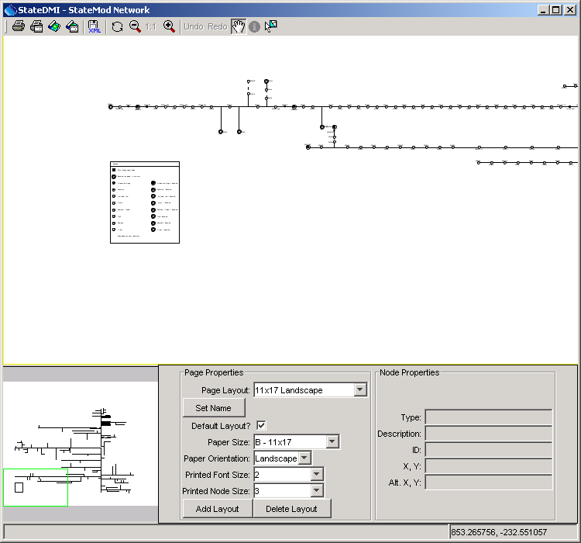
NetworkEditor
Network Editor
The network editor consists of the following areas:

- Tools (top) – initiate actions (e.g., printing), switch mode, edit tools
- Main canvas (middle) – area where editing occurs
- Overview window (lower left) – indicates the current view as a subset of the total network
- Page properties (lower middle) – the settings used for the network display, if printed
- Node properties (lower right) – the properties of the node that was last selected.

4.2.1 Network Tools

The tools that are available include the following:

Print the entire network using the selected layout (page size, orientation, etc.) This is useful for generation of final products.
Print the visible network using letter-sized paper. This is useful for troubleshooting or reviewing specific parts of the network.
Save the entire network to an image file.
Save the visible network extent to an image file. This is useful for creating inserts for documents.
Save the network to the XML file.
Refresh the network (redraw).
Zoom out by 50%, based on the current extent.
Reset the scale to match the layout.
Zoom in by 50%, based on the current extent.
If a node position has changed, allow it to be undone (or redone).
Pan the visible extent of the network – currently this is the default when clicking on other than a node.
Information tool – currently unused. It is envisioned that this tool could be enabled to show model-related data from a data set.
Select a feature – currently this is the default when clicking on a node.

4.2.2 Main Canvas

The main canvas displays the network for the current scale and location. Use the tools to scroll, pan, or zoom to a specific region.

To move an existing node, select it with the mouse and drag to the new location. Use the Undo/Redo tool if necessary to discard a change.

See sections below for information about adding/moving/deleting nodes and other actions.

Right-clicking on the canvas (not near a node), displays the following menu:

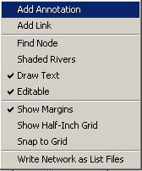
NetworkEditor_Popup

The actions for the menu items are described in the following table.

Network Editor Popup Menu Items

Menu Item | Action
Add Annotation | Add an annotation at the point where the mouse was clicked. See Section 4.2.7 below.
Add Link | Add a link between nodes. See Section 4.2.8 below.
Find Node | Display the following dialog, listing all nodes in the network.  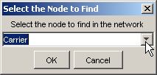  NetworkEditor_Popup_FindNode  After selecting a node and pressing OK, the network will scroll so that the selected node is in the center of the network window.
Shaded Rivers | If selected, shade the rivers based on stream order. This is useful to emphasize upstream to downstream progression.
Draw Text | If selected, draw text labels on the network. Text can be turned off if only the lines need to be printed.
Editable | If selected, the network is editable. If it is important to protect a network from editing, the network can be made non-editable. Editing actions will then be prohibited in the session.
Show Margins | If selected, the page margins are shown, representing an approximate boundary within which drawing should be limited. It is recommended that network features not extend into the margins.
Show Half-Inch Grid | If selected, a grid of lines will be drawn at half-inch intervals. This is useful for layout purposes.
Snap to Grid | If selected, nodes will be restricted to being positioned on grid lines.
Write Network as List Files | Prompt for a base file name and then write delimited list files for each station type, to be used as lists of stations with commands files. Each file is listed in order of upstream to downstream. This recognizes that it can be more generic to use list files with StateDMI processing, rather than reading from the network itself. This approach is being evaluated as list files are used. Issues to be resolved include:  - DIV and D&W nodes both exist in the network and are written as separate lists. Therefore two commands may be needed when processing the lists.  - Stream gages (FLO nodes) are written as one list and baseflow stations (FLO and other stations where baseflow is True) are written as separate lists. Users must decide which list to use.

4.2.3 Overview Window

The overview window indicates the current extent of the network in the main canvas.

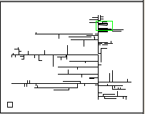
NetworkEditor_Overview

Click anywhere in the overview window to center the main canvas view on that point. Or, drag the overview window extent box to a new location to reposition the network in the main canvas.

4.2.4 Page Properties

The page properties can be set for multiple layouts using the Page Properties settings.

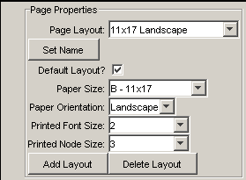
NetworkEditor_PageProperties

Because one of the primary products related to the network is a printed network diagram, the network is essentially configured as a document. Therefore, the graphics and text on the diagram are scaled (unlike some map and graph displays where the text point size is constant even when the data scale changes).

Modelers responsible for data sets should define one or more layouts for the network to allow printing on common page sizes. Often, there is so much detail on the network that a hard copy can only be printed on large paper sizes. However, more unreadable versions may be appropriate for review. Once layouts are defined, only minor changes should be required. It is recommended that the Page Layout name include the page size and orientation.

Network editing should typically occur using the page layout that will be used in production printouts. Differences in the relative dimensions of page sizes can cause some scaling in output when switching between layouts.

4.2.5 Node Properties

The node properties area in the network editor shows the properties for the most recently selected node.

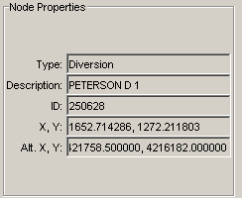
NetworkEditor_NodeProperties

This is useful when scanning network node information. See the next section for information about changing node properties.

4.2.6 Adding/Deleting/Changing a Node

To add a node and insure that data in station files is kept consistent with the network, use the Edit…Add menu items, as described in Section 4.9 below. To delete a node, use the Edit…Delete menu items, as discussed in Section 4.10 below. A node is moved by selecting the node on the network and dragging to a new location. To move multiple nodes draw a box around nodes and then move the group. Node properties for an existing node are edited by selecting a node in the network, right clicking, and pressing the Properties menu item, which will display a dialog similar to the following:

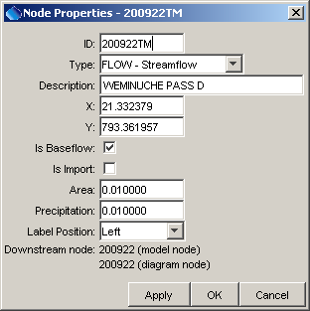
NetworkEditor_Popup_NodeProperties
Node Properties Dialog

The node types correspond either to StateMod station types or to node types needed for visualization (e.g., confluences), which are not transferred to StateMod files. Although the legacy CDSS Makenet software allowed Import and Baseflow node types, these types are no longer supported. Instead, node types correspond to StateMod station types, with the Other node type used where needed. The Is Baseflow check indicates that Area and Precipitation information are available for the node – these data are used when processing stream estimate stations.

4.2.7 Adding/Deleting/Changing Annotations

Annotations are text labels that can be drawn on the network. They are typically used for title, author, revision date, stream names, etc., using font sizes appropriate for the information.

To add an annotation, right-click at a point of interest (not near a node) and select the Add Annotation menu item, which will display the following dialog:

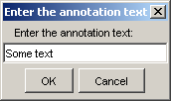
NetworkEditor_Popup_AddAnnotation

Pressing OK displays the annotation text centered at the point where the mouse was clicked. Once an annotation is added, it can be moved and its properties can be set by right clicking on the annotation anchor point and pressing Properties:

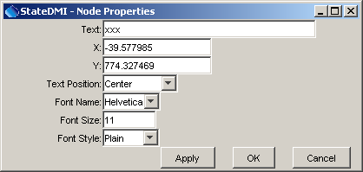
NetworkEditor_Popup_AnnotationProperties

An annotation can be moved by selecting the annotation and dragging it to the new location.

An annotation can be deleted by right clicking on the annotation and pressing the Delete Annotation menu item.

4.2.8 Adding/Deleting Links

Links are dashed lines between nodes, typically used to represent an operational relationship between nodes (e.g., to represent carrier ditches). Annotations can be placed next to links to describe the link.

To add a link, right-click on the network (not near a node) and use the Add Link menu item. The following dialog will be shown:

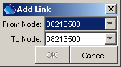
NetworkEditor_Popup_AddLink

After selecting nodes and pressing OK, the link will be drawn between the nodes as a straight dashed line.

To delete the link, select one of the nodes involved in the link, right-click and select Delete Link. If the node is involved in more than one link, a list of links will be shown.

4.3 Printing a Model Network

To print the entire network, use the tool and follow the procedure described below. To save the visible network as an image, use the tool and follow the procedure described below. Note that when printing, curved graphics are drawn using a technique called “anti-aliasing,” where curves are created by using shades of gray. This may result in graphics that are difficult to read for some page sizes.

When the print tools are used, several dialogs are shown, as required by the Java and Microsoft environments. Although options are available in various dialogs, the following approach is recommended (improvements are being evaluated):

- After selecting one of the tools mentioned above, a Java Page Setup dialog will be shown (this should be the same regardless of Windows version):

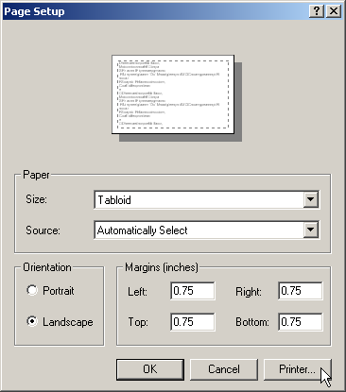
NetworkEditor_Print1

Select the printer of interest by using the Printer… button, as discussed in the next item.

- A Windows Page Setup dialog will be shown:

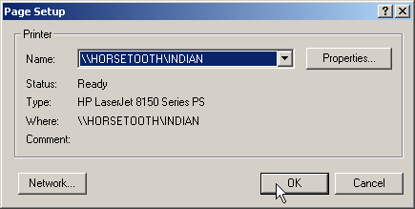
NetworkEditor_Print2

Pick a printer that can handle the page size specified in the current network editor page layout and press OK.

- In the original dialog, select the paper size to match the current network layout and press OK:

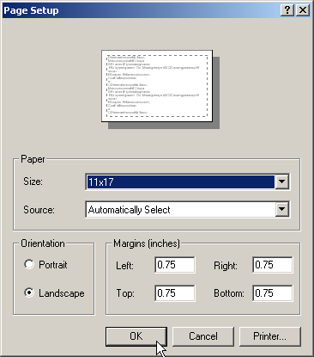
NetworkEditor_Print3

- A Windows Print dialog will be shown:

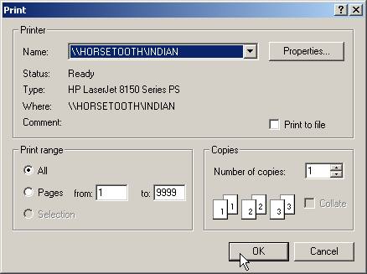
NetworkEditor_Print4

DO NOT change the printer settings. Simply press OK to finish printing.

4.4 Saving a Model Network as an Image

To save the entire network as an image, use the tool and select an image file. To save the visible network as an image, use the tool and select an image file.

4.5 Adding an Existing Model Network to an Existing Data Set

Older StateMod data sets did not directly reference the general network file (*.net). When opening older data sets, the StateMod GUI will display the following warning:

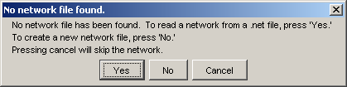
Menu_File_Open_Warning
Warning Message When the Data Set Has No Network File

If a model network is available, either from the older Makenet software or from StateDMI, press Yes and select the *.net file. Saving the response file from the StateMod GUI (see the File…Save menu) will associate the network file with the data set and the warning will not be displayed the next time that the data set is opened.

4.6 Creating a New Model Network for an Existing Data Set

The StateMod GUI does not allow a network to be created for an existing data set because the Edit…Add and Edit…Delete menus attempt to keep the various data files synchronized with the network. To create a new network to use with an existing data set, use the StateDMI software. Once the network is created, use the procedure described in Section 4.4 to attach the network to the data set.

4.7 Creating a New Model Network With a New Data Set

If File…New is selected, a completely new data set will be initialized. At this time, a new network can be started. Using the Edit…Add menu items will create new model data (see Section 4.9 below). The positions of the model nodes on the network can be adjusted during this process.

The StateDMI software can also be used to create a network and automate data set creation.

4.8 Synchronizing a Model Network with a Data Set

The model network, when used with the StateMod GUI, is primarily a visualization tool and therefore is secondary to the core data files. The features that have been implemented help enforce consistency of the network with other data. If the network becomes inconsistent with other data files, then it is recommended that the StateDMI software be used to edit the network. The network file can then be copied over the previous version in the data set and the Edit menu can once again be used, as described below.

4.9 Editing a Model Network – Adding Data

The lists of nodes in the network diagram must remain consistent with the list of stations in the various StateMod files. Therefore, when adding data, the Data…Add menu should be used. Important: If the data set is created and maintained using an automated procedure (e.g., StateDMI and TSTool software within CDSS), it is recommended that the command files used to create the set be edited and DMIs be rerun, rather than editing the data set directly.

The following figure illustrates the data that can be added:
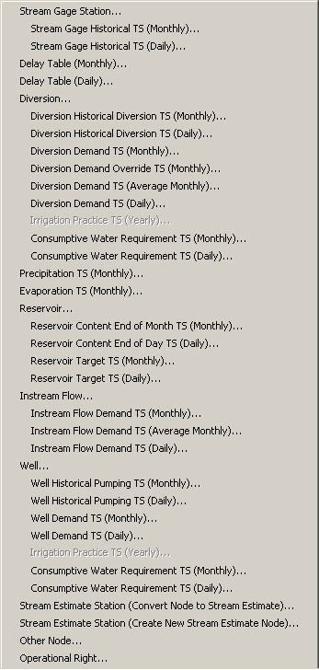
Menu_Data_Add
Edit…Add Menu

The above figure illustrates that not all data that can be added are represented in the network and in some cases secondary data components can be added. Secondary components may need to be added because an initial modeling effort used defaults for data but later work requires the addition of more specific data. Therefore, constraining data edits through the menu allows a single entry point for users. When adding data that are represented in the network, a node will automatically be added to the network by interpolating or extrapolating coordinates. The network interface can then be used to position the node in the diagram, if appropriate. In the future, data may be added from the network interface, but in this case, the intervening dialogs shown below will still be needed to provide important required and initial values for the data.

The basic procedure to add data is as follows:

- Select the appropriate Data…Add menu item.
- Fill out the information that is requested (see examples below). Default information can be specified and can be edited in more detail in step 4.
- Acknowledge the information by pressing the Add button, resulting in new data being added to one or more data lists in memory.
- The appropriate data window for the data will be shown and can be used to further edit the information.
- If the item that was added corresponds to a node in the network, automatically add the node to the network.
- If appropriate, interactively use the network editor to position the node.

The following sections illustrate features to add data.

4.9.1 Adding Stream Gage Data

The Edit…Add…Stream Gage Station… menu adds a new stream gage station:

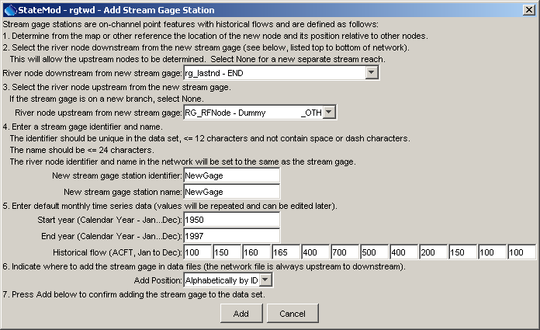
Edit_Add_StreamGage
Data for New Stream Gage Station

A node will automatically be added to the network, as shown in the following figure:
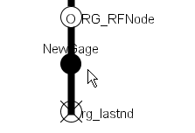
Edit_Add_StreamGage2
Stream Gage Added to Network

The Edit…Add…Stream Gage Historical TS (Monthly)… menu adds a new or redefines a monthly historical time series for an existing stream gage station:

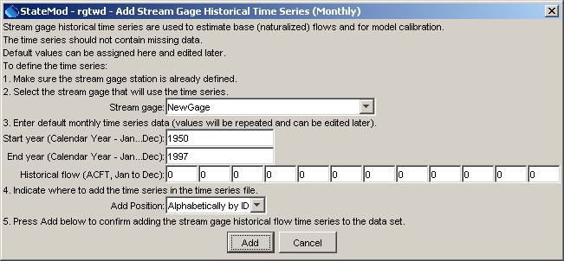
Data_Add_StreamGage_TSMonthly
New Stream Gage Historical Time Series (Monthly)

The Edit…Add…Stream Gage Historical TS (Daily)… menu adds a new or redefines a daily historical time series for an existing stream gage station:

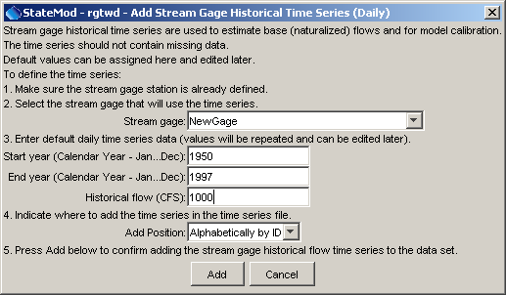
Edit_Add_StreamGage_TSDaily
New Stream Gage Historical Time Series (Daily)

4.9.2 Adding Delay Table Data

The Edit…Add…Delay Table (Monthly)… menu adds a new monthly delay table:

The Edit…Add…Delay Table (Daily)… menu adds a new daily delay table:

4.9.3 Adding Diversion Data

The Edit…Add…Diversion… menu adds a new diversion station:

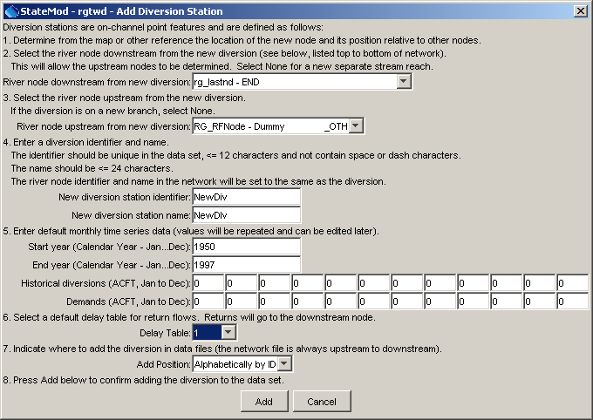
Edit_Add_Diversion
New Diversion Station

The Edit…Add…Diversion Historical Diversion TS (Monthly)… menu adds a new or redefines a diversion historical time series (monthly) for an existing diversion station:

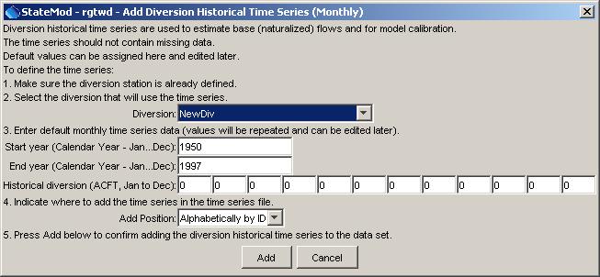
Edit_Add_Diversion_HistoricalTS_Monthly
New Diversion Historical Time Series (Monthly)

The Edit…Add…Diversion Historical Diversion TS (Daily)… menu adds a new or redefines a diversion historical time series (daily) for an existing diversion station:

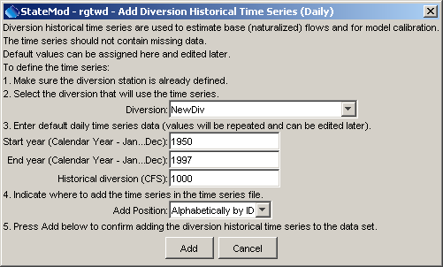
Edit_Add_Diversion_HistoricalTS_Daily
New Diversion Historical Time Series (Daily)

The Edit…Add…Diversion Demand TS (Monthly)… menu adds a new or redefines a diversion demand time series (monthly) for an existing diversion station:

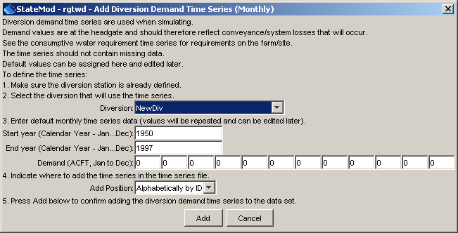
Edit_Add_Diversion_DemandTS_Monthly
New Diversion Demand Time Series (Monthly)

The Edit…Add…Diversion Demand Override TS (Monthly)… menu adds a new or redefines a diversion demand override time series (monthly) for an existing diversion station:

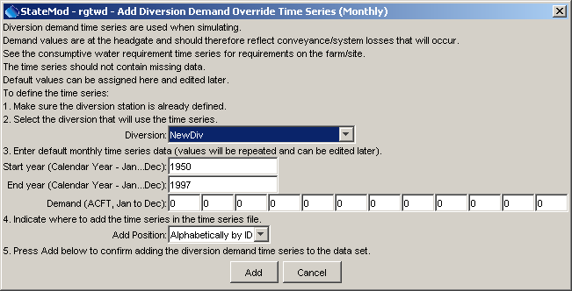
Edit_Add_Diversion_DemandOverriudeTS_Monthly
New Diversion Demand Override Time Series (Monthly)

The Edit…Add…Diversion Demand TS (Average Monthly)… menu adds a new or redefines a diversion demand time series (average monthly) for an existing diversion station:

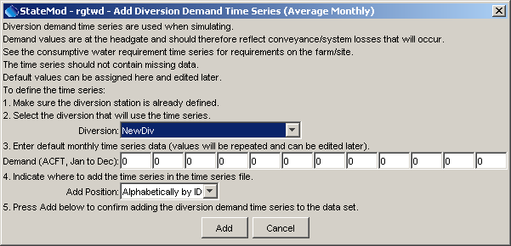
Edit_Add_Diversion_DemandTS_AverageMonthly
New Diversion Demand Override Time Series (Average Monthly)

The Edit…Add…Diversion Demand TS (Daily)… menu adds a new or redefines a diversion demand time series (daily) for an existing diversion station:

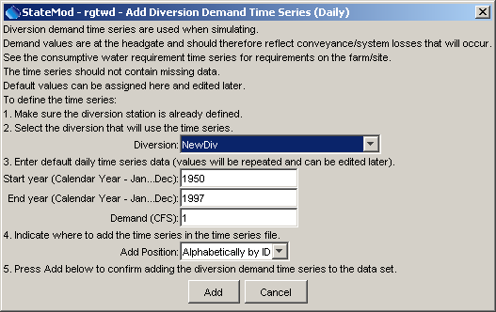
Edit_Add_Diversion_DemandTS_Dailly
New Diversion Demand Time Series (Daily)

4.9.4 Adding Precipitation Data

The Edit…Add…Precipitation TS (Monthly)… menu adds a new monthly precipitation time series:

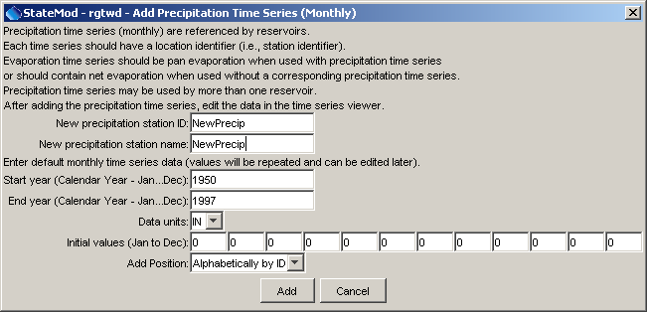
Edit_Add_Precip
New Precipitation Time Series

4.9.5 Adding Evaporation Data

The Edit…Add…Evaporation TS (Monthly)… menu adds a new monthly evaporation time series:

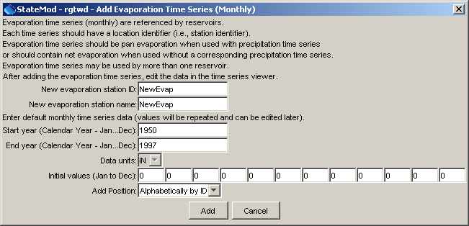
Edit_Add_Evap
New Evaporation Time Series

4.9.6 Adding Reservoir Data

The Edit…Add…Reservoir… menu adds a new reservoir station:

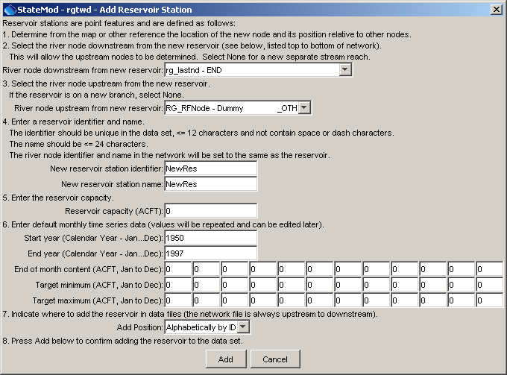
Edit_Add_Reservoir
New Reservoir Station

The Edit…Add…Reservoir Content End of Month TS (Monthly)… menu adds a new or redefines a reservoir end of month content time series (monthly) for an existing reservoir station:

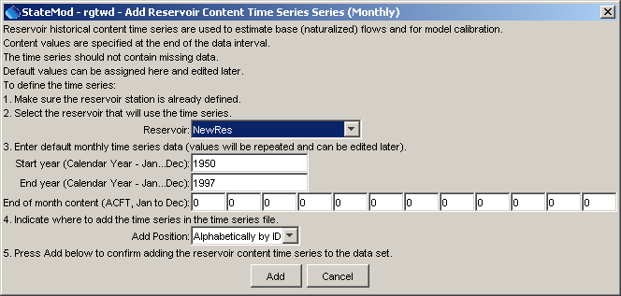
Edit_Add_Reservoir_ContentTS_Monthly
New Reservoir Content Time Series (Monthly)

The Edit…Add…Reservoir Content End of Day (Daily)… menu adds a new or redefines a reservoir end of day content time series (daily) for an existing reservoir station:

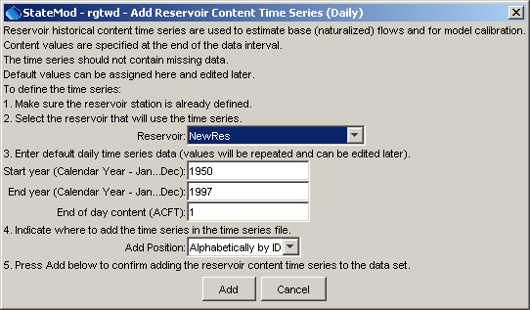
Edit_Add_Reservoir_ContentTS_Daily
New Reservoir Content Time Series (Daily)

The Edit…Add…Target TS (Monthly)… menu adds a new or redefines a reservoir target time series (monthly) for an existing reservoir station:

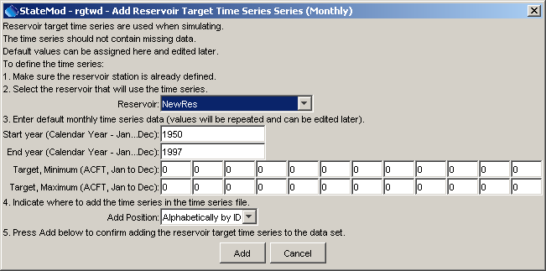
Edit_Add_Reservoir_TargetTS_Mnthly
New Reservoir Target Time Series (Monthly)

The Edit…Add…Target TS (Daily)… menu adds a new or redefines a reservoir target time series (daily) for an existing reservoir station:

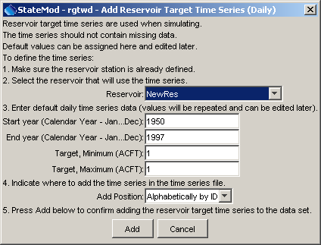
Edit_Add_Reservoir_TargetTS_Daily
New Reservoir Target Time Series (Daily)

4.9.7 Adding Instream Flow Data

The Edit…Add…Instream Flow… menu adds a new instream flow station:

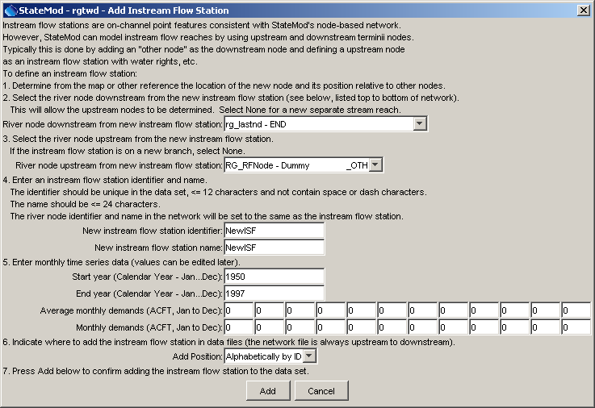
Edit_Add_InstreamFLow
New Instream Flow Station

The Edit…Add…Instream Flow Demand TS (Monthly)… menu adds a new or redefines an instream flow demand time series (monthly) for an existing instream flow station:

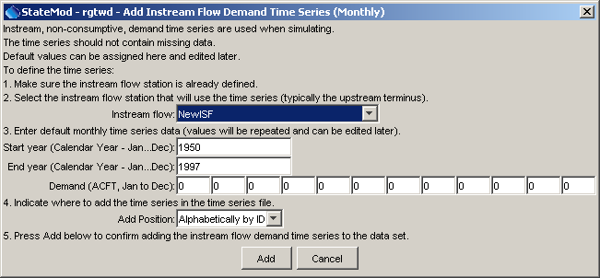
Edit_Add_InstreamFlow_DemandTS_Monthly
New Instream Flow Demand Time Series (Monthly)

The Edit…Add…Instream Flow Demand TS (Average Monthly)… menu adds a new or redefines an instream flow demand time series (average monthly) for an existing instream flow station:

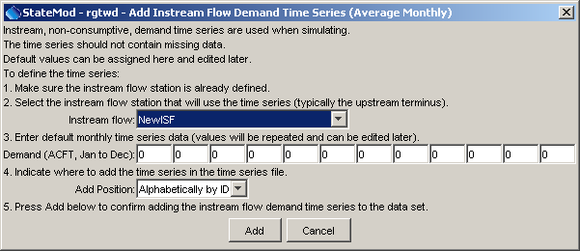
Edit_Add_InstreamFlow_DemandTS_AverageMonthly
New Instream Flow Demand Time Series (Average Monthly)

The Edit…Add…Instream Flow Demand TS (Daily)… menu adds a new or redefines an instream flow demand time series (daily) for an existing instream flow station:

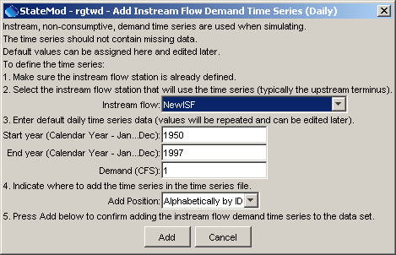
Edit_Add_InstreamFlow_DemandTS_Daily
New Instream Flow Demand Time Series (Daily)

4.9.8 Adding Well Data

The Edit…Add…Well… menu adds a new well station:

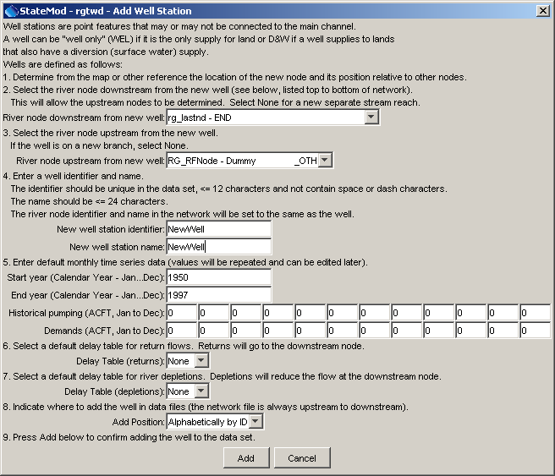
Edit_Add_Well
New Well Station

The Edit…Add…Well Historical Pumping TS (Monthly)… menu adds a new or redefines a well historical pumping time series (monthly) for an existing well station:

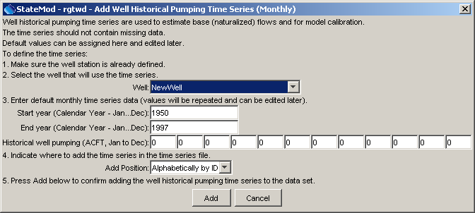
Edit_Add_Well_HistoricalTS_Monthly
New Well Historical Pumping Time Series (Monthly)

The Edit…Add…Well Historical Pumping TS (Daily)… menu adds a new or redefines a well historical time series (daily) for an existing well station:

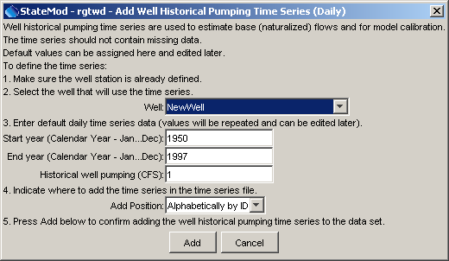
Edit_Add_Well_HistoricalTS_Daily
New Well Historical Pumping Time Series (Daily)

The Edit…Add…Well Demand TS (Monthly)… menu adds a new or redefines a well demand time series (monthly) for an existing well station:

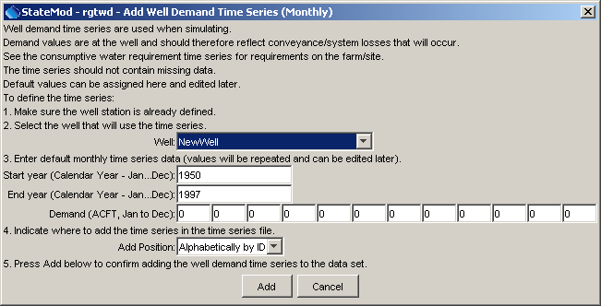
Edit_Add_Well_DemandTS_Monthly
New Well Historical Demand Time Series (Monthly)

The Edit…Add…Well Demand TS (Daily)… menu adds a new or redefines a well demand time series (daily) for an existing well station:

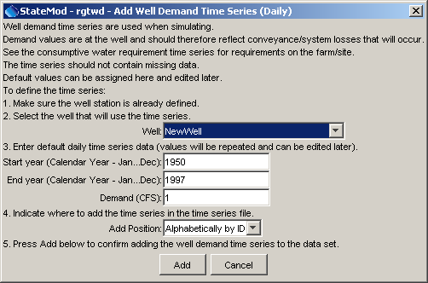
Edit_Add_Well_DemandTS_Daily
New Well Historical Demand Time Series (Daily)

The Edit…Add…Well Consumptive Water Requirement TS (Monthly)… menu adds a new or redefines a well consumptive water requirement time series (monthly) for an existing well station.

The Edit…Add…Well Consumptive Water Requirement TS (Daily)… menu adds a new or redefines a well consumptive water requirement time series (daily) for an existing well station.

4.9.9 Adding Stream Estimate Data

The Edit…Add…Stream Estimate Station (Convert Node to Stream Estimate)… menu converts an existing station to a stream estimate station:

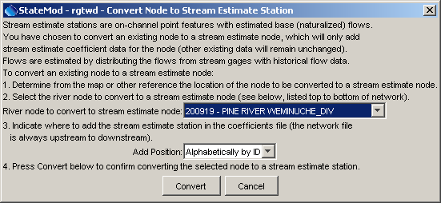
Edit_Add_StreamEstimate_Convert
Converting a Station to a Stream Estimate Station

The Edit…Add…Stream Estimate Station (Create New Stream Estimate Node)… menu creates a new stream estimate station:

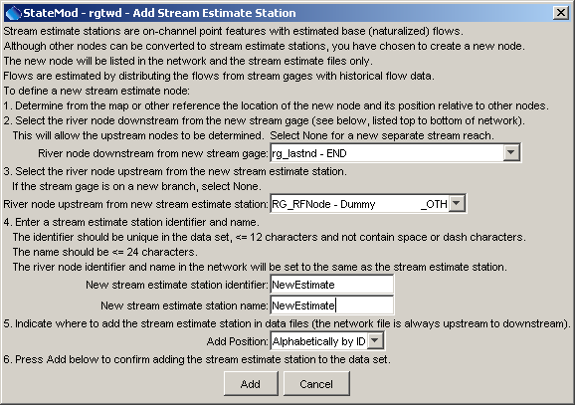
Edit_Add_StreamEstimate
New Stream Estimate Station

4.9.10 Adding Other Data

The Edit…Add…Other Node… menu creates a new node in the river network file that is not a station in any other file:

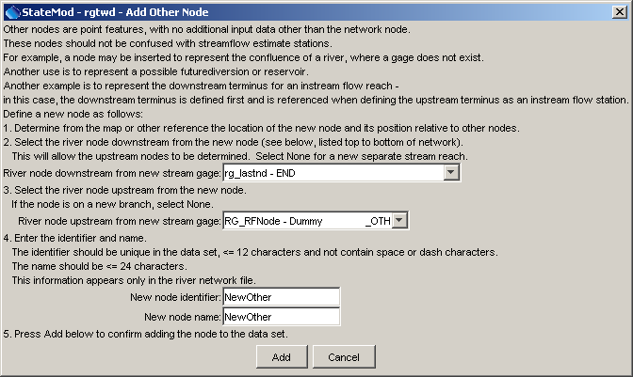
Edit_Add_Other
New Other (River Node) Station

4.9.11 Adding Operational Right Data

The Edit…Add…Operational Right… menu creates a new operational right:

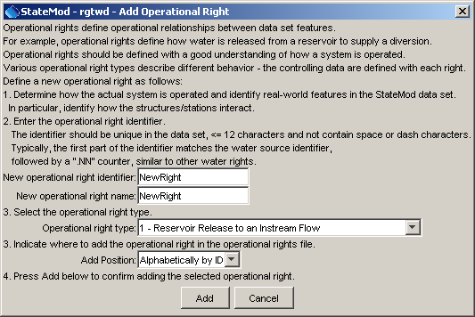
Edit_Add_Other
New Operational Right

4.10 Editing a Model Network – Deleting Data

Similar to adding data to the data set, deleting data requires using the Edit…Delete menu to maintain consistency between the model network and data components:

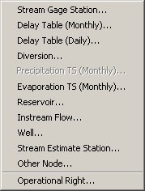
Menu_Edit_Delete
Edit…Delete Menu

Features that exist in the network will be deleted, and the corresponding upstream/downstream nodes will be reconnected as appropriate. After deleting the node, the data files should be saved and the StateMod data check should be run. The StateMod GUI will not reconnect return flows, operational rights, or baseflow nodes. Edit windows must be used to adjust these data. Any problems associated with the deletion will be described in the StateMod log file.

The basic procedure to delete data is as follows:

- Select the appropriate Data…Delete menu item.
- Select the data item to delete. The Update Details button can be pressed to show information about the data item – this feature is under development and is envisioned to indicate related data that could be impacted by the delete.
- Confirm the delete by pressing the Delete button, resulting in data being deleted from one or more data lists in memory. If a station is being deleted, the related time series will also be deleted.
- If the item that was added corresponds to a node in the network, automatically remove the node from the network and reconnect effected nodes.
- If appropriate, interactively use the network editor to position the node.

The following sections illustrate features to delete data.

4.10.1 Deleting a Stream Gage Data

The Edit…Delete…Stream Gage… menu deletes a stream gage:

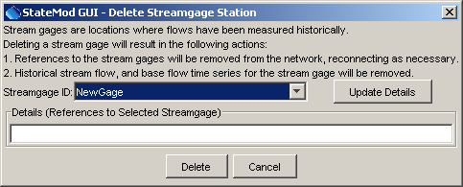
Edit_Delete_StreamGage
Deleting a Stream Gage Station

4.10.2 Deleting Delay Table Data

The Edit…Delete…Delay Table (Monthly)… menu deletes a monthly delay table:

The Edit…Delete…Delay Table (Daily)… menu deletes a daily delay table:

4.10.3 Deleting Diversion Data

The Edit…Delete…Diversion… menu deletes a diversion station:

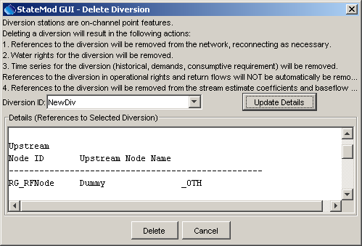
Edit_Delete_Diversion
Deleting a Diversion Station

4.10.4 Deleting Precipitation Data

The Edit…Delete…Precipitation TS (Monthly)… menu deletes a monthly precipitation time series.

4.10.5 Deleting Evaporation Data

The Edit…Delete…Evaporation TS (Monthly)… menu deletes a monthly evaporation time series:

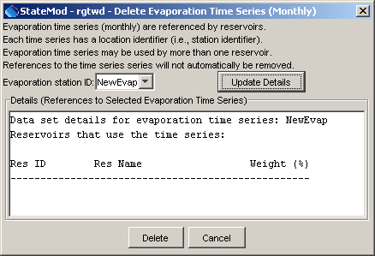
Edit_Delete_Evap
Deleting an Evaporation Time Series

4.10.6 Deleting Reservoir Data

The Edit…Delete…Reservoir… menu deletes a reservoir station:

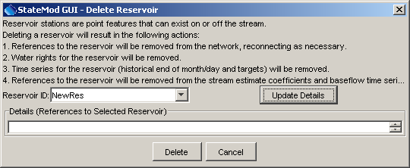
Edit_Delete_Reservoir
Deleting a Reservoir Station

4.10.7 Deleting Instream Flow Data

The Edit…Delete…Instream Flow… menu deletes an instream flow station:

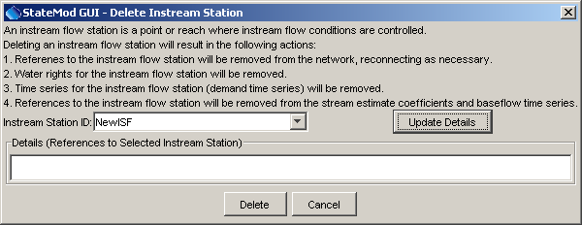
Edit_Delete_InstreamFlow
Deleting an Instream Flow Station

4.10.8 Deleting Well Data

The Edit…Delete…Well… menu deletes a well station:

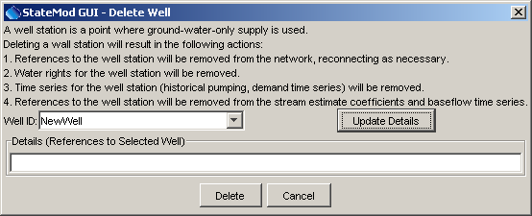
Edit_Delete_Well
Deleting a Well Station

4.10.9 Deleting Stream Estimate Data

The Edit…Delete…Stream Estimate Station… menu deletes a stream estimate station:

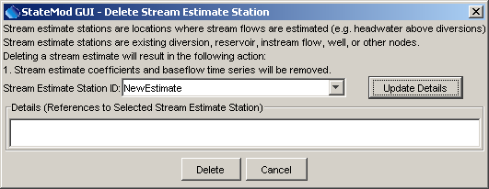
Edit_Delete_StreamEstimate
Deleting a Stream Estimate Station

4.10.10 Deleting Operational Right Data

The Edit…Delete…Operational Right… menu deletes an operational right:

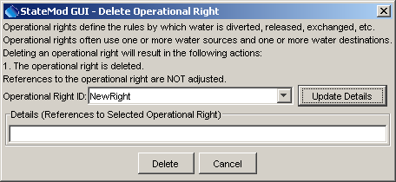
Edit_Delete_OpRight
Deleting an Operational Right

This page is intentionally blank.

