5 Viewing and Editing Data
Version 07.04.00, 2013-04-18

The Data menu allows data sets to be viewed and edited, with data being organized according to the major StateMod data types:

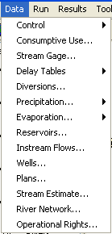
Menu_Data

The Data menu items are listed in approximately the order of creation, similar to the CDSS StateDMI software. In particular, components that depend on other components are generally listed last.

The primary components each have a main display window, which may display data from one or more StateMod data files. For example, diversion data contains diversion station information, water rights, delay tables, and associated time series. Consequently, there are fewer Data menu items than there are StateMod files. See the StateMod software documentation for information about the model data. The StateMod GUI allows changes to data but in many cases cannot check for data connections (e.g., it does not know which delay table to use for return flows when adding a new structure). It is therefore important that users understand the implications of editing data and realize that changes in more than one window may be necessary for a working data set. The data windows do not allow adding new model features or deleting existing features. To do so, use the Edit menu, which enforces consistency between the model network and other files. Each edit feature is described in the following sections.

5.1 Control Data

The Data…Control menu allows viewing/editing of control file information:

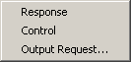
Menu_Data_Control

Control data consists of important properties and also organizes the files in the data set. Each control data component is described in the following sections.

5.1.1 Response File

The Data…Control…Response menu displays the response file contents, which lists files being used for the current data set:
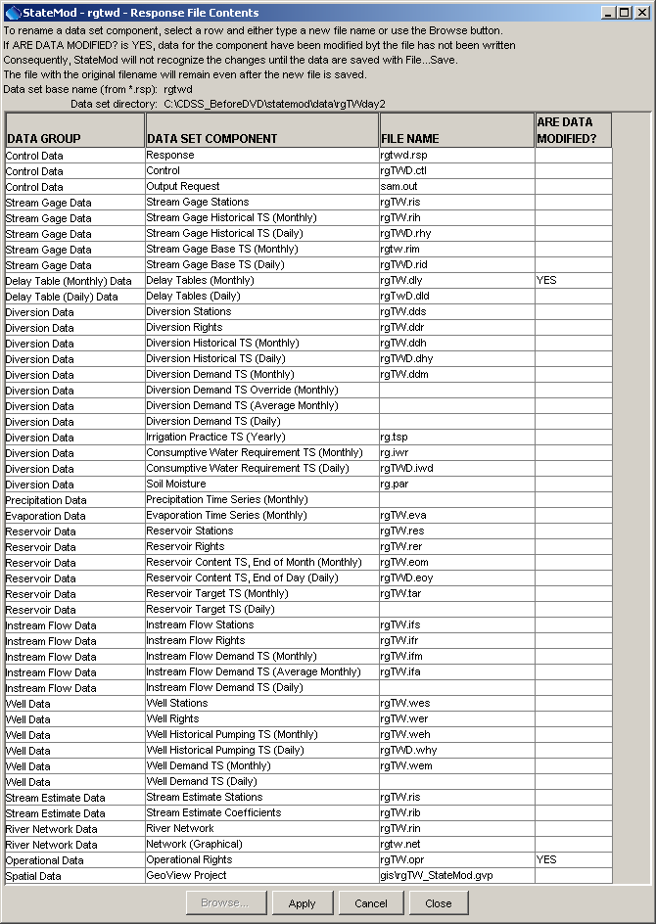
Data_Control_Response
Response File Data Window
The response file display shows the primary data group, the specific data set component, and the corresponding file name in the response file. Relative paths are encouraged to promote portability of data sets. The ARE DATA MODIFIED? column indicates if data files have been modified within the StateMod GUI. If YES is indicated, then the associated files will need to be saved with File…Save before the StateMod software will recognize the changes in a run. If model file formats change over time, the data files may automatically be tagged as being modified when read. Saving the files will result in using the new file format.

There is typically no need to modify filenames and consistent filenames are encouraged. The names of files in a data set typically have the same base name, with file extensions following StateMod modeling conventions. In older versions of StateMod, it was often necessary to use an empty “dummy” file in the response file. This is no longer needed and the above figure illustrates how omitting a file name indicates that the data component is not used in the data set.

5.1.2 Control File

The Data…Control...Control menu allows viewing/editing the StateMod control data, which consists primarily of string and numeric properties for the data set. The control data are presented using a tabbed panel window, as shown in the following figures.

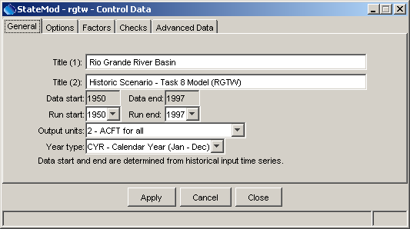
Data_Control_Control_General
Control Data – General Properties

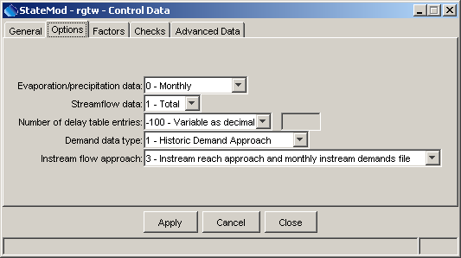
Data_Control_Control_Options
Control Data – Option Properties

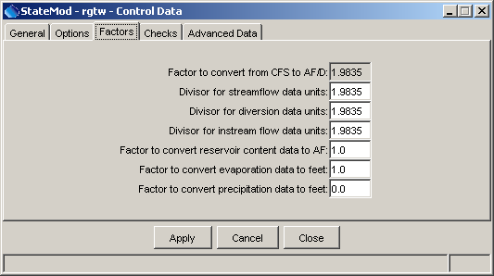
Data_Control_Control_Factors
Control Data – Conversion Factor Properties

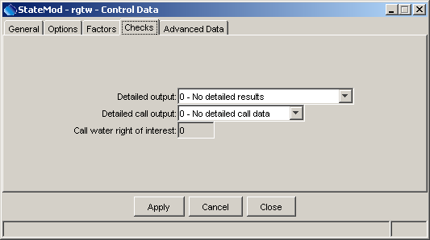
Data_Control_Control_Checks
Control Data – Data Check Properties

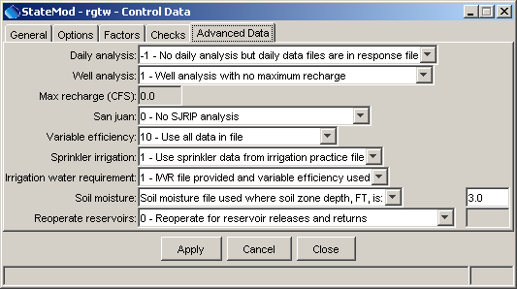
Data_Control_Control_Advanced
Control Data – Advanced Properties

Refer to the StateMod documentation for more information about the meaning of control data. Changing the run period of record is one of the more useful features of this window and limits the model output (the graphing tool also uses the run period to determine the period to graph). The StateMod GUI determines the data period of record by evaluating all the input time series files and finding the maximum period of record (if time series are not read when selecting the data set, then only the streamflow time series file is used for the data period). The StateMod GUI shows standard choices for control data and will attempt to pass through unrecognized values. This allows for enhancement to the StateMod software.

5.1.3 Output Control File

The Data…Control…Output Request menu displays a dialog that controls how much output StateMod will produce.

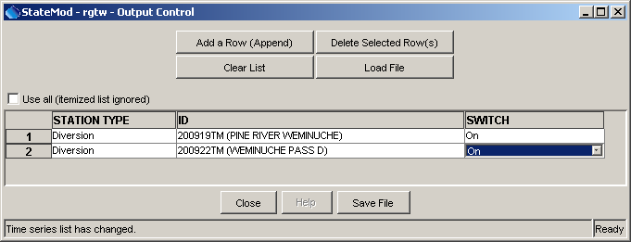
Data_Control_OutputControl
Output Control Window

The output control interface edits the StateMod output control file. The purpose of the output control file is to limit the StateMod output to a few structures. This reduces model execution time but also limits the output that can be viewed after a run. The output control file name is usually left constant in the response file, being overwritten as needed. StateMod, when run in data check mode, will automatically create a template output control file with extension .xou. If the response file also uses this name, then a custom output control file may be overwritten when StateMod runs in check mode.

The output control window creates a list of stations that will have output generated when the model runs. Stations can be selected either by manually entering the identifiers or relying on the interface to generate the identifiers. An output control file also allows all structures to be output. Selecting the Use all checkbox turns on this feature and the structures in the list are ignored (but will be included in the output control file for subsequent manipulation of the file).

Adding a row initializes a new row in the list. Selecting a station type results in a selectable list of identifiers, which will be alphabetized and include stations for the selected station type. The switch should be set to On but can be set to Off to deactivate the item. When finished editing the contents of an output control file, select Save File. A file selector is displayed with a default file extension of .tpo (although the file extensions .out and .xou are also often used). To be recognized by StateMod, this file name should match the output control file in the response file. If necessary, rename the output control file outside the StateMod GUI or read a file and then re-save using a different name.

5.2 Consumptive Use Data

The Data…Consumptive Use menu displays the consumptive use locations and associated data:

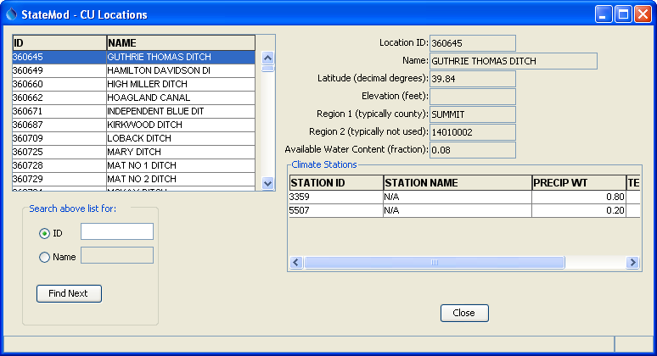
Data_CULocation
Consumptive Use Locations Data Window

Consumptive use locations correspond to locations that supply consumptive use data (e.g., irrigation water requirement) data. Currently the data are read-only and the irrigation water requirement time series are not accessible from the window.

5.3 Stream Gage Data

The Data…Stream Gage menu displays the stream (river) gage stations:

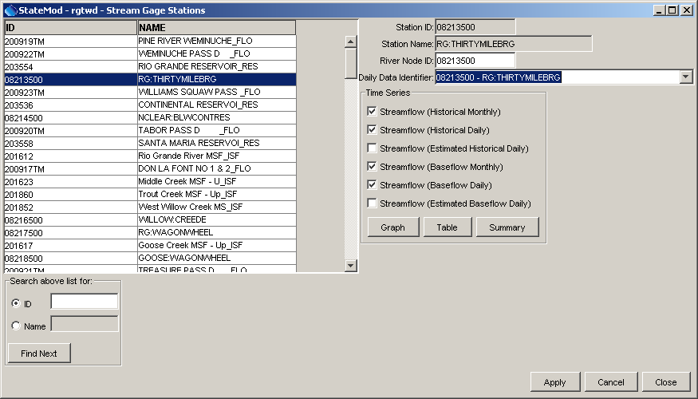
Data_StramGage
River Stations Data Window

River stations consist of points with historical streamflow data (the alternative being stream estimate stations where streamflow is estimated using baseflow coefficients – see Section 5.12). Selecting a station from the list on the left will display the station data on the right side of the window. The station data shown in the upper right can be edited and saved.

Use the Edit menu to add or delete a station.

A list of available input time series is shown and can be selected for display with the Graph, Table, and Summary buttons. If the data set does not contain certain time series, then checkboxes will be disabled.
For example, a streamflow gage may have historical time series data and baseflow time series, which is created by running StateMod in baseflow mode. All available time series are shown on a single “page”, with separate graphs used to group similar data intervals, as shown in the following example:

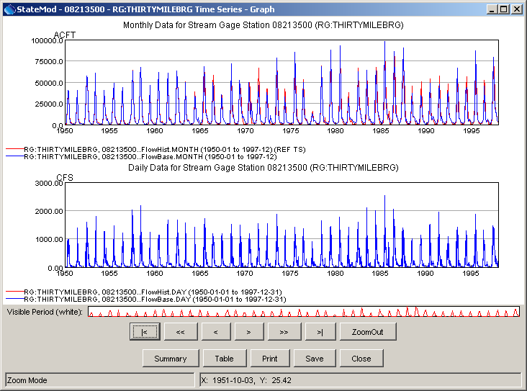
DataRiverStationsMonthlyTimeSeries
River Station Monthly Time Series Graph

The data types for the time series are consistent with the nomenclature used in the Results…Graphing Tool menu, where possible. The Summary button can be used to display a text summary of the time series. The Table button can be used to view the time series in tabular form. Refer to the TSView Time Series Viewing Tools Appendix for more information about the graphing tools.

5.4 Delay Table Data

The Data…Delay Tables menu displays delay table information.

5.4.1 Delay Tables (Monthly)

The Data…Delay Tables…Monthly menu displays the list of monthly delay tables, which are used by diversion stations and well stations when indicating return flows or depletions.

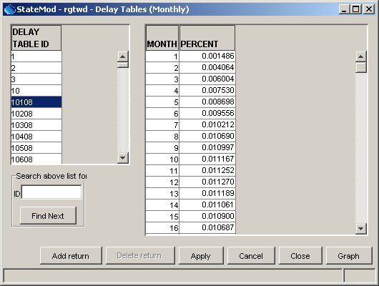
Data_DelayTables_Monthly
Delay Table Data (Monthly)

Delay table information can be specified as percent or fraction (decimal), depending on the interv control file parameter. To add a new delay table entry, select the Add return button. This will add a row to the display with default data above the highlighted row. If the last row is highlighted and a row is added, a prompt will allow adding the row above or below the last row. Fill in the data as appropriate. To delete a delay table entry, select a row and then press the Delete return button.

Care should be taken when modifying delay tables because delay tables can be used by more than one station. It may be necessary to modify the diversion or well station delay table assignments.

Use the Edit menu to add or delete a delay table.

Pressing the Graph button displays the delay table as shown in the following figure, treating the data as a time series where the initial year is one (the following example shows a delay table that spans twenty years):

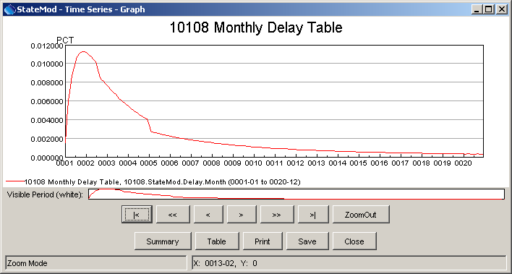
DataDelayTableGraph
Monthly Delay Table Graph

5.5 Diversion Data

The Data…Diversions menu displays information for diversions. The primary data component is diversion stations, and secondary components are water rights, historical time series, demand time series, return flows (delay table assignments).

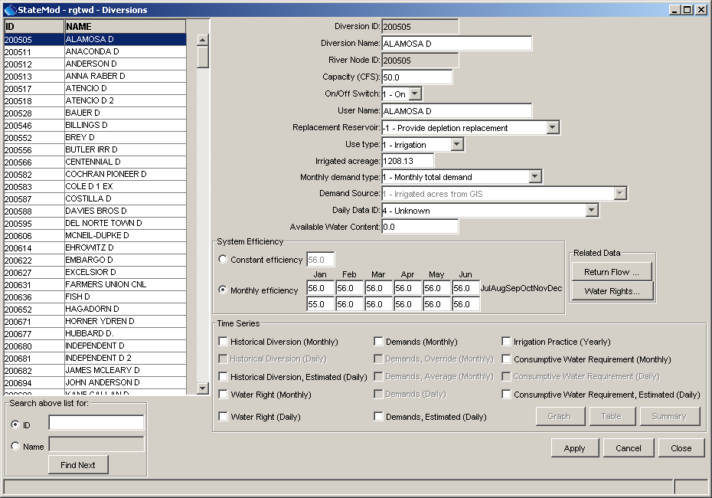
Data_Diversions
Diversion Data Window

All diversion stations in the data set are listed on the left side of the window. Selecting a diversion from the list displays that diversion station's information in the window. Secondary data are displayed in additional windows accessed via buttons. Access to other data is disabled if the data were not read or are not a part of the data set. All data are editable except for the identifier and river node identifier, which are referenced in the network and other data. Press the Apply button after making changes. Changes are also applied if the Close button is pressed. Use the main Edit menu to add or delete diversion stations and optionally the secondary data.

The list of diversions can be search by entering the identifier or name in the appropriate search boxes located below the list. Any number of characters can be entered in the search box. Press Enter to perform the case-insensitive search, starting at the top of the list. The Find Next button, when pressed, will find the next station that matches the information.

The diversion efficiency is displayed for each month in the year. If the diversion has a constant efficiency, the same value is displayed in each of the twelve monthly fields. Variable efficiencies, if used in modeling, are not shown (only the average efficiencies shown in the diversion station file are shown).

The Daily Data ID is used to associate a daily time series with a diversion station. Changes to this value take effect when either a different diversion in the list is chosen or when Enter is pressed in the Daily Data ID text field. The following options are available:

- If the Daily Data ID exactly matches the Diversion ID, the pattern and values are the same.
- If the Daily Data ID is “0”, the pattern and values are again the same but are the average daily values, calculated using the monthly time series.
- If the Daily Data ID does not match the Diversion ID and is not “0”, the pattern time series corresponding to the Daily Data ID is displayed as-is. However, the values time series is calculated using the pattern and known monthly totals. The daily time series monthly total should agree with the monthly time series, but the distribution should correspond with the pattern. More than one diversion may reference the same pattern. For that reason, care should be taken when changing the pattern itself.
- Additional options may be available from StateMod. Refer to the StateMod software documentation.

5.5.1 Diversion Station Return Flows

Diversion station return flows (delay table assignments) are displayed by pressing the Return Flow button in the main diversions window:

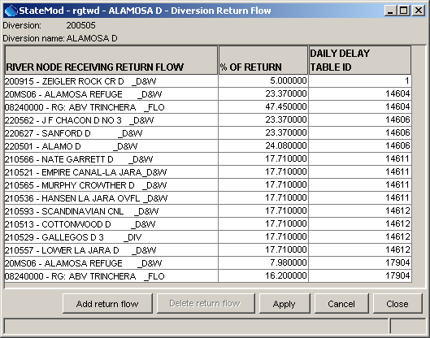
Data_Diversions_ReturnFlow
Diversion Return Flow Data
Press the Add return flow button to add a row to the display. Fill in the information as appropriate, using the choices that are provided. To delete a return flow, select a row and press the Delete return flow button. Press the Apply button to update the reservoir station data. The Close button will apply changes and close the window.

5.5.2 Diversion Water Rights

The water rights that apply to the diversion can be viewed by pressing the Water Rights button in the diversion data window, resulting in a display as shown in the following figure:

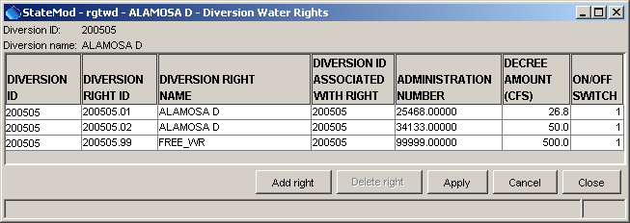
Data_Diversions_WaterRights
Diversion Water Rights Data Window

To add a water right, press Add right. This will add a row with default information, which should be updated as appropriate. To delete a water right, select the row and press Delete right. Press the Apply button to update the reservoir station data. The Close button will apply changes and close the window.

5.5.3 Diversion Time Series

The bottom of the main diversions window lists all time series associated with diversion stations. The checkboxes next to time series are enabled according to the data that are available for the currently selected diversion station. To view time series, select one or more time series and press the Graph, Table, or Summary buttons. The following figure illustrates a graph of monthly data:

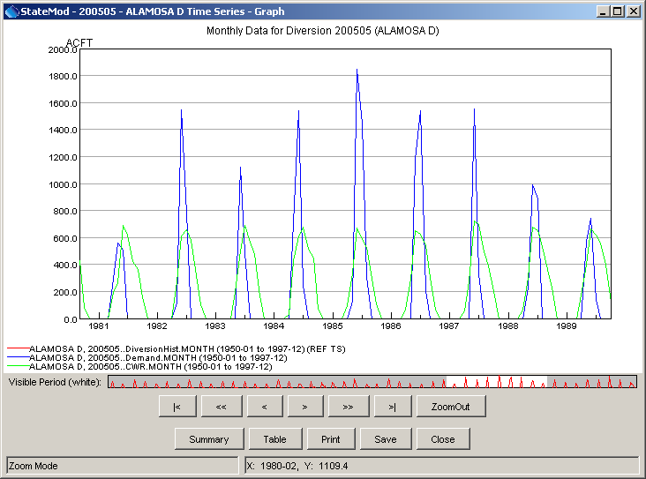
Data_Diversions_Graph
Diversion Time Series (Monthly)

The data types for the time series are consistent with the nomenclature used in the Results…Graphing Tool menu, where possible. The Summary button can be used to display a text summary of the time series. The Table button can be used to view the time series in tabular form. Refer to the TSView Time Series Viewing Tools Appendix for more information about the graphing tools.

5.6 Precipitation Data

The Data…Precipitation… menu displays monthly precipitation data (average annual precipitation currently cannot be displayed). Precipitation data consist of precipitation time series and are used to compute net reservoir evaporation. Frequently, net evaporation is pre-calculated and is provided in the evaporation data. Refer to the next section for information about viewing evaporation data. The display features for precipitation and evaporation data are similar.

5.7 Evaporation Data

The Data…Evaporation… menu displays evaporation data. Evaporation data consist of evaporation time series and are used to compute net reservoir evaporation (based on reservoir surface area). Frequently, pan evaporation and precipitation time series are analyzed external to StateMod to produce a net evaporation time series (e.g., see the TSTool software). In this case, no precipitation time series will be provided to StateMod and only the evaporation time series will be used. The identifiers for the climate stations in the time series files are referenced in reservoir station data. The StateMod GUI currently displays all monthly evaporation time series in a table (average annual evaporation currently cannot be displayed), from which a graph can be displayed. Enhancements are being considered to facilitate selecting specific time series for graphs.

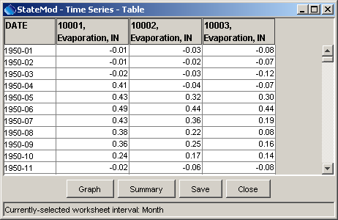
Data_Evaporation_Graph
Evaporation Time Series Table

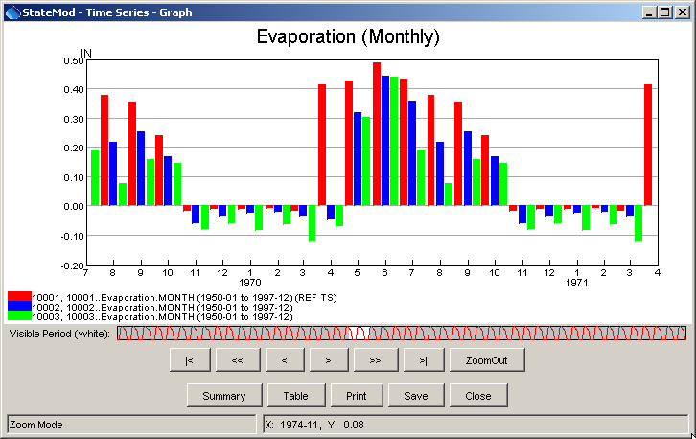
Data_Evaporation_Graph
Monthly Evaporation Time Series Graph

5.8 Reservoir Data

The Data…Reservoirs menu displays information for reservoirs. The primary data component is reservoir stations, and secondary components are water rights, historical time series and target time series.

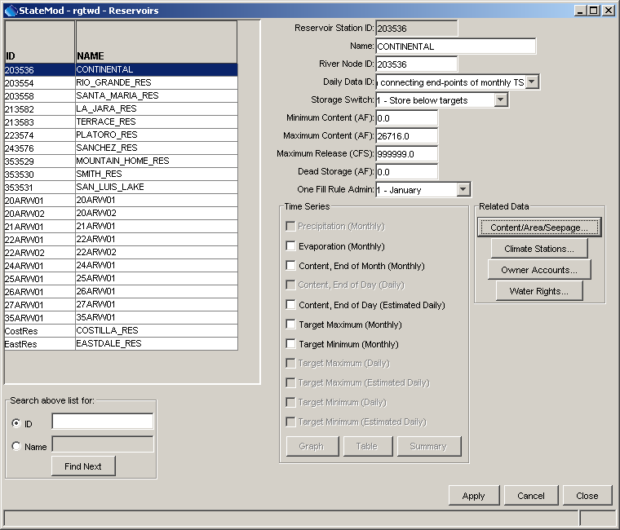
Data_Reservoirs
Reservoir Data

All reservoir stations in the data set are listed on the left side of the window. Selecting a reservoir from the list displays that reservoir station's information in the window. Secondary data are displayed in additional windows accessed via buttons. Access to other data is disabled if the data were not read or are not a part of the data set. All data are editable except for the identifier, which is referenced in the network and other data. Press the Apply button after making changes. Changes are also applied if the Close button is pressed. Use the main Edit menu to add or delete reservoir stations and optionally the secondary data.

To search for a particular station, enter the identifier or name in the appropriate search boxes located below the list. Any number of characters can be entered in the search box. Press Enter to perform the case-insensitive search, starting at the top of the list. The Find Next button, when pressed, will find the next station that matches the information.

5.8.1 Reservoir Content/Area/Seepage

Selecting the Content/Area/Seepage button in the main reservoirs window displays the reservoir's content/area/seepage curve information, as shown below:

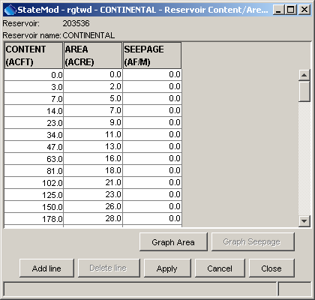
Data_ReservoirsArea_Content
Reservoir Area Capacity Content Table

The Add line button adds a row at the bottom of the table. The Delete line button will delete the selected row. Information should be added to the table in ascending order. Zero and high point values should be included to bound interpolations. For example, include a very large content value with an area and seepage value that are only slightly larger than the next to last row. Select Apply to apply the changes to the reservoir data. The Close button will apply the changes and close the window.

If a range of data values is available, the data can be graphed. Seepage values are often not supplied and therefore the graph button is disabled. The following figure illustrates a reservoir content versus area graph displayed with the Graph Area button:

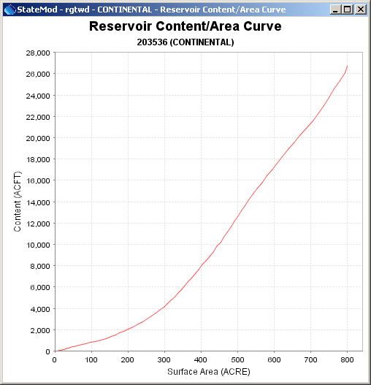
Data_Reservoirs_Content_Graph
Reservoir Content/Area Graph

In the above graph, the very large bounding content value is omitted. Right click to print or save the graph to an image. When printing, select the page layout in the first dialog and the printer in the second dialog. Drawing a box on the window will also zoom the graph. Drag the mouse vertically to zoom out.

5.8.2 Reservoir Climate Station Assignment

Selecting the Climate Stations button in the main reservoirs window displays the climate stations that supply precipitation and evaporation time series for the reservoir, as shown below:

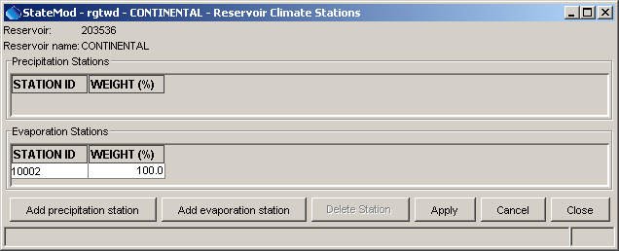
Data_Reservoirs_Climate
Reservoir Climate Station Assignments

The climate station identifiers correspond to the identifiers in the precipitation and evaporation time series. The above example illustrates that no precipitation time series are used and therefore the evaporation time series contain net evaporation data.

The Add precipitation station and Add evaporation station buttons will add a row at the bottom of the appropriate table. The Delete Station button will delete the selected row. Select Apply to apply the changes to the reservoir data. The Close button will apply the changes and close the window.

5.8.3 Reservoir Accounts

Selecting the Owner Accounts button in the main reservoirs window displays the accounts associated with the reservoir, as shown in the following figure.

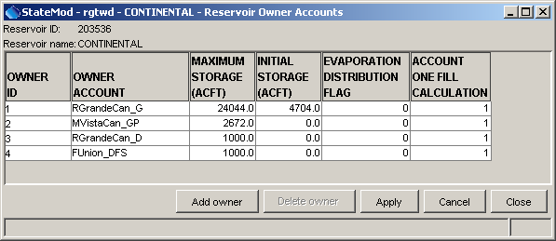
Data_Reservoirs_Accounts
Reservoir Owner Accounts Data Window

The Add owner button will add a row at the bottom of the table. The Delete owner button will delete the selected row. Select Apply to apply the changes to the reservoir data. The Close button will apply the changes and close the window.

5.8.4 Reservoir Water Rights

Selecting the Water Rights button in the main reservoirs window displays the water rights associated with the reservoir, as shown in the following figure:

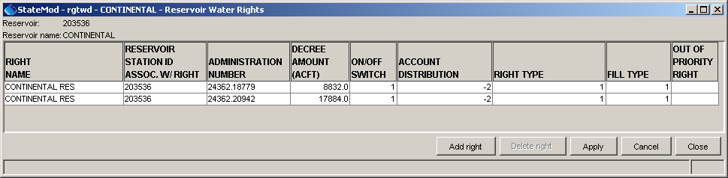
Data_Reservoirs_Rights
Reservoir Water Rights

The Add right button will add a row at the bottom of the table, using default values that should be changed to appropriate values. The Delete right button will delete the selected row. Select Apply to apply the changes to the reservoir data. The Close button will apply the changes and close the window.

5.8.5 Reservoir Time Series

The bottom of the main reservoirs window lists all time series associated with reservoir stations. The checkboxes next to time series are enabled according to the data that are available for the currently selected reservoir station. To view time series, select one or more time series and press the Graph, Table, or Summary buttons. The following figure illustrates a graph of monthly data:

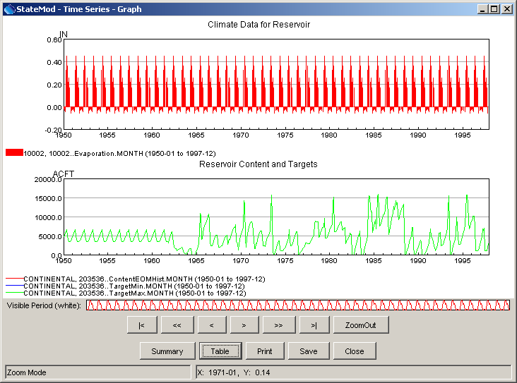
Data_Reservoirs_Graph
Reservoir Time Series Graph (Monthly)

The data types for the time series are consistent with the nomenclature used in the Results…Graphing Tool menu, where possible. The Summary button can be used to display a text summary of the time series. The Table button can be used to view the time series in tabular form. Refer to the TSView Time Series Viewing Tools Appendix for more information about the graphing tools.

5.9 Instream Flow Data

The Data…Instream Flows menu displays information for instream flow reaches. The primary data component is instream flow stations, and secondary components are water rights and demand time series.

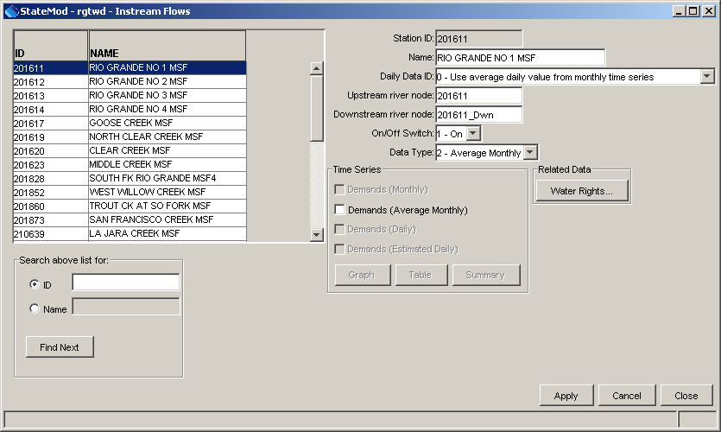
Data_Instream_Flows
Instream Flows Data

All instream flow stations in the data set are listed on the left side of the window. Selecting an instream flow from the list displays that instream flow's information in the window. The instream flow station information is displayed in the main instream flows window and the remaining data are displayed in secondary windows accessed via buttons. Access to other data is disabled if the data were not read or are not a part of the data set. All data are editable except for the identifier, which are referenced in the network and other data. Press the Apply button after making changes. Changes are also applied if the Close button is pressed. Use the main Edit menu to add or delete instream flow stations and optionally the secondary data.

To search for a particular station, enter the identifier or name in the appropriate search boxes located below the list. Any number of characters can be entered in the search box. Press Enter to perform the case-insensitive search, starting at the top of the list. The Find Next button, when pressed, will find the next station that matches the information.

5.9.1 Instream Flow Rights

Selecting the Water Rights button in the main instream flows window displays the water rights associated with the instream flow station, as shown in the following figure:

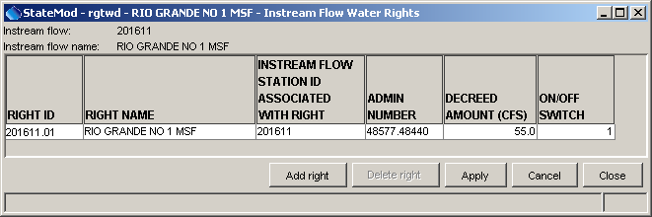
Data_InstreamFlows_Rights
Instream Flow Water Rights

The Add right button will add a row at the bottom of the table, using default values that should be changed to appropriate values. The Delete right button will delete the selected row. Select Apply to apply the changes to the reservoir data. The Close button will apply the changes and close the window.

5.9.2 Instream Flow Time Series

The bottom of the main instream flows window lists all time series associated with instream flow stations. The checkboxes next to time series are enabled according to the data that are available for the currently selected instream flow station. To view time series, select one or more time series and press the Graph, Table, or Summary buttons. The following figure illustrates a graph of average monthly demand data:

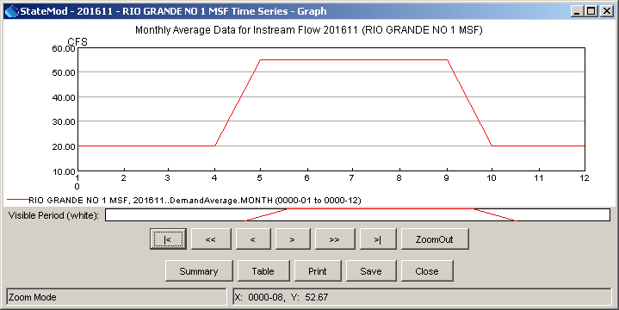
Data_InstreamFlows_Graph
Instream Flow Average Monthly Demand Graph
The data types for the time series are consistent with the nomenclature used in the Results…Graphing Tool menu, where possible. The Summary button can be used to display a text summary of the time series. The Table button can be used to view the time series in tabular form. Refer to the TSView Time Series Viewing Tools Appendix for more information about the graphing tools.

5.10 Well Data

The Data…Wells menu displays information for wells. The primary data component is well stations, and secondary components are water rights, historical time series, demand time series, depletions, and return flows (delay table assignments). A well station can be a single physical well, or a group of wells treated as a single well for modeling purposes. Additionally, wells can be associated with a diversion station, in which case the identifier for the well typically matches the diversion station and the Associated Diversion is specified.

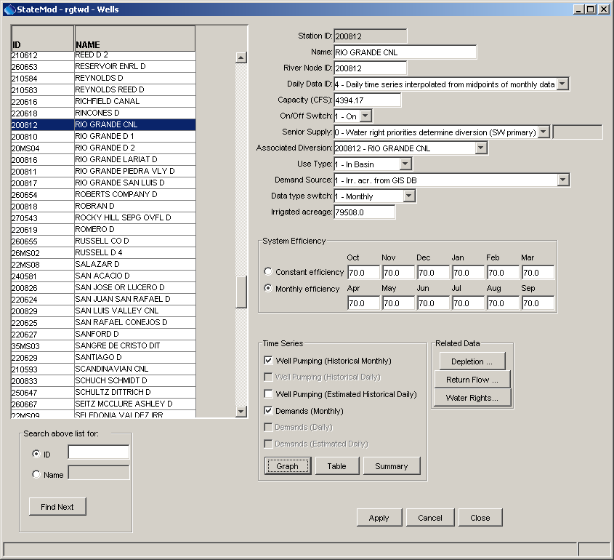
Data_Diversions
Diversion Data Window

All well stations in the data set are listed on the left side of the window. Selecting a well from the list displays that well's information in the window. The well station information is displayed in the main wells window and the remaining data are displayed in secondary windows accessed via buttons. Access to other data is disabled if the data were not read or are not a part of the data set. All data are editable except for the identifier, which is referenced in the network and other data. Press the Apply button after making changes. Changes are also applied if the Close button is pressed.

Use the main Edit menu to add or delete well stations and optionally the secondary data.

To search for a particular station, enter the identifier or name in the appropriate search boxes located directly below the list. Any number of characters can be entered in the search box. Press Enter to perform the case-insensitive search, starting at the top of the list. The Find Next button, when pressed, will find the next station that matches the information.

The well efficiency is displayed for each month in the year. If the well has a constant efficiency, the same value is displayed in each of the twelve monthly fields. If variable efficiencies are used in modeling they are not reflected in this display (only the average efficiencies shown in the well station file are shown).

The Daily Data ID is used to associate a daily time series with this well. Changes to this value take effect when either a different well in the list is chosen or when Enter is pressed in the Daily Data ID text field. The following options are available:

- If the Daily Data ID exactly matches the well Station ID, the pattern and values are the same.
- If the Daily Data ID is “0”, the pattern and values are again the same but are the average daily values, calculated using the monthly time series.
- If the Daily Data ID does not match the well Station ID and is not “0”, the pattern time series corresponding to the Daily Data ID is displayed as-is. However, the values time series is calculated using the pattern and known monthly totals. The daily time series monthly total should agree with the monthly time series, but the distribution should correspond with the pattern. More than one well may reference the same pattern. For that reason, care should be taken when changing the pattern itself.
- Additional options may be available from StateMod. Refer to the StateMod software documentation.

5.10.1 Well Station Depletions

Well station depletions are displayed by pressing the Depletion button in the main wells window:

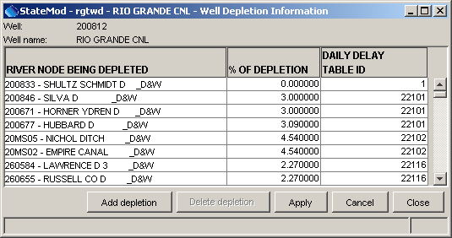
Data_Wells_Depletions
Well Depletion Data

Press the Add depletion button to add a row to the display. Fill in the information as appropriate, using the choices that are provided. To delete a return flow, select a row and press the Delete depletion button. Select Apply to apply the changes to the well data. The Close button will apply the changes and close the window.

5.10.2 Well Station Return Flows

Well station return flows (delay table assignments) are displayed by pressing the Return Flow button in the main wells window:

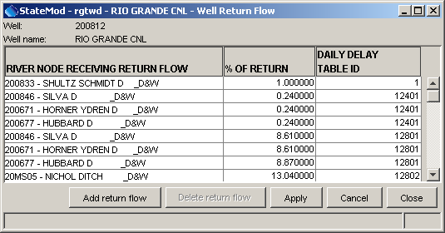
Data_Wells_Returns
Well Return Flow Data
Press the Add return flow button to add a row to the display. Fill in the information as appropriate, using the choices that are provided. To delete a return flow, select a row and press the Delete return flow button. Select Apply to apply the changes to the well data. The Close button will apply the changes and close the window.

5.10.3 Well Water Rights

The water rights that apply to the well can be viewed by pressing the Water Rights button in the wells data window, resulting in a display as shown in the following figure:

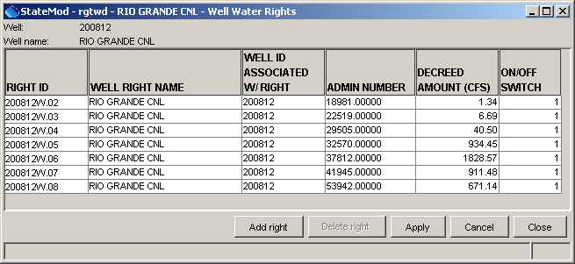
Data_Wells_WaterRights
Well Water Rights Data Window

To add a water right, press Add right. This will add a row with default information, which should be updated as appropriate. To delete a water right, select the row and press Delete right. Select Apply to apply the changes to the well data. The Close button will apply the changes and close the window.

5.10.4 Well Time Series

The bottom of the main wells window lists all time series associated with well stations. The checkboxes next to time series are enabled according to the data that are available for the currently selected well station. To view time series, select one or more time series and press the Graph, Table, or Summary buttons. The following figure illustrates a graph of monthly data:

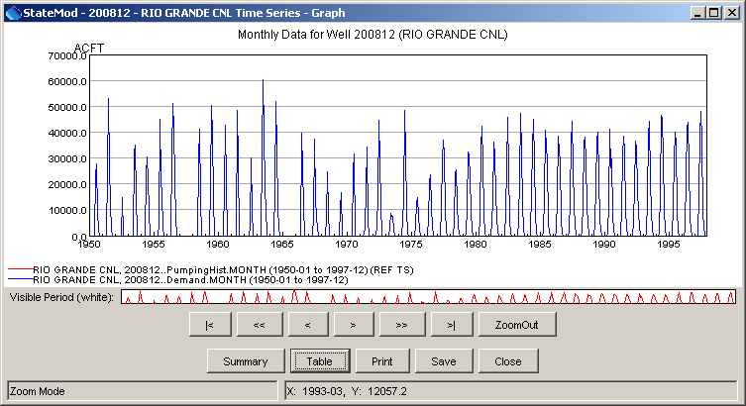
Data_Wells_Graph
Well Time Series (Monthly)

The data types for the time series are consistent with the nomenclature used in the Results…Graphing Tool menu, where possible. The Summary button can be used to display a text summary of the time series. The Table button can be used to view the time series in tabular form. Refer to the TSView Time Series Viewing Tools Appendix for more information about the graphing tools.

5.11 Plan Station Data

The Data…Plans menu displays a data window for plan stations. Plan stations are representations of system operational features that do not fall into other model node types. For example, an augmentation plan involving recharge can be represented as a plan. See the StateMod documentation for details about plans.

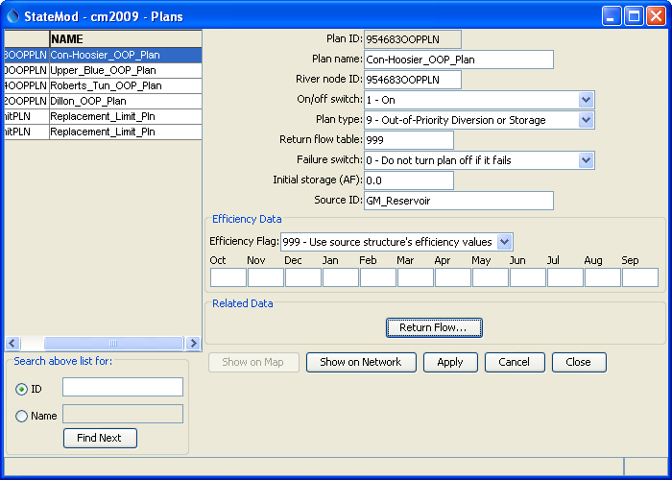
Data_Plans
Plan Station Data

The available plan station nodes are shown in the list on the left side of the window. When a node is selected, data associated with the plan are shown on the right side of the window.

5.12 Stream Estimate Data

The Data…Stream Estimate menu displays a data window for stream estimate stations. Stream estimate stations are locations where historical streamflow time series are not available (as opposed to stream gage stations discussed in Section 5.2). Such points are often needed in headwater basins in order to insert streamflow into the model.

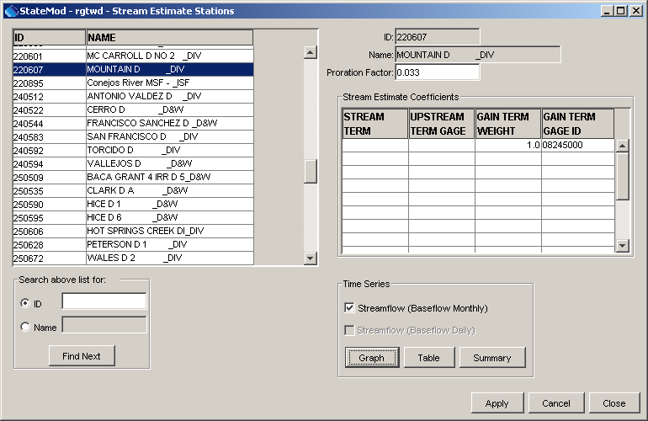
Data_StreamEstimate
Stream Estimate Data

The available baseflow nodes are shown in the list on the left side of the window. When a node is selected, the coefficients used to estimate data are shown on the right side of the window. Baseflow coefficient information is not trivial to specify and should be done carefully. See the StateMod software documentation and the StateDMI software documentation for more information.

5.12.1 Stream Estimate Time Series

The bottom of the main stream estimate stations window lists all time series associated with stream estimate stations. The checkboxes next to time series are enabled according to the data that are available for the currently selected stream estimate station. To view time series, select one or more time series and press the Graph, Table, or Summary buttons. The following figure illustrates a graph of monthly data:

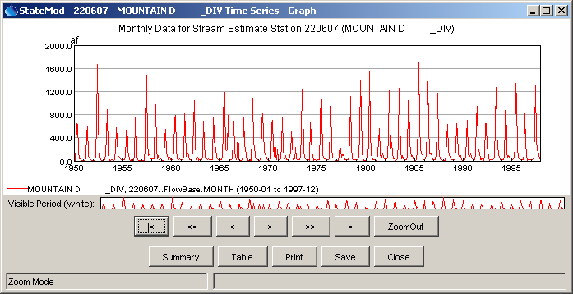
Data_StreamEstimate_Graph
Stream Estimate Time Series (Monthly)

The data types for the time series are consistent with the nomenclature used in the Results…Graphing Tool menu, where possible. The Summary button can be used to display a text summary of the time series. The Table button can be used to view the time series in tabular form. Refer to the TSView Time Series Viewing Tools Appendix for more information about the graphing tools.

5.13 River Network Data

The Data…River Network menu displays the river network data:

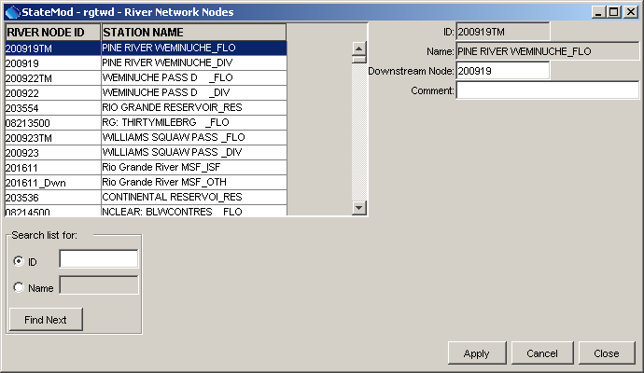
Data_RiverNetwork
River Network Data

The river network data describes the connectivity of the river network, in particular by indicating the downstream station for each station in the network. In general, it should not be edited because doing so may break data links in memory (e.g., changing a river node identifier in the river network requires that the node be changed in any other data that uses the old identifier; the StateMod GUI will not do this automatically). Instead, nodes should be added and deleted using the main Edit menu. StateMod reports results at river nodes and it may be appropriate to add a river node that is not in any other station list. It is reasonable to edit the description in the river network window.

To search for a particular station, enter the identifier or name in the appropriate search boxes located directly below the list. Any number of characters can be entered in the search box. Press Enter to perform the case-insensitive search, starting at the top of the list. The Find Next button, when pressed, will find the next station that matches the information.

If modeling in Colorado’s Decision Support Systems (CDSS), the StateMod network file is typically created using the StateDMI software. Other files are created by determining station lists from the network.

5.14 Operational Rights Data

The Data…Operational Rights menu displays operational rights data.

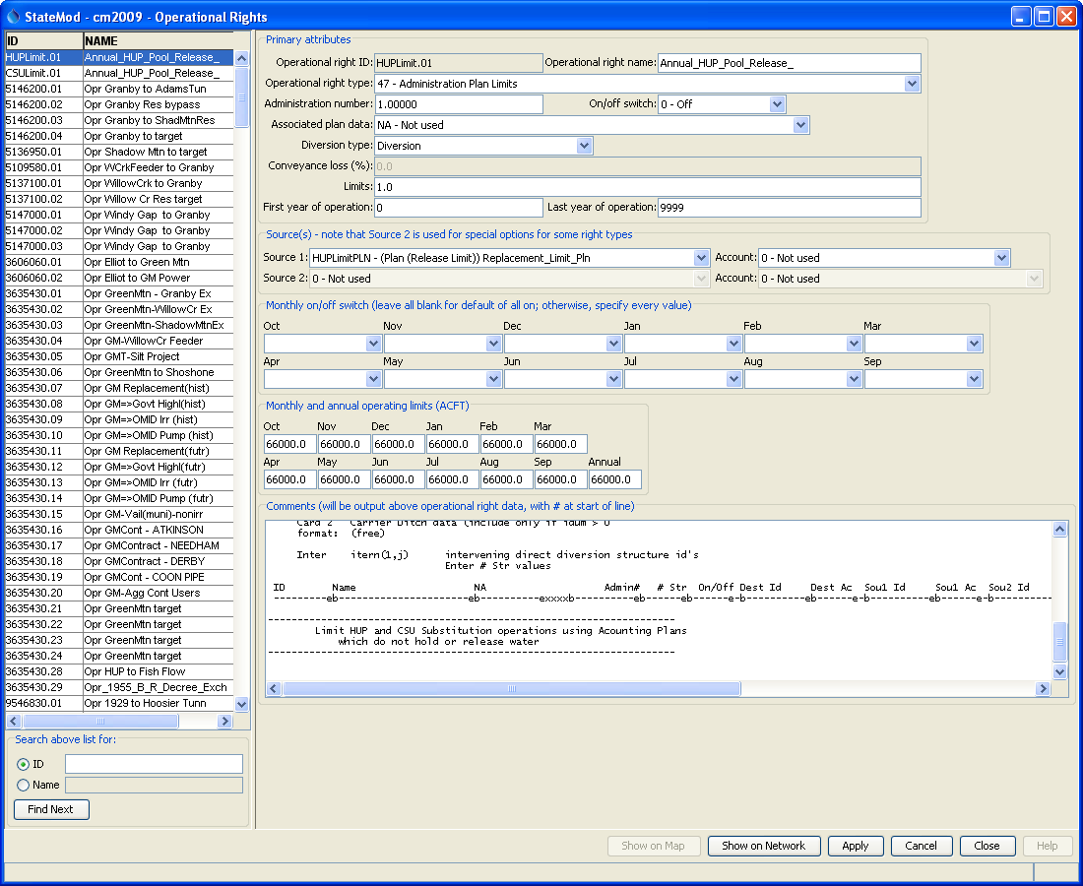
Data_OperationalRights
Operational Rights Data

Operational rights data control operating policies for reservoirs and other structures. This file often is edited by hand during initial data set development. The StateMod GUI attempts to display all operational right types; however, there are a number of limitations that will require additional resources to resolve and using the GUI to edit rights is discouraged at this time:

- The StateMod model software has features that have not been considered by the GUI.
- The operational rights are complex and difficult to treat generically. The GUI window has been segmented for major operational right data; however, the documentation for operational rights and use in practice needs to be verified against GUI features.
- Handling of comments in the operational rights file is problematic. Additional standardization on the file format and modeling practices is needed.
- Right types that are not understood are displayed as text.

Different areas of the window will be enabled, depending on the right type. See the StateMod software documentation for more information about operational rights.

All data are editable except for the identifier and name, which are referenced in other data. Press the Apply button after making changes. Changes are also applied if the Close button is pressed. Use the main Edit menu to add or delete operational rights.

To search for a particular right, enter the identifier or name in the appropriate search boxes located directly below the list. Any number of characters can be entered in the search box. Press Enter to perform the case-insensitive search, starting at the top of the list. The Find Next button, when pressed, will find the next station that matches the information.

The Show on Network button is enabled if the operational right source and destination identifiers can be determined. Pressing the button annotates the network with information about the operational right, as shown in the following figure. The intervening flow path is highlighted, although in some cases wet water will not actually flow along the path for the operational right. Right click on the Annotations area in the lower right to clear the annotations. The annotations will not be saved in the (*.net) file if the network is saved.

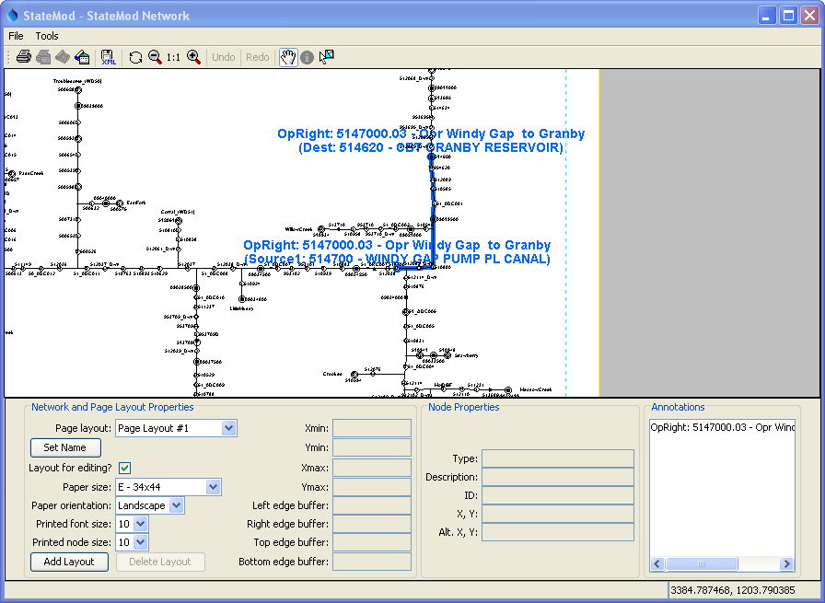
Data_OperationalRights_Network
Operational Right Annotated on the Network

The Show on Map button is enabled if the operational right source and destination location information can be determined. Pressing the button annotates the map with information about the operational right, using push pin symbols. The locations are connected with a straight line for visualization purposes. Right click on the Annotations area in the lower left to clear the annotations.

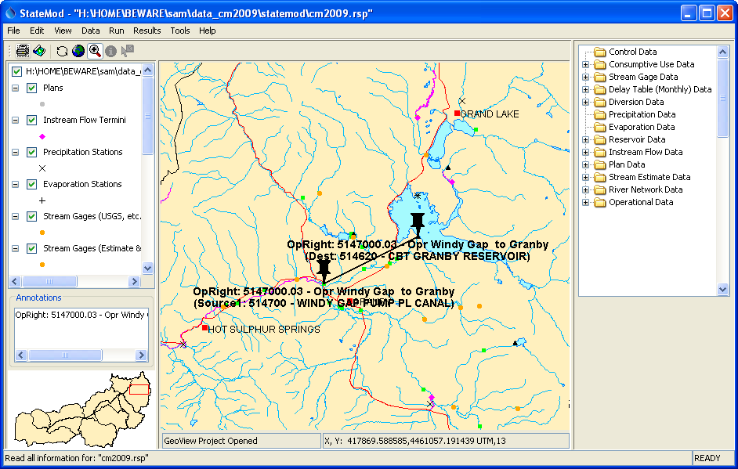
Data_OperationalRights_Network
Operational Right Annotated on the Map

