6 Running StateMod
Version 06.03.02, 2006-03-04, Color, Acrobat Distiller

The Run menu runs the StateMod model, based on its main run modes, as listed in the menu:

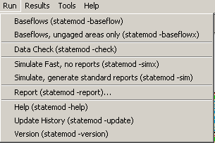
Menu_Run
Run Menu

The StateMod GUI runs StateMod by starting a separate StateMod process. StateMod console output is read and displayed it in the GUI. The StateMod exit status is detected by a STOP code printed to the console.

The StateMod GUI automatically provides the StateMod software with appropriate command line parameters in most cases, requiring no further input from users. The exception is that when running in report mode, additional information will be requested to select the report type, as discussed below.

When running simulations that generate output, the StateMod software uses the output request file to limit output. See Section 5.1.3 – Output Control File for more information about controlling StateMod output.

6.1 Running StateMod in Baseflow, Data Check, Simulation, and Information Modes

Most StateMod run modes only require selecting the proper choice from the Run menu. Users should be familiar with the StateMod run modes by referring to the StateMod software documentation.

If a run mode is selected that uses the model data files and the data have been modified within the StateMod GUI, a prompt will allow the data to be saved, similar to the File…Save menu discussed in Chapter 3. Changes made in the StateMod GUI must be saved to files in order for the StateMod software to recognize the changes.

When a run option has been selected (and data set files have been saved, if appropriate), a StateMod model process is created and controlled through the use of a new window, called a process manager, as shown below (in this case for a StateMod version run):

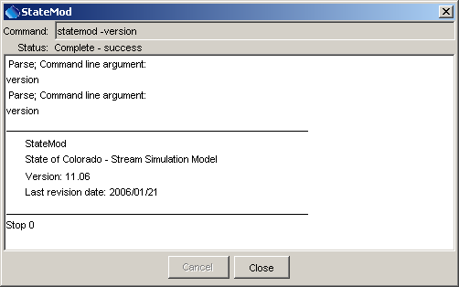
Menu_Run_Version

The StateMod calling command, run and exit status are displayed at the top of the dialog. The StateMod process can be cancelled at any time by pressing the Cancel button (doing so may require a few seconds to register and an interruption may result in partial output). The dialog does not automatically go away when the model is finished running. Therefore, press the Close button to dismiss the dialog. Warning: The run period is set in the Data…Control…Control menu. Using a shorter run period during initial model setup and troubleshooting is advised to decrease run time.

If an error occurs while running StateMod, the Process Manager dialog will turn red and the status will indicate the StateMod exit status, as shown in the example below:

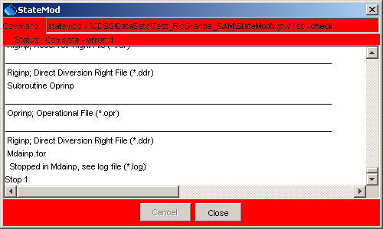
Menu_Run_Error
StateMod Run Error Dialog

There are variations in how the StateMod GUI interacts with StateMod, depending on the operating system version and Java Runtime Environment that runs the StateMod GUI. Therefore, it is usually best to review the last output from the StateMod run shown in the above window. A messaging indicating a STOP 0 code will be printed by StateMod if a run is successful. Otherwise, an error occurred and the StateMod log file should be reviewed (see the Results…Output Files menu and select a log file that matches the response file name).

In most cases a run will fail due to an error in a data file or because the response file references a file that does not exist. After determining the cause of the message, various StateMod GUI windows can be used to correct the data, to allow another run to be made.

In addition to running the main StateMod simulation modes, the StateMod version, update history, and help summary information can be reviewed from the StateMod GUI. The version information may be helpful during troubleshooting.

6.2 Running StateMod in Report Mode

Selecting the Run…Report menu displays the following dialog prompting for the report type. The tabbed panels list the various report categories and allow input of user-specified information, as appropriate.

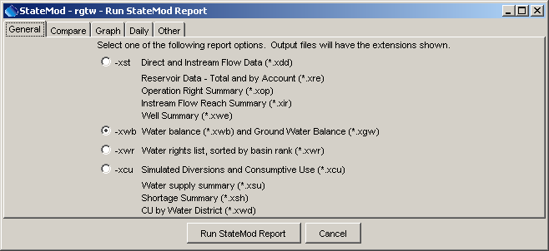
Menu_Run_Report_General
Report Generation Dialog – General Reports

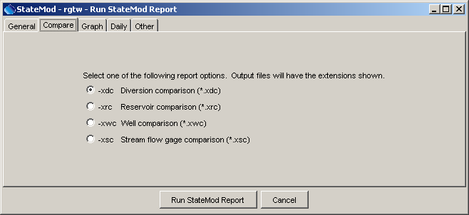
Menu_Run_Report_Compare
Report Generation Dialog – Comparison Reports

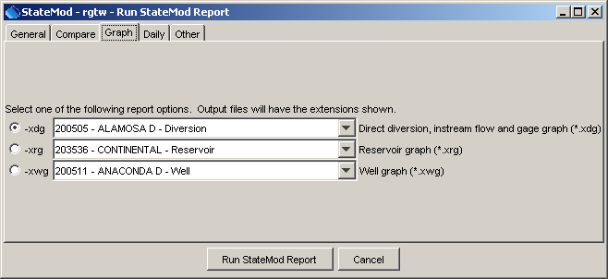
Menu_Run_Report_Graph
Report Generation Dialog – Graph Reports

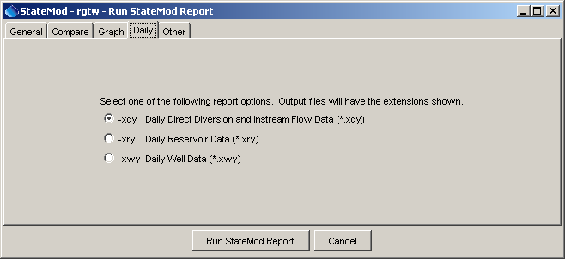
Menu_Run_Report_Daily
Report Generation Dialog – Daily Reports

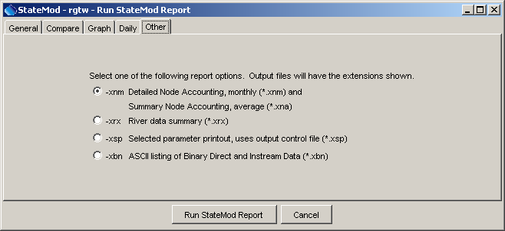
Menu_Run_Report_Other
Report Generation Dialog – Other Reports

To generate a report, select one of the available radio buttons, and if required, provide additional information. See the StateMod software documentation for more information about each report type. Some reports may be available in the StateMod software but are not yet enabled in the StateMod GUI. Press Run StateMod Report to generate the output files or press Cancel to cancel the report.

View the report output using the Results…Output Files menu. The report files will have the same base name as the response file and an extension that matches the report command line option for StateMod (as indicated in the above tabbed panels).

