7 Viewing StateMod Results
Version 06.03.02, 2006-03-05, Color, Acrobat Distiller

The Results menu provides access to StateMod results in graphical form, and allows StateMod output files to be viewed.

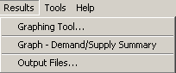
Menu_Results

See the Data menu to view/edit StateMod input data. See the Tools menu for additional tools for data and output.

7.1 Graphing Tool – Create Graphs for StateMod Input and Results

As described in Chapter 5 – Viewing and Editing Data, input time series data can be graphed from various data windows if the time series have been read for the data set. However, graphing from the data windows only allows the data for the specific station to be displayed.

The graphing tool overcome these limitations by:

- Graphing input and output time series on the same graph.
- Graphing time series from different stations on the same graph.
- Graphing time series that have been read in, and those that have not on the same graph.

Output time series can only be graphed if the StateMod baseflow and simulate options have been run. In cases where input time series have not been read into the StateMod GUI, processing will be slower because the requested time series will be read from input files.

The features described below are comparable to features available in the TSTool software. The main difference is that the graphing tool described below has knowledge about the StateMod data set and therefore can provide lists of choices to facilitate selecting stations for graphing. The TSTool software is more appropriate if many graphs are to be produced in batch mode, for example during model calibration.

Graph configurations may be saved as “time series products” for use at a later time. The time series product file format is described in the TSView Time Series Viewing Tools Appendix.

The Results...Graphing Tool menu displays a window similar to the following:

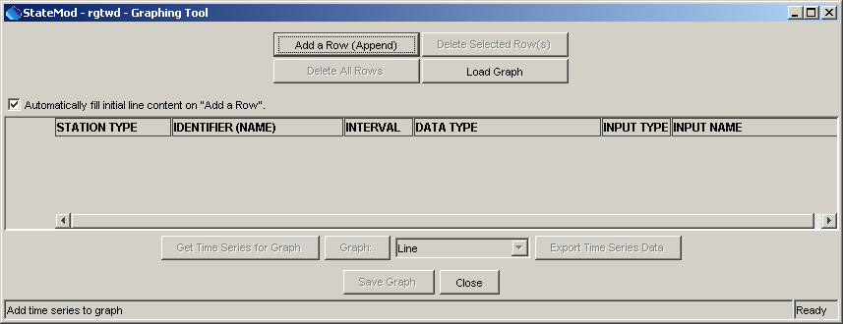
Results_GraphingTool0
Graphing Tool – No Time Series Listed

The above window facilitates selecting the time series to be graphed. Each row in the list corresponds to a time series and contains the following information:

STATION TYPE | The StateMod station type.
IDENTIFIER (NAME) | The identifier and name for the station associated with the time series to be graphed. A list is provided based on the selected station type. Only the identifier part of provided information is used to identify the time series.
INTERVAL | The interval for data.
DATA TYPE | A unique string indicating the input data type or output parameter. Only the first part of the string is used to indicate the data type for the time series.
INPUT TYPE | StateMod for input files and StateModB for output parameters read from the binary output files.
INPUT NAME | The name of the file from which to read the time series. If the file has been read as part of the data set, the StateMod GUI will use the time series that was read. Otherwise, the time series will be read from the indicated file.

To generate a list of time series to graph, and to read or save a list of time series, use the buttons discussed below:

Add a Row (Append) | Add another row. Each time series to be graphed corresponds to a row. Each new row contains default contents matching the previous line to help quickly add a row. The contents of the row should be edited to match a desired time series.
Delete Selected Row(s) | Delete the highlighted rows from the list. Each line to be deleted can be selected by clicking on a cell in the row. Use Ctrl-click to select additional rows.
Delete All Rows | Delete all rows from the list.
Load Graph | Load a time series product that was previously saved.
Save Graph | Save the list of time series as a time series product (*.tsp). This feature allows time series products to be loaded at a later time.

The order of the columns in the time series list facilitates selection of subsequent choices. The remaining buttons at the bottom of the window are used to read time series data and display graphs. The following example illustrates the process to list time series and create a graph; in this case to display historical input data and corresponding simulated output:

- Start the graphing tool using Results…Graphing Tool.
- Add an input time series to the list:
  - Select Add a Row (Append). A row will be added with default contents.
  - Select a STATION TYPE of Diversion.
  - Select an IDENTIFIER (e.g., 200812).
  - Select an INTERVAL of Month.
  - Select a DATA TYPE of DiversionHist - Input.
  - Select an INPUT TYPE of StateMod (this is the only choice since an input data type has been selected).
  - Select an INPUT NAME of *.ddh (this is the default and indicates that the time series will be read from the diversion historical time series file corresponding to the data set, matching the response file name). A specific file name can be entered if desired.
- Add an output time series to the list:
  - Press Add a Row (Append). The information from the previous row will be duplicated in the new row.
  - Select a DATA TYPE of RiverDivert - Output.
  - Select an INPUT TYPE of StateModB (this is the only choice since an output data type has been specified and must be read from a StateMod output binary file).
  - Select an INPUT NAME of *.b43 (this is the default and indicates that the time series will be read from the diversion historical time series file corresponding to the data set, matching the response file name).
- Retrieve the time series:
  - Press the Get Time Series for Graph button below the list. After retrieving the time series, the Graph button will be enabled. The process will be slower if time series need to be read from files.
- Graph the time series:
  - Select the desired graph type from the choice to the right of the Graph button.
  - Press the Graph button. A graph will appear (see example below). The graphing tool is described in more detail in the TSView Time Series Viewing Tools Appendix.
  - If appropriate, select a different graph type and create additional graphs.
- Save the time series product:
  - Press the Save Graph button. Save the graph as a time series product (*.tsp) file. The file can then be loaded later using the Load Graph button, and steps 4 and 5 can be executed.
- If appropriate, save the time series data to a file using the Export Time Series Data button.

The above steps can be repeated as appropriate, to change the time series list or select a different graph type for output.

For the above example, the resulting graphing tool interface with a list of time series appears as follows:

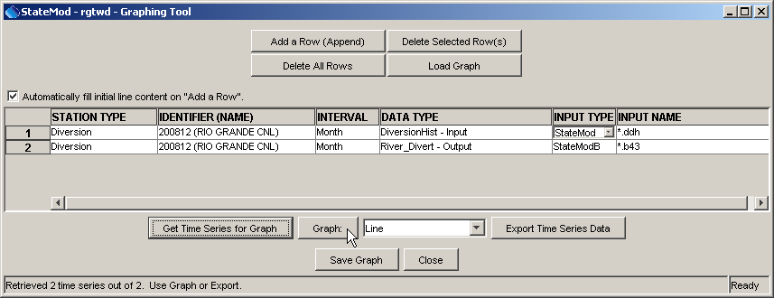
Results_GraphingTool1
Graphing Tool – With Time Series Listed, Before Creating a Graph

Once time series are retrieved, the Graph and Export Results buttons will be enabled. The status message area at the bottom of the window will indicate whether all time series could be retrieved. During the retrieval process, errors may be shown for time series that cannot be retrieved. This is usually due to a time series not being found in output (e.g., because of the output control file limiting the output) or because StateMod has not been run to generate output.

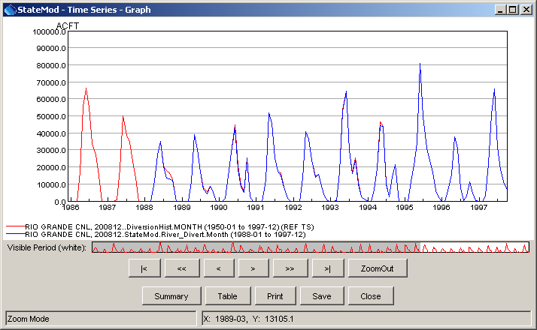
Results_GraphingTool2
Example Graph Illustrating Input and Output Time Series

7.2 Graph Demand/Supply Summary

The Results…Graph – Demand/Supply Summary menu creates a monthly and yearly graph of important water supply and demand time series. Every time series in the data set is added to calculate the total. These graphs are useful for determining overall basin behavior and to illustrate long-term trends.

The following figures are examples of the resulting graphs.

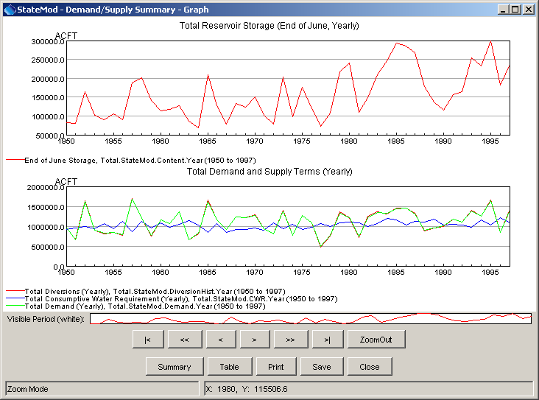
Results_DemandSupply_Year
Example Demand/Supply Summary Graph (Yearly)

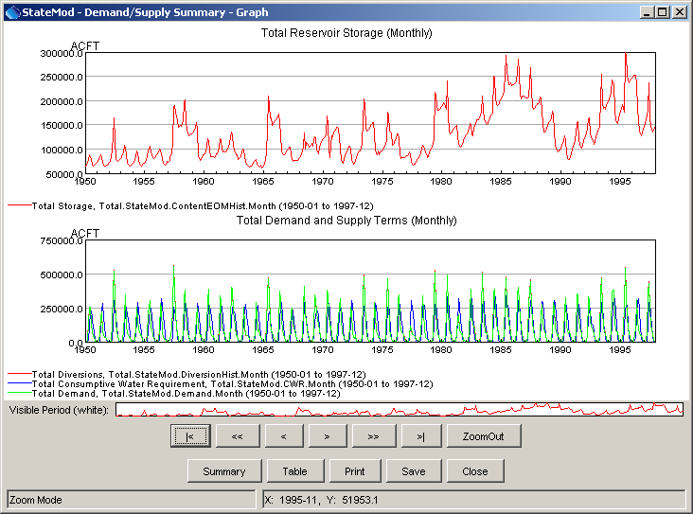
Results_DemandSupply_Month
Example Demand/Supply Summary Graph (Yearly)

7.3 View StateMod Output Files

The Results…Output Files menu displays a list of StateMod output files, as shown below:

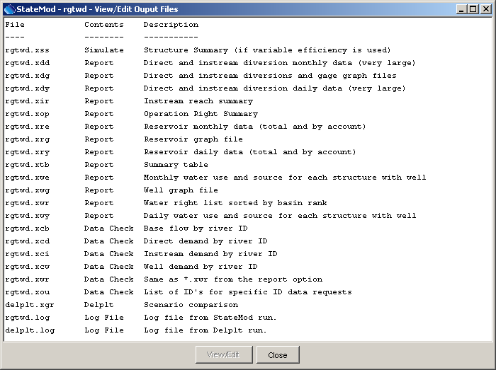
Results_OutputFiles
StateMod Output File List

The output file list is determined by checking recognized file extensions. To view an output file, select an item from the list and then press the View/Edit button. By default, Notepad is used to display the file. The editor for the session can be changed using the Tools ... Options menu.

This page is intentionally blank.

