8 Using the Map
Version 07.04.00, 2013-04-18

This chapter describes how to use the map features in the StateMod GUI. Other information related to maps includes:

- See Chapter 9 – Tools for more information about map-based tools, such as displaying summary information on the map.
- The Configuring Spatial Data for the StateMod GUI appendix describes how to configure the GeoView Project file (*.gvp), which controls the initial appearance of the StateMod GUI map display for a data set.

8.1 Integration of Spatial Data with a StateMod Data Set

The StateMod GUI will display a map if the selected data set response file specifies a valid GeoView project file (*.gvp) using the GeographicInformation property. The map interface uses software that has been developed for CDSS tools and has features appropriate for visualization, navigation, and data access. It is not a full GIS analysis tool.

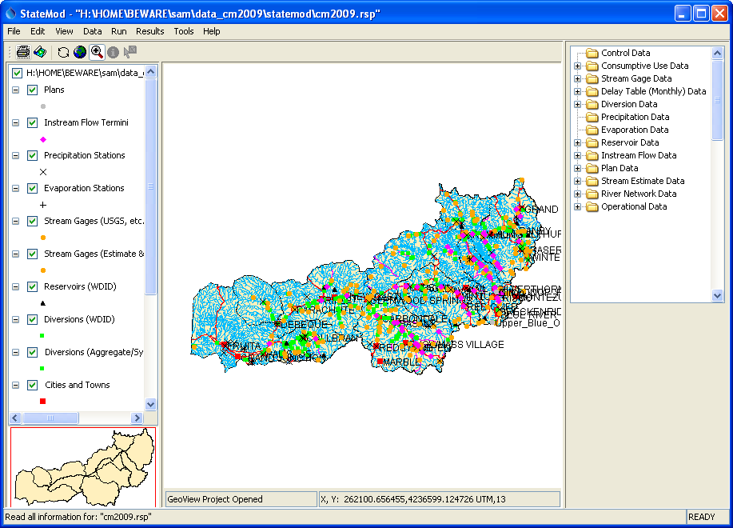
Tools_Delplt0
Main Map after Opening Data Set

StateMod data files do not include spatial information such as latitude and longitude. Therefore, all interactions between the map and the data set occur using identifiers that are present in the data set and as a spatial data layer attribute. For example, the stream gage layer will include USGS stream gage identifiers and the same identifiers are used in the StateMod network and StateMod stream gage data files. Cross-referencing spatial data can be complicated by a number of issues, including:

- Care must be taken to treat zero-padded identifiers as such. USGS stream gages with identifiers that start with zero must be treated as strings to preserve the zeros and allow comparison.
- Spatial data layers may contain more or fewer features than are in a StateMod data set.
  - To facilitate spatial data use, the GUI allows using layers that have more features than are in the StateMod dataset. Only matching features are displayed. See the View…Map – Show Features not in Data Set menu, which allows displaying all features in a layer.
  - The GUI will identify data set stations with missing coordinates and create x-gui-MissingSpatialData*.csv files with the information, as illustrated in the following figure:

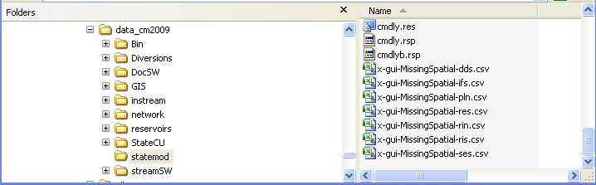
Map_MissingSpatialData

  - The resulting CSV files can be configured in the *.gvp file and coordinates specified (for example use Google Maps or other approach to determine coordinates). To simplify configuration, geographic coordinates (longitude and latitude) are used. An example of a missing data file is shown below:

# File generated by...
# program: StateModGUI 07.04.00 (2013-04-17)
# user: sam
# date: Thu Apr 18 14:04:34 MDT 2013
# host: AMAZON
# directory: H:\HOME\BEWARE\sam\data_cm2009\statemod
# command line: StateModGUI
# -home
# # C:\Develop\StateModGUI_SourceBuild/StateModGUI/test/operational/CDSS
#
# dds has 39 out of 414 locations with missing spatial data.
#
# Specify X and Y in projected coordinates to match other layer data.
#
"ID","Name","Long","Lat","X","Y","Note"
420520,GRAND JCT GUNNISON PL,,,,,"GUI Detected no coordinates"
420541,REDLANDS POWER CANAL,,,,,"GUI Detected no coordinates"
950001,Grand Valley Project,,,,,"GUI Detected no coordinates"
950002,USA Power Plant,,,,,"GUI Detected no coordinates"
950003,Orchard Mesa Check,,,,,"GUI Detected no coordinates"
…

- The GUI allows multiple layers to be identified for a single StateMod station type. For example, the *.gvp file property AppLayerType=Diversion indicates that the layer should be associated with diversion stations. In this way, it is possible to use an “official” data file for actual diversion stations (e.g., as produced from a spatial database), and a separate layer for stations that are known only the model, such as aggregate diversions that have contrived identifiers.
- In cases where a location identifier appears in more than one layer, the layer that is matched first is used. Consequently, it may be important to list layers in a specific order in the *.gvp file.
- The StateMod GUI does not currently edit spatial data files when stations are added through the GUI. This issue may be resolved with additional software enhancements.

With the above data-handling features in the StateMod GUI, it is possible to ensure that every StateMod data set feature has spatial data and can be displayed on the map.

8.2 Map Display Features

The map display has been designed to draw maps very quickly, using common input data formats. The following tools are provided to interact with the map:

Print the map (after printing it may be necessary to refresh the map to restore the view)
Save the map as an image file
Redraw the map
Zoom to full extent of map
Change to zoom mode – the mouse can be used to draw a box on the map to specify the zoom extent
Change to information mode – the mouse can be used to click on or draw a box around map features to display attribute values for the feature(s) (a map layer must first be selected in the legend by clicking on the layer name)
Change to select mode – the mouse can be used to click on or draw a box around map features to select the feature(s) (a map layer must first be selected in the legend by clicking on the layer name) – this feature currently is not used

An overview map is shown in the lower left of the main GUI window.

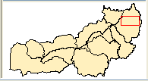
Tools_Overview
Overview Map Showing Current Zoom Extent

This map shows the current visible extent of the main map. Using the mouse to draw a box on the overview map will cause the main map to zoom. The layers shown in the overview map are indicated by ReferenceLayer=True in the *.gvp map configuration file.

The map legend (layer list) on the left side of the map displays layers. Use the checkboxes to turn layers on and off. The map will automatically refresh. Right click on a layer name to access its properties:

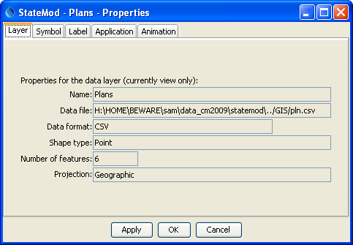
Map_Layer_Properties
Map Layer Properties

The properties are useful for understanding data file locations and troubleshooting map issues. Map layer properties can be changed to facilitate understanding the displayed information. For example, layer labels can be enabled to display station names. By default only major features are labeled and the map tool does not provide scale-dependent labeling. Changed map properties cannot be saved (the GeoView Project file, *.gvp, must be edited with a text editor).

The layer attributes can be viewed by right clicking on the layer name and selecting View Attribute Table, which will display a table as shown in the following figure:

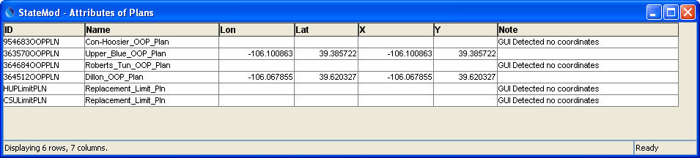
Map_Layer_Attributes
Map Layer Attributes

Note that in the above example the list of plans in the spatial data file is provided by a simple comma-separated-value file and some of the coordinates are missing (or perhaps are not appropriate for the plan).

8.3 Displaying Specific StateMod Data Set Items on the Map

StateMod data windows for primary data types with a physical location (diversion stations, reservoir stations, etc.) include a Show on Map button at the bottom of the window, which will be enabled if the selected location has spatial information in a map layer (determined by matching the station identifier with identifiers in map layers).

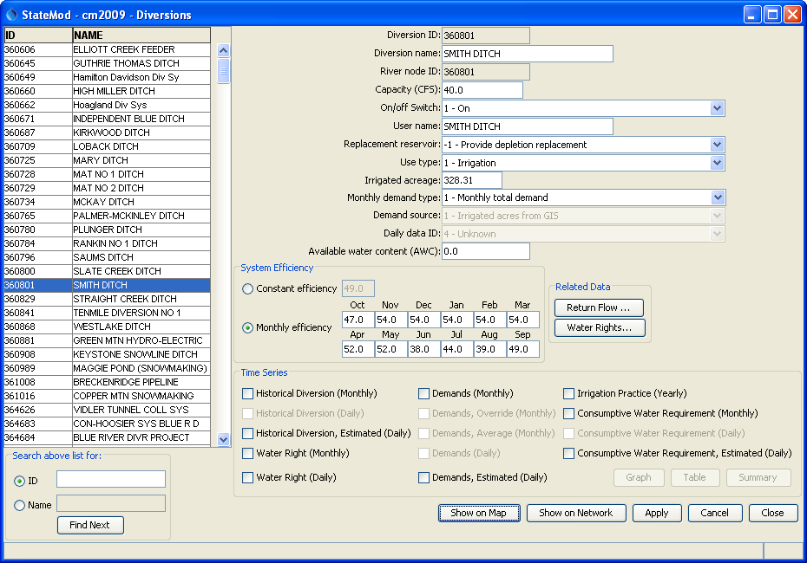
Map_Diversions_ShowOnMap
Diversion Stations Window Illustrating “Show on Map” Button (bottom)

Clicking on the Show on Map button will cause the diversion station to be annoted on the map with a push pin and label. The map will zoom to the region of the diversion station. Repeating the steps will add additional annotations to the map (see figure below). To clear the annotations, right click on the Annotations list below the map legend.

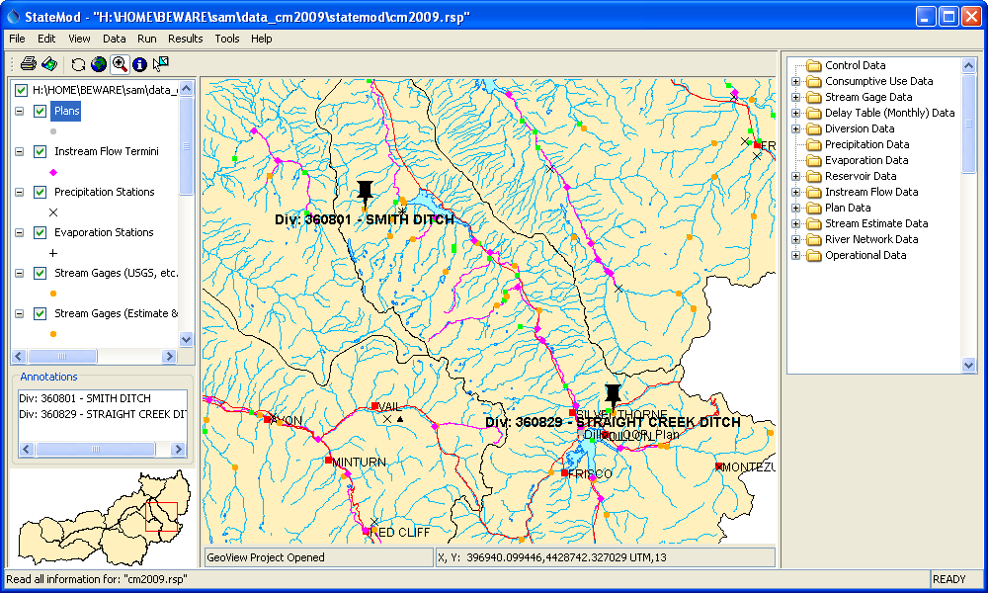
Map_Diversions_ShowOnMap2
Map Annotated with Diversion Stations After Using “Show on Map” Button

