9 Tools
Version 07.04.00, 2013-04-18

The Tools menu provides access to useful tools.

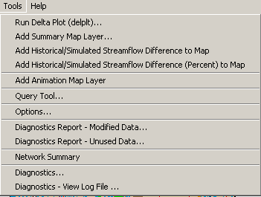
Menu_Tools

The following sections describe each tool. In some cases, tools have been added to facilitate development and have limited functionality.

9.1 Run Delta Plot – Summarize Simulation Results and Compare Data Sets

Current StateMod utilities may not be consistent with the GUI. The following feature was implemented with an early version of the delplt tool and may no longer be functional. A work-around is to use TSTool processing features.

The Tools…Run Delta Plot (delplt) menu runs the delplt program, a utility program supplied with StateMod software that analyzes StateMod results. The delplt program can:

- Summarize parameter values for the current data set.
- Summarize one or more parameters for a data set, for one or more data sets.
- Determine the difference for common parameters in multiple data sets.

The delplt program functionality is described in the StateMod model documentation. The StateMod GUI edits the delplt input file, runs the program, and optionally displays results on the main interface map. When the Tools…Run Delta Plot (delplt) menu is initially selected, the interface appears as shown in the following figure:

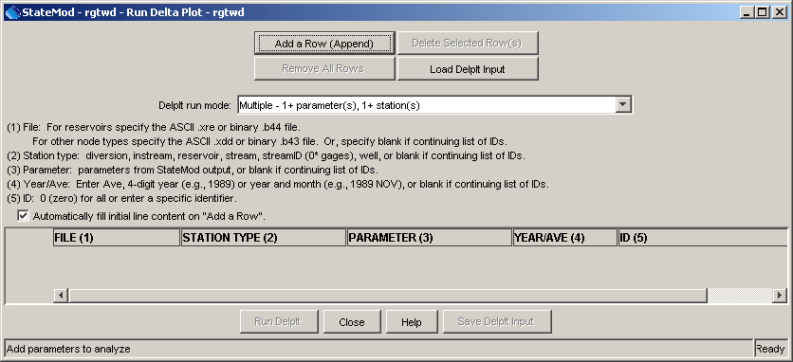
Tools_Delplt0
Delta Plot Run Window – No Combinations Listed

The columns in the list are used to create a delplt input file. See the StateMod software documentation for details about the file format. The columns are summarized as follows:

FILE | Specify an .xre or .b44 file for reservoirs. Specify an .xdd or .b43 file for everything else. Using these files requires that the full simulation reports have been generated. Specify the binary files (.b44 and .b43) if files are large, in order to increase performance.  Specify blank if continuing a list of identifiers in the same file. Specify the file name only to use files in the StateMod data set directory or specify an absolute path to read information from a different StateMod data set.
STATION TYPE | Select a station type from the available choices. This will limit the parameters that are available. Specify blank if continuing a list of identifiers.
PARAMETER | Select a parameter type from the list. This list is dynamically created when the station type is selected. Specify blank if continuing a list of identifiers.
YEAR/AVE | Specify a 4-digit year, or year and month abbreviation (e.g., 1975 NOV), or AVE to compute period averages. Specify blank if continuing a list of identifiers
ID | The station/structure identifier from the StateMod data files. Specify zero “0” to include all identifiers for the combination in the previous columns.

Use the Add a Row (Append) button to add new rows to the list. The Automatically fill initial line content on “Add a Row” checkbox, when selected, will attempt to intelligently fill out a row that is added. For example, if the previous row includes an identifier other than “0”, the new row will be blank in the expectation that you will specify only a new identifier. If the previous row has a “0” identifier, then the new row will copy more of the previous row, assuming that you will likely want to change the parameter. If the Automatically fill initial line content on “Add a Row” checkbox is not selected, then blank rows will be added when rows are added.

Use the Remove all Rows and Delete Selected Row(s) buttons to remove existing rows. Use the Load Delplt Input and Save Delplt Input buttons to operate on a delplt input file, which is useful if the same list of input will be run repeatedly.

After adding information to the table, the window will appear similar to the following:

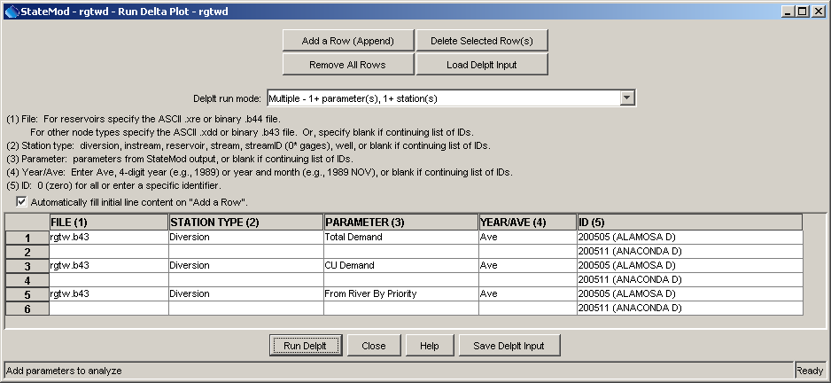
Tools_Delplt1
Delta Plot Run Window – With Combinations Listed

Save the delplt input by selecting the Save Delplt Input button. Alternatively, the StateMod GUI will prompt to do so when Run Delplt is pressed (see step 2 below). To process the StateMod output using delplt:

- Press the Run Delplt button. The following dialog will be shown:

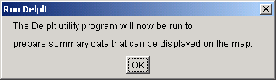
Tools_Deplt2

- If the input file has not been saved, the following dialog will be shown. Press OK and then use the file browser to select a file name. The delplt program can only process filenames that follow the 8.3 DOS filename convention.

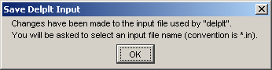
Tools_Delplt3

- The delplt program is run as a separate process and output is displayed in a dialog as shown below. The output from the run should be reviewed to make sure a STOP 0 code is printed and the messages do not indicate a problem. If successful, press Close and continue below. If an error occurs, refer to troubleshooting information and the delplt log file, which will have the same base name as the input file and an extension .log.

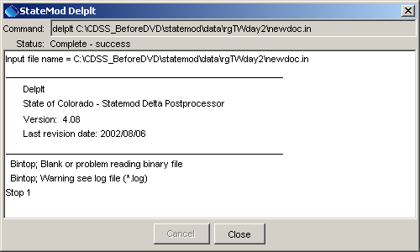
Tools_Delplt4

- A successful delplt run creates an output file with the extension .xgr. This file is converted to a more general format by the StateMod GUI, as indicated by the following dialog. Press OK and then enter a name for the text file using the file browser that is displayed.

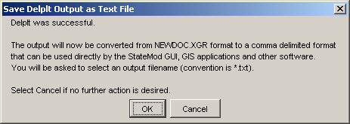
Tools_Delplt5

- After the delplt is converted to a text file, you will be prompted to indicate whether the results should be shown as a summary map layer:

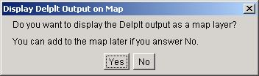
Tools_Delplt6
- If you specify No in response to the above dialog, the delplt run is complete and nothing will be shown on the main interface map. Refer to Section 9.2 for information about adding the information to the map later. The text file can also easily be imported into another application, including a spreadsheet. If you specify Yes in response to the above dialog, a summary map layer will be added to the main interface, as shown below. The main delplt run window can be closed or the combinations of parameters can be further modified and the process repeated.

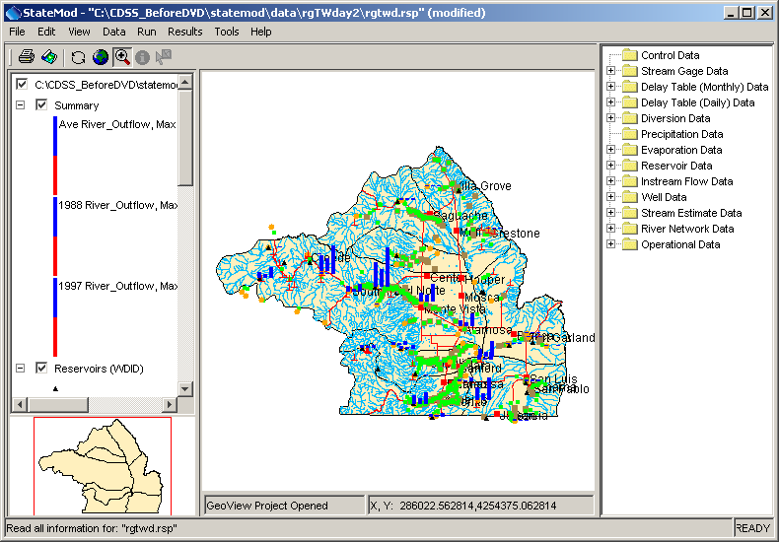
Tools_Delplt7
StateMod GUI Main Interface Showing Summary Map Layer

The scale for each bar is consistent and the maximum value is indicated in the legend. Positive values are shown as blue bars and negative values are shown as red bars. The layer can be deleted by selecting it in the layer list, right clicking, and selecting Remove Layer.

9.2 Add Summary Map Layer

The Tools…Add Summary Map Layer menu creates a map layer using existing layers to find coordinates, and draws bars on the map to symbolize data values in a supplied data file. This tool performs steps similar to the final steps discussed in the previous section. An example data file to use for summary data is as follows:

Identifier, Name, Ave River_Outflow, 1988 River_Outflow, 1997 River_Outflow
"08213500",RG:THIRTYMILEBRG,142212.0,101920.0,247227.0
"08214500",NCLEAR:BLWCONTRES,20299.0,16702.0,32499.0
…etc…

A text file of this format consists of a header line describing the contents of each column, followed by rows of data. Each row contains a station identifier, its name, and data values corresponding to the headers. The identifiers in the file must match the join fields (identifiers) in one or more layers in the data set. Only features with geographic locations can be displayed on the map. After selecting the Tools…Add Summary Map Layer menu, the following dialog will be shown, which allows configuration of the new layer. Input has been provided as an example. Pressing OK adds the map layer.

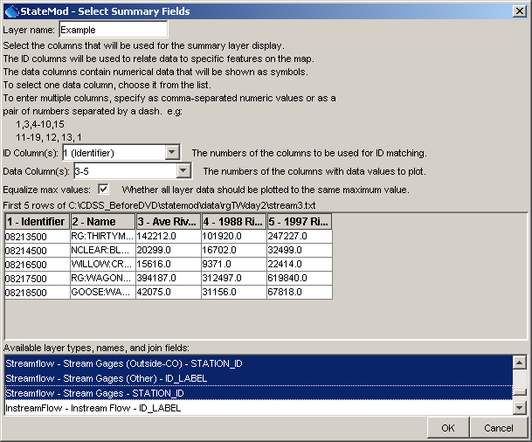
Tools_Add_SummaryMapLayer
Dialog to Configure the Summary Map Layer

9.3 Add Historical/Simulated Streamflow Difference to Map

The Tools…Add Historical/Simulated Streamflow Difference to Map menu creates a new map layer that indicates absolute differences between historical and simulated streamflow, for stream gage stations. The difference is computed as the average annual historical streamflow minus the average annual simulated streamflow, using calendar years, for the period of the historical streamflow time series (both time series must have values in a year to be considered in the calculations). This tool is useful for model calibration, in particular to identify locations were large absolute differences between historical data and simulation results are occurring. The tool may require several minutes to process all the data.

The following figure illustrates the map interface after using the tool. When viewed in color, blue bars indicate cases where the historical time series had larger values and red indicate cases where simulated time series had larger values. Warnings may be shown if streamflow stations are not present in the streamflow station layers on the map.

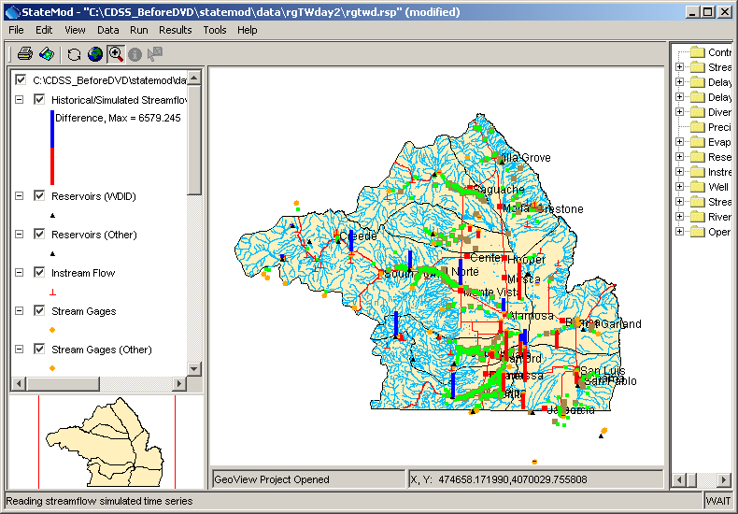
Tools_HistSim_Difference
Historical/Simulated Difference Map Layer

The map layer can be selected and its attribute table viewed (right click on the layer name in layer list and select View Attribute Table):

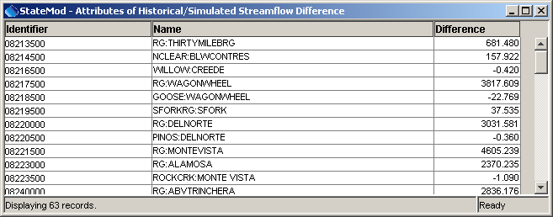
Tools_HistSim_Difference_Table
Historical/Simulated Difference Map Layer Attribute Table

9.4 Add Historical/Simulated Streamflow Difference (Percent) to Map

The Tools…Add Historical/Simulated Streamflow Difference (Percent) to Map menu creates a new map layer that indicates percent (0 to 100) differences between historical and simulated streamflow, for stream gage stations. See the previous section for background information and example output. The percent is calculated by taking the average annual difference divided by the average annual historical streamflow. Displaying percent may provide a better overview of differences.

9.5 Add Animation Map Layer

The Tools…Add Animation Map Layer adds a layer to the map and provides an interface for animating the symbols in the layer. Streamflow levels are shown as bars and reservoir levels are shown as “teacup” symbols, where the size of the symbols is relative to the reservoir capacity.

When the tool is started, the StateMod GUI collects necessary data for the animation. This may require several minutes and progress is reported in the status area at the bottom of the main window.

A map tool controls the animation itself. After initial data collection the following dialog will be shown to initialize the animation:

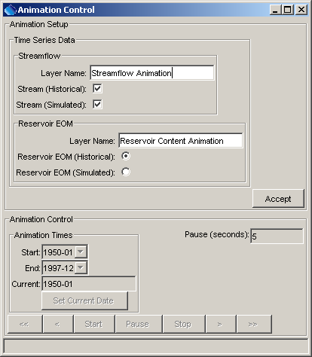
Tools_Animation1
Animation Setup – Select Reservoir Time Series to Animate
Historical streamflow (taken from the historical streamflow input file) and simulated streamflow (taken from the River_Outflow parameter in the binary file) can be shown as bars on the map. Either reservoir historical data (taken from end of month content time series) or simulated values (taken from the Sim_EOM parameter in the StateMod output binary file) can be displayed.
After the time series data input is selected, press Accept to continue with the animation setup. The StateMod GUI will then attempt to build a map layer for the selected layers, and will associate the time series with the points in the layer. The scaling of map symbols takes into account the full period of time series data. Additional configuration of the animation period can occur, as shown in the following figure.

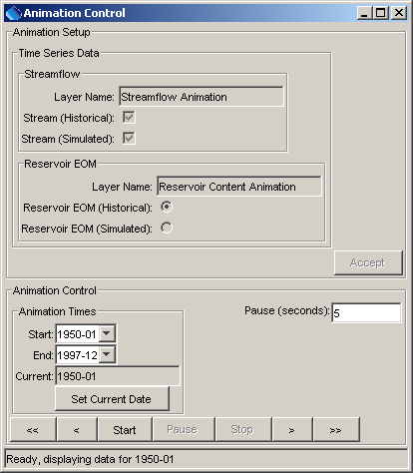
Tools_Animation2
Animation Setup – Define Period to Run

Define the period for the animation and set the start date. Press Start to start the animation. The << button will set the current date to the start date. The < button will go to the previous date. The Pause button will pause the animation. The > button will advance to the next date. The >> button will set the current date to the end date. The Stop button will stop the animation.

The following figure illustrates how the status bar at the bottom of the window indicates animation progress.

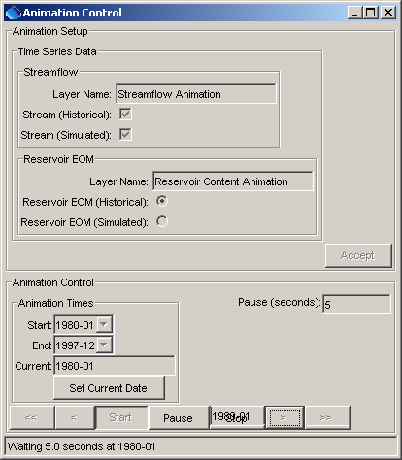
Tools_Animation3
Animation Control While Running Animation

A map layer is added to the layer list during animation setup. This layer is treated similar to other layers. However, right clicking on the layer shows the Show Animation Control dialog (as illustrated above), which is used to control the animation. The following figure illustrates the map during animation. Refer to the animation control for dates associated with the map display.

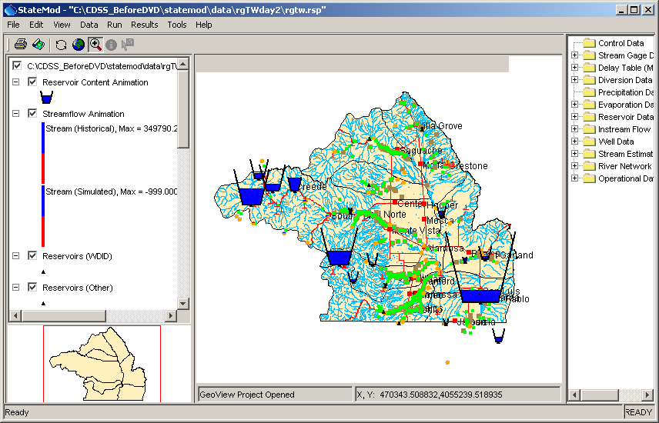
Tools_Animation_Map
StateMod GUI Map Display During Animation

9.6 Query Tool – Find Stations that Match Criteria

The Tools…Query Tool menu displays a query dialog that allows selection of stations based on multiple query criteria. This is similar to a database query and can be used for quality control and analysis. This tool was implemented as a prototype and has limited functionality. The following figures illustrate an example query and results.

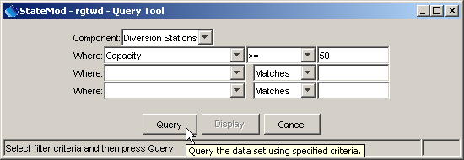
Tools_Query1
Query Tool Before Executing Query

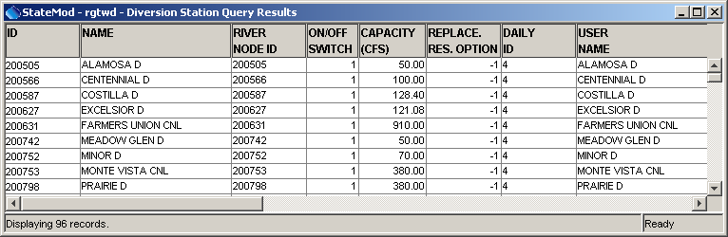
Tools_Query2
Query Tool Results

The results can be sorted by right clicking on the column headings and exported by right clicking on the worksheet and selecting from popup menu choices.

9.7 StateMod GUI Options

The Tools…Options menu allows StateMod GUI session properties to be changed:

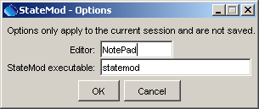
Tools_Options
StateMod GUI Options

The settings cannot currently be saved to a file. Changes from the defaults are therefore in effect only during the current session. The editor is used when viewing StateMod output files (Results…Output Files). The StateMod executable is normally set to the name that will be found if the PATH environment variable is searched. However, it may be changed, for example, if several StateMod versions are being run and a specific executable is to be used. An absolute path can be entered if necessary.

9.8 Listing Modified Data

The Tools…Diagnostics Report - Modified Data menu displays a list of data that have been modified. This tool was developed to aid software developers in properly handling user edits but has limited functionality. Detecting modified data is important because the StateMod GUI must write modified files before the StateMod software will recognize the data changes. The following figure illustrates output from the tool:

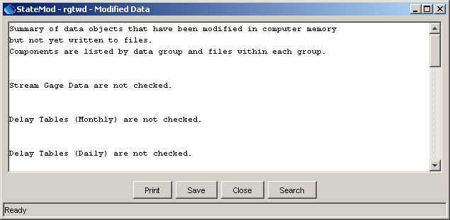
Tools_Modified
Report Listing Modified Data

9.9 Listing Unused Data

The Tools…Diagnostics Report – Unused Data menu displays a list of stations that are not used in the data set. This tool was developed to aid software developers and has limited functionality. The following figure illustrates output from the tool:

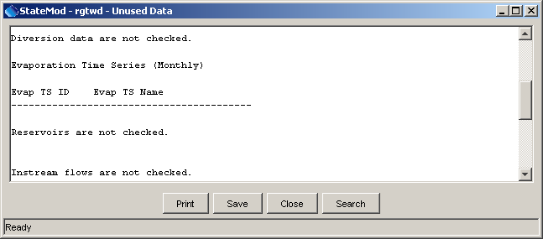
Tools_Unused
Report Listing Unused Data

9.10 Network Summary

The Tools…Network Summary tool provides a summary of each node type in the network. This tool was implemented to troubleshoot networks and has limited functionality. The following figure illustrates the tool output:

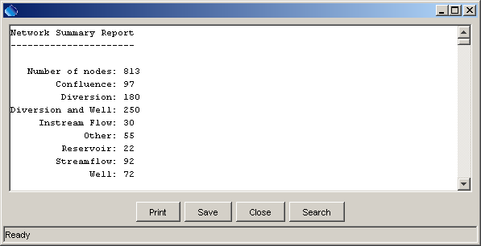
Tools_NetworkSummary
Network Summary Report

9.11 Diagnostics Tools

Diagnostics features are useful for troubleshooting. When an error occurs, a small warning dialog may be displayed and the message is also recorded in the StateMod GUI log file.

9.11.1 Diagnostics Settings

The Tools…Diagnostics menu item displays the Diagnostics dialog, which is used to set message levels and view messages as the application runs. The Diagnostics dialog (see the following figure) can be used to evaluate a problem.

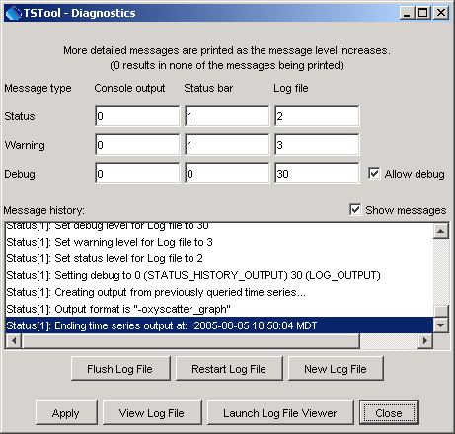
Diagnostics
Diagnostics Interface

The settings at the top of the dialog are used to specify the level of detail for messages printed to the console window, the status area at the bottom of the main window (and the Diagnostics dialog), and the log file. The log file contains warning, status, and debug messages, many of which are not normally displayed in the main interface. The log file is created in the logs directory under the installation directory. The Diagnostics interface features are as follows:

Status, Warning, Debug |  | Enter integer values, with larger numbers resulting in more output and slower performance. Zero indicates no output. If troubleshooting, a good guideline is to set the debug level to 10 or 30 (and select the Allow Debug checkbox). The default settings are often enough for normal troubleshooting and result in good software performance.
Allow Debug |  | Select to enable debug messages. Turning on debug messages will significantly slow down the software.
Show Messages |  | Select to display messages in the Diagnostics window.
Flush Log File |  | Force messages to be written to the log file. Messages can be buffered in memory and may not otherwise immediately be written to the log file.
Restart Log File |  | Restart the log file. This is useful if a long session has occurred and troubleshooting will occur on new actions.
New Log File |  | Open a new log file, with a new name.
Apply |  | Apply the settings in the Diagnostics dialog.
View Log File |  | View the log file in an integrated window. The View Log File button will be enabled if the log file has been opened.
Launch Log File Viewer |  | View the log file using a viewer from the operating system. On Windows computers, Notepad will be used.
Close |  | Apply the settings in the Diagnostics dialog and close the window.

9.11.2 Diagnostics – View Log File

The Tools…Diagnostics – View Log File menu item displays the integrated log file viewer. Selecting this menu item is equivalent to selecting the View Log File button in the Diagnostics dialog. The log file viewer is shown in the following figure:

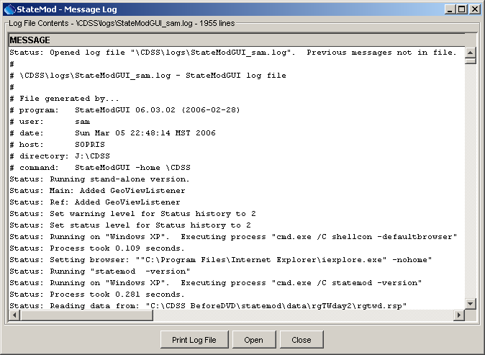
Diagnostics_LogViewer
Log File Viewer Window

The log file messages can be scrolled. To find a string in the log file, right-click and select the Find menu item. The information in the log file can also be copied and pasted into email when contacting support.

This page is intentionally blank.

