Appendix: StateMod GUI Installation and Configuration for CDSS
07.04.00, 2013-04-18

1. Overview

This appendix describes how to install the StateMod GUI in Colorado’s Decision Support Systems (CDSS) environment. Installing the StateMod GUI will also install the StateMod model and related utility programs, which can be further updated if separate updates have been provided.

2. StateMod GUI File Locations

The State of Colorado's CDSS consists of the HydroBase database, modeling, and data viewing/editing applications. In this environment, StateMod model files are usually prepared in an automated fashion using the StateDMI and TSTool software. The StateMod GUI is used to review data sets, make minor changes to the data sets, and prepare graphical data products from model input and output.

Locations of StateMod GUI software files are as shown below, where Version is similar to 07.04.00. The version allows multiple versions of the StateMod GUI and associated StateMod software to be installed at the same time, facilitating new development and allowing versions to be archived for use with old data sets.

\CDSS\StateModGUI-Version\ |  | Top-level install directory (install home).
bin\ |  | Software directory for StateModGUI and StateMod software files.
*.jar |  | Java software files used by the GUI.
SmDelta.exe |  | Program to generate average and difference statistics from StateMod output.
StateMod-Version.exe |  | StateMod model executable used by default by the StateMod GUI.
StateModGUI.bat |  | Batch file to run the StateMod GUI using the JRE software. This may be phased out since the StateModGUI.exe is now used.
StateModGUI.exe |  | StateMod GUI executable.
doc\UserManual\ |  | Main documentation directory for the StateMod GUI.
StateModGUI.pdf |  | StateMod GUI documentation as PDF.
Training\ |  | Training material PowerPoint and related files.
jre_*\ |  | Java runtime environment that executes the software.
logs\ |  | Location of log files.
system\ |  | Location of system files used for configuration.
DATAUNIT |  | Data units.
OperatingRules.* |  | Files used to provide operating rules information in general way.
StateModGUI.cfg |  | StateMod GUI configuration file.

3. Installing the StateMod GUI

The StateMod GUI can be installed with other CDSS software, or as a separate installation (e.g., to perform StateMod modeling without the support of the State of Colorado’s HydroBase and related tools). In both cases, is recommended that the default file organization is used. The StateMod model software is installed with the StateMod GUI, although newer versions of the model may be provided separately.

Use the following instructions to install the StateMod GUI using the StateModGUI_CDSS_Version_Setup.exe installer program, for example if StateMod GUI software was downloaded from the CDSS web site (http://cdss.state.co.us):

- Run the StateModGUI_CDSS_Version_Setup.exe file by selecting from Windows Explorer, the Start…Run… menu, or from a command shell. The setup filename will include a version number (e.g., StateModGUI_CDSS_07.04.00_Setup.exe).

You must be logged into the computer using an account with administrator privileges. Otherwise, a warning will be displayed.

If you have administrative privileges, the following welcome will be displayed, and the installation can continue:

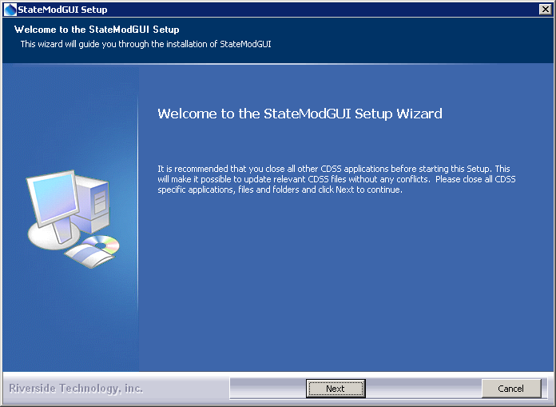
Install_Welcome

Press Next to continue with the installation.
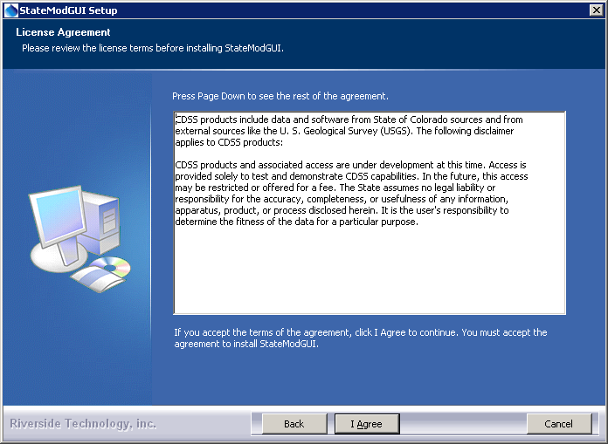
Install_Disclaimer

The StateMod GUI is distributed as a component of CDSS with no license restrictions. However the disclaimer must be acknowledged. Press I Agree to continue with the installation.

- Several components can be selected for the install as shown in the following dialog. Position the mouse over a component to see its description.

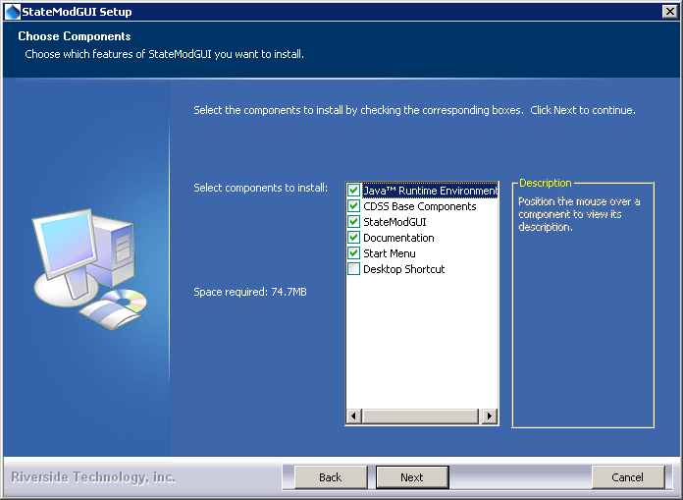
Install_SelectComponents

Select the components to install and press Next.

- The following dialog is then shown and is used to select the installation location for the StateMod GUI. To be consistent with other CDSS components, select the versioned folder under the main CDSS folder, as shown by default. The following dialog will display the CDSS install location if the CDSS Base component has been previously installed:

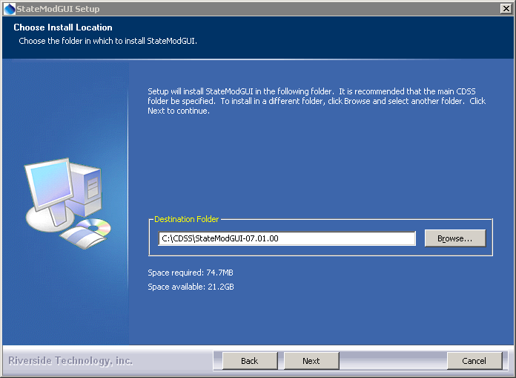
Install_SelectFolder

After selecting the install location, press Next.

Note that this location will be saved as a Windows registry setting (HKEY_LOCAL_MACHINE\Software\State of Colorado\StateModGUI-Version\Path) to allow future updates to check for and default to the same install location, and to allow the standard software uninstall procedure to work correctly.

- The following dialog will be shown to select the menu for the software:

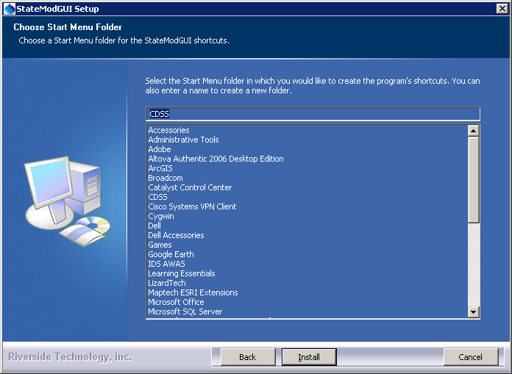
Install_StartMenuFolder

After selecting the folder, press Install.

- The following dialog will show the progress of the installation:

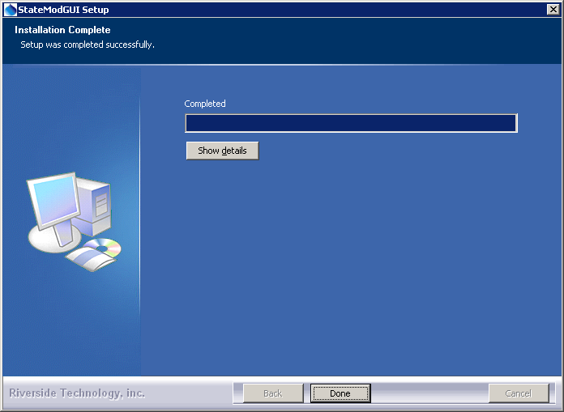
Install_Complete

Press Show details to see the files that were installed or press Done to continue.

- The following dialog will then be shown asking whether the StateMod GUI software should be run:

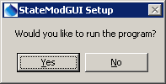
Install_RunStateModGUIQuestion

Press Yes to run the software or No to exit the installation procedure.

- A reboot is not required to use the software from the Start menu.

3.1 Installing the StateMod GUI on a File Server

The StateMod GUI can be installed on a file server, which allows software updates to be made in one location, thereby eliminating the need to install software on individual machines. For this type of installation, it is recommended that all computers that access the software must have similar configuration, including network configuration. The standard installer described in this documentation focuses on individual installs on user computers. To install the StateMod GUI software on a server and make available to other computers, perform the following (this is typically performed by system administrators):

- Run the StateModGUI_CDSS_Version_Setup.exe installer on the server, using the steps as described above. During installation specify the CDSS home using a drive letter and path for the server or specify a Universal Naming Convention (UNC) path (e.g., \\CDSSServer\CDSS\StateModGUI-Version). The home directory of the software is determined at runtime to be that corresponding to the parent folder of the StateModGUI.exe file. Alternatively, copy the installed files from a local computer installation to a server (in this case menus and shortcuts will not be configured on the server).
- The menus and shortcuts will only be configured for the computer from which the installation was run. Therefore, menus and shortcuts for other computers will need to be manually configured.

If the StateMod GUI has been installed on a local computer and it is also available on the network, the network version can be run by running the NetworkInstallHome\StateModGUI-Version\bin\StateModGUI.exe program.

4. Uninstalling StateMod GUI Software

To uninstall the StateMod GUI (and StateMod model and utilities) software, select CDSS…Uninstall…StateModGUI-Version from the Start menu and confirm the uninstall.

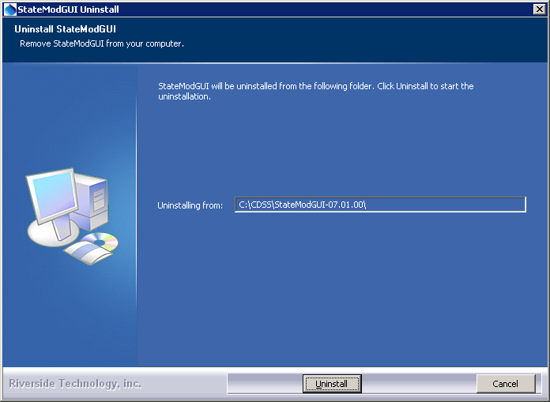
Uninstall_Intro

Press Uninstall to uninstall the software.
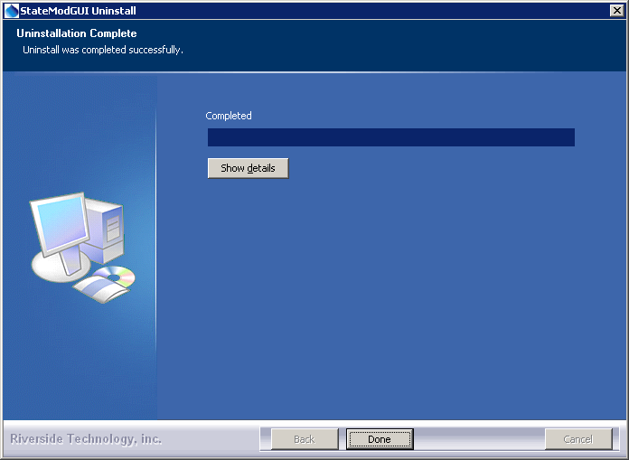
Uninstall_Complete

Press Show details to see the list of files that were removed. Press Done to exit the uninstall.

5. Running the StateMod GUI

The StateMod GUI can be started in several ways as described below.

5.1 CDSS Menu

The Start…All Programs…CDSS…StateModGUI-Version (or Start…Programs…StateModGUI-Version) menu can be used to start the software. This runs the InstallHome\bin\StateModGUI.exe software.

5.2 Command Line Executable

The installation process DOES NOT add the InstallHome\bin folder to the PATH environment variable, primarily because different versions of the software can be installed and it can be difficult to automatically determine which one should be listed first in the PATH. To add a folder to the PATH, edit the information accessible via Start…Control Panel…System…Advanced…Environment Variables.

Previous StateMod GUI installers (prior to 7.00.00) modified the path and such changes may still be in effect on the computer. Uninstall the earlier version and/or edit the PATH environment variable to remove this configuration.

5.3 StateModGUI Batch File

The StateMod GUI was previously started with and can still be run with the InstallHome\bin\StateModGUI.bat file, for example to support troubleshooting. In this case, the file name StateModGUI.bat must be fully specified because running StateModGUI will result in the executable program being run (see previous section).

6. StateMod GUI Configuration Files

The StateMod GUI requires minimal configuration after installation. This section describes StateMod GUI configuration files that can be customized for a system.

6.1 Data Units File

The system\DATAUNIT file under the main installation directory contains data unit information that defines conversions and output precision. In most cases the default file can be used but additional units may need to be added for a user's needs (in this case please notify the developers so the units can be added to the default file distributed with installations).

6.2 Configuration File

The system\StateModGUI.cfg file specifies StateMod GUI configuration information, accessible from the Tools…Options menu in the StateMod GUI. The defaults in the file currently must be manually edited if they are to remain between StateMod GUI sessions. The following illustrates how the path to the StateMod and SmDelta executables can be set, and are specific to each StateMod GUI version that is installed:

#
# StateModGUI configuration properties
#
# ${Home} will be replaced by the software with the -home command line parameter
# from installation. This is the software installation home, which by default is:
# C:\CDSS\StateModGUI-Version
#
# ${WorkingDir} will be replaced by the response file folder
#

# StateMod executable to run from the GUI
# Although a generic location like "StateMod.exe" could be used, the model version
# may impact model results and therefore the version can be specifically defined

# Use the following if a StateMod executable is not expected to be found with the dataset
# This is preferred to the work-around described below
#StateModExecutablePath = "${Home}\bin\StateMod-13.00.00.exe"
# Use the following if a StateMod executable is expected to be found with the dataset
# The following default is used because the StateModExecutable = ..\Bin\StateMod-13.00.00
# response file property causes an error with StateMod 13.00.00.
# This work-around is not desirable because it lessens the modeler's control of the dataset
# and assumes that all datasets are similarly configured
StateModExecutablePath = "${WorkingDir}\..\Bin\StateMod-13.00.00.exe"

# Delta plot executable to run from the GUI...

SmDeltaExecutablePath = "${Home}\bin\SmDelta.exe"

# Startup folder for the GUI when doing: File...Open...Response File

DataHomeDefault = "C:\CDSS\data"

6.3 Map Configuration

Refer to the Configuring Spatial Data for the StateMod GUI Appendix for more information about configuring maps for use with the StateMod GUI.

This page is intentionally blank.

