Appendix: Configuring StateMod Datasets for the StateMod GUI
7.03.01, 2011-08-28

1. Overview

This appendix describes how to configure StateMod dataset files for optimal use with the StateMod GUI. Datasets traditionally have been constructed using utility programs. This facilitates efficient, automated, regeneration of data sets. However, once a dataset is constructed, the StateMod GUI is useful for viewing data and results, as well as performing minor edits to datasets. The following sections describe common configuration tasks that must be performed in order for a StateMod data set to be properly handled by the GUI.

These notes were reviewed/tested using the CDSS_WhiteR_09 data set. Why does the naming convention for data sets change every time? For example, old data sets are sj2009, etc? Is there a standards document that is being followed?

2. File Naming Conventions

The StateMod GUI does not have file naming restrictions. However, older versions of StateMod may not recognize files that are in a folder that includes spaces anywhere in the name or has folder/file names greater than X characters. Are there still issues?

StateMod dataset file naming conventions should follow the guidelines described in the StateDMI Instroduction Chapter (is this the best place for guidelines and are they correct in the StateDMI documentation)?

3. Response File

The StateMod response file (*.rsp) is typically edited by hand using a copy of a response file from a different dataset. Changes also can be made in the StateMod GUI. If a response file has not been configured for the GUI, then the GUI will be limited in its ability to display and edit data files. The following example illustrates GUI properties that can be placed in the StateMod response file (note that because a StateMod dataset my have multiple response files, the following issues may need to be resolved in each response file):

#-----------------------------------------------------------------------
# Used by the StateMod GUI but not by StateMod the model...
Network = ..\network\wm2009.net
GeographicInformation = wm2009.gvp
StateModExecutable = ..\bin\StateMod-12.29.24.exe
# ... end StateMod GUI items
#-----------------------------------------------------------------------

The StateMod software will ignore these properties. Details about the files referenced by the above properties are discussed in the following sections.

4. Network File

Section 3 indicated how to add the response file property to specify the generalized network file. The generalized network file is an XML file that describes the connectivity of the model nodes, as well as providing some layout information for the network viewer. This file is not used directly by StateMod but must be consistent with StateMod data files. The standard approachi for creating a StateMod dataset is to edit the network in StateDMI and generate associated model data files using automated data processing. Once a data set has “graduated” to use in the StateMod GUI, any changes to the StateMod network also must have consistent edits to the generalized network. The StateMod GUI enforces such actions through its edit features.

Although the StateMod software does not used the generalized network file, it must be included in the response file to allow the GUI to properly edit the data set, and to allow visualization of model features in the model network editor.

5. Location of StateMod Executable Program

The StateMod executable program can be run on the command line independent of the StateMod GUI. The StateMod GUI runs the StateMod executable program and displays the standard output (program progress) in the GUI. The location of the StateMod executable program when run from the GUI is determined as follows:

- Use the location specified by the StateModExecutable property in the dataset response file (see the example in Section 3). The location can be relative to the response file folder or can be absolute.
- Use the location specified by the StateModExecutablePath property in the system\StateModGUI.cfg file, located under the StateMod GUI software installation. A recent StateMod executable program will be distributed with the StateMod GUI.

In order to isolate the impacts of the StateMod software version on a model run, it is recommended that a copy of the executable program that is used with a data set is saved with the data set, for example in a bin folder parallel to other data set folders (“bin” means binary and is common folder name for executable software):

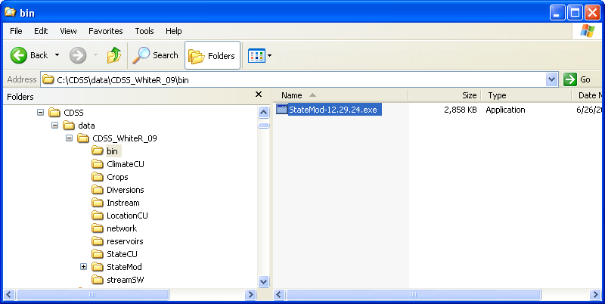
DataSetConfig_Bin
Example of Configuring StateMod Executable Location with Dataset
This practice isolates the dataset from any other software changes on the system and ensures that the dataset, if archived or transported to another computer, will include a compatible model. Once a location for the StateMod executable is determined, its location can be specified for the GUI as described above.

6. Location of StateMod Files

The response file (*.rsp) contains locations of files that comprise a dataset. The location of files can generally be specified relative to the response file. For example, the following line indicates that the control file is in the same folder as the response file:

# cm2009.rsp
#
#
# StateMod Response File
#
# Type Name
# ______________________________________ ___________________________________________
Control = wm2009.ctl

The locations of files also generally can be specified relative to the response file. For example, the following illustrates how data related to the consumptive use model could be specified as residing in the StateCU folder that is on the same level as the StateMod folder:

# cm2009.rsp
#
#
# StateMod Response File
#
# Type Name
# ______________________________________ ___________________________________________
IrrigationPractice_Yearly = ..\StateCU\wm2009.ipy
ConsumptiveWaterRequirement_Monthly = ..\wm2009.iwr
StateCU_Structure = ..\StateCU\wm2009.str

Both of the above approaches allow the dataset to be self-contained and transportable to other computers that may have different top-level folder organizations. StateMod determines the final file location by concatenating the response file folder with the filename in the response file. This works as expected when SateMod is run from the command line in the same folder as the response file. However, if StateMod is run from the GUI (which itself starts in a different folder than the response file) or StateMod is run from the command line in a folder that is different from the response file, an error may occur because StateMod does not properly concatenate relative paths for all files. The following sequence of actions illustrates detecting the problem and implementing a work-around, using the San Juan StateMod dataset. The StateMod data check can be executed from the GUI as follows:

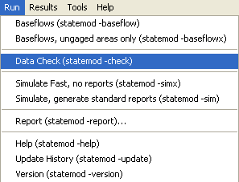
Appendix_ConfigCDSSDataSet_RspPathError1
Running the StateMod Data Check Module

An error may be indicated, as shown below:

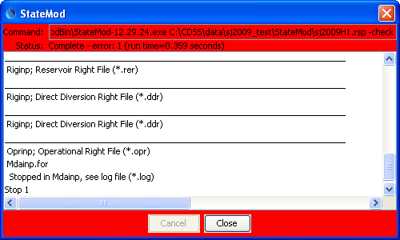
Appendix_ConfigCDSSDataSet_RspPathError2
StateMod Data Check Error – StateMod Found an Error

More detailed information about the error will be listed in the StateMod log file, which can be accessed in the GUI using the Results…Output File menu item (then scroll the file list, select the log file corresponding to the response file, and click on the View/Edit button) :

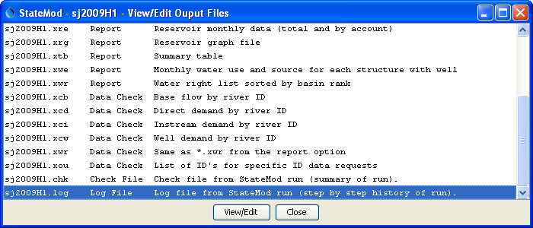
Appendix_ConfigCDSSDataSet_RspPathError3
StateMod Data Check Error – Selecting the StateMod Log File to View

The following figure illustrates the contents of the log file. In this case, the Notepad program is used to view the file on Windows and the file has been scrolled to the bottom to show the error.

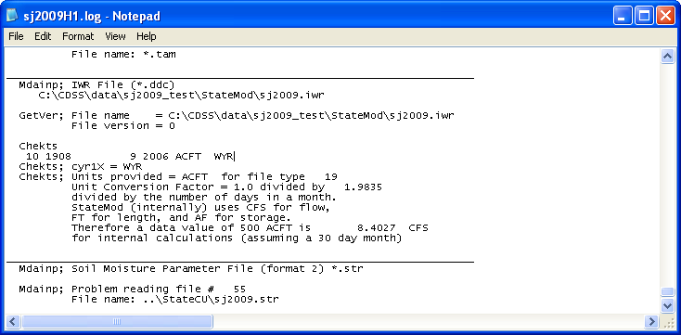
Appendix_ConfigCDSSDataSet_RspPathError4
StateMod Data Check Error – Viewing the StateMod Log File Contents

The last line indicates that there is a problem reading the StateCU sj2009.str file, which has been specified as a relative path in the StateCU folder. The warning message is not very descriptive. However, a clue is that the sj2009.iwr file listed near the top of the above figure shows the file name as an absolute path using a combination of the response file folder and the *iwr filename in the response file. The StateMod code properly handles a relative path for the *iwr file but not the *str file. This is a limitation in StateMod that needs to be fixed in order to allow relative paths for all files to be used when running StateMod from the GUI.

Work-arounds for this issue include:
- copy the file from its current location to the dataset StateMod folder and edit the response file so that a simple filename (without ..\, etc.) is used
  - CON: multiple copies of a file may result in confusion about which file is the most recent
  - CON: multiple copies of a file results in a file organization that does not adhere to dataset standards
- use an absolute path in the response file
  - CON: using an absolute path will make the dataset more difficult to transport to other machines or file system locations
  - CON: an absolute path may result in a specific file unintentionally being used for multiple copies of the dataset

Ideally, the StateMod limitation can be resolved in the near future so that this issue can be resolved and this section of the documentation can be removed.

7. Spatial Data Files

The StateMod model software does not require spatial data for the simulation and in fact StateMod data files do not contain fields for spatial data. Instead, all spatial information (such as area/precipitation information and network upstream/downstream relationships) are provided by preprocessing data with tools such as StateDMI and TSTool. For example area/precipitation information is used to create the proration factors in the *rib file and upstream/downstream relationships are included in the *.net and *.rin files as “downstream ID” for each node.

Spatial data are useful for visualization in the StateMod GUI. Currently, the StateMod GUI does not require that spatial data are specified for a StateMod dataset; however, map visualization will be missing or limited without spatial data.

The StateMod GUI uses a text properties map definition file that was developed years ago. This map file format and the mapping software do not require licenses such as ArcGIS. However, the mapping tools provide limited geoprocessing capabilities and support limited data formats. In particular, ESRI shapefiles that are commonly used in CDSS are supported; however, background imagery and web services are not.

There are a number of challenges to using spatial data with StateMod datasets, including:

- CDSS spatial data files available on the CDSS website (http://cdss.state.co.us/DNN/GIS/tabid/67/Default.aspx) typically include all features for a data type. For example, diversion structures in Division 5 include all headgates, no matter whether they are included in a dataset, and also include abandoned structures. Consequently, displaying all of the locations in a dataset would be overwhelming.
- Structures that are used in a dataset may inaccurate or missing coordinates. Although correcting the locations in a dataset may need to occur, ideally quality control of the data should occur before locations are even used in a dataset.
- It is typical that a dataset will include nodes for modeling purposes that do not correspond to physical locations. In these cases, adding the locations to “official” spatial data would clutter up actual physical data.
- Software mapping software such as ERSI tools can be expensive, complicated, and difficult to maintain, in particular as software versions and data formats change.
- Although tools to process spatial data are generally available to modelers, some of the above issues require resources that have not been available on modeling projects and consequently, generating data sets with completely defined spatial data has not been a priority.

The compromise that has been implemented with the StateMod GUI is to provide a simple, optional map interface that uses simple data files. Increasingly, it is desirable to convert “optional” to “mandatory” for map visualization. The following information seeks to help preparers of StateMod data sets quickly implement spatial data so that data sets are indeed spatially integrated. Note that additional software development is needed to fully-integrated spatial data with StateMod data; however, the configuration described below is a step towards this eventuality.

The StateMod GUI uses software called “GeoView” and configuration of the map uses a “GeoView Project” (GVP) file. The GeoView Mapping Tools appendix provides details about how to use the mapping software components. The discussion below focuses on how to set up spatial data for the map.

GIS (spatial) data for CDSS are available on the CDSS website (http://cdss.state.co.us/DNN/GIS/tabid/67/Default.aspx) and traditionally files are installed in the C:\CDSS\GIS folder, with subfolders for each water division:

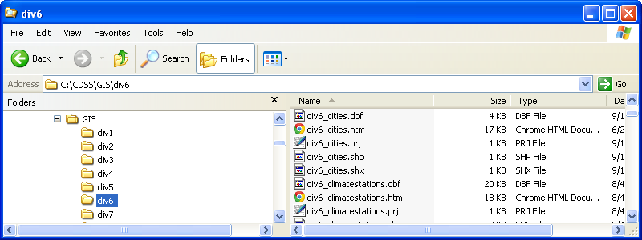
Appendix_ConfigCDSSDataSet_Spatial1
StateMod Spatial Data Configuration – Typical CDSS Spatial Data Folder Organization

This organization facilitates sharing of spatial data files (which can be large), in the same way that HydroBase should be used as the master copy of CDSS data. However, similar to how HydroBase data are processed to create StateMod model files, it is useful to copy GIS files to a dataset so that they can be “frozen” and are documented as part of the dataset. To this end, it is recommended that a GIS folder be created in the dataset folder, and copy spatial data files to the dataset GIS folder. Because the GIS folder may be distributed with the dataset, care should be taken to include only layers that are used in the data set (in any way), in order to minimize the size of the dataset distribution file. For example:

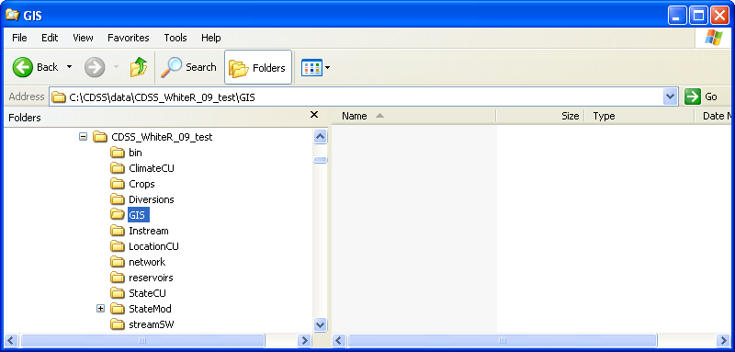
Appendix_ConfigCDSSDataSet_Spatial2
StateMod Spatial Data Configuration – Initial Dataset Spatial Data Folder Organization

It is recommended that the *.gvp file for the StateMod data set be saved in the StateMod folder (rather than the GIS folder), using a filename consistent with the response file. This ensures that the map is consistent with other StateMod files. If necessary, create more than one *.gvp file consistent with various response files. Similarly, map configurations for StateCU or other tools can be stored in folders containing the files for those tools. Does this make sense? Or should the standard be to put the *.gvp file in the GIS folder (if so, what is the naming convention to avoid conflict between different versions of the files)? To facilitate initialization of the *.gvp file, copy a file from the example dataset distributed with the StateMod GUI and then edit the file with a text editor. The first step usually is to copy the *.gvp file, indicate its presence in the response file (see Section 3), and try loading the dataset in the StateMod GUI. An initial attempt will yield something like the following figure, which indicates that no data can be found. The labels that are displayed in the legend on the left side of the map can be searched for in the *.gvp file to determine the missing file.

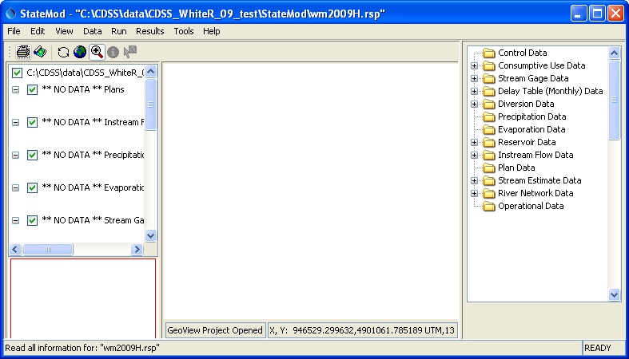
Appendix_ConfigCDSSDataSet_Spatial3
StateMod Spatial Data Configuration – StateMod GUI Map with Missing Data Layers

Note that the map interface, when configured by specifying a *.gvp file, takes over the bulk of the main StateMod GUI window. This is because the map interface is better suited for the main window whereas the network editor requires a separate window.

In order to enable the data layers, edit the *.gvp file (wm2009.gvp in this case), update the names of spatial data files as needed, and copy the needed files from the main CDSS\GIS folder to the dataset GIS folder. Below is an excerpt of the *.gvp file that is distributed as an example with the StateMod GUI, with highlights to illustrate changes that will need to be made for a specific data set.

# GeoView project file for Colorado basin.

# Main GeoView properties.

[GeoView]

# <by default the location is relative to the response file so no need to define the home>
# Main home for data
# If a directory is not specified, the directory will be determined when the
# GeoView project file is selected.
#GeoDataHome = "C:\cdss\data\cm2009\gis"
# ArcView/ArcExplorer Default...
#SelectColor = Yellow
# Arc 8...
#SelectColor = Cyan
# All-purpose (magenta/pink)
SelectColor = "255,120,255"
MaximumExtent = "140000,4313800 450000,4485000" <comment this out until some data are added,
and then use the mouse cursor in the GUI to
determine lower-left and upper-right>
# Projection for data unless otherwise indicated with data files
Projection = "UTM,13" <for CDSS use this or "Geographic">

# Now list the layer views. A layer view consists of specifying a data layer
# (e.g., shapefile) and view information (e.g., symbol). This is equivalent to
# the ESRI "theme" concept. The layers specified first are drawn on the bottom.
# Start with number 1 and increase the layer number sequentially as layers are
# added on top.
#
# Important properties are:
#
# GeoLayer - file name for layer data
# Name - Name to show in legend
# SkipLayerView - if true, don't display (but keep in file to maintain layer
# numbering)
# AppLayerType - this is "hardcoded" in software to allow recognition in
# specific displays. The value is "softcoded" here to
# allow flexibility.
# AppJoinField - attribute field(s) in the GIS data that are used to link to
# the StateMod data. The number of fields must match what
# is needed for the AppLayerType (e.g., diversions
# require a wd,id).

[GeoLayerView 1] <the layer numbers currently MUST be sequential from 1>
GeoLayer = ../GIS/div5_districts.shp
Name = "Water Districts"
# RGB 153 204 50 - green-yellow
#Color = "0x99CC32"
# tan
Color = "255,240,190"
OutlineColor = black
ReferenceLayer = true
AppLayerType = "BaseLayer" <this indicates how the StateMod GUI should treat the layer>

#<although displaying irrigated lands would be nice, additional software enhancements are needed>
# The following layer is currently skipped. It can be turned on. Additional
# classification/symbolization is being developed.
[GeoLayerView 2]
SkipLayerView = true <consequently, skip the layer in the map display>
GeoLayer = ../GIS/div5_irrig_2005.shp
#Name = "Irrigated Parcels"
Name = "Crops"
AppLayerType = "BaseLayer"
# Draw as single color...
#SymbolClassification = "Single"
# Green
#Color = "0,255,0"
# black
OutlineColor = "0,0,0"
# ---- OR draw as unique values -----------
#SymbolClassification = "UniqueValues"
#SymbolClassField = "wd"
#Color = "red;blue;green;yellow;pink;cyan;orange;magenta"
# ---- OR draw as class breaks -----------
SymbolClassification = "ClassBreaks"
#ColorTable = "Custom;3;red;green;blue"
ColorTable = "YellowToRed,10"
#ColorTable = "BlueToCyan,10"
#SymbolClassField = "wd"
#SymbolClassBreaks = "20,22,24,26,30"
# Try acres for testing
SymbolClassField = "ACREAGE"
SymbolClassBreaks = "1,10,20,40,100,150,200,300,400,500"

[GeoLayerView 3]
GeoLayer = ../GIS/div5_lakes.shp
#GeoLayer = div5_lakes.shp
Name = "Lakes"
# - blue
Color = "165,250,254"
OutlineColor = "0,130,254"
AppLayerType = "BaseLayer"

Note that there are global map properties on the top of the file. Because CDSS spatial data are distributed in UTM Zone 13 coordinate system, the *.gvp file specifies this as the projection and all layers are assumed to be in this projection unless otherwise noted. Because projecting data to UTM or other coordinate systems requires additional software, the StateMod GUI does support geographic (decimal degrees) coordinates.

To make the map functional, simply look for similar filenames in the CDSS main GIS folder, copy files to the dataset GIS folder, and edit the *.gvp file accordingly. Note that ESRI “shapefiles” consist of more than one file per layer. Layers are listed in the *.gvp with base (background) layers first and topmost layers last. If a GIS layer cannot be found, remove it from the *.gvp file (renumbering the layers as needed), or set the SkipLayerView=True property. After making one or more changes, reload the response file in the StateMod GUI to display changes to the map configuration. After a few iterations, the map should be close to complete and StateMod GUI map features will be enabled accordingly. See below for consideration of specific issues.

Some water division layers may not be sufficient for a dataset. For example, a dataset may contain streamflow gages from multiple divisions. In this case, data should be copied from multiple CDSS\GIS division folders and should be configured in the *.gvp. Each layer will be displayed separately in the legend and the StateMod GUI will use all available data.

The sample *.gvp distributed with StateMod uses symbols and colors for each layer. However, cartography is somewhat of an art and there are many standards. Colors can be changed; however, it is recommended that a “look and feel” be chosen that is similar to other CDSS and state map products. Should we attempt to standardize symbols and colors? Who should define the standard? How should it be published and enforced?

