SPDSS MEMORANDUM

TO: Ray Alvarado
FROM: Steve Malers, Riverside
DATE: 2011-07-17
SUBJECT: SPDSS Phase 3 Task 104-109 Administration Tools Workshop

1. Introduction

This memorandum is the deliverable for SPDSS Phase 3 Task 104-109 “Administration Tools Workshop”. The intent of this task was to discuss CDSS administration software tools and provide recommendations for future direction. This memorandum was prepared using input from DWR staff, including Division 1 and the HydroBase team.

2. Background

The CDSS CWRAT (Colorado Water Rights Administration Tool) software originally was developed to provide an administration tools for division offices and water commissioners, with development beginning in 1997. It also was realized that there was a general need for HydroBase data viewing software and consequently the StateView and CWRAT software were developed as one application, with both having the same data viewing functionality and CWRAT additionally having an Administration menu with tools for water administration.

The primary administration tool that was developed was the Water Information Sheet (WIS). This software consists of a tabular representation of the river from upstream to downstream, with columns for water balance terms at each location (see Figure 1).

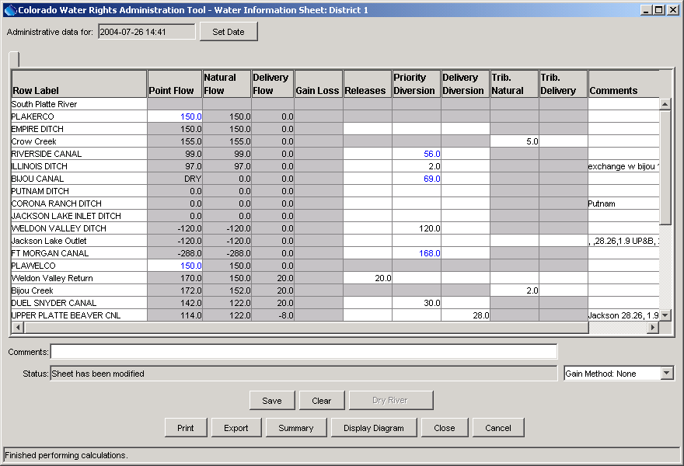

Figure 1. Example WIS Implementation

Although the impetus for the WIS came from Division 1 (South Platte) and previous prototype software, WIS features in CWRAT actually were developed during the Colorado River Decision Support System (CRDSS). Because the focus of CRDSS was not Division 1, there was a bit of a disconnect with users. In fact, it became obvious that West Slope users did not have a strong need for the WIS software. A similar tool, the Division 5 Workbook, also was developed and has seen diminished use.

Ultimately, the South Platte Decision Support System (SPDSS) development started and more direct application of the WIS to Division 1 could occur. However, because of other technology advances, the WIS features have not been extensively used.

The other administrative tool that was developed in CWRAT was the Edit Calls tool. This tool is still being used to edit call data. Functionality has not changed substantially since the initial development and is described in the CWRAT documentation. Because this software seems to be meeting a primary need, it is not discussed further. CWRAT 4.02.00 added support for Windows 7 and therefore the State should be able to rely on the Edit Calls tool for the foreseeable future.

3. Evaluation of Technologies for Administration

In order to generate recommendations for administration software, it is useful to evaluate reasons why the WIS is not currently used, including:

- The software was slow. This was truer in the past, but faster computers, Java Runtime Environment, and internet connections for data transfer have removed many of the barriers that impacted the early software.
- The software was complicated and difficult to configure. There is some truth to this because the WIS attempted to represent branching river systems in a “flat” table and a river network was essentially constructed behind the scenes. There were issues with editing WIS; however, many issues were related to slow performance, which made interactive editing of the configuration somewhat difficult. It is likely that insufficient training and technical support was provided.
- Not all basins required a WIS. Perhaps the tool was not appropriate for all users.
- Alternate technologies and tools were more useful to users. For example Excel is readily available and users could build their own WIS. Excel was considered for the WIS in CWRAT but technologies did not exist to easily manage the data transfer in and out of Excel.

Although a great deal of effort went into the WIS development, the tool in its current form is not required. However, the effort that was expended was not wasted because many of the software components ultimately were used in other ways in CDSS software.

Conversations with DWR indicate that the additional data and tools that are now available often provide sufficient information for administration and a complex tool like the WIS is not needed. For example, additional real-time streamflow stations have been added and data displays are available on the DWR website. It should be noted that the early environment for WIS software required synchronization of data from a central DWR server to the local PC, a process that was complicated and slow. This was corrected when greater internet access became available but may have contributed to lack of use.

4. Recommendations

The improved capabilities of computers, fast network connections, and wide variety of water-related data that are available on the internet, result in a drastically different environment than was in place when CWRAT development started. Because of varying water administration needs in different basins, it is likely that no single tool can meet the needs of all water commissioners and flexibility is needed. Therefore, it is recommended that going into the future that more flexibility is given to users in defining tool needs, and selecting and using tools. What is important is that the representation of administrative decisions is consistent, that sufficient data is provided for decisions, and that quality control is considered in work products. The following recommendations are provided, not as a statement of work for future development, but ideas for how to capitalize on previous work in order to meet more complex needs.

- Determine data products required for administration. The WIS resulted in a tabular water balance for a basin, and the resulting cell values also were available to generate graphs over time. However, other than the commissioner that used the WIS and some handoff of upstream administrative data to downstream commissioners, these products were not “published”. This may be one reason why the WIS ultimately has not been required for administration. It is recommended that before any additional administrative tools are developed (or enhanced) that data products and their use are defined.
- Utilize existing CDSS components as much as possible and enhance where appropriate. Because more real-time data now are available via web services and through direct query within the State’s network environment, it is possible to assemble information from various sources into meaningful products that can be used for administration. The result can be a highly user-configured toolset that has meaning to each user. For example, the TSTool software, in conjunction with real-time data web services can be used to create products such as that shown in the following figure:

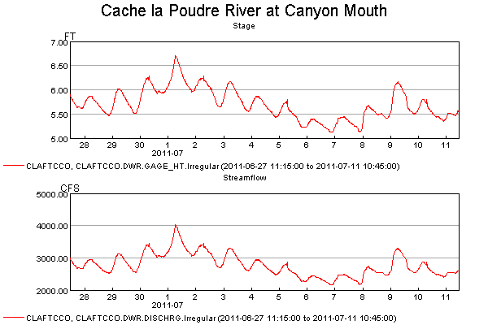
Figure 2. TSTool Real-time Data Product

TSTool or similar software could be used to access real-time data, create data products for administrative decisions, and evaluate data for critical conditions. In addition to the observed values, forecasts from the National Weather Service or other agencies can be incorporated into data products to help make administrative decisions.
- Evaluate whether Excel can be used for WIS. Technologies now exist that allow data to be entered into and extracted from Excel workbooks. Consequently, the functionality of the WIS could be implemented in Excel and resulting administrative data could be archived as Excel files and the data extracted from the workbooks. Some standards would need to be put in place for data exchange; however, the use of a common tool such as Excel could encourage more formal handling of administration, which could help future generations of water commissioners learn how to perform administration.
- Evaluate whether new needs can be met with enhanced or new CDSS tools. As CDSS has matured, the data, software and procedures that have been put in place for basin modeling have evolved from experimental prototypes to an operational framework. It is therefore possible to consider applying and enhancing the tools to meet new needs. Examples to consider include:
  - Using additional web applications, such as the DWR data viewing tools, for water administration.
  - Implementing additional web data services to allow CDSS and other tools to access data in a distributed fashion. For example, water providers could utilize CDSS tools like TSTool on their computers to create their own data products related to administration, and allow similar viewing by water commissioners.
  - Using existing basin network components, such as the StateMod network, in building administrative tools (this was utilized to a degree with the WIS, but could be improved). The USGS National Hydrography Dataset also could be considered, in particular for GIS-based applications. For example, a real-time network representation of river systems could be used to estimate flows at intermediate locations and check incoming real-time data for critical values.
  - Continue to focus on understanding data processes and using automation as much as possible. For example, rather than requiring extensive user input, develop data products that automatically are created to inform decisions. These products can be archived, and important decision input can also be recorded in appropriate form.

Overall, it is recommended that future development of administration tools focus on understanding the needs of users and that a core team of developers and users be engaged to evaluate tools in a collaborative, agile fashion, with frequent software releases and application in operational environments. This is much more possible now given the state of software development tools, network performance, and mature CDSS tools to use as a starting point.

