Colorado’s Decision Support Systems
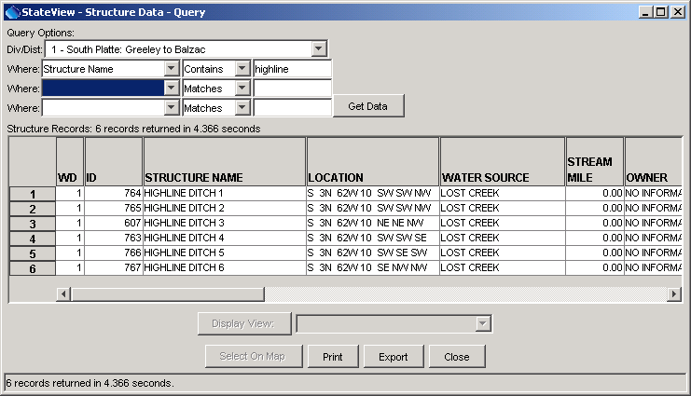
Colorado Water Rights Administration Tool (CWRAT)
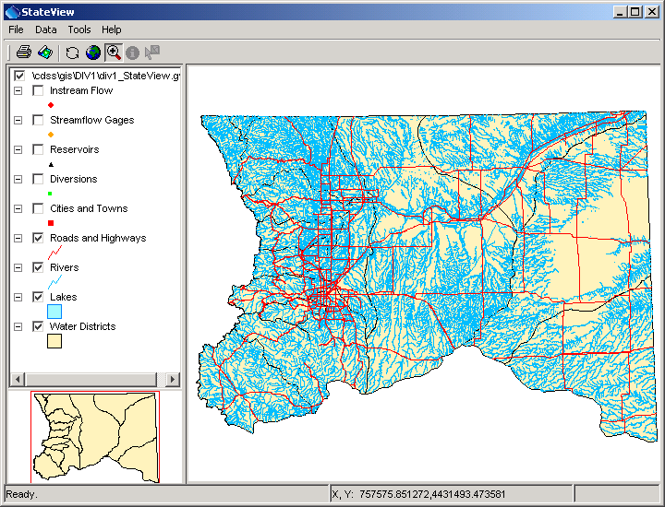
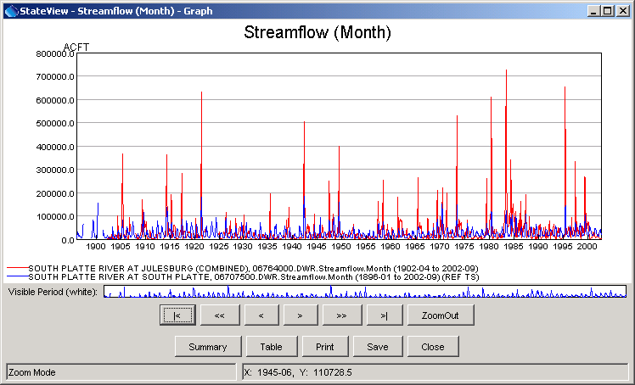

Colorado Department of Natural Resources
Colorado Water Conservation Board
Division of Water Resources

Developed by:

 | Riverside Technology, inc.

Version 04.00.00, 2007-03-02
This page is intentionally blank.

This document is formatted for double-sided printing.

