3

Getting Started
Version 04.00.00, 2007-03-02, Color, Acrobat Distiller

This chapter provides an overview of the StateView/CWRAT graphical user interface (GUI). The main interface components are described below, with specific chapters devoted to the main features.

3.1 Starting StateView/CWRAT

StateView/CWRAT can be started using the Start…Programs…CDSS…StateView and Start…Programs…CDSS…CWRAT menus. Newer systems may use the Start…All Programs…CDSS… menus.

3.2 Select HydroBase Dialog

At startup you are requested to select a HydroBase database. A HydroBase database can also be selected from the File...Open… menu. The dialog shown in the following figure will be displayed (in this case illustrating the use of HydroBase running on a local desktop computer):

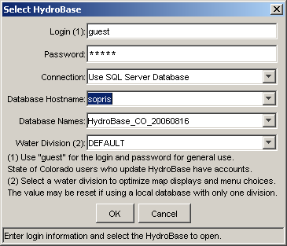
HydroBaseLogin_Local
Select HydroBase Database Dialog for Local Computer

The following figure illustrates the HydroBase login when a shared (remote) database server is used:

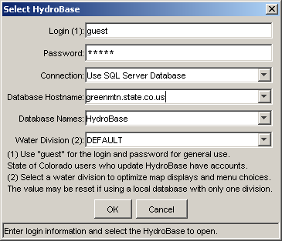
HydroBaseLogin
Select HydroBase Database Dialog for Shared Database Server

You can also cancel the login, in which case HydroBase features will be disabled. If a previous HydroBase connection has been made, then Cancel reverts to the previous connection.

The main items displayed in the login dialog are described below. Footnotes in the login dialog provide information about some of the data fields.

Login | The login identifies the user to the system. Many users can use the default guest login for viewing data. CWRAT Administration features require a valid login and password in order to edit data.
Password | The password is associated with the login and is required to edit data. The default guest login and password are suitable for most users.
Connection | The connection indicates the database that will be used for data viewing and editing. If Use SQL Server Database is selected, then the main Denver SQL Server database or a SQL Server Express server will be used. If Use Access Database is selected, then a Microsoft Access version of HydroBase will be used (Access is being phased out and is not discussed further below).
Database Hostname | The database host name choices are defaulted to available servers. If necessary, enter an alternate name or Internet address.
Database Names | A list of databases is listed for the selected Database Hostname (any databases that include HydroBase in the name).
Water Division | The Water Division choice is used to determine user preferences for the session. For example, a user who always works with Division 3 data can select DIV3. The Tools…Options…Water District Filter and Tools…Options…Map settings, when changed, will then be applied to a Division 3 login session. The settings in the SQL Server databases for State of Colorado staff may be pre-configured to typical settings. Using the DEFAULT Water Division setting will typically result in no map display and Water Division/District lists that include all divisions and districts.

3.3 Main Interface

The StateView/CWRAT application provides two main interface options:

- No map interface. In this configuration, all interface features are accessed using the main menus.
- With map interface. In this configuration, an interactive map is displayed that shows background layers (e.g., rivers and water districts) and data associated with other display windows (e.g., diversion locations), allowing some queries to be performed from the map interface. Spatial data to support the map interface are available from the State of Colorado.

The following figure illustrates the StateView interface after startup, with no map. The interface will appear as follows until you have completed the login procedure. (Note that the CWRAT interface is the same except that it includes an Administration menu.)

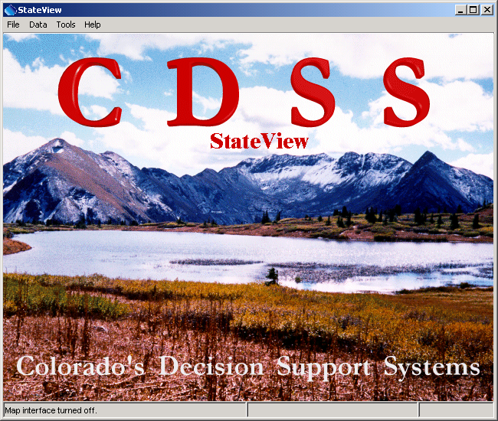
StateView_Main_NoMap
StateView Main Interface - No Map

3.3.1 Map Interface

StateView/CWRAT will display a map interface if, for your login, the Tools...Options...Map settings indicate a valid GeoView project file. Supporting GIS (Geographic Information Systems) files are typically distributed with StateView/CWRAT on CDs or are made available to State of Colorado staff on a file server. The following figure illustrates the main StateView interface when a map is displayed.

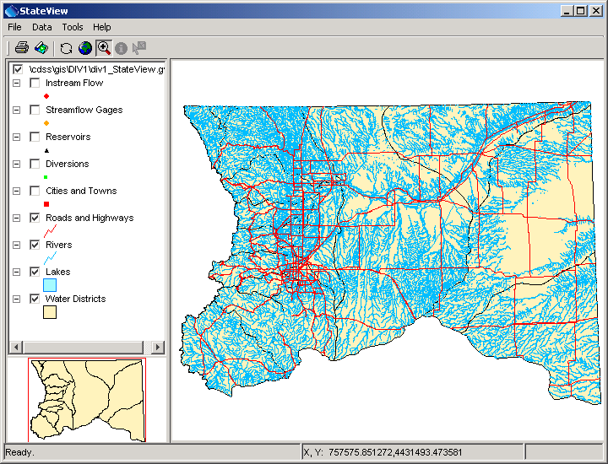
StateView_Main_WithMap
StateView Main Interface - With Map

The mapping tool used by StateView/CWRAT is a general tool and is described in the GeoView Mapping Tools appendix. The map interface is similar to other common map interfaces; however, it has been implemented to specifically provide features to view HydroBase data and related spatial data. The mapping tools can be used interactively (e.g., you can zoom in to an area or turn layers on and off). To streamline the specific StateView/CWRAT functionality, the following actions are taken by StateView/CWRAT:

- The GeoView project file, which describes the layers that are initially shown in the map, identifies layers as Baselayer or specific data types (e.g., Diversion). StateView/CWRAT is then able to automatically turn layers on and off during operation. For example, if the Data...Structures menu item is selected, only the structure layer types (Diversion, Reservoir, Well) will be enabled on the map (indicated by the check-box in the map table of contents). This automatic enabling/disabling of layers is meant to streamline data viewing. You can turn on other layers if necessary by enabling them in the table of contents. Automatically displaying some map layers will cause StateView/CWRAT to pause temporarily if spatial data layers are large. Loading the spatial data at startup will also temporarily slow down the software.

- Several Data menu displays include Select on Map buttons that allow data from those displays to be selected on the map (e.g., station or diversion locations). The default behavior in this case is to zoom in to the selected structures. Again, this behavior has been implemented to help streamline data viewing.

Chapter 7 - Examples of Use provides step-by-step examples of how to use the map interface to simplify spatial queries of the database (e.g., finding diversions in an area). Additional information is discussed for each Data display that supports map interaction (see Chapter 4 – Viewing Data).

3.3.2 Time Series Viewing Tools

Many StateView/CWRAT data views allow time series data to be displayed. In most cases, regardless of how time series data are initially displayed, time series can be displayed in the following ways:

- Graph
- Table
- Summary (i.e., text report)

The TSView Time Series Viewing Tools appendix describes the features of the time series viewing package, which is used by several CDSS programs.

3.3.3 Tabular Lists (Worksheets)

Tabular lists are used for record-based output, such as lists of structures or water rights. Because the size of such output may be large, both vertical and horizontal scrollbars may be used. The following figure illustrates a tabular list.

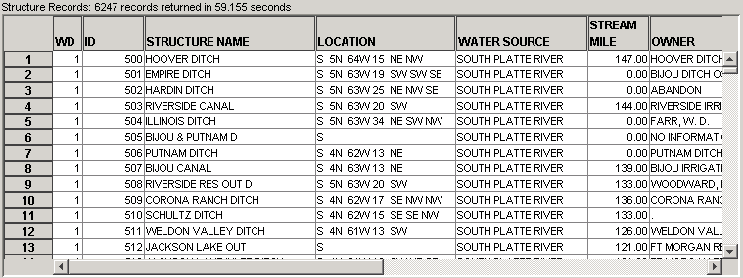
TabularList
Example Tabular List

Features of tabular lists are summarized below:

- Default widths for columns are set based on the contents of the column; however, the column widths can be changed by dragging the boundary between two columns.
- The contents of a column can be sorted by right-clicking on the column header and selecting Sort Ascending, Sort Descending, or Original Order. The sorts are performed alphabetically and numeric sorts are also performed based on alphabetic ordering of the number's digits. This limitation at times causes some columns to not sort properly because of the output format (e.g., blanks occurring at the beginning of a line).
- Long tabular lists typically are shown with a label indicating the total number of records. Most tabular lists include a column with the record number, to facilitate scrolling.
- To facilitate interaction with other software, most tabular lists allow copy and paste. To select all cells, press Ctrl-A. To select a single cell, use Ctrl-left-click. To select groups of cells, select one cell and then use Shift-left-click, or drag over several cells. To copy selected cells, use Ctrl-C or right-click on the worksheet and select Copy from the popup menu. The selected cells’ contents can then be pasted into other applications like Microsoft Excel. Currently, copy and paste is performed using text only and the resulting copy may need to be formatted in the receiving application.

3.3.4 Filters for Queries

Many queries provide choice-based input filters, as shown in the following figure:

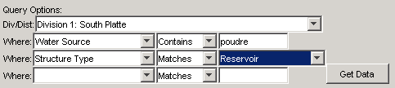
InputFilter
Filter Used to Limit Query

By default, all data will be returned. However, the filters can be used to restrict the query. Depending on the data being evaluated, a choice may be provided, or a value may need to be typed. If more than one filter is used, the query will be further restricted.

3.3.5 Tool Tips

In many cases, holding the mouse stationary over a graphical interface component for a few seconds will display useful information, as shown in the following example:

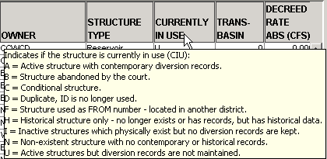
ToolTip
Example Tool Tip

3.4 File Menu – Open HydroBase, Display HydroBase Properties, Exit

The File menu provides standard input and output features as described below.

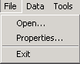
Menu_File
File Menu
3.4.1 Open HydroBase

The File…Open menu displays the Select HydroBase dialog, as previously discussed in Section 3.2 – Select HydroBase Dialog.

3.4.2 HydroBase Properties

The File...Properties menu displays properties for the HydroBase database, as shown in the following figure. The properties indicate the database server that is being used and the version of the database. This information is useful when diagnosing database problems or comparing differences between database contents.

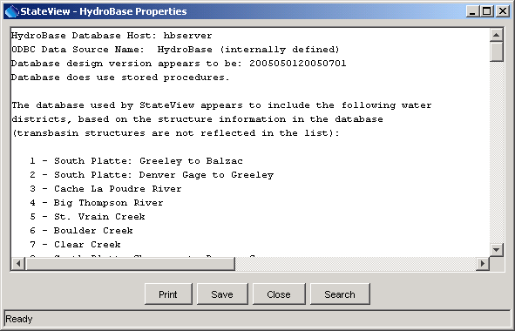
HydroBase_Properties
HydroBase Properties Dialog

3.4.3 Exit

The File...Exit menu exits StateView/CWRAT. You are given the option to cancel the exit. If you have changed display options and are logged in as someone other than guest, the settings will be saved in HydroBase for use in the next session.

3.5 Data Menu

The Data menu provides displays for most of the data in HydroBase, and is summarized below. See Chapter 4 – Viewing Data for more information.

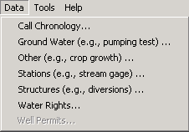
Menu_Data
Data Menu

3.5.1 Call Chronology

The Data…Call Chronology menu item displays river call data for active and previously set/released calls. The interface is similar to that available from the Administration…Edit Calls interface except that calls cannot be modified. Call data may only be available in the central databases (not on CD).

3.5.2 Ground Water

The Data… Ground Water menu item displays data related to ground water, including well levels and pumping tests. Ground water data are only available for basins where a CDSS ground water modeling effort has occurred.

3.5.3 Other

The Data…Other menu item displays data that do not fit into the other menus, primarily crop statistics and consumptive use information.

3.5.4 Stations

The Data…Stations menu item displays data for climate and streamflow stations, including time series data.

3.5.5 Structures

The Data…Structures menu item displays data for administered structures (diversions, reservoirs, instream flow locations, dams, and wells). All structures except dams have water rights. Multiple data views are available for structures, reflecting the variety of data available in HydroBase for structures. The water rights view can be accessed from structure displays.

3.5.6 Water Rights

The Data…Water Rights menu item displays water right transactions and net amounts. Water rights data can be viewed in raw form or can be formatted in standard reports.

3.5.7 Well Permits

The Data…Well Permits menu item displays well permit data. Because well permit data have traditionally only been available for a fee, the menu is only enabled when using a SQL Server database with a non-guest login.

3.6 Administration Menu

The Administration menu is available only in CWRAT, and provides water administration tools, as summarized below. The data editing features of administration tools allow saving data to HydroBase only when logged in as someone that has permission in a water district, as configured by the HydroBase database administrator. See Chapter 5 – Administration Tools for more information.

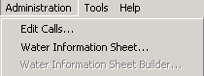
Menu_Administration
Administration Menu

3.6.1 Edit Calls Menu

The Administration…Edit Calls menu item displays the interface for setting and releasing river call information. After call information is saved to HydroBase, it can be viewed by other system users, including web site users.

3.6.2 Water Information Sheet Menu

The Administration…Water Information Sheet menu item displays the Water Information Sheet (WIS) interface, which provides a daily water administration worksheet. Water commissioners and others who administer data use WIS.

3.6.3 Water Information Sheet Builder

The Administration…Water Information Sheet Builder menu item displays the WIS builder tool, which allows WIS formats to be adjusted. This tool is used infrequently to adjust a WIS. It can also be used to edit the WIS diagram.

3.7 Tools Menu

The Tools menu provides useful tools, as summarized below. See Chapter 6 – Tools for more information

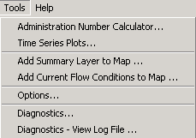
Menu_Tools
Tools Menu

3.7.1 Administration Number Calculator

The Tools…Administration Number Calculator menu item displays a dialog that converts between administration number and appropriation date.

3.7.2 Time Series Plots

The Tools…Time Series Plots menu item provides a general time series plotting tool that allows time series from other displays (e.g., stations and structures) to be dragged onto a configuration window to produce complex plots. Time series products can be saved in HydroBase for reuse at a later time. The TSTool software is also useful for displaying time series of different type and interval.

3.7.3 Add Summary Layer to Map

The Tools…Add Summary Layer to Map menu item provides a general tool that allows a delimited file to be used to create a summary map layer. For example, average historical flow conditions at stream gages can be displayed as bars on the map.

3.7.4 Add Current Flow Conditions to Map

The Tools…Add Current Flow Conditions to Map menu item displays current flow conditions on the map, using the streamflow gage layer for locations. This feature requires that HydroBase includes real-time streamflow data.

3.7.5 Options

The Tools…Options menu item displays options for configuring StateView/CWRAT.

3.7.6 Diagnostics

The Tools…Diagnostics menu item displays a dialog that controls diagnostics settings, which are used in troubleshooting. The Tools…Diagnostics – View Log File menu item displays the log file, allowing scrolling and searches.

3.8 Help Menu

The help menu displays the software version and support information.

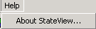
Menu_Help
Help Menu

3.8.1 About StateView/CWRAT

The Help…About StateView menu (and Help…About CWRAT menu for CWRAT) displays the program version number, as shown in the following figure. Indicate the version number when reporting problems or suggestions. StateView and CWRAT share most features and the software versions will be consistent.

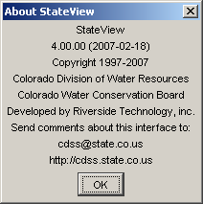
Help_AboutStateView
Help...About StateView Dialog

