5

Administration Tools
Version 03.06.05, 2005-08-05, Color, Acrobat Distiller

The CWRAT Administration menu provides access to water administration tools. This menu is not available in StateView.

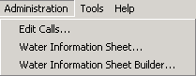
Menu_Administration
CWRAT Administration Menu

The following sections describe the features available for each menu item:

5.1 Edit Calls | Set and release calls and edit data for existing calls.
5.2 Water Information Sheets | Use existing Water Information Sheets for administration, and display stream network diagrams.
5.6 Water Information Sheet Builder | Create and modify Water Information Sheets and associated diagrams.

Earlier versions of CWRAT relied on local Microsoft Access databases to store real-time streamflow and administrative data. This information could then be synchronized with the central SQL Server database. Due to advances in network communications, administration performed with CWRAT should now occur using the central SQL Server database. The overall performance of this approach is better and simplifies the software tools.
5.1 Edit Calls

The Administration...Edit Calls menu allows river call data to be viewed and edited. The interface serves as a record-keeping mechanism for calls but currently does no analysis to help determine when calls should be placed. The viewing features are similar to those available from the Data...Call Chronology menu (the latter being non-editable). Users with a valid login and permissions for the water district of the call can edit the call data (guest users are not allowed to edit calls).

The following figure illustrates the Edit Calls interface.

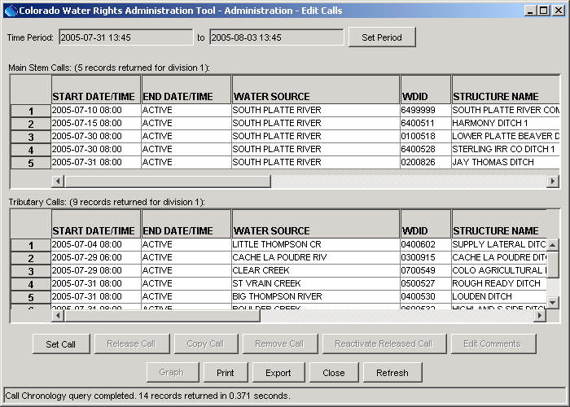
Admin_EditCalls
Edit Calls Interface

The calls that are initially displayed have been active during the display period listed at the top of the window. The period shown defaults to the period set in the Tools...Options...Time Period settings. The calls are divided into Main Stem Calls (those occurring on streams that are not a tributary) and Tributary Calls. Recent calls are listed at the top of each list. The following sections describe how to set and release calls. Use the Refresh button to requery the database without setting the period (e.g., use this feature when others may have set calls after the current session has started).

5.1.1 Setting a Call

To set a new call, first press the Set Call button on the bottom of the Edit Calls interface, which will display a view as illustrated in the following figure.

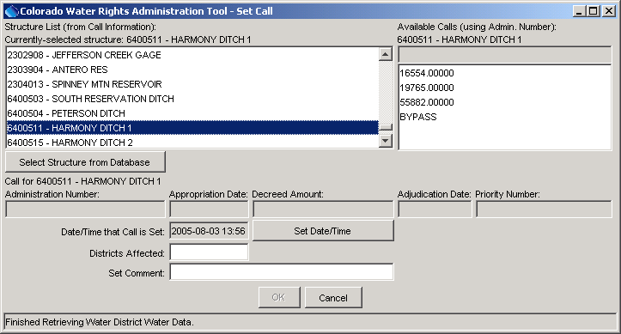
Admin_EditCalls_SetCall_StructureBlank
Set Call Dialog - Before Entering Call

Calls are set by first selecting a structure using its water district identifier (WDID) and then selecting a net amount water right for the structure. The first structure in the list will be selected by default. Because there are a large number of structures in the HydroBase database, it is difficult to provide a selectable list containing all structures. Additionally, only structures that are actually administered need to be listed. Consequently, the list of structures that is initially displayed is generated either from available Water Information Sheets or previous calls (see the Tools...Options...Administration settings to control which method is used by default). If the desired structure is not in the list, press the Select Structure from Database button to make a general database query, which will display the Structure Data view as described in Section 4.5 – when done selecting a single structure, press OK and the structure will be added to the Structure List as shown in the above figure.

To set a call for a structure using the Set Call interface:

- Select the calling structure’s name from the Structure List. As discussed above, the list of structures can be listed from available WIS, previous calls, or from a HydroBase query. The structures are sorted by water district identifier. You can also right-click on the list and select Find Structure to display a search dialog for the list, as shown in the following figure.

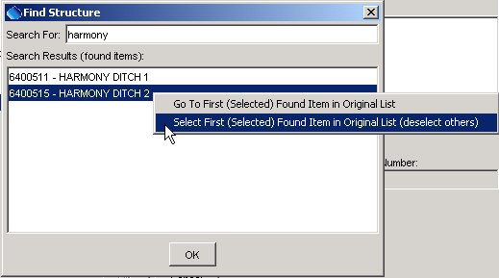
Admin_EditCalls_SetCall_FindStructure
Find Structure Dialog

To use the search dialog, enter a string in the Search For text field and press the Enter key. All matching structures in the structure list will be listed in the search dialog. To select a structure in the original list, select the structure in the Find Structure dialog, then right-click on the list and indicate to select the first found item in the original list. The item will be selected in the original list as if you had selected it directly. Press OK to close the Find Structure dialog. The currently selected structure will be indicated with a label above the Structure List.

- Based on the structure that is selected, a list of all the available water rights for the structure will be displayed (see Available Calls in the Set Call interface). The list is sorted in ascending order. The content of the list is set by the Tools...Options...General settings and can be the administration number, appropriation date, decree amount, adjudication date, or priority number. When a calling right is selected, all of the values related to the call are displayed in the center of the Set Call interface.

- Set the Date/Time that Call is Set for the call to start (defaults to the current time) using the Set Date/Time button.

- List the Districts Affected, separated by commas. You must enter these manually (the list is not automatically generated).

- Enter a Set Comment, if desired. The completed call information in the Set Call window will look similar to that shown in the following figure.

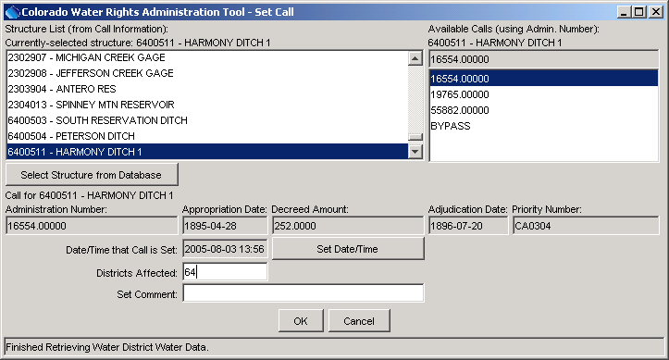
Admin_EditCalls_SetCall_Complete
Completed Call Data

- Press the OK button to set the call. The call will then by listed in the Edit Calls screen. The call will be available for viewing by other system users.

Setting a Bypass Call

Bypass calls are used in Division 1 and involve using water rights for a secondary structure. The procedure for setting a bypass call is as follows:

- Select the calling structure’s name from the Structure List, as described above. This will display the available rights for the structure in the Available Calls list.
- Rather than selecting a water right for the structure, select BYPASS under the Available Calls. This will display a window similar to the following:

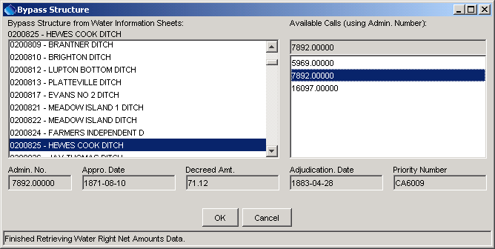
Admin_EditCalls_SetCall_BypassStructure
Selecting the Bypass Structure and Associated Calling Right

- The list of bypass structures is determined by listing structures in water information sheets. Select the bypass structure and the water right to use for the call and then press OK. The bypass structure will be indicated in the Set Comment for the call, as shown in the following figure. The Set Comment is used later when copying calls; therefore, any additional comments should be added at the end of the default comment. Note that the information in the lower part of the Set Call window is labeled as being related to the bypass structure.

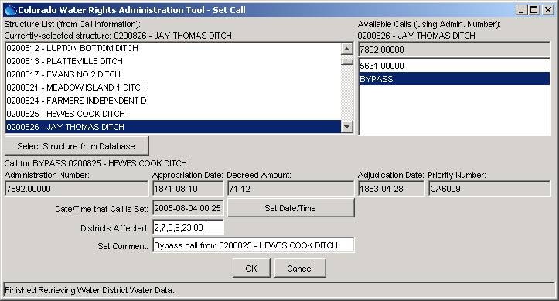
Admin_EditCalls_SetCall_Bypass
Final Bypass Call Information
- Press OK to set the bypass call.
5.1.2 Releasing a Call

A call is released when the conditions for the call no longer apply and therefore the call is no longer needed. Releasing a call releases the call in the database but does not delete it from the database. A call that has been released can be reactivated (discussed in subsequent section). To release a call:

- Select the desired call from the Main Stem Calls or Tributary Calls list in the Edit Calls interface and press the Release Call button. This displays the dialog similar to the following:

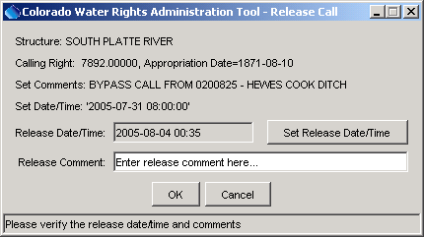
Admin_EditCalls_ReleaseCall
Release Call Dialog

- If appropriate, edit the Release Date/Time.
- If appropriate, enter a Release Comment.
- Press the OK button. The main Edit Calls display will be updated to reflect the release.

5.1.3 Removing a Call

In cases where a call was set by mistake, it can be removed by selecting the call in the Edit Calls window and pressing the Remove Call button. The following figure shows the warning that is issued before the call is removed.

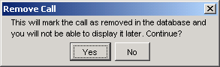
Admin_EditCalls_RemoveCall
Warning Issued when Removing a Call

To confirm the delete, press the OK button. The main Edit Calls display will be updated to reflect the removal of the call.

5.1.4 Reactivating a Released Call

To reactivate a released call, select the call in the Edit Calls window and press the Reactivate Released Call button, which will display the following dialog:

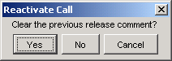
Admin_EditCalls_ReactivateCall
Reactivating a Released Call

This dialog provides the choice of retaining the original release comment or clearing it so that a new release comment can be added later. You may need to change the time period in the Edit Calls window to be able to see the call.

5.1.5 Editing a Call’s Comments

Call comments may need to be edited if the information for the call has changed. To edit call comments, select a call in the main Edit Calls window and press the Edit Call Comments button. A dialog similar to the following will be shown:

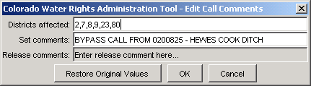
Admin_EditCalls_EditComments
Editing Call Comments

Press OK to save edits, or Cancel to cancel the edit. The Restore Original Values button can be used to restore the original comment information, if an error was made in the dialog.

5.1.6 Copying a Call

To streamline setting calls, previous calls can be copied. To copy a call:

- Select a call in the main Edit Calls window and press Copy Call. The Set Call window will then be displayed with the same information as the original call, with the Set Date being the current date/time. If the original call was a bypass call, the labels in the Set Call window will display the bypass structure and right.
- Edit the call information as desired and press OK to set the call. The main Edit Calls window will be updated to reflect the change.

5.1.7 Graphing Calls

Calls can be graphed to see when calls are on/off over a time period. See Section 4.1 - Call Chronology for more information.

5.1.8 Displaying Calls on the WIS Diagram

Calls that are set can be displayed on a diagram representation of the river system. To do so, use the Administration…Water Information Sheet menu, select an appropriate WIS, and then use the Display Diagram button – see Section 5.2.2 – WIS Diagram. Note that this feature can be used even if daily data in the WIS are not actively being maintained (although the format of the WIS must be reasonably accurate).

5.2 Water Information Sheet

The WIS (Water Information Sheet) is a useful administration tool in CWRAT. Using the WIS, you can submit or view vital information regarding the condition of the river. Before loading a WIS, the format of the WIS must be defined (see Section 5.3 - Water Information Sheet Builder for a complete discussion of WIS capabilities). Water information sheets are typically defined by State of Colorado staff familiar with the WIS Builder.

Once a WIS has been built, load it using the Administration...Water Information Sheet menu, which will display a selection dialog as shown in the following figure.

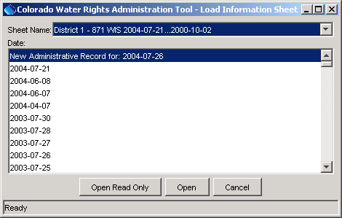
Admin_WIS_Load
Load Information Sheet Dialog

The Sheet Name choice lists available WIS. The first part of each choice is the sheet name. The number of sheets that have been saved and the period for the saves is also shown. This gives an indication of the amount of data that are available for viewing, including graphing of decisions over time.

Typically, water commissioner information in HydroBase is configured to allow a water commissioner to edit administrative data only for districts for which they are responsible. However, WIS can be viewed (not edited) by all CWRAT users.

To load a WIS, select a Sheet Name from the drop-down list. The list of administrative dates available for the selected sheet name will be shown. Select an administrative Date, which is the date for which the data applies (selecting a new sheet name will refresh the list of administrative dates), and press:

- Open Read Only – to view the WIS but not be able make changes. This is useful when an old sheet needs to be reviewed in order to make current administrative decisions.
- Open – to load the WIS for full functionality.

If a sheet is not saved for the current date, you have the option of loading a sheet that will be treated as a new administrative record (as shown in the above figure). When a new administrative record date is selected, the sheet will initially be filled with data from the previous sheet, regardless of the amount of time that has passed since a WIS was previously saved. A sheet for a previous date can be selected and then archived with a new date (e.g., when setting information for weekends). During the week, sheets will normally be edited for a new administration record. Only one sheet per day can be saved – the last sheet saved for the day will remain in the database.

Once a sheet and date are selected, the WIS will be displayed as shown in the following figure.

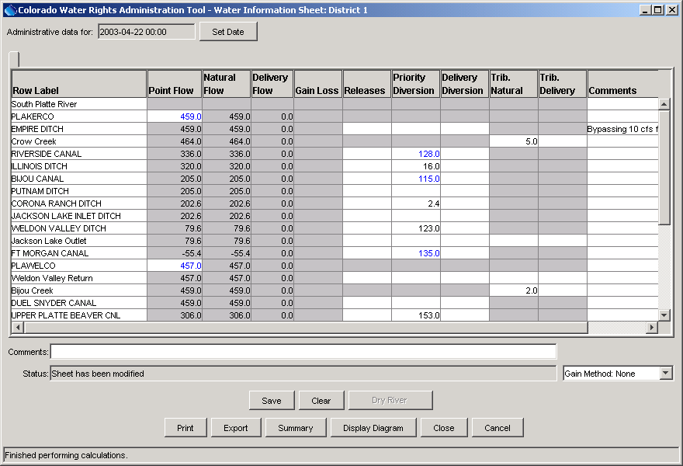
Admin_WIS_Initial
Water Information Sheet after Loading

Each tributary (or stream) is represented by rows on the sheet and links between streams can be made. See Section 5.3 – Water Information Sheet Builder for more information about configuring sheets.

If the sheet has never been used, it will be blank and/or contain zeros. If a previous archive exists, then the sheet will display the previous data values, with current data imports superimposed in the appropriate cells. During normal operation, the previous sheet's values will be carried forward to the current sheet, minimizing the need for data entry.
WIS cell formats are as follows:

Gray Cell |  | Contents are view-only and have their values computed automatically.
blue contents |  | Real-time flow data imported according to the import definition in the WIS builder (some gaged diversions are also imported). Blue cells change to black after initial computations are complete. You can enter values in any of the white cells, and can override imported values if desired (for example, if a real-time stream gage value is inaccurate, a different value can be entered).
red contents |  | Cell is computed based on a formula, as defined in the WIS builder. You can enter values in any of the white cells.
black contents |  | When initially loaded, cells with black contents are carried forward from a previous sheet. After the WIS is computed, black contents in gray cells are computed. Values in white cells can be entered.

WIS columns are described in the following table.

WIS Columns (left to right)

WIS Row | Description
Row Label | A (generally) verbose row label. If the row is a structure or station from HydroBase, the label is the station/structure name. Otherwise, the label is defined in the WIS Builder.
Point Flow | The point flow on the river. The point flow is determined by one of the following methods:  - imported from a stream gage  - computed as the upstream point flow + Gain/Loss + Trib. Natural + Trib. Delivery + Releases – Priority Diversions – Delivery Diversions  The point flow also is the sum of Natural Flow and Delivery Flow.
Natural Flow | The portion of the point flow that has not been allocated to human use. It is free river water (other than it is can be checked against minimum flow requirements). This is either set with a formula (defined in the WIS Builder) or is computed as Point Flow – Delivery Flow.
Delivery Flow | The portion of the point flow that is allocated to human use. For the most upstream node in a tributary, it is determined as:  - user-supplied (enter a user-supplied value in the releases column), or  - define a formula using the WIS Builder  For other nodes, it is the upstream point’s Delivery Flow + Trib. Delivery + Releases – Delivery Diversion.
Gain Loss | The gain or loss that occurs from the upstream point on the stream. It is computed as the gain/loss between base (gaged) flow locations on the reach, prorated by stream mile or weight, depending on the gain method that is used (selected in the lower right of the Water Information Sheet window).
Releases | A release made at the structure (typically only for reservoirs or to set the initial flow at the top of a tributary).
Priority Diversion | A priority diversion, which subtracts from the natural flow.
Delivery Diversion | A delivery diversion, which subtracts from the delivery flow.
Trib. Natural | For confluence rows (defined in the WIS Builder), this is the natural flow that is contributed from the upstream tributary.
Trib. Delivery | For confluence rows (defined in the WIS Builder), this is the delivery flow that is contributed from the upstream tributary.
Comments | Comments for the row (e.g., to explain an administrative decision).

Flow values shown in rows are immediately downstream of the point for the row. For streamflow gage rows, this is essentially the value at the gage. For rows that have diversions or releases, the flow is that after the diversions and releases have been accounted for.

Additional information about the Water Information Sheet interface is listed below, from top to bottom and left to right in the interface:

Administrative data for  (top of window) | Sets the date for which the WIS applies. To save sheets for the weekend, load a previous sheet and then save using the date that corresponds to the weekend day.
Comments  (below worksheet) | Comments that apply to the entire sheet (comments can also be set for each row).
Status  (below comments) | Indicates whether the sheet has been modified, which will be the case if editing a new sheet or when an existing sheet is loaded and edited.
Gain Method  (below comments) | Indicates the gain method to be used when calculating the cell contents. The following options are available:
Gain Method  (below comments) | None | Flows between points are essentially carried forward with no adjustment for the overall gain/loss between known point flows (stream gages). This method is the simplest.
Gain Method  (below comments) | Stream Mile | Gain/loss between known point flows (stream gages) is distributed based on the stream mile of the points. This method is not often utilized because the stream mile for all points is not typically known.
Gain Method  (below comments) | Weights | Gain/loss between known point flows (stream gages) is distrubuted based on a simple proration factors defined in the WIS Builder. This method allows hydrologic conditions of the basin to be recognized in each stream reach.
Save | Save the current sheet contents. The sheet is automatically recomputed before saving. You will be warned if the archive date is in the past or the future. You will also be warned if negative flow values are detected. You should consider correcting negative flow values because they indicate a problem with water balance. Negative flows may be the result of the gain method (see above).
Clear | Clear all the cell contents. This action is used primarily during development and is typically not used by water commissioners. You will be prompted to verify the clear.
Dry River | The Dry River button will be highlighted if you have selected a row that is of type Diversion, Reservoir, Minimum Flow or Other. If you press this button on a selected row, the Point Flow is set to zero and is labeled as "DRY". The row is then treated as a known point flow row (similar to a stream gage) during subsequent computations. If a dry row is selected, the button will change to UN-Dry River and you have the option of restoring the original condition. You can select multiple dry rows in a stream reach in which case the point flow is interpolated between the dry points. The effects of gains and losses in a reach may result in negative flows when dry rows are used. It is your responsibility to adjust for negative flows before archiving the sheet.
Print | Print a text version of the WIS.
Export | Export the WIS to a file, in either text or HTML formats.
Summary | Similar report as the Export but includes a diversion coding summary at the bottom.
Display Diagram | Display a diagram of the basin (see Section 5.2.2 – WIS Diagram for more information)
Close | Close the WIS. You will be prompted to determine if you want to save the sheet.
Cancel | Close the WIS without saving changes.

5.2.1 Displaying WIS Cell Attributes

To display a WIS cell’s attributes, right-click on the cell (if necessary, first select the cell with the left mouse button). This results in a dialog similar to that shown in the following figure.

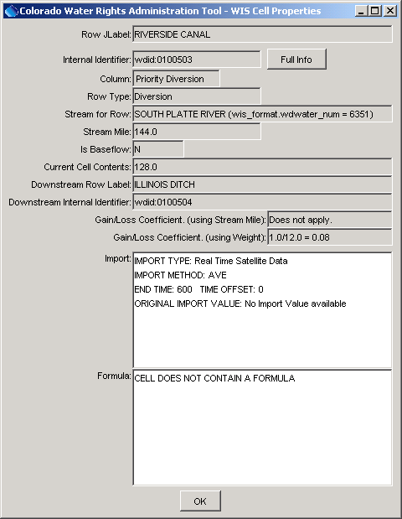
Admin_WIS_CellProps
WIS Cell Properties Dialog

The information that is shown is consistent with the cell properties shown by the WIS Builder.

5.2.2 WIS Diagram

The WIS Diagram is a simple schematic representation of the basin that is described by the WIS and is displayed using the Display Diagram button on the main WIS window. A sample diagram is shown below:

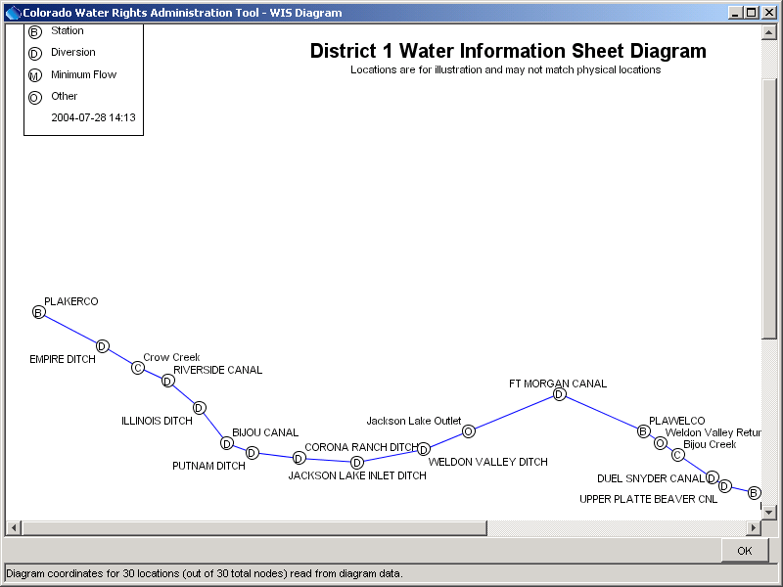
Admin_WIS_Diagram
WIS Diagram for District 1

The layout of the river system is not meant to match traditional line diagrams or physical locations. The layout is configured in the WIS Builder to allow display of location names and other information, without information overwriting itself. The basic display provides a visual representation of the order of the river, in order to better understand data values shown in the WIS.

Right-clicking on the diagram displays a menu with the following choices:

Show Flow Data |  | Label the diagram with point flows from the WIS.
Show Calls |  | Label the diagram with calls, as of the time of the WIS.
Show Rights |  | Label the diagram with water rights for structures in the WIS.
Print on Letter in Landscape |  | Print the diagram as shown, on letter-sized paper, in landscape orientation.
The following figure illustrates an example of the WIS Diagram showing point flows and calls:

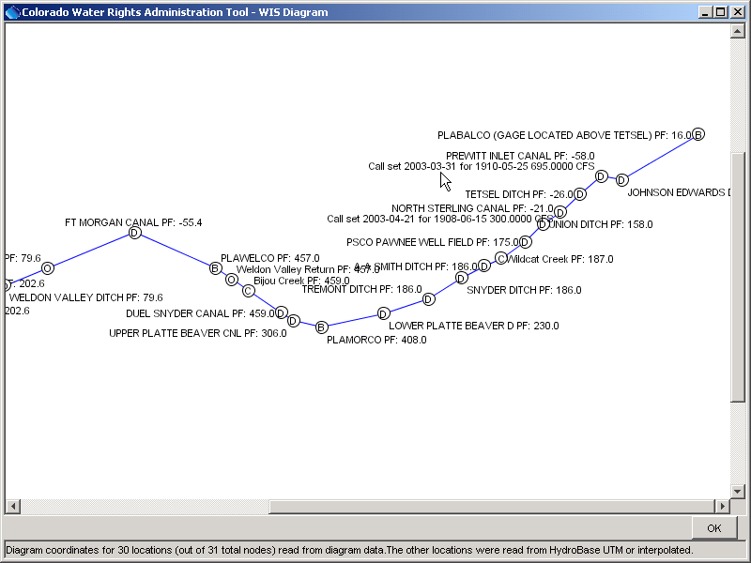
Admin_WIS_DiagramLabelled
District 1 WIS Diagram with Point Flows and Calls

The above figure illustrates that it is difficult to fully control the display of labels so that they do not overwrite (displaying rights adds additional labels to the diagram). The intent of the WIS Diagram is not to provide publication-quality graphics but to present data in a concise and reasonable layout. If necessary, the WIS Builder can be used to fine-tune the diagram representation.

WIS Diagram data are stored in the HydroBase database. Consequently, any user that is able to display a WIS can also view the diagram. Additionally, it is not a requirement to have actively-maintained WIS to use the diagram. If a WIS is defined for a water district and minimal configuration has been done to import real-time gage values, then a diagram can be shown to display the real-time point flow values. Calls that have been set with the Administration…Edit Calls interface will also be shown, even if the WIS is not actively maintained. Consequently, the WIS Diagram is a useful tool for viewing administrative data in a spatial representation.

5.2.3 Graphing Cell Contents

Any data cell in a Water Information Sheet can be graphed, as follows:

- Left-click in the cell to select the cell. Only data cells (cells with numerical information) can be graphed.
- Right-click in the cell to show the popup menu and select the Graph menu item. All of the available data period for the cell will be used to create a graph, similar to the following (graphing from an old WIS may show data after the WIS was saved):

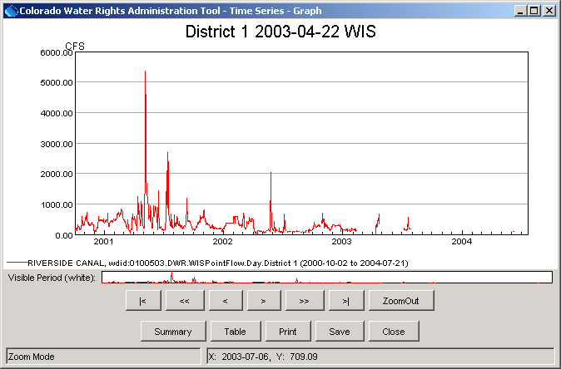
Admin_WIS_Graph1
Graph of Natural Flow Column for a WIS

- Interact with the graph as described in the TSView Time Series Viewing Tools appendix. For example, use the Table and Summary buttons to view different data formats. The data can also be saved in DateValue format, for import into a spreadsheet or other tool.

It is also possible to graph all of the data for a row. To do so, select the row by clicking on the Row Label column. Then follow steps 2 and 3 above.

Using the above approach, there is currently no way to create a graph with cells from different rows. The TSTool software will allow data from different WIS cells to be graphed on the same page.

5.2.4 Diversion Coding

Diversion coding indicates the diversion records for a structure, including the water source (e.g., Natural Stream Flow), the structure from which the water is taken (e.g., a reservoir water district identifier), water use (e.g., irrigation), and type (e.g., Released to River), collectively known as SFUT (Source, From, Use, Type). See the State of Colorado’s Water Commissioner Manual for more information. The WIS can be used to perform diversion coding so that electronic diversion records are available for review in the winter off-season (when diversion records are transferred from water commissioners to the Denver offices and are entered in HydroBase as official diversion records). WIS diversion coding data are not saved in HydroBase in the same data tables as official diversion coding records and therefore do not take the place of official records – the WIS diversion coding values are meant as a data entry and verification aid. Because diversion coding is a somewhat laborious process, the WIS tool tries to help by using carry-forward logic, similar to the WIS data values. Diversion coding using the WIS is an optional activity and is turned on using the Tools...Options...Administration menu.

WIS diversion coding saves the SFUT information for each appropriate cell, using a convention similar to normal SFUT diversion coding conventions. The specific data that are saved are explained below.

The following steps are executed when using the diversion coding features.

- When a WIS is loaded, WIS diversion coding records are queried from the database. For each structure, a query is executed to determine the nearest previous date when diversion coding was entered. If data are found on the WIS's date, then the observation flags are left as is. If data are found on an earlier date, then the data values are used but the observation flags are set to C to indicate that the data are being carried forward. The first time that a WIS is loaded with diversion coding turned on, a warning like the following will be displayed:

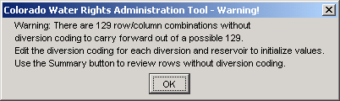
Admin_WIS_DivCoding_Warning
WIS Load Warning when Diversion Coding is Enabled

The above warning indicates that the carry-forward procedure used by the diversion coding logic cannot be completed because there were no previous diversion coding values to carry forward. Once initial values are entered, the warning should not appear. Use the Summary feature of the Water Information Sheet interface to list cells that do not have diversion coding.

- Edit diversion coding information by first left-clicking on a white cell for Priority Diversion, or Delivery Diversion. Then select the Diversion Coding item in the popup menu. This will display a dialog similar to the following.

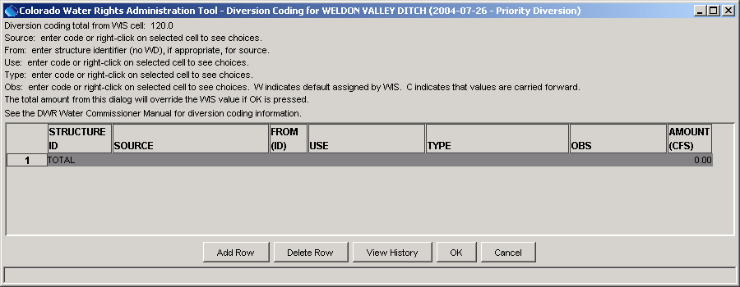
Admin_WIS_DivCoding_Blank
Example Diversion Coding Dialog with No Data

The above example illustrates the case where previous diversion coding data for the structure are not available. In this case, you must enter the diversion coding that will be used until changed. In cases where diversion coding records are available (either because they were previously entered for the date or because they are being carried forward), those records will be displayed. To enter diversion coding values, first add a row using Add Row and then left-click in a cell to be edited. Select appropriate values from available choices or type in values where choices are not available (see the Water Commissioner Manual for more information). The Obs flag indicates whether the diversion value is observed by a water commissioner (*), is user-supplied (U) or is carried forward (C). If any value is changed from its original value and the Obs flag is C, then the Obs flag is automatically changed to *. If a record is added or deleted, the observation flag is automatically changed from C to *, if necessary. The flag should be verified because U might be the correct flag. See also Section 5.2.5 – Diversion Coding when Previous Coding Exists for an explanation of the W flag, which the WIS will use in some cases.

- Press the OK button in the Diversion Coding dialog to save the diversion coding information to the Water Information Sheet. This does not save the information to HydroBase (see below for that step). Press the Cancel button to ignore changes that you made in the Diversion Coding dialog. When diversion coding information is saved with OK, the following occurs:

- the total amount from the Diversion Coding dialog is entered in the WIS in the appropriate cell,
- the diversion coding records from the Diversion Coding dialog replace those that were initially read and will consequently be saved if the WIS is saved.

- When the Water Information Sheet Save button is pressed (or Close with a confirmation to save), the diversion coding records are saved to HydroBase.

Note that if you re-edit a WIS from a previous date, the changes that are made in that sheet do not automatically propagate to later sheets. Consequently, later values that indicate a carry-forward Obs flag of C will not agree with values that are edited (the C flag will not be accurate). However, no feature is currently in place to propagate a change forward in time as this would likely compromise the validity of decisions made when those sheets were saved.

5.2.5 Diversion Coding when Previous Coding Exists

When diversion coding has been enabled in a WIS, it may be difficult to consistently edit the coding for every cell. Consequently, default behavior has been implemented to streamline diversion coding.

If a cell value in the main sheet is changed, the associated diversion coding records (if available), are changed as follows:

- If the cell has a single diversion coding SFUT combination, then the total value for the record is immediately updated to the value in the main WIS and the observation flag is set to *. Opening the Diversion Coding dialog will display the new total value and observation flag. The Diversion Coding dialog must be used if the observation flag should be set to something other than *.

- If the cell has multiple diversion coding SFUT combinations, no immediate action is taken to adjust the associated diversion coding records. Ideally the Diversion Coding dialog should be used for the cell to enter SFUT combinations that add to the total in the main display (note that if the Diversion Coding dialog is used, the total is always transferred back to the WIS). However, if the diversion coding is not entered, then when the WIS is saved, a diversion coding record will be saved with empty SFUT values and an observation flag of W, indicating that unknown diversion coding has occurred and the WIS is making an assumption. This case will be carried forward in future WIS (the W flag will be changed to C in future records). A warning is printed before the save to allow you to enter diversion coding for cells where default SFUT has been assumed.

In most cases, diversion coding will consist of a single SFUT record and no assumptions will need to be made by the WIS. In cases where multiple SFUT combinations are used, it will generally be best to edit the diversion amount using the diversion coding interface, rather than by only entering a total in the main WIS.

In summary, using the diversion coding feature allows more detail to be recorded about administrative decisions. However, it also adds additional data entry requirements. The carry-forward logic that has been implemented ideally minimizes the day to day data entry requirements.

5.2.6 Examples of WIS Use

A water commissioner typically uses the WIS as follows:

- Login to CWRAT using the HydroBase login.
- Load the WIS for the region of interest (typically a water district) using the Administration...Water Information Sheet menu. Typically a new administrative record is used, which carries forward the previously WIS values.
- Real-time data (e.g., streamflow gage point flows) are reviewed, and if necessary, corrected. This may also involve using the Data…Stations interface or previously configured time series plots to view real-time streamflow hydrographs.
- Administrative data (e.g., release, diversion, delivery flows) are reviewed and are updated as appropriate. If appropriate, use the Dry River feature. If enable, use the diversion coding feature to enter detailed diversion record information.
- Display the WIS Diagram to review overall basin flows and calls.
- When satisfied, save the sheet using the Save (or Close) buttons.

The use of gain/loss information is the main option that can be exercised when using Water Information Sheets. The following examples illustrate features of the WIS using actual data.

The following example uses no gain method (gain method: None), in which the gain or loss between known point flows is not computed.

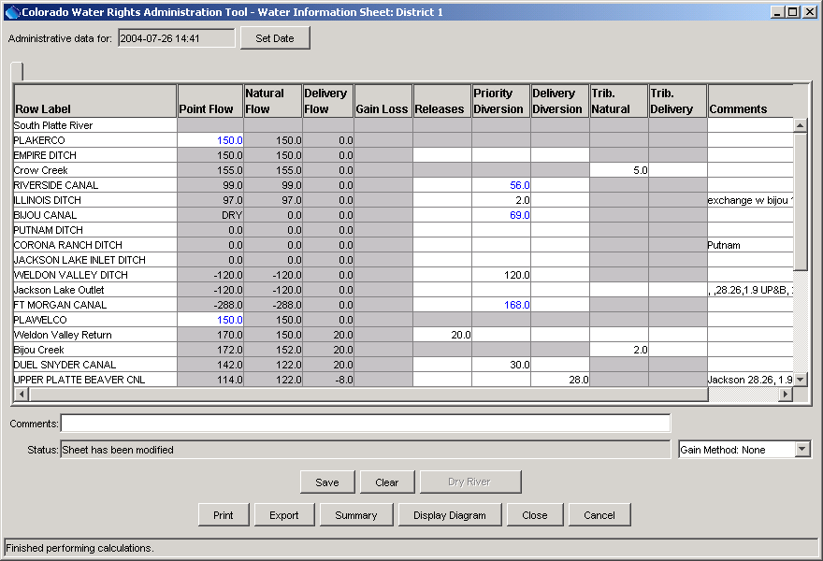
Admin_WIS_Gains_None
Example WIS Using Gain Method "None"

The above figure illustrates a WIS that does not use gains. Consequently, if no diversion, release, or confluence occurs, flows are just carried forward from one row to the next. Note that negative flows may result because losses are not distributed in this approach.
The following example uses the weights gain method, in which the gain or loss between known point flows is distributed using a simple weighting method, as illustrated by the constant value in the Gain Loss column.

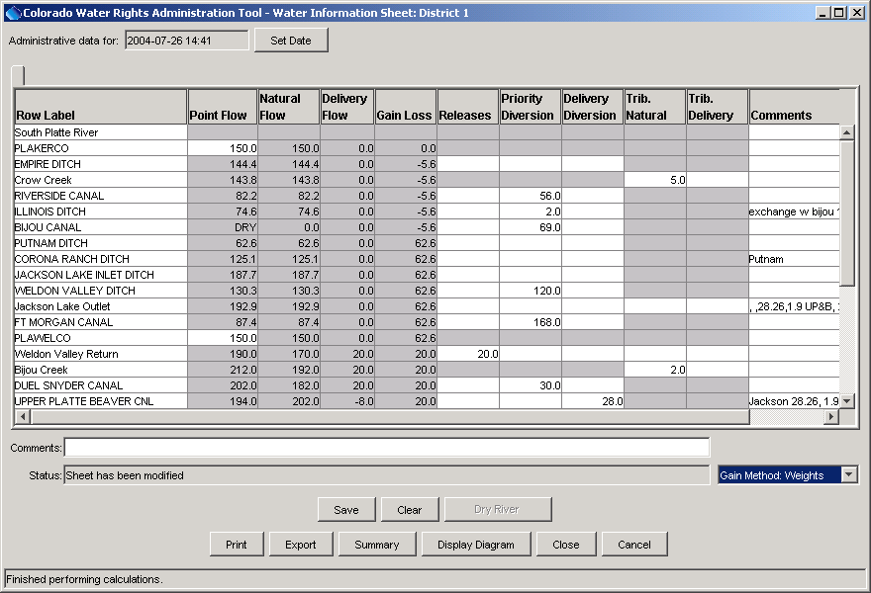
Admin_WIS_Gains_Weights
Example WIS Using Gain Method "Weights"

Because a gain or loss can occur between each point in the stream, the point flow values are adjusted at each point, even if no diversions, releases, or confluences occur. Consequently, negative flow shown in the previous example are removed.
The following example illustrates the Dry River feature (see the UNION DITCH and TETSEL DITCH rows), which essentially sets the known point flow to zero at the specified location(s).

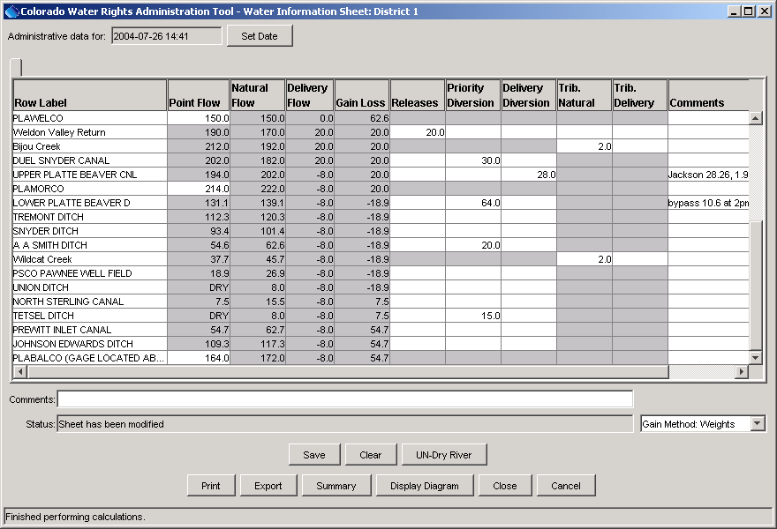
Admin_WIS_DryRiver
WIS Illustrating Dry River Feature

The Dry River feature influences how the gain/loss is computed in a reach because it introduces new known point flow locations in a stream. In the above example, the weights gain method is used and therefore negative point flows are minimized.
5.3 Water Information Sheet Builder

The WIS Builder provides tools to build or edit a Water Information Sheet and is intended for infrequent use. A WIS must first be built in order to populate the operational WIS with data and allow curtailment, depletion, and point flow analyses to be performed (see Section 5.2 – Water Information Sheet for information about the operational WIS).

Important: The WIS Builder relies on information in HydroBase in order to build a sheet. In particular, water sources for structures are used to form lists of structures on a stream and stream tributary information is used to help indicate how confluences should be treated. HydroBase data are not always accurate or complete. Consequently, the WIS Builder provides several ways to specify some information. Additional quality control of HydroBase location data and enhancements to the WIS Builder will improve are occurring to improve overall functionality.

The WIS Builder is displayed using the Administration...Water Information Sheet Builder menu item. The initial dialog as shown below prompts you to select a WIS sheet name.
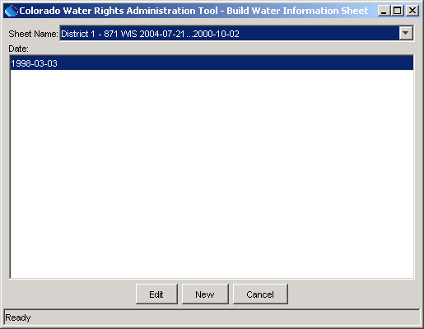
Admin_WISBuilder_Load
Build Water Information Sheet – WIS Selector

A list of existing sheet names is displayed, and the archive dates for the selected sheet formats are displayed.

The following options are available when loading a sheet:

Edit |  | Select an existing sheet name and date, and Edit. The edited sheet can be saved with a new date and optionally a different name. See subsequent sections for information about editing the sheet. Most water districts have had baseline sheets created and can be modified if necessary.
New |  | Select New to create a new blank sheet. You are first prompted for main sheet information, as shown below.  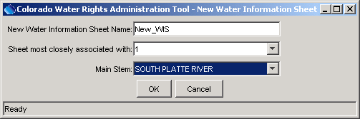  Admin_WISBuilder_New  Enter appropriate information and then press OK. Then refer to subsequent sections for how to add information to the sheet. It is important that the first row added to the sheet is a Stream row.

When creating a new sheet or editing an existing sheet, the WIS Builder interface will be displayed, as shown in the following figure (this example is for an existing sheet).

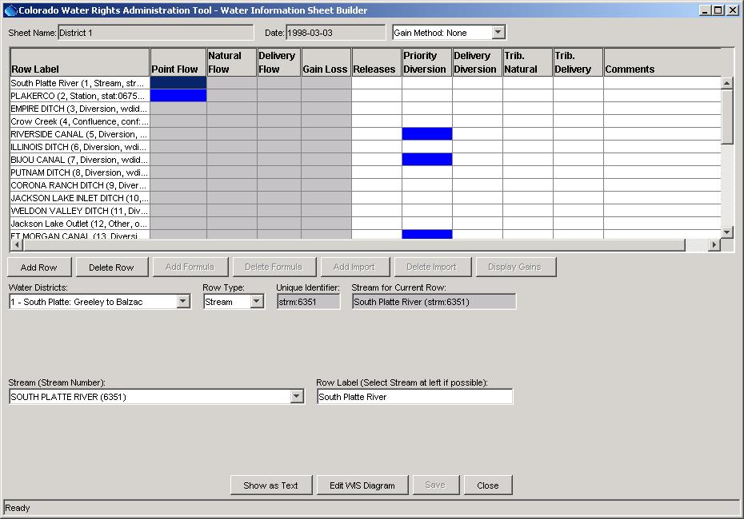
Admin_WISBuilder_Initial
Water Information Sheet Builder after Loading a WIS

When a new row is added, the information on the bottom of the display should be filled out appropriately for the row. In most cases, this consists of making simple selections from choices but in some cases (e.g., when data from HydroBase are incorrect or unavailable), additional information may need to be entered.

The following sections describe the components of a Water Information Sheet and the builder.
5.3.1 WIS Format Description

The WIS Builder displays rows and columns similar to a spreadsheet; however, the columns have been pre-selected (and are fixed) and the rows correspond to stations and structures that have data in the HydroBase database. Special rows used for managing the sheet are also available. The WIS is not a full-featured spreadsheet like Microsoft Excel, although it has many features like a spreadsheet. The rows and columns of the sheet (along with formulae and imports, as discussed in subsequent sections) describe the format of the sheet. This format can be reused each day as new data are entered. Changing the WIS format changes the nature of the sheet. Each row has a row label that is typically a structure, stream, or station name. The streams that are entered in the sheet should be entered upstream to downstream, with each tributary’s rows grouped together. The WIS row types are as shown in the following table.

WIS Row Types

Row Type | Description
Confluence | A point where tributaries meet.
Diversion | A diversion structure.
MinFlow | A minimum flow point (at this time, minimum flow reaches are not fully implemented – only a minimum flow point is enabled).
Other | A point used as a base flow node for computations.
Reservoir | A reservoir structure.
Station | A streamflow station, possibly with real-time data.
Stream | Indicates the top of a stream reach (used to keep track of streams). A stream must always be present in the sheet.
String | A row that only has a label but which can contain formulas.

The WIS columns are described in the following table.

WIS Columns (left to right)

WIS Row | Description
Row Label | A (generally) verbose row label. If the row is a structure or station from HydroBase, the label is the station/structure name. Otherwise, the label is defined in the WIS Builder.
Point Flow | The point flow on the river. The point flow is determined by one of the following methods:  - imported from a stream gage  - computed as the upstream point flow + Gain/Loss + Trib. Natural + Trib. Delivery + Releases – Priority Diversions – Delivery Diversions  The point flow also is the sum of Natural Flow and Delivery Flow.
Natural Flow | The portion of the point flow that has not been allocated to human use. It is free river water (other than it is can be checked against minimum flow requirements). This is either set with a formula (defined in the WIS Builder) or is computed as Point Flow – Delivery Flow.
Delivery Flow | The portion of the point flow that is allocated to human use. For the most upstream node in a tributary, it is determined as:  - user-supplied (enter a user-supplied value in the releases column), or  - define a formula using the WIS Builder  For other nodes, it is the upstream point’s Delivery Flow + Trib. Delivery + Releases – Delivery Diversion.
Gain Loss | The gain or loss that occurs from the upstream point on the stream. It is computed as the gain/loss between base flow nodes on the reach, prorated by stream mile or weight, depending on the gain method that is used (selected in the lower right of the Water Information Sheet window).
Releases | A release made at the structure (typically only for reservoirs or to set the initial flow at the top of a tributary).
Priority Diversion | A priority diversion, which subtracts from the natural flow.
Delivery Diversion | A delivery diversion, which subtracts from the delivery flow.
Trib. Natural | For confluence rows (defined in the WIS Builder), this is the natural flow that is contributed from the upstream tributary.
Trib. Delivery | For confluence rows (defined in the WIS Builder), this is the delivery flow that is contributed from the upstream tributary.
Comments | Comments for the row (e.g., to explain an administrative decision).

Flow values shown in rows are immediately downstream of the point for the row. For streamflow gage rows, this is essentially the value at the gage. For rows that have diversions or releases, the flow is that after the diversions and releases have been accounted for.

Once a WIS has been loaded, information about the row can be displayed and edited by selecting the row. The information for the row is displayed at the bottom of the WIS Builder.
5.3.2 The Stream Network

The rows of the WIS, along with some behind-the-scenes data, allow rows in the WIS to be represented as nodes in a stream network. Being able to represent the WIS as a stream network allows efficient traversal of the data for computations and output. The Show as Text button at the bottom of the WIS Builder displays the network in a text fashion, as illustrated in the following figure.
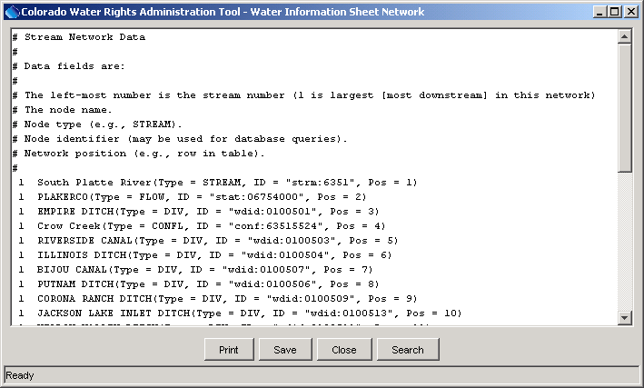
Admin_WISBuilder_Network
WIS River Network

The stream network display illustrates how tributaries join each other and eventually meet with the main stem. Some of the information in this interface is for developers. The numbers on the left indicate the tributary level, with one being the most downstream (main stem) and the highest number being the most removed from the main steam. Indentations are used as appropriate to reinforce the stream ordering concept. See also Section 5.3.7 – WIS Diagram for information about the graphical network display.

The relationship of the rows (nodes) to each other is currently controlled by a stream table in the database. Base flow nodes are known flow points, rather than being computed from water passed from upstream. In the WIS, base flow nodes are restricted to the Streamflow and Other node types. These nodes provide necessary known data that are used in computations. Currently, baseflow nodes are required at the headwater and mouth of each tributary. Section 5.2 – Water Information Sheet describes the concept of drying the river, which allows you to dynamically treat a row as a known point of zero, when appropriate during dry periods.
5.3.3 Data Imports

The WIS has several features that allow data sharing and manipulation. The data import feature can be used to add an import (e.g., gaged streamflow or diversion value) to any editable cell. The Add Import button at the bottom of the WIS Builder is used to add import information for a selected cell, as illustrated in the following initial import dialog:

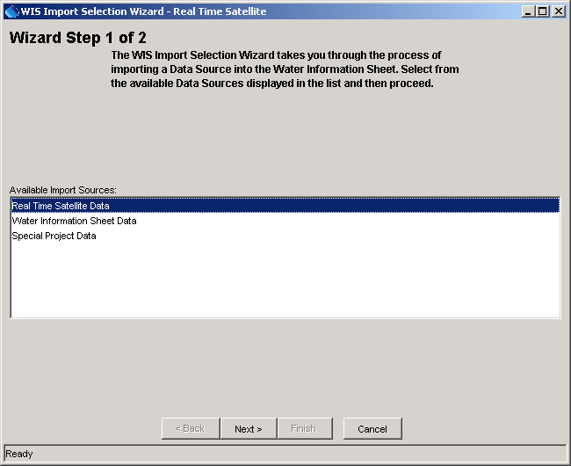
Admin_WISBuilder_ImportGage1
Import Dialog to Select Import Data Type

An import can be applied in any editable cell and transfers data from the specified data source to the WIS. If an import fails during operation, the cell value from the previous archive will be used.

The following figures illustrate imports of different data types.

The following figure illustrates the dialog used to import real-time data (streamflow).

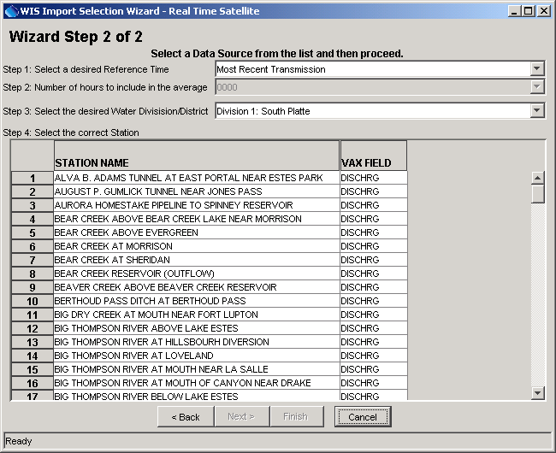
Admin_WISBuilder_ImportGage2
WIS Import for Real-time Data

Select a reference time (Most Recent Transmission, or a military time for the time of day corresponding to the end of the observation period). If a time is selected, select the number of hours (again, military time) to include in the average prior to the reference time. For example, pick a reference time of 0600 and 2400 hours to return the average flow in day ending at 0600. Also select the real-time measurement to import from the station list. Only data that are available in the central HydroBase can be imported.

The following figure illustrates an import of data from a WIS.

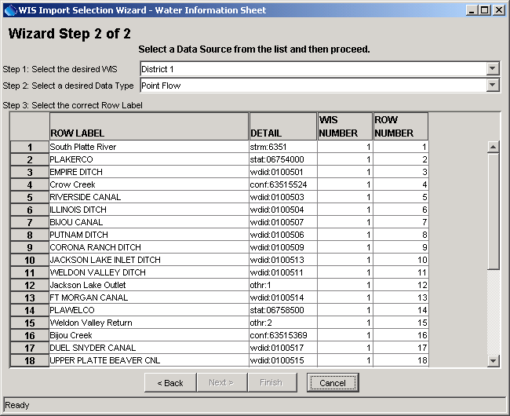
Admin_WISBuilder_ImportWIS
Import Dialog for WIS Data

This is used, for example, to import the outflow from an upstream WIS (if used operationally, this requires that WIS data be saved on an appropriate schedule so that downstream WIS can use data from upstream WIS). The value for the administration date will be imported when used operationally. If not available, the cell value from the last archive will be carried forward. To complete the import, select a WIS and, column, and row. Note that only WIS that are available in HydroBase can be imported.
The following figure illustrates an import of Special Project data.

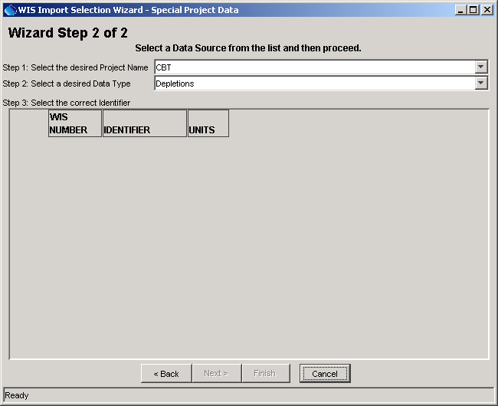
Admin_WISBuilder_ImportSP
WIS Import Dialog for Special Project Data

To import data, select a special project sheet and the data type for the special project. The import value for the administrative date. If not available, the cell value from the last archive will be carried forward.

Special project have been used on a limited basis with the Division 5 Workbook and data may not be available.
5.3.4 Formulas

The formula editor allows formulas to be assigned to an editable cell. Formulas have three primary purposes in the WIS:

- Transfer tributary mouth flows to a confluence node. For example, select the Tributary Delivery cell for a confluence row and then add a formula where the cell value equals that of the tributary mouth delivery flow.
- Transfer flow to a baseflow point. For example, there may be a gaging station downstream in the basin but not at the headwater. In order to provide some flow at the headwater, either a release has to be made or a known streamflow has to be prorated to the headwater. A formula can be used to set the Natural Flow of the headwater node to a fraction of the downstream natural flow.
- Implement a summary-type formula. For example, summarize all the tributary mouth natural flows.

To add a formula, select a cell and then press the Add Formula button at the bottom of the WIS Builder . An interface similar that shown in the bottom of the following figure will appear.

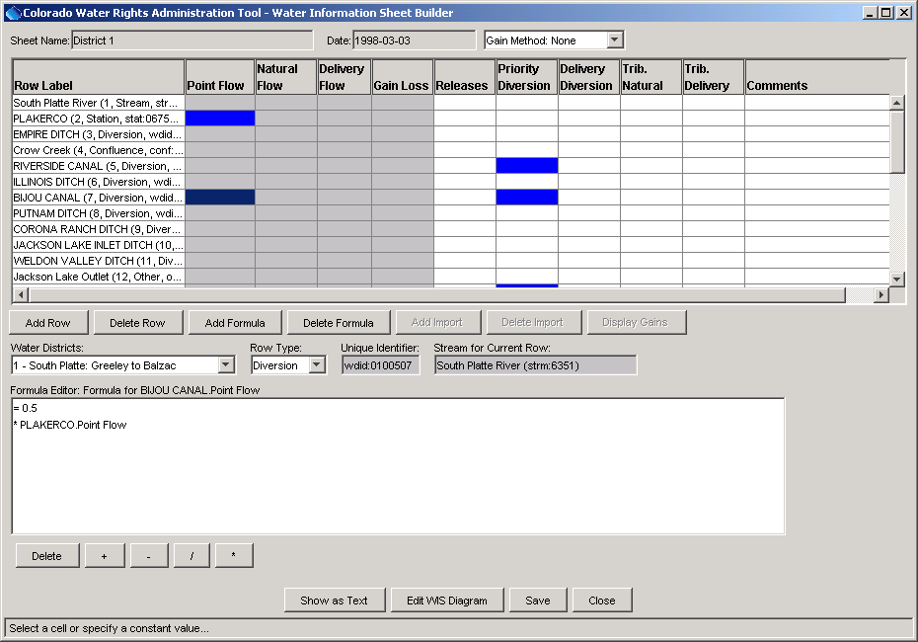
WIS Builder Formula Editor

The selected cell will be highlighted in red. The formula wizard at the bottom of the interface steps you through building a formula. Note that at this time, the formula builder does not support complicated formulas, such as those requiring parentheses. Formulas can occur in the following cells:

- Known base flows (e.g., real-time station).
- Releases, Priority Diversion, Delivery Diversion, Tributary Natural, Tributary Delivery, regardless of row type.
- Any cell of a String row type.

To delete a formula, select a cell with a formula and press the Delete Formula button.

To identify cells as they are being added to formulas, a verbose cell location notation is used. This consists of the cell row and column being displayed as the row label and column heading. To enter terms of a formula, either enter a constant (followed by Return) or an operator, then select a cell of interest.
String row types can have formulas in any cell and are ignored during network computations. Formula cells are displayed in red.

5.3.5 Computations

When building a WIS, data values are not present in the sheet because the WIS format and the WIS data are stored separately. However, it is valuable to discuss here the sequence of events that occur when the WIS is loaded and solved because this sequence must be kept in mind when building the WIS. The flow values and gain/loss information for a row consider the releases, diversions, and tributary contributions for the row. Therefore, the flow values are shown immediately downstream of the structure (essentially at the structure for gages).

The following steps occur in order to calculate the current values in a WIS.

- The WIS format is loaded to define the relationship of rows and columns.
- If a previous archive date for the WIS data is available, load the data into the current sheet. Only data from a WIS format matching the current format can be loaded.
- Next, apply data imports. For example, if valid real-time data exists, import and display in the sheet in a blue font. The data import value can be reset by the user if the field is editable.
- Solve the network:
- Solve for Delivery Flow throughout.
- Compute Natural Flow for user-entered Point Flow (Point Flow is known).
- Compute the base flow node flows. If Natural Flow is a formula, then process the formula first and compute the Point Flow second. If Point Flow is a user-entered formula, process the formula first and compute the Natural Flow second.
- Loop over the network nodes, going from upstream to downstream and compute the Gain/Loss, then the Point Flow, and then the Natural Flow.
- Compute the Gain/Loss for all base flow nodes.
- Evaluate string formulas.

Turn on gains information in the builder by selecting the Gain Method in the upper right corner of the WIS Builder interface. Then press the Display Gains button in the middle of the interface to recompute gains. The gain weight for a row is editable in the bottom of the interface when a row is selected (the default weight is 1). A similar approach is used for stream mile data (stream mile is from the Colorado border).

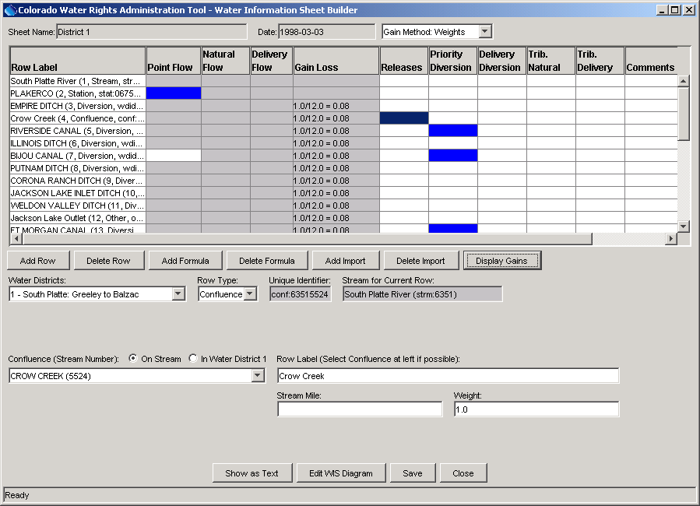
Admin_WISBuilder_Gains
WIS Builder Illustrating Gain Information

5.3.6 Editing Rows

To add a row to a WIS, use the Add Row button. The lower part of the screen will then allow data entry for the row. The row will always be inserted above the selected row. If the selected row is the last row in the WIS, you will be prompted to answer whether the insert should be before or after the last row. It is important that groups of rows in the WIS associated with a stream have a top row that is of type Stream. Information for the row should adhere to the guidelines specified in earlier sections of this documentation. After adding a row, you can apply imports and formulas as necessary.

To delete a row, select a cell in the row and then press Delete Row.

5.3.7 WIS Diagram

The Edit WIS Diagram button on the WIS Builder displays the WIS Diagram, which provides a visual representation of the WIS stream network. The first time that a WIS Diagram is opened for a WIS, the software will try to use UTM location information in HydroBase to position the nodes in the network, and will interpolate or extrapolate missing coordinates. After loading the data, the network representation can be edited (as explained below), and saved to HydroBase. Subsequent displays of the network will use the information that was previously saved.
The following figure illustrates the appearance of a WIS Diagram, showing an existing diagram.

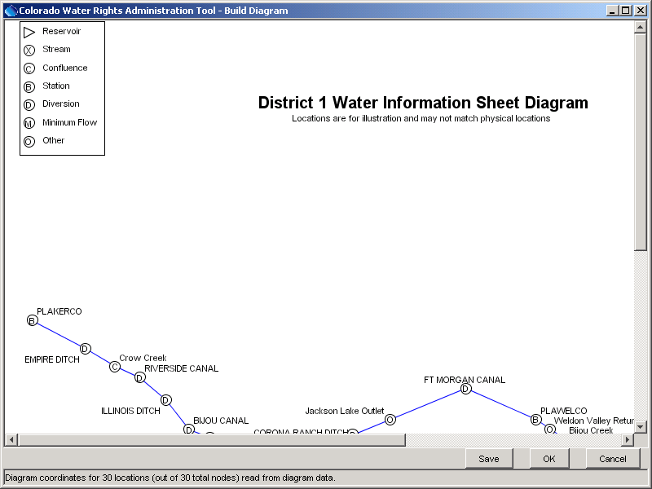
Admin_WISBuilder_Diagram
WIS Diagram Editor

Characteristics of the diagram are as follows:

- The page size for the diagram is pre-selected as letter. Currently this page size cannot be changed. The screen representation of the diagram closely matches the hard copy representation.
- A standard legend is automatically drawn in the upper-left of the diagram and indicates the symbols used for each node type.
- Nodes are labeled with the row label from the WIS and a symbol is drawn for each node.
- Only rows with a physical representation are drawn. String and stream row types are not drawn on the diagram.
- The first time the network diagram builder is opened, node positions are automatically determined, but they can be repositioned interactively (see below). If a node has been added since the last time the nodes were manually positioned in the network diagram, it may be automatically placed inaccurately, and will likely need to be repositioned to fit the rest of the diagram.
- The WIS Builder and WIS Diagram communicate with each other, so that if a node is deleted from the WIS it will be automatically deleted from the diagram (if the diagram editor is open at the same time). Likewise, if a node is added to the WIS, it will automatically be placed into the diagram using default coordinates.

The buttons on the bottom of the WIS Diagram are as follows:

Save |  | Save the diagram representation to HydroBase, associating the diagram with the WIS that is being edited.
OK |  | Save changes and close the WIS Diagram editor.
Cancel |  | Cancel any edits to the WIS Diagram and close the WIS Diagram editor.

Additionally, right-clicking on the diagram will display a popup menu with the following menu items:

Add Annotation |  | Add an annotation (e.g., title) to the diagram. See the explanation below.
Delete Diagram Data from Database |  | Delete the WIS Diagram data from HydroBase. A confirmation dialog will be displayed before deleting the data. This action is useful if updates to the spatial data in HydroBase have occurred that allow a better default representation of the diagram to be regenerated (when the diagram is reopened again). However, label positions for each node will likely need to be reset to optimize the display.
Print on Letter in Landscape |  | Print the WIS Diagram on letter size paper in landscape orientation.

The following sections provide details on using specific features of the diagram editor.

Moving Nodes on the Diagram

Nodes can be repositioned on the diagram as follows:

- Click on the node to be moved.
- While holding the mouse button down, drag the mouse to a new location. When dragging a node, the node will not display any information and the river connection lines will not be redrawn.
- Release the mouse button. The associated connecting lines on the diagram will redraw.

If for some reason it is difficult to select the proper node (e.g., several nodes have very similar coordinates), it may be necessary to first spread out the nodes and then reposition each node.

Editing Node Properties

To edit the properties for a node, right-click on a node symbol and select the Properties menu item, which will display a dialog similar to the following:

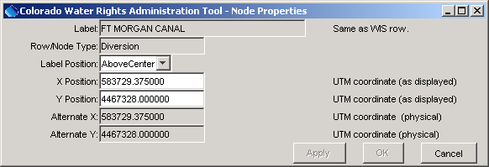
Admin_WISBuilder_Diagram_NodeProperties
WIS Diagram Node Properties Dialog

Node properties include only properties that impact the visual representation of the node. All other properties are defined in the main WIS Builder tool (including node/row type, whether a baseflow, etc.). Node properties include:

Label |  | The label for the node – same as the WIS row label.
Row/Node Type |  | The row/node type – same as the WIS row type.
Label Position |  | Indicates the position of the node label, relative to the symbol. An appropriate position should be selected to minimize the condition where labels overwrite.
X, Y Position |  | The coordinate of the node on the diagram. Initially this will be the same as Alternate X, Y, but values will reflect nodes being moved in the diagram editor.
Alternate X, Y |  | The alternate coordinate is initially set to the UTM coordinates from HydroBase, or the interpolated coordinates.

Adding Annotations

Annotations can be added by right-clicking on the WIS Diagram and then selecting the Add Annotation menu item. Initially, the following dialog will be shown:

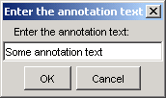
Admin_WISBuilder_Diagram_AddAnnotation

After pressing OK, the text will be displayed on the diagram centered on the location that the mouse was clicked.

Once the annotation has been added, it can be moved by selecting and dragging the text. Additionally, right-click on the annotation and select Delete to delete the annotation, or select Properties to change the appearance of the annotation, using the following dialog:

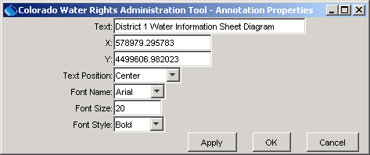
Admin_WISBuilder_Diagram_AnnotationProperties

The meaning of the specific properties is as follows:

Text |  | Text for the annotation.
X, Y |  | Coordinate for the annotation – not usually hand edited.
Text Position |  | Indicates the position of the annotation text, relative to the X, Y coordinates.
Font Name |  | Font to use for the annotation.
Font Size |  | Font size (points) to use for the annotation.
Font Style |  | Font style for the annotation.

This page is intentionally blank.

