Appendix

StateView/CWRAT Installation and Configuration
04.00.00, 2007-03-02, Acrobat Distiller

1. Overview

This appendix describes how to install StateView/CWRAT in the CDSS (Colorado's Decision Support Systems) environment. StateView and CWRAT share the same software files. The main difference between the programs is that StateView does not display the Administration menu. The files that run StateView and CWRAT are the same except for one command-line argument (StateView uses –viewonly true).

The StateView/CWRAT software is typically installed on servers within the State of Colorado’s network, for use by State of Colorado personnel, and requires no further installation by users within that environment.

2. File Locations

The State of Colorado’s CDSS consists of the HydroBase database, modeling, and data viewing/editing software. StateView/CWRAT can be used with this system to view HydroBase data and edit administrative data. State of Colorado personnel who are performing water administration usually install CWRAT. StateView is typically used for general data viewing and will be used by most users.

Locations of StateView/CWRAT software files are as shown below. The _XXX notation indicates the JRE [Java Runtime Environment] version number (e.g., _142), which may change as upgrades to the system occur:

\CDSS\ |  | Top-level install directory.
bin\ |  | Software directory for .exe, .bat files and Java JAR files.
CWRAT.bat |  | Batch file to run CWRAT using the JRE software, which can be used if the installation is not standard. A standard installation will use the CWRAT.exe file to run software. See comments below and in the batch file.
CWRAT.exe |  | CWRAT executable program that starts the JRE software.
CWRAT_XXX.jar |  | StateView/CWRAT main application package.
HydroBaseDMI_XXX.jar |  | State of Colorado HydroBase database interface package.
msbase.jar, mssqlserver.jar,  msutil.jar |  | Microsoft SQL Server packages (see special installation instructions below).
RTi_Common_XXX.jar |  | Riverside Technology, inc. supporting packages.
shellcon.exe |  | Executable program used to read from the Windows registry (e.g., to determine the list of available ODBC data source names).
StateView.bat |  | Batch file to run StateView using the JRE software, which can be used if the installation is not standard. A standard installation will use the StateView.exe file to run software. See comments below and in the batch file.
StateView.exe |  | StateView executable program that starts the JRE software.
doc\CWRAT\UserManual\ |  | Main documentation directory for CWRAT.
CWRAT.pdf |  | CWRAT documentation as PDF.
Doc\ StateView\UserManual\ |  | Main documentation directory for StateView.
StateView.pdf |  | StateView documentation as PDF.
JRE_XXX\ |  | Java Runtime Environment.
logs\ |  | Directory for StateView/CWRAT log files (should be writable).
system\ |  | Directory for system files.
cwrat.gif |  | Startup graphic for CWRAT.
DATAUNIT |  | Data units file.
stateview.gif |  | Startup graphic for StateView.

3. Installing StateView/CWRAT

StateView/CWRAT can be installed either as part of the HydroBase Tools CD/DVD installation, or as a separate installation. In both cases, is recommended that the CDSS file structure be used.

3.1 Installing StateView from the “HydroBase data set Analysis Query Tools CD/DVD”

If you have purchased a HydroBase CD/DVD, StateView will be installed during the CD/DVD install process. Refer to the installation instructions for that distribution.

3.2 Installing StateView/CWRAT from the Setup File

Use the following instructions to install StateView/CWRAT using the StateView_Setup.exe or CWRAT_Setup.exe installer program, for example if software was downloaded from the CDSS web site (http://cdss.state.co.us). The following example is for StateView, but is similar for CWRAT.

- Run the StateView_Setup.exe file (or CWRAT_Setup.exe file) by selecting from Windows Explorer, the Start… Run… menu, or from a command shell. The setup filename will include a version number (e.g., StateView_4.00.00_Setup.exe).

You must be logged into the computer using an account with administrator privileges. Otherwise, the following warning will be displayed:

Graphic is needed.
Install_AdministratorWarning

If you have administrative privileges, the following welcome will be displayed, and the installation can continue:

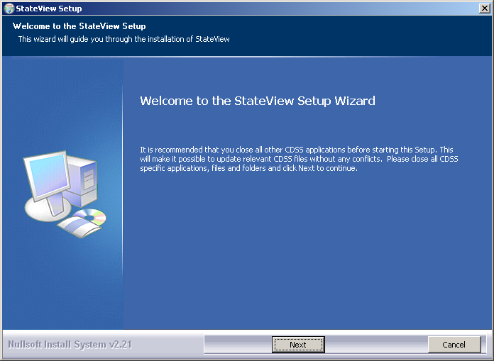
Install_Welcome

Press Next to continue with the installation.
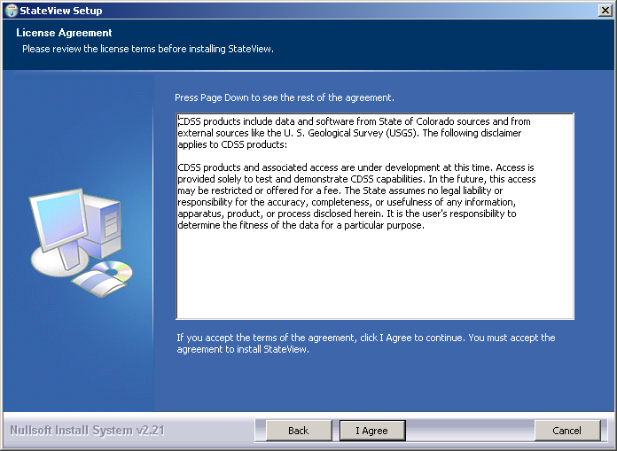
Install_Disclaimer

StateView is distributed with CDSS with no license restrictions. However the disclaimer must be acknowledged. Press I Agree to continue with the installation.

- Several components can be selected for the install as shown in the following dialog. Position the mouse over a component to see its description.

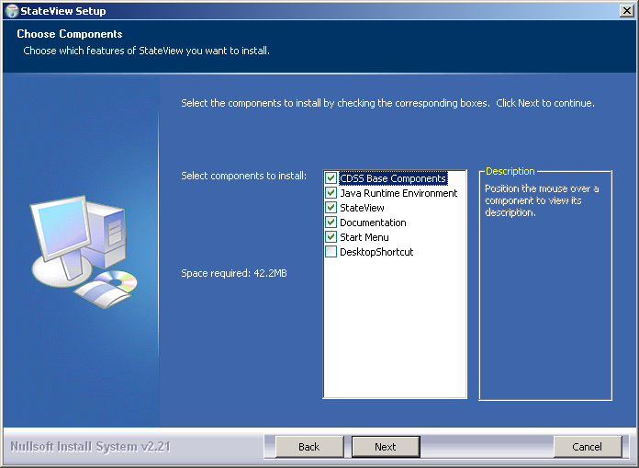
Install_SelectComponents

Select the components to install and press Next.

- The following dialog is then shown and is used to select the installation location for StateView/CWRAT. To be consistent with other CDSS components, select the main CDSS folder. The following dialog will display the CDSS install location if the CDSS Base component has been previously installed:

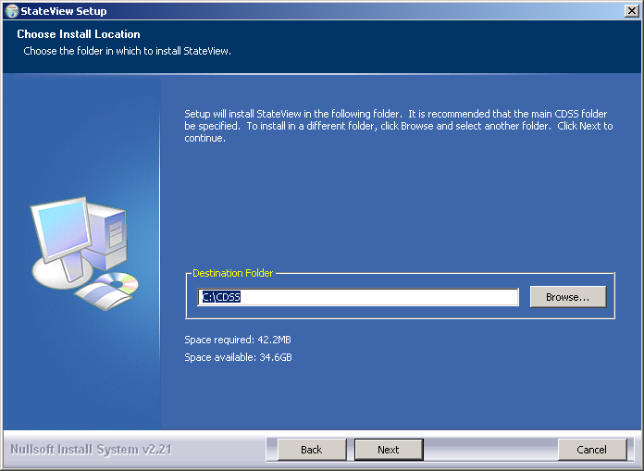
Install_SelectFolder

After selecting the install location, press Next.

Note that this location will be saved as a Windows registry setting (HKEY_LOCAL_MACHINE\Software\State of Colorado\StateView\Path or HKEY_LOCAL_MACHINE\Software\State of Colorado\CWRAT\Path) to allow future updates to check for and default to the same install location, and to allow the standard software uninstall procedure to work correctly.

- The following dialog will be shown to select the menu for the software:

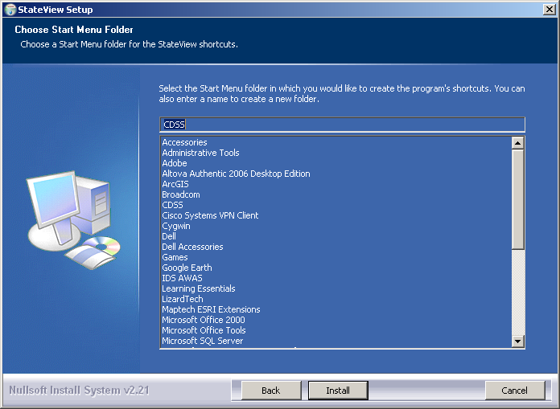
Install_StartMenuFolder

After selecting the folder, press Install.

- The following dialog will show the progress of the installation:

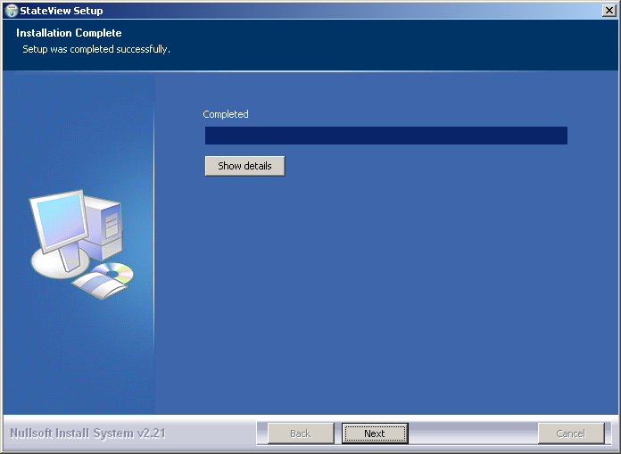
Install_Complete

Press Show details to see the files that were installed or press Next to continue.

- If the CDSS Base Components were selected for install, the following dialog will be displayed to allow further HydroBase configuration:

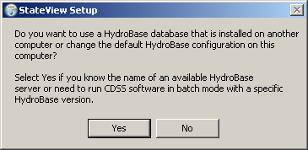
Install_HydroBaseQuestion

StateView/CWRAT and other CDSS software can utilize HydroBase running on the local computer as well as other computers. Press Yes if HydroBase has been installed on another computer in the network environment and may be used by the software (then continue to the next step). Otherwise, press No (skip to step 8).

- The following dialog allows additional HydroBase servers to be specified for use by CDSS software (the example below configures CDSS software to list the dwrappsdb HydroBase server in choices and defaults to HydroBase on the local computer). The dialog will initially show previous settings from the \CDSS\system\CDSS.cfg file and settings typically only need to be changed after installing a new HydroBase version.

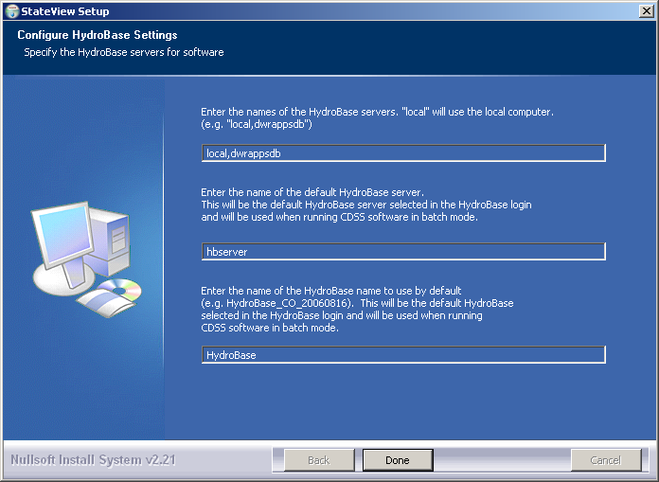
Install_HydroBaseConfiguration

After entering the name of a HydroBase server and the default server to use, press Done.

- The following dialog will then be shown asking whether the StateView/CWRAT software should be run:

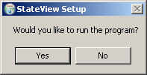
Install_RunStateViewQuestion

Press Yes to run the software or No to exit the installation procedure.

- A reboot is not required to use the software from the Start menu. However, a reboot may be required on some computers to run StateView/CWRAT from the command line.

3.3 Installing StateView/CWRAT on a File Server

StateView/CWRAT can be installed on a file server, which allows software updates to be made in one location, thereby eliminating the need to install software on individual machines. For this type of installation, all computers that access the software must have similar configuration, including network configuration. The standard installer described in this documentation focuses on individual installs on user computers. To make StateView/CWRAT software installed on a server available to other computers, perform the following (this is typically performed by system administrators):

- Run the StateView_Setup.exe installer (or CWRAT_Setup.exe installer) as described above. During installation specify the CDSS home using a drive letter and path for the server or specify a Universal Naming Convention (UNC) path (e.g., \\CDSSServer\CDSS). All computers that will use the software will need to have access to the server in a consistent way because the StateView/CWRAT software will expect the CDSS installation home at runtime to be that specified during the installation.
- The menus and shortcuts will only be configured for the computer from which the installation was run. Therefore, menus and shortcuts for other computers will need to be manually configured.
- If appropriate, edit the CDSSInstallHome\system\CDSS.cfg file to include additional information (e.g., Satellite Monitoring System database configuration – see the TSTool Installation and Configuration). The installer described in this documentation focuses on general users who in most cases will not have access to advanced features available only within the State of Colorado’s server environment.

If StateView/CWRAT has been installed on a local computer and it is also available on the network, the network version can be run by running the software in the NetworkCDSSInstallHome\bin folder. The software will expect that file locations use the same drives as when the software was installed.

3.4 Special Installation Instructions for Microsoft SQL Server Support

CDSS software uses the free SQL Server driver from Microsoft. The CDSS software requires only the msbase.jar, mssqlserver.jar, and msutil.jar files from the Microsoft installation. However, Microsoft requires that you do a full installation of its driver in order to acknowledge the End User License Agreement (EULA). Because only three files listed previously are needed for CDSS Java software, it is recommended that the Microsoft install be completed once within an organization (to complete the EULA recognition), but then use the three files distributed with CDSS software as is (ignore the files from the full Microsoft installation). If installing the HydroBase CD, the Microsoft files will be installed automatically and this EULA will be displayed.

To manually perform the Microsoft installation, do one of the following:

- Contact the supplier of the CDSS software (e.g., the State of Colorado IT staff) to provide the Microsoft driver. For software installations at the State, this step needs be done only once by the State of Colorado IT staff. All other CDSS users at the State can then use the software using the three software files described above.

- Download and install the Microsoft JDBC driver from http://www.microsoft.com/sql/downloads and install according to its instructions. Do this if you have purchased SQL Server and will install the State’s HydroBase using SQL Server at your organization.

4. Uninstalling StateView/CWRAT Software

To uninstall StateView/CWRAT software, select CDSS…Uninstall…StateView (or similar for CWRAT) from the Start menu and confirm the uninstall. CDSS components that are used by other software (e.g., CDSS Base component software) as well as user data will remain installed.

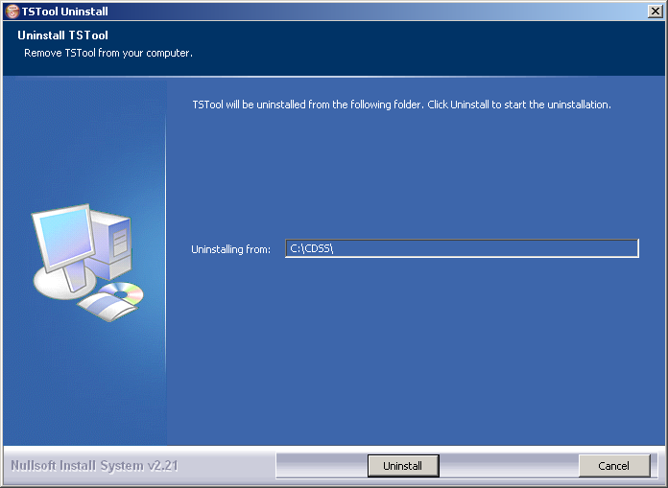
Uninstall_Intro

Press Uninstall to uninstall the software.

If StateView/CWRAT is the last CDSS application to be uninstalled, you will also be prompted to confirm uninstalling CDSS system files.
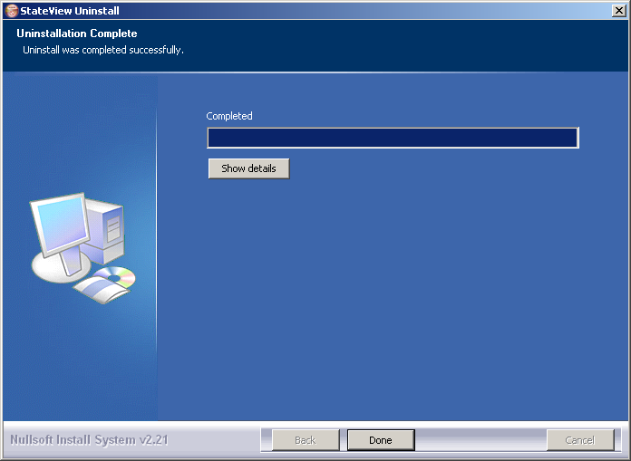
Uninstall_Complete

Press Show details to see the list of files that were removed. Press Done to exit the uninstall.

5. Running StateView/CWRAT

The Start…All Programs…StateView (or Start… Programs… StateView) menu can be used to start the StateView software. This runs the CDSSInstallHome\bin\StateView.exe software. CWRAT can be run similarly.

6. StateView/CWRAT Configuration

StateView/CWRAT requires minimal configuration. This section describes the StateView/CWRAT configuration files that can be customized for a system. Installations on a server use one configuration for all users.

6.1 CDSS Configuration File

By default, StateView/CWRAT will automatically look for HydroBase databases on the current machine and the State servers. State server databases are typically only accessible to State of Colorado computers. If SQL Server or MSDE HydroBase versions have been installed on a different machine, the \cdss\system\CDSS.cfg file can be used to indicate the database servers. An example of the configuration file is as follows:

[HydroBase]

ServerNames="ServerName,local"
DefaultServerName="ServerName"
DefaultDatabaseName="HydroBase_CO_East_20050730"

In the above example, HydroBase has been installed on a machine called ServerName and the local computer. The database on ServerName will be the default in the StateView/CWRAT login dialog. The CDSS configuration properties are described in the following table:

CDSS HydroBase Database Configuration Properties

Property | Description | Default
ServerNames | A comma-separated list of server names to list in the HydroBase login dialog. | The state server is listed.
Default  ServerName | The default HydroBase server name to use. This allows the HydroBase login dialog to preselect a default that applies to most users in the system. If TSTool or StateDMI are run in batch mode and the HydroBase input type is enabled, use this property to make a default connection to HydroBase, for use with other commands in the batch run. | greenmtn.  state.co.us
Default  DatabaseName | The default HydroBase database name to use. This allows the HydroBase login dialog to preselect a default that applies to most users in the system. If TSTool or StateDMI are run in batch mode and the HydroBase input type is enabled, use this property to make a default connection to HydroBase, for use with other commands in the batch run.

6.2 Data Units File

The \cdss\system\DATAUNIT file contains data unit information that defines conversions and output precision. In most cases the default file can be used but additional units may need to be added for a user's needs (in this case please notify the developers so the units can be added to the default file distributed with installations). Currently, the data units file is the only source for units information – in the future units may be determined from HydroBase.

6.3 Map Configuration

The GeoView Mapping Tools appendix describes mapping tools in detail. The StateView/CWRAT GeoView project files (typically available as \CDSS\GIS\divX\*.gvp) have been preconfigured and generally can be used without modification. The following table lists the GeoView project file AppLayerType properties, which allow StateView/CWRAT to know the spatial data layers that correspond to display features in the software. The AppLayerType values are reserved for use with StateView/CWRAT, although some data types do not currently have a link with spatial data (instream flow, water right, well permit), either because the data do not support the feature, or because StateView/CWRAT do not have an appropriate display.

AppLayerType Value | How Used in StateView/CWRAT
BaseLayer | Indicate base layers that can be ignored by specific displays.
Diversion | Used when displaying diversion structure information.
InstreamFlow | Used when displaying instream flow structure information.
Precipitation | Used when displaying precipitation station information.
Reservoir | Used when displaying reservoir structure information.
Streamflow | Used when displaying streamflow station information.
Temperature | Used when displaying temperature station information.
WaterRight | Used when displaying water right information.
Well | Used when displaying well structure information.
WellPermit | Used when displaying well permit data.

The AppLayerType values correspond to physical features, which are represented by the spatial data layers. However, some StateView/CWRAT displays focus on time series data types, which may not correspond one-to-one with physical features. For example, streamflow stations can have real-time and/or historical data using a variety of station identifiers and time intervals. Additional enhancements to HydroBase, spatial data, and/or software are needed to allow relating physical features to time series data types for all combinations.

6.4 Additional Configuration

To change the program configuration at run-time, use the Tools…Options menu. StateView/CWRAT will save changed configuration information to the HydroBase database so that the settings are active the next time that StateView/CWRAT is run. The guest login settings are only valid during the current session and cannot be saved to the database.

