Colorado’s Decision Support Systems
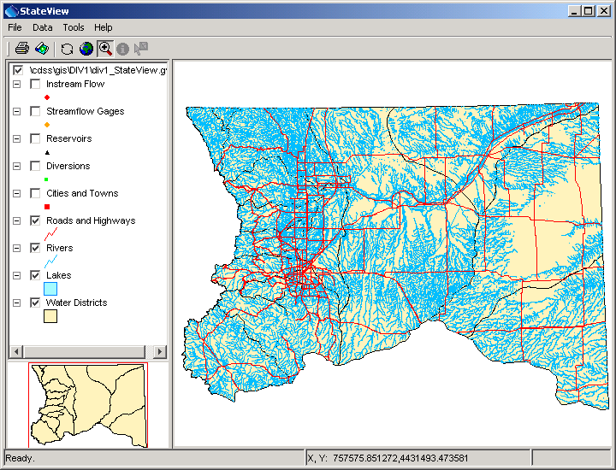
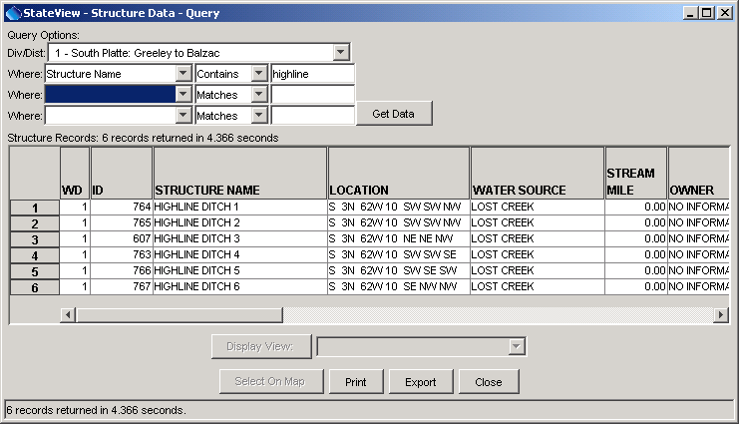
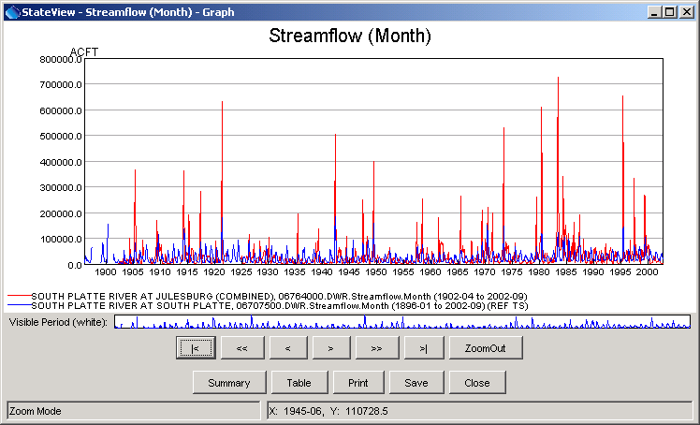
Colorado Water Rights Administration Tool (CWRAT)

Colorado Department of Natural Resources
Colorado Water Conservation Board
Division of Water Resources

Developed by:


Version 04.02.02, 2013-04-16
1

This page is intentionally blank.

This document is formatted for double-sided printing.

