4 Viewing Data
Version 4.02.00, 2011-07-15

The Data menu provides displays for major categories of data, including nearly all of the data in the HydroBase database. In each case, a main display window is available, which provides access to additional display windows as appropriate. The following sections describe the various data types that can be displayed.

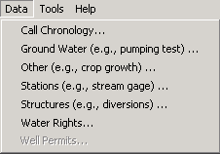
Menu_ViewData
Data Menu

The Well Permits menu will only be enabled if you have logged in as someone other than “guest” using a SQL Server database that includes well permit data. Well permit data access is meant primarily for State of Colorado personnel.

4.1 Call Chronology

The Data...Call Chronology menu displays a view-only history of calls affecting a water district or entire division during a particular period, as shown in the following figure.

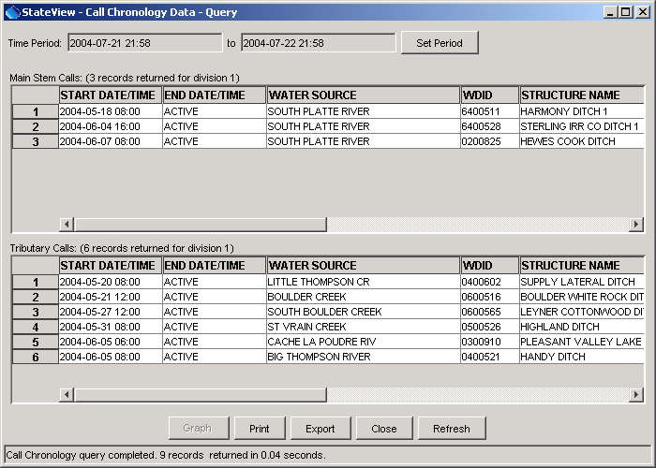Call_Chronology
Call Chronology Window

The initial display uses the time period set with Tools...Options...Time Period, which is typically set to display a recent period of time. To obtain results for a different period, specify the new period using the Set Period button, which will automatically re-query HydroBase. Calls that were active at any time in the specified period are displayed, with active calls being listed first. Calls are listed separately for main stem and tributary calls (main stem calls are on streams that do not flow into other streams). Use the Refresh button to refresh the display (e.g., to monitor changing conditions during the day).

Calls are set with the Administration…Edit Calls menu in the CWRAT program. Call data cannot be modified using the Data…Call Chronology menu.

Selecting one or more calls and pressing the Graph button allows calls to be graphed. This feature, described below, is more useful when a long period is specified because it shows when calls are on/off over the period. The call data that are displayed can be printed or exported for use by other tools.

After the Graph button is selected, the following dialog will be displayed:

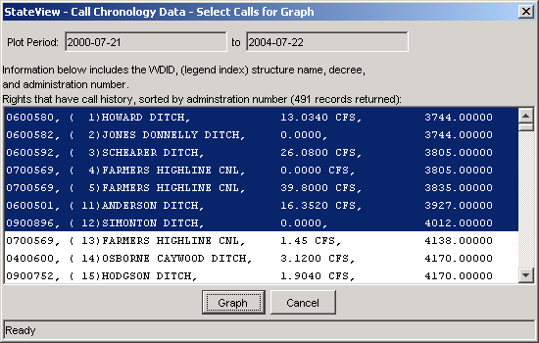
Call_Chronology_Graph_Select
Call Chronology Graph Selection Dialog

In the above example, for the specified period, there are 491 available calls, which are uniquely identified by the structure identifier and the water right administration number. The calls are listed with the most senior water right first. A gap in the counter that is shown indicates that the first right before the gap has had multiple calls during the period. A graph cannot normally display a very large number of calls, so a subset is typically selected. In the above example, multiple calls have been selected by clicking on the first call and then using shift-click on the seventh call. After selecting calls to graph, press Graph.

The following figure provides an example of a call chronology graph.

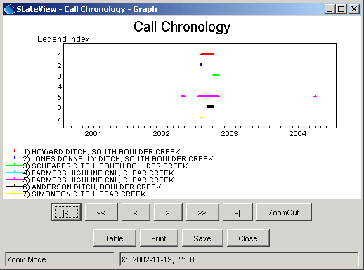
Call_Chronology_Graph
Call Chronology Graph

Each call that was selected for graphing is shown as a horizontal line on the graph. The vertical order of the graph is consistent between the legend and the numbered indexes on the vertical axis. A small plus sign is drawn at each day on which a call was active; consequently, if a call was only active for one day, there will only be a plus symbol and no line.

The general features of the graphing tool are described in the TSView Time Series Viewing Tools Appendix.

4.2 Ground Water Data

The Data...Ground Water menu provides views for ground water data, which include driller’s K sum, geophysical logs, pumping tests, pumping time series, volcanics, and well level data. Ground water data are available only for some divisions where a ground water modeling effort has occurred (e.g., Divisions 1 and 3). Well permits are available using the Data…Well Permits menu item. The Data…Structures menu displays well data for structures that have water rights. Data may only be available for certain water divisions (select Div/Dist as Entire State to see all available data).

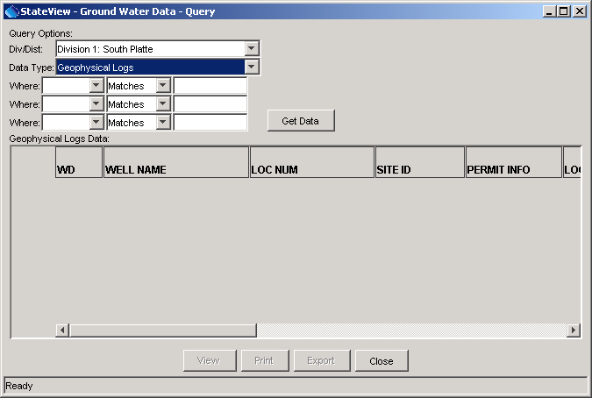
GroundWater
Ground Water Query Window as Initially Displayed

Similar to other views, you must first select a data type and then press the Get Data button to display data. The following sections describe the ground water views that are available. Each display typically displays available identifier and location information for the wells, in addition to the specific data. Some wells have identifiers from multiple sources.

4.2.1 Driller’s K Sum

To list driller’s K sum data, first select Driller’s K Sum as the Data Type. If desired, filter the query by specifying Where information. Press Get Data to query the database.

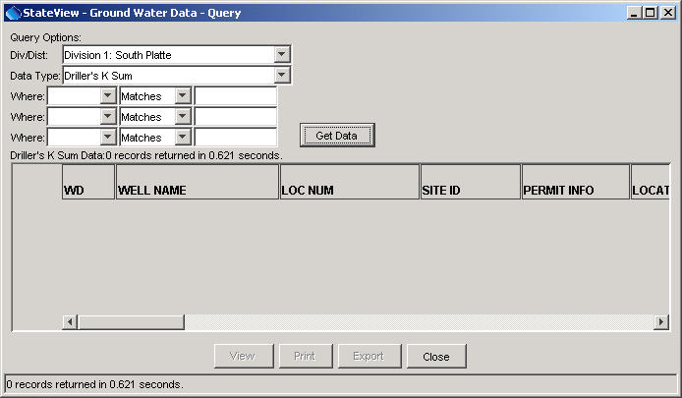
Groundwater_DrillersKSum
Driller’s K Sum Data

4.2.2 Geophysical Logs

To list geophysical log data, first select Geophysical Logs as the Data Type. If desired, filter the query by specifying Where information. Press Get Data to query the database. The corresponding list of geophysical log data will be shown, as in the following figure:

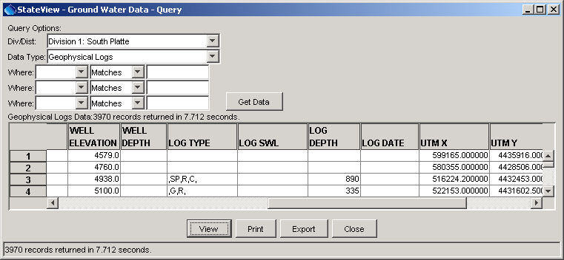
Groundwater_GeophysicalLogs
Geophysical Logs Data

To see a text view of the data, select a record and press the View button:

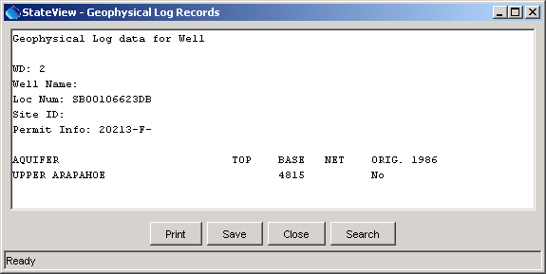
Groundwater_GeophysicalLogs2
Geophysical Logs Data – Report View

4.2.3 Pumping Tests

To list pumping test data, first select Pumping Tests as the Data Type. Optionally, also enter Where information to limit the query. Then press Get Data. The corresponding list of pumping test data will be shown, as in the following figure:

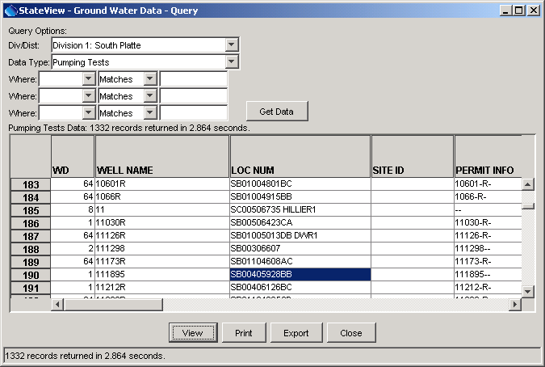
GroundWater_PumpingTestMain
Pumping Test List

The above example illustrates the results of the query, which lists pumping tests and parameters determined from the tests. To see a single pumping test in an expanded view, select the pumping test from the list (left click) and then press the View button.

The following figure illustrates the resulting pumping test view.

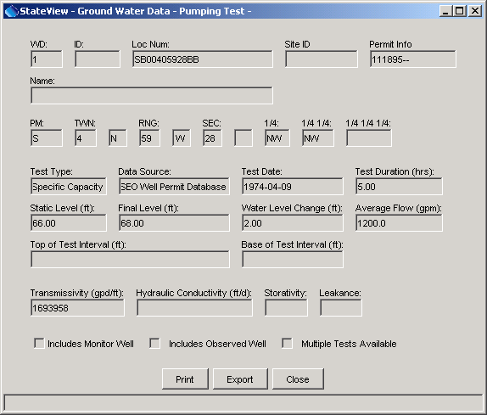
GroundWater_PumpingTestSingle
Pumping Test Data

4.2.4 Pumping Time Series

Currently, pumping time series are not available in HydroBase, other than as part of the diversion coding data. To view pumping time series, use the Data...Structures menu and select the Diversion Coding/Reservoir Releases view (see Section 4.5 - Structures).

4.2.5 Volcanics

To volcanics data, first select Volcanics as the Data Type. If desired, filter the query by specifying Where information. Press Get Data to query the database.

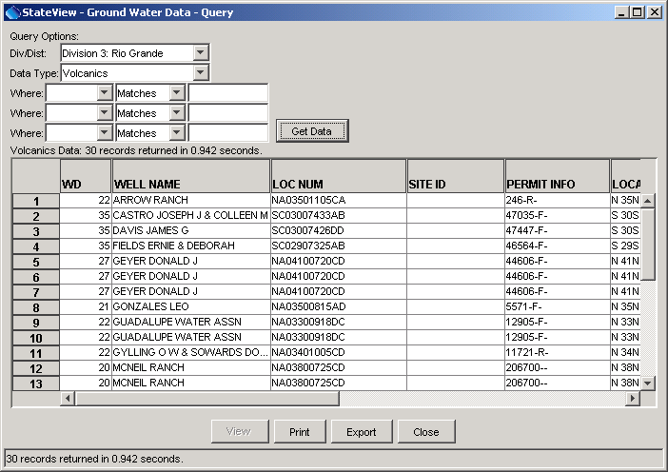
Groundwater_VolcanicsMain
Volcanics Data

4.2.6 Well Level Measurements

To list information about well level time series, select Well Level Measurements as the Data Type. Optionally, also enter Where information to limit the query. Then press Get Data. The following figure illustrates the resulting list:

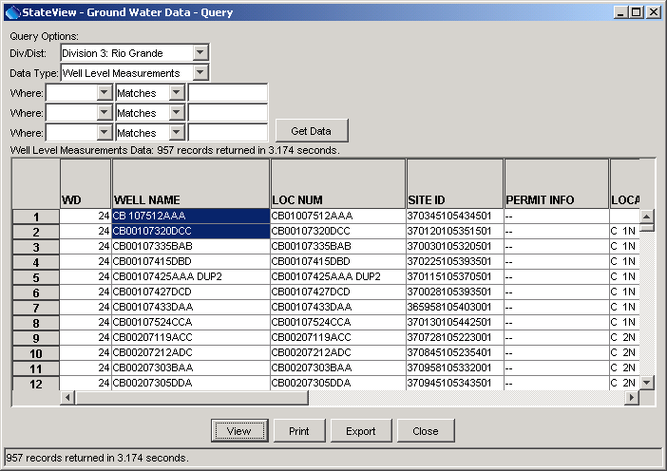
GroundWater_WellLevelMain
Well Level Measurement List

To graph well level measurement time series, select one or more items from the list and then press the View button. In HydroBase, wells with well level measurements may or may not correspond to a structure with water rights. For example, wells may have a USGS or USBR identifier. For time series identifiers, the location is determined from the agency that is the data source for the time series data. If available, the datum is used to adjust well levels to elevation (as opposed to depth).

The following figure illustrates the resulting graph for well level measurements.

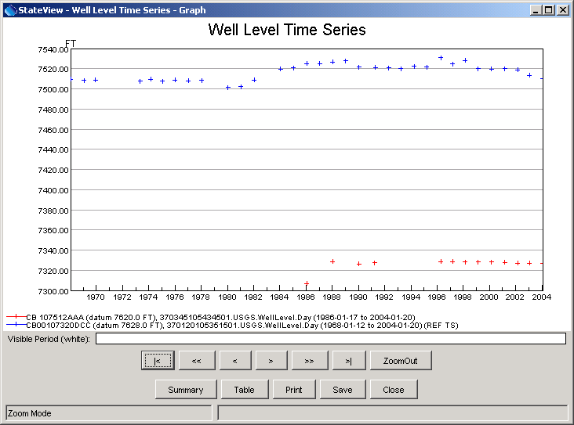
GroundWater_WellLevelGraph
Well Level Time Series Graph

In order to display the data as a graph, daily well level measurements are treated as a daily time series, although not every day may have a measurement. Because well measurements are often measured in absolute units (e.g., elevation from sea level), the y-axis for the graph does not start at zero. If zero were used, the well level graph would be difficult to distinguish from a horizontal line. The datum is shown so that it can be evaluated for accuracy.

The features of the graphing tool are described in the TSView Time Series Viewing Tools Appendix.

Well level data also can be viewed and processed using the CDSS TSTool software.

4.3 Other Data

The Data...Other menu displays miscellaneous data that are not directly associated with the other data types in the Data menu. Many of these data are static information (rather than time series or administrative data). The main query dialog is shown in the following figure.

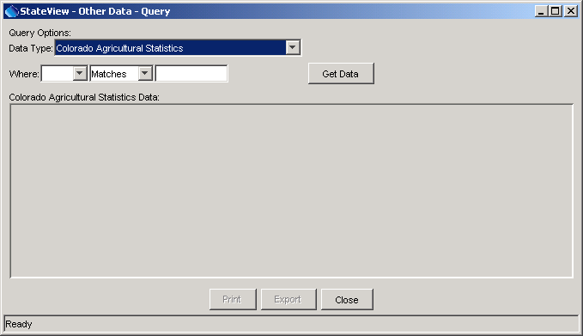
Other
Other Data Query Window

To view data, select a data type and then press the Get Data button. You can filter the amount of output by selecting using the Where information. In some cases, all data are displayed and cannot be filtered. Each data type is explained in subsequent sections.

4.3.1 Colorado Agricultural Statistics

Colorado agricultural statistics are available by county. Agricultural statistics are time series of crops sorted by county, crop (commodity), irrigation practice, and year. Familiarity with the Colorado Agricultural Statistics Service (CASS) data is helpful when using the data.

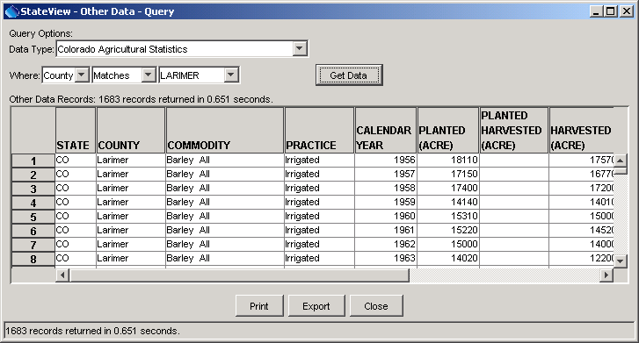
Other_ColoradoAgStats
Colorado Agricultural Statistics

Colorado agricultural statistics data also can be viewed and processed using the CDSS TSTool software.

4.3.2 National Agricultural Statistics

National agricultural statistics are available by county. Agricultural statistics are time series of crops (commodities), sorted by county, crop, irrigation practice, and year. Familiarity with the National Agricultural Statistics Service (NASS) data is helpful when using the data.

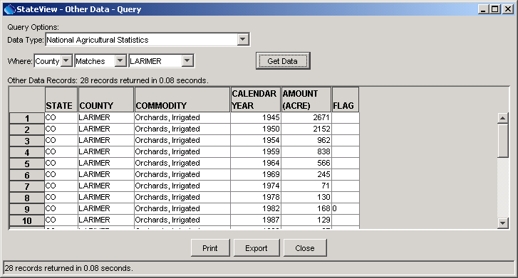
Other_NationalAgStats
National Agricultural Statistics

National agricultural statistics data also can be viewed and processed using the CDSS TSTool software.

4.3.3 Crop Characteristics

Crop characteristics are parameters associated with crops and are used by the consumptive use model. Refer to the StateCU model documentation for more information about how these data are used.

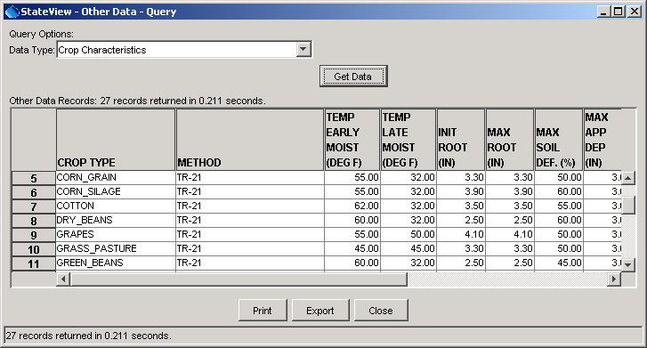
Other_CropCharacteristics
Crop Characteristics

Crop characteristics data also can be viewed and processed using the CDSS StateDMI software.

4.3.4 Crop Growth Characteristics

Crop growth characteristics are used by the StateCU consumptive use model. Refer to the StateCU model documentation for more information about how these data are used. The output for these data is shown in a report because of the variability in the data for different methods.

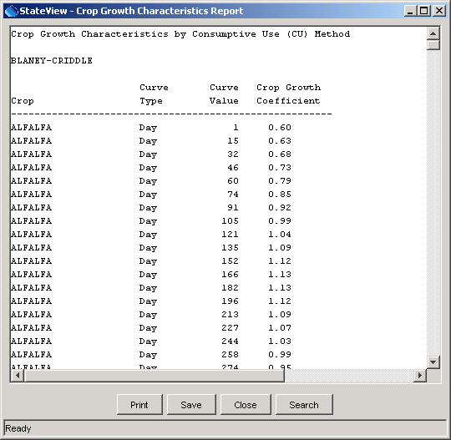
Other_CropGrowthCharacteristics
Crop Growth Characteristics

Crop growth characteristics data also can be viewed and processed using the CDSS StateDMI software.

4.3.5 Human and Livestock Consumptive Use Characteristics

Human and livestock consumptive use characteristics are used by the consumptive use estimates. Refer to the StateCU model documentation for more information about how these data are used.

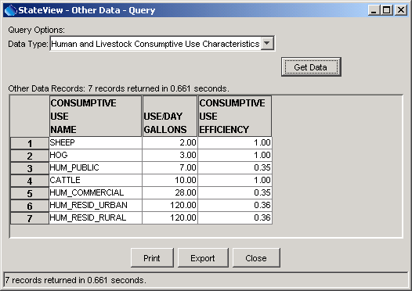
Other_HumanAndLivestockCharacteristics
Human and Livestock Consumptive Use Characteristics View

Population data also can be viewed and processed using the CDSS TSTool software.

4.4 Stations

The Data...Stations menu displays station information, primarily as a way to access real-time and historical time series data. The following figure illustrates the Station Data interface, which displays basic information including identifier, name, and location. The CDSS TSTool software also can be used to view and process station time series data.

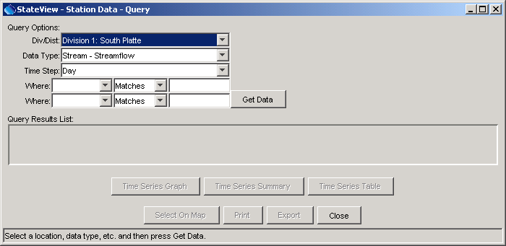
Stations
Stations Query Interface

Each station may be associated with one or more time series. For example, a streamflow station may have daily and monthly time series as averages, totals, minimum, maximum, etc. To display station data, first select query options, as described below:

Water Division/District | The water division and district are used to limit queries to a region. The available options are typically constrained using the Tools...Options...Water District Filter settings.
Data Type | Station queries are based on knowing the data type of interest. Consequently, you cannot ask “what are the data types available at a station”. The available data types correspond to time series data stored in HydroBase. Data types are listed in logical groupings. Real-time data may only be available when using a State server HydroBase.  To mix time series data types and intervals, use the Tools...Time Series Plot feature or the TSTool software.
Time Step | The time step indicates the data interval and provides an additional level of detail when selecting time series for stations.
Where | Use the Where lists to choose additional criteria for limiting a query.

After selecting query options, press the Get Data button (or press the Enter key in Where text fields).
The following figure illustrates the results of a station query.

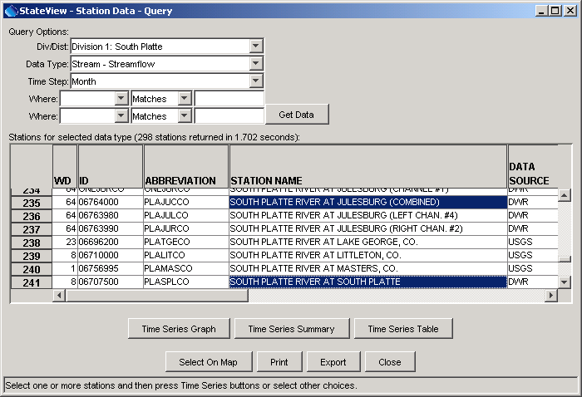
Stations_List
Station Query showing Monthly Streamflow Stations

The results of the query are displayed in the list area and consist of stations that have time series data of the requested type. Select one or more stations from the list. The following buttons can be pressed to act on the list:

Time Series Graph | Display the selected time series in a graph. See below for an example.
Time Series Summary | Display the selected time series in a text report form.
Time Series Table | Display the selected time series in a tabular form.
Select On Map | If the map interface is enabled and station data are available on the map, select the stations on the map. Warning: only streamflow stations and general climate station data are typically available for maps. Not all data types may have corresponding map layers. See Chapter 7 - Examples of Use for information about interacting with the map interface.
Print | Print the contents of the list.
Export | Export the contents of the list to a file.
Close | Close the Station Data window.
When the Time Series Graph, Time Series Summary, or Time Series Table buttons are pressed, the period that is used to query the time series data can be limited. Specifying a shorter period can increase performance. The following figure illustrates the period selector dialog.

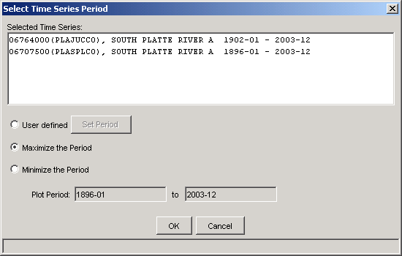
Stations_Period
Time Series Period Selector

The period can be specified as the maximum period, the minimum overlapping period, or a user-defined period. Pressing OK will display the appropriate view (graph, summary, or table).

The following figure illustrates a graph view.

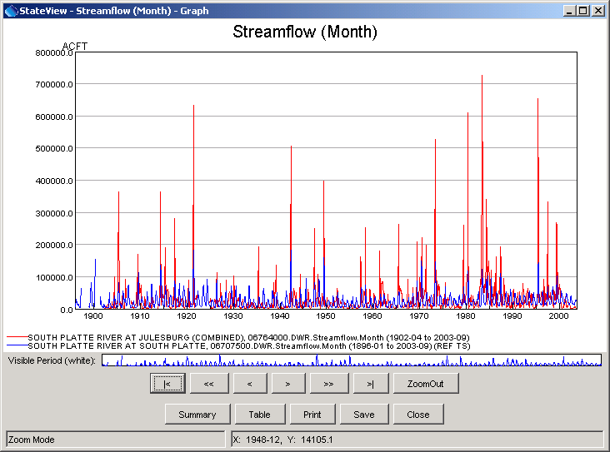
Stations_Graph
Graph Showing Monthly Streamflow

The TSView Time Series Viewing Tools Appendix describes the features of the graph and also provides examples of the summary and table views. Note that the graph, summary, and table views can be displayed from the each of the individual views by pressing the appropriate buttons.

For example, use the arrow buttons to scroll through the graph or use the mouse to draw a box on the main graph or the overview graph above the buttons. Right-click on the graph to edit graph properties.

4.5 Structures

The Data...Structures menu displays information associated with structures (e.g., diversions, reservoirs) that have administrative data. The following figure illustrates the Structure Data display.

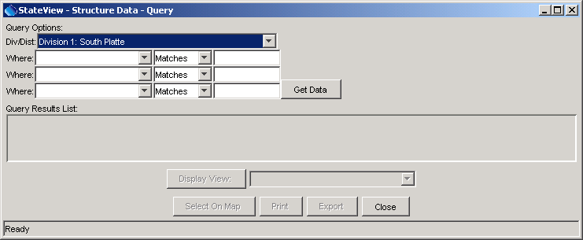
Structures
Structure Data Window

To display structure data, first select query options, as described below:

Div/Dist | The water division and district are used to limit queries to a region. The available options are typically constrained using the Tools...Options...Water District Filter settings.
Where | Use the Where list to choose additional criteria for limiting a query. To see an explanation of the choices, do a simple query, and then use the tool tips for each column heading.  Use the Location choice to query by legal location. To input the location, click in the entry field, which will cause the following dialog to be displayed:  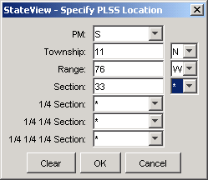  Location_Dialog  Wildcard characters (*) can be used to make the search as broad as desired.
Initiate a query by pressing the Get Data button or press Enter while the mouse cursor is in a text entry field. Queries of entire districts or divisions may require a few minutes to return results but typically only a few seconds are required. The results from the query are displayed in list format, as illustrated in the following figure:

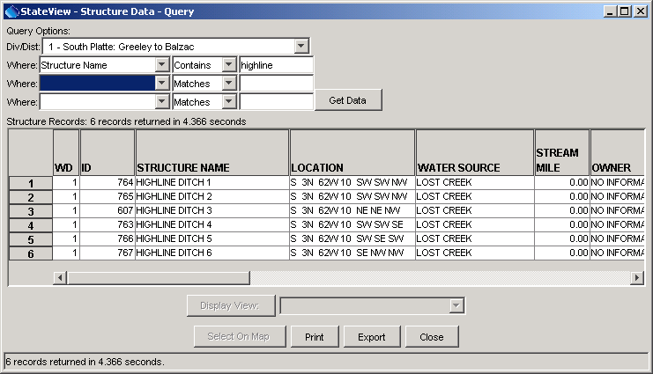
Structures_Diversion
Structure Data Query Showing Results List

Information displayed in the tabular list includes water district, identifier, name, legal location, water source (stream, lake, etc.), stream mile (from the state line), owner, structure type, currently in use (see below), whether a trans-basin structure, sum of decreed rights, and location coordinates. These data fields are available for all structure types in HydroBase. The currently in use flag can change from year to year and has the following possible values (from State of Colorado Water Commissioner Manual):

A |  | Active structure with contemporary diversion records
B |  | Structure abandoned by the court
C |  | Conditional structure
D |  | Duplicate, ID is no longer used
F |  | Structure used as FROM number – located in another District
H |  | Historical structure only – no longer exists or has records, but has historical data
I |  | Inactive structures which physically exist but no diversion records are kept
N |  | Non-existent structure with no contemporary or historical records
U |  | Active structures but diversion records are not maintained

Unlike the Data...Stations display, where multiple stations can be selected and viewed together, structure views are displayed by first selecting a single structure (click on the list) and then selecting a view from a list of available views. This approach is taken because available structure views depend on the structure type and structures have several related views. The following buttons can be pressed to act on the structure list:

Display View | Display the selected view for the selected structure. See below for a list of views.
Select On Map | If the map interface is enabled and structure data are available on the map, select the stations on the map. Warning: only diversion, reservoir, and well data (for some divisions) are typically available for maps. Not all data types may have corresponding map layers.  See Chapter 7 - Examples of Use for information about interacting with the map interface.
Print | Print the contents of the list.
Export | Export the contents of the list to a file.
Close | Close the Structure Data window.

Once a structure is selected from the list, the list of available views next to the Display View button is updated, based on the structure type. The following views are available:

Available Structure Display Views

View Type | Structure Type | Description
Detail | Any | Detailed information specific to the structure type; the view choice will be specific to the structure type (Jurisdictional Dam - Detail, Minimum Flow Reach - Detail, Non-Jurisdictional Dam - Detail, Reservoir – Detail). Headgates and wells do not have additional detail data.
Diversion Coding/  Reservoir Releases | Headgate, Reservoir | Historic diversion coding (diversion time series), which may include reservoir releases.
Historical Reservoir Measurements | Reservoir | Time series associated with reservoirs (e.g., elevations, storage)
Irrigated Acres by Parcel | Any | Irrigated acreage information associated with the structure.
Location | Any | Location information
More Structure Information | Any | More structure information that is available for any structure but which does not fit on the main Structure Data screen
Owner/Contact Information | Any | Owner and contact information
Structure Summary | Any | A summary of several data values for the structure, including water rights, irrigated acreage, and diversion coding, if available.
Water Rights - Transaction,  Water Rights - Net Amounts | Headgate, Minimum Flow Reach, Reservoir, Well | Water rights associated with the structure. Note that wells with water rights may or may not also be represented in the Data...Well Permits displays.

Examples of each view are provided in the following sections.

4.5.1 Detail - Jurisdictional Dam

The structure Jurisdictional Dam - Detail view shows information for jurisdictional (non-exempt) dams, as shown in the following figure.

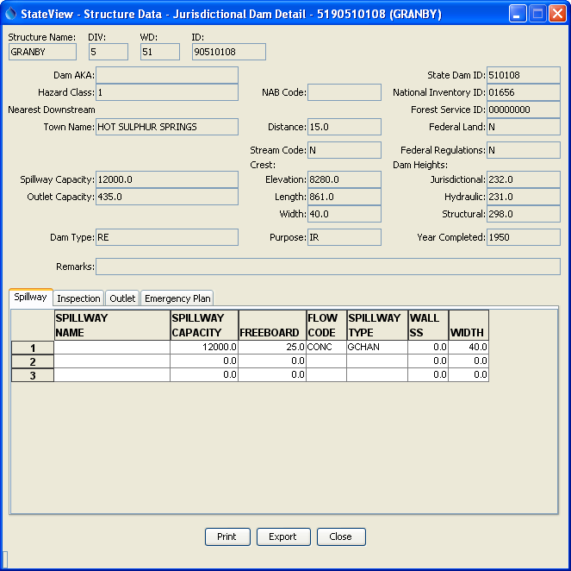
Structure_JurDam_Detail
Jurisdictional Dam Detail View

Note that several tabbed displays can be viewed at the bottom of the view for Spillway, Inspection, Outlet, and Emergency Plan data.

4.5.2 Detail - Minimum Flow Reach

The structure Minimum Flow Reach - Detail view shows information for minimum flow reaches, as shown in the following figure.

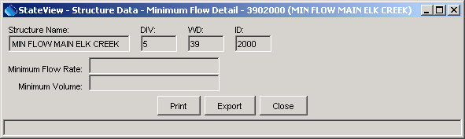
Structure_MinFlowReach_Detail
Minimum Flow Reach Detail View

Currently, HydroBase does not include the CWCB’s instream flow database (it mainly includes information related to water rights). The CWCB database is being linked to HydroBase and may be available in the future.

4.5.3 Detail - Non-Jurisdictional Dam

The structure Non-Jurisdictional Dam - Detail view shows information for non-jurisdictional (exempt) dams, as shown in the following figure.

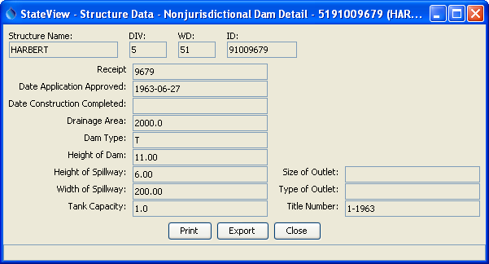
Structure_NonJurDam_Detail
Non-Jurisdictional Dam Detail View

4.5.4 Detail - Reservoir

The structure Reservoir - Detail view shows information for reservoirs, as shown in the following figure.

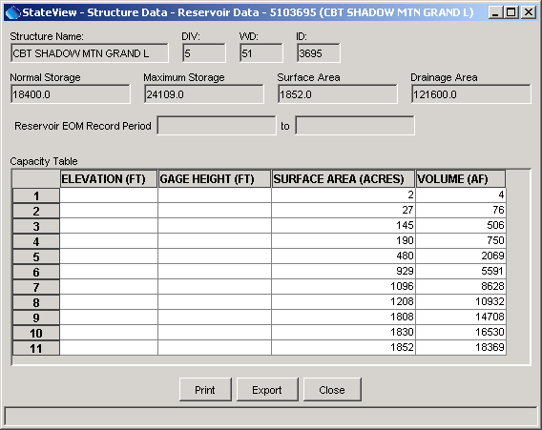
Structure_Reservoir_Detail
Reservoir Detail View

4.5.5 Diversion Coding/Reservoir Releases

The Diversion Coding/Reservoir Releases view provides access to historic diversion coding and reservoir release (time series) records in graphical, report, and tabular formats. Diversion coding applies to diversion and reservoir administrative data. When this view is initially selected, the following dialog is displayed, which lists the available diversion coding combinations.

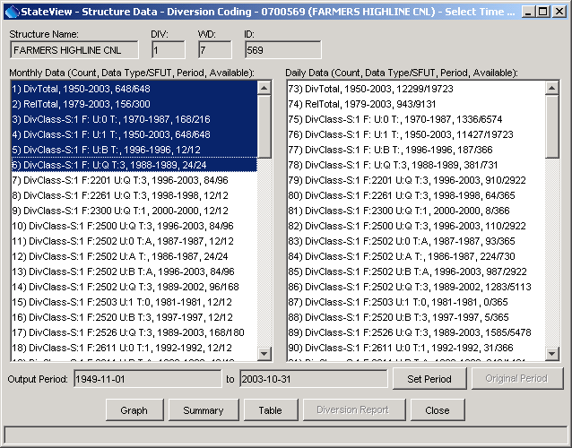
Structure_Headgate_DiversionCodingList
Diversion Coding Time Series List Dialog

As shown in the above example, time series that are available for a structure are categorized by diversion total, release total, and SFUT (source, from, use, type) water classes. The SFUT values are explained in the State of Colorado Water Commissioner Manual. One or more time series can be selected from the list and can consequently be viewed by pressing the Graph, Summary, or Table buttons. The Output Period that is shown is adjusted automatically as time series are selected but can also be manually set with the Set Period button.

This display does not currently list infrequent diversion or diversion comments. These time series can be viewed in the Structure Summary display and TSTool software.

An example of a graph for the above time series is shown in the following figure. See the TSView Time Series Viewing Tools Appendix for more information about time series viewing tools.

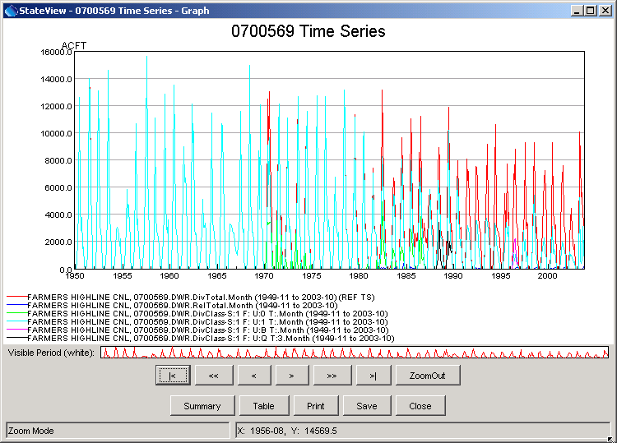
Structure_Headgate_DiversionCodingGraph
Example Diversion Coding Graph

Diversion/reservoir coding data also can be viewed and processed using the CDSS TSTool software.

4.5.6 Historical Reservoir Measurements

The structure Historical Reservoir Measurements view is only available for reservoirs. It lists in tabular form the reservoir measurements that are recorded on a day.

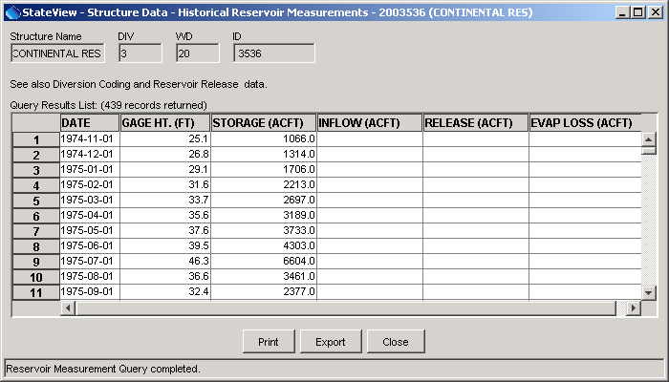
Structure_ReasMeas
Historical Reservoir Measurements View

Records are typically not continuous and all data types may not be available for a reservoir.

Reservoir measurement data also can be viewed and processed using the CDSS TSTool software.

4.5.7 Irrigated Acres by Parcel

The structure Irrigated Acres by Parcel view shows the irrigated acres associated with a structure.

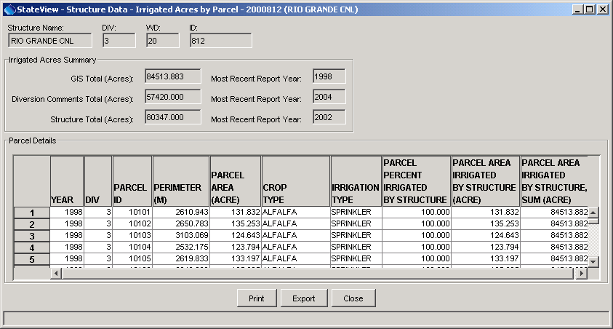
Structure_IrrigatedAcres
Irrigated Acres by Parcel View

Irrigated acres are shown by year, parcel identifier, crop type, and irrigation method. The percent of the parcel irrigated by the structure is also shown, which allows calculation of the acres irrigated. The total acres irrigated by the structure for a year are also shown, repeated in each row. The parcel data are typically determined during the irrigated lands assessment that is performed to support consumptive use modeling for CDSS projects. The spatial data and attributes are loaded into HydroBase to facilitate queries.

Irrigated parcel data also can be viewed and processed using the CDSS TSTool software.

4.5.8 Location

The structure Location view provides location-related information about a structure.

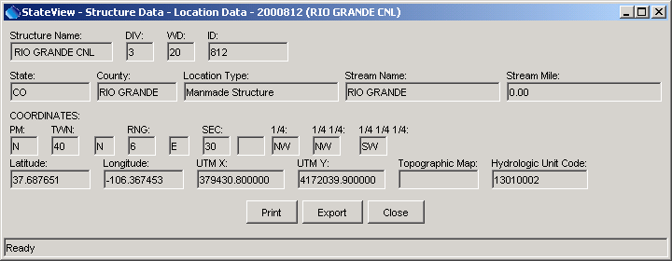
Structure_Location
Location View

4.5.9 More Structure Information

The structure More Structure Information view provides additional information common to all structure types that will not fit on the main structure display. Use available Detail views described previously to see information specific to a structure type.

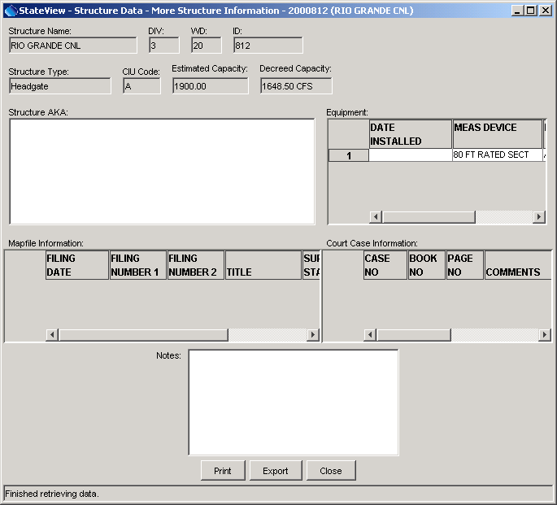
Structure_MoreStructure
More Structure Information View

4.5.10 Owner/Contact Information

The structure Owner/Contact Information view provides information about the owner of the structure.

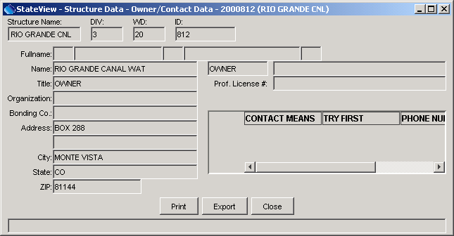
Structure_Owner
Structure Owner/Contact Information View

4.5.11 Structure Summary

The Structure Summary view displays summary information for a structure.

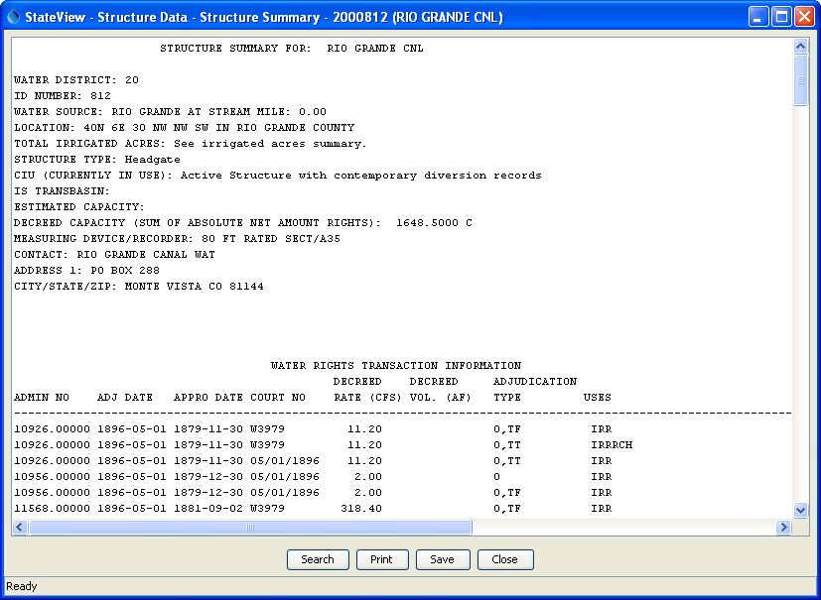
Structure_Summary
Structure Summary View for a Headgate

This report summarizes structure information from several database tables, including:

- Structure identifier, name, location, and physical characteristics
- Water rights
- Irrigated acreage
- Diversion and reservoir release records

The report is useful when one or a few structures are of interest.

4.5.12 Water Rights - Net Amounts

The structure Water Rights - Net Amounts view for a structure is the same as the general Data...Water Rights view, constrained to show only the structure of interest. See Section 4.6 - Water Rights for more information.

4.5.13 Water Rights - Transaction

The structure Water Rights - Transaction view for a structure is the same as the general Data...Water Rights view, constrained to show only the structure of interest. See Section 4.6 - Water Rights for more information.

4.6 Water Rights

The Data...Water Rights menu displays transaction and net amount water rights as raw data and reports. The following figure illustrates the Water Rights Query display.

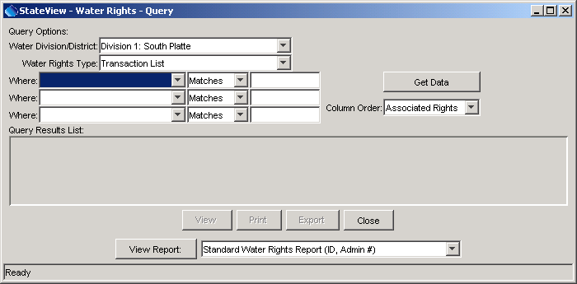
WaterRights
Water Rights Query

To display water rights data, first select query options, as described below:

Water Division/District | The water division and district are used to limit queries to a region. The available options are typically constrained using the Tools...Options...Water District Filter settings.
Water Rights Type | The water rights type can be either Transaction List (the individual transactions that have occurred over time) or Net Amounts (the resulting sum of the transactions). The available output formats depend on the water right type.
Where | Use the Where list to choose additional criteria for limiting a query. To see an explanation of the choices, do a simple query, and then use the tool tips for each column heading.  Use the Location choice to query by legal location. To input the location, click in the entry field, which will cause the following dialog to be displayed:  Location_Dialog  Wildcard characters (*) can be used to make the search as broad as desired.
Column Order | If the Legal column order is selected, then the legal location is shown before other information. If the Summary column order is selected, the legal location information is shown at the right end of the table. The column order is changed after data are queried.
Output Format | After water rights are displayed to the screen as raw data, the results can be formatted and displayed in a report window. The format of the report, including sort order, is predefined for reports; therefore, the data may be requeried if the displayed order is not consistent with the report. Displaying the raw data is useful because it can be exported to a delimited format (e.g., for use with a spreadsheet) and the query options can be used to narrow the query. Printing some of the reports may require landscape and/or oversized paper (this is not automatically selected).

Initiate a query by pressing the Get Data button or press Enter while the mouse cursor is in the Is field. Queries for an entire district or division can take several minutes but typically require only a few seconds. The results from the query are displayed in list format, as illustrated in the following sections.

4.6.1 Net Amount Water Rights

The following figure illustrates a net amounts water rights data view.

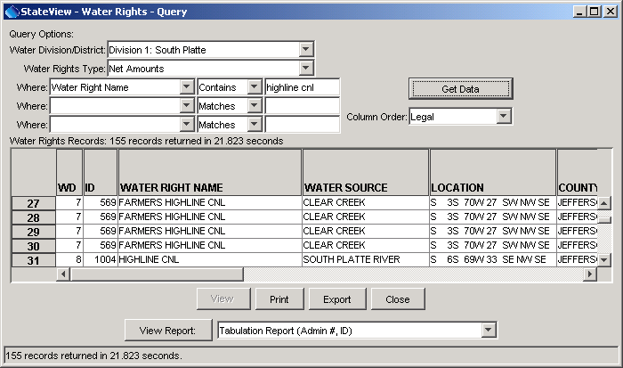
WaterRights_Net_List
Water Rights View Showing Net Amounts List

The water rights data display includes a large number of columns. This format is useful for finding specific data items. However, standard reports are also available that organize data in useful formats. To view the water rights in a report format, select the appropriate format from the View Report choices. If necessary, the database will be requeried in order to sort data as needed for the report. Available net amounts reports are as follows and adhere to existing report formats, as much as possible.

Available Net Amounts Water Right Reports

Net Amounts Output Format | Sort Order
Administrative Summary List | Admin #, ID
Administrative Summary List by Stream | Stream, Admin #, ID
Priority List | Admin #, ID
Priority List by Stream | Stream, Admin #, ID
Stream Alphabetical List | Stream, Name, Admin #
Tabulation Report | Admin #, ID

The following figure illustrates a net amounts tabulation report.

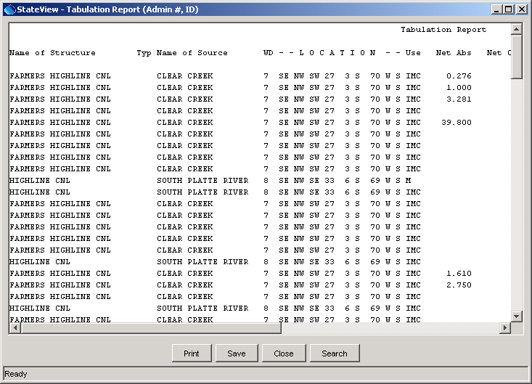
WaterRights_Net_Tabulation
Net Amounts Water Rights Tabulation Report

In addition to the water rights data list and reports, a single net amount water right can be viewed in expanded form by selecting the water right in the list in the Water Rights Query window and then pressing the View button. The following figure illustrates the resulting view.

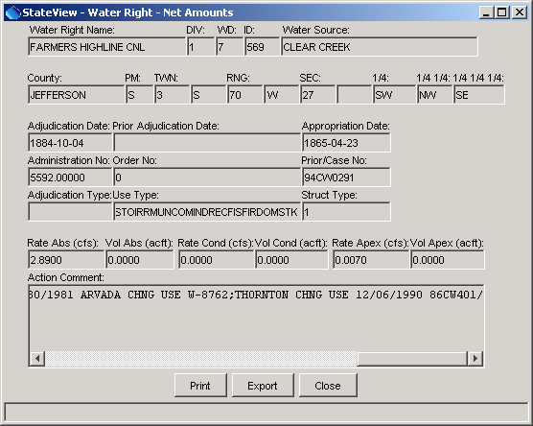
WaterRights_Net_View
Example Net Water Right View

4.6.2 Water Rights Transaction List

The following figure illustrates a water rights transaction list data view.

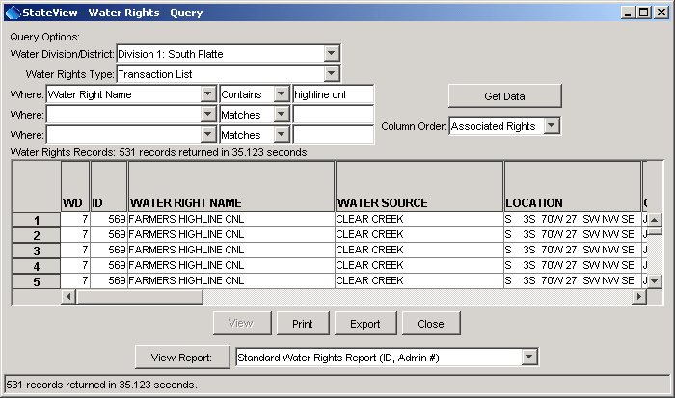
WaterRights_Transaction_List
Water Rights Transaction List View

The transaction list view includes a large number of columns. This format is useful for finding specific data items. However, standard reports are also available that organize data in useful formats. To view the water rights in a report format, select the appropriate format from the View Report choices. Available transaction list reports are as follows and adhere to existing report formats, as much as possible. The standard and extended reports are very similar, with the extended report having comments.

Available Water Right Transaction List Reports

Transaction List Output Format | Sort Order
Standard Water Rights Report | ID, Admin #
Standard Water Rights Report | Stream #, ID, Admin #
Standard Water Rights Report | Name, Admin #
Standard Water Rights Report | Location
Standard Water Rights Report | Admin #, Name
Standard Water Rights Report | Stream #, Admin #, ID
Extended Water Rights Report | ID, Admin #
Extended Water Rights Report | Stream #, ID, Admin #
Extended Water Rights Report | Name, Admin #
Extended Water Rights Report | Location
Extended Water Rights Report | Admin #, Name
Extended Water Rights Report | Stream #, Admin #, ID

In addition to the water rights data list and reports, a single water right transaction can be viewed in expanded form by selecting the water right in the list in the Water Rights Query window and then pressing the View button. The following figure illustrates the resulting view.

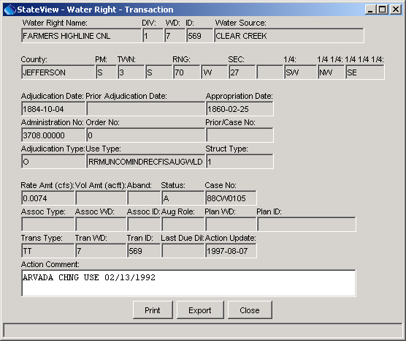
WaterRights_Transaction_View
Water Right Transaction View

4.7 Well Permits

The Data...Well Permits menu displays information associated with well permits. Because these data are not typically distributed to the public with HydroBase, the Data...Well Permits menu is only enabled if at login the SQL Server database is selected for a non-guest login. The following figure illustrates the Well Permit Query display.

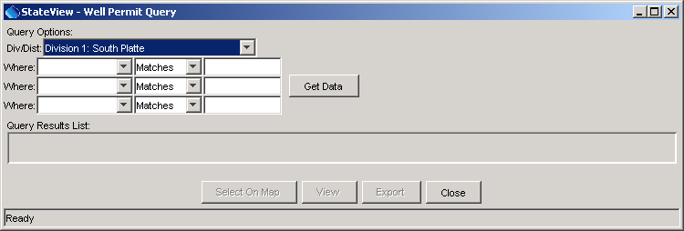
WellPermits
Well Permit Query

To display well permit data, first select query options, as described below:

Div/Dist | The water division and district are used to limit queries to a region. The available options are typically constrained using the Tools...Options...Water District Filter settings.
Where | Use the Where list to choose additional criteria for limiting a query. To see an explanation of the choices, do a simple query, and then use the tool tips for each column heading.  Use the Location choice to query by legal location. To input the location, click in the entry field, which will cause the following dialog to be displayed:  Location_Dialog  Wildcard characters (*) can be used to make the search as broad as desired.
Initiate a query by pressing the Get Data button or press Enter while the mouse cursor is in a Where text field. Queries of entire districts or divisions may require a few minutes to return results, but typically only a few seconds are required. Because some districts have many thousands of wells, it may be necessary to use the location Where selector to limit the query.

The results from the query are displayed in list format, as illustrated in the following figure:

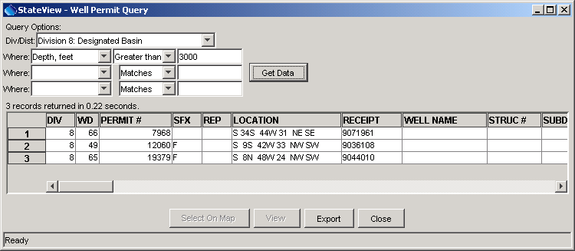
WellPermits_List
Well Permit Query List

Information displayed in the tabular list includes water district, permit number, suffix and replacement code, legal location, receipt, name, and many other data fields. Currently, well permits cannot be displayed on the map. The list of permits can be exported to a file.

Selecting a well permit from the list and pressing the View button displays a detailed view of the specific well permit, as shown below. This interface illustrates the meaning of the different fields in the list view shown previously.

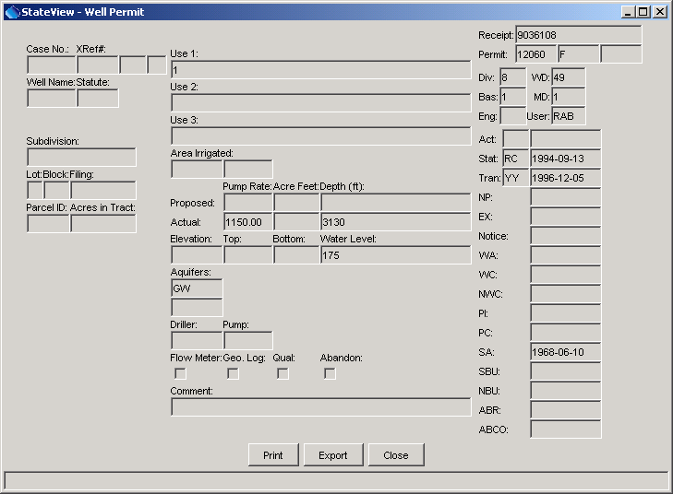
WellPermits_View
Well Permit Data

