6 Tools
Version 4.02.00, 2005-08-03, Color, Acrobat Distiller

The Tools menu provides access to useful tools and allows program options to be set.

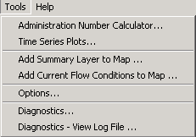
Menu_Tools
Tools Menu

6.1 Administration Number Calculator

The Tools…Administration Number Calculator menu displays an interface to convert between appropriation and prior adjudication dates and the administration number, all of which are used by the State of Colorado to indicate the seniority of water rights. The administration number is a useful representation because it allows priorities to be quickly sorted.

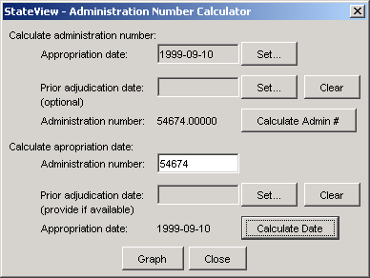
Tools_AdminNumCalc
Administration Number Calculator

The administration number depends on the appropriation date and prior adjudication date for a water right and in simple terms is the number of days since 1849. Use the calculator to convert between dates and the administration number. Use the upper part of the dialog to calculate the administration number from dates and the bottom to calculate the dates from the administration number. Use the Calculate Admin # and Calculate Date buttons to perform the calculations. In the above example the date was entered in the top to compute the administration number. The administration number was then entered in the bottom to compute the date. The information should be consistent. Use either of these options as needed. Press the Graph button to see a graph of whole administration numbers over time (ignoring the prior adjudication date).

6.2 Time Series Plots

The Time Series Plot tool can create plots for time series of different data type and time step and is a generic plotting tool. Whereas older versions of the plotting tool used the term template to describe a graph configuration, the current tool uses the term time series product. The time series product configuration features are essentially the same that are available in the general plotting tool described in the TSView Time Series Viewing Tools Appendix. The main additional feature is that an interface is provided to retrieve time series products from HydroBase and save modified products back to HydroBase. The feature to display real-time data shifted to overlay historical data has been removed because the features were not extensively utilized in StateView/CWRAT and similar features are available in the TSTool software.

A time series product consists of a list of time series identifiers and configuration properties to describe one or more graphs on a “page”. Time series identifiers are determined internally by the software and conform to the conventions described in the TSTool software documentation (see also the TSView Time Series Viewing Tools Appendix for background). Properties include titles, graph types, colors, symbols, etc. In order to facilitate reuse of time series products, the definitions of time series products can be saved to HydroBase, for the current login, and can be saved to text files (*.tsp), for later use or to share with other software like TSTool.

The remainder of this section describes how the Tools...Time Series Plots features are used to define and retrieve time series products, and how to display the graphs associated with the products.

When the Tools...Time Series Plots menu is first selected, you will be prompted to select an existing time series product or create one, as shown in the following figure.

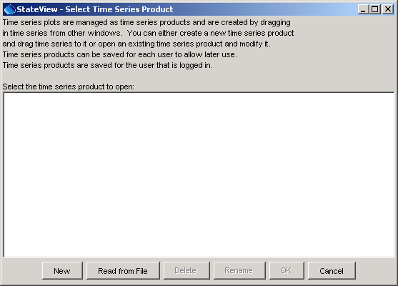
Tools_TSPlot_Load
Select Time Series Product Dialog

Note that if logged in as guest, you cannot save the plot configuration to HydroBase but you can save as a time series product file (see below). The following buttons are available in the load dialog:

New |  | Create a new time series product – see Section 6.2.1 – Create a New Time Series Product below.
Read from File |  | Read an existing time series product from a file (instead of from HydroBase). For example, read a time series product file created with the TSTool software.
Delete |  | Delete the selected time series product from the list.
Rename |  | Rename the selected time series product.
OK |  | Load the selected time series product from HydroBase.
Close |  | Close the time series product load dialog.

6.2.1 Create a New Time Series Product

Creating a new time series product involves the following steps. Although the initial configuration will involve using a number of windows in StateView/CWRAT, once the configuration is complete, displaying the resulting time series product is much simpler). It may be simpler to use the TSTool software to create the initial time series product.

- From the Select Time Series Product dialog, press New. The following dialog will be displayed.

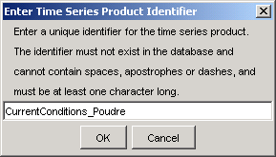
Tools_TSPlot_New

- Enter a unique identifier for the product. The previous Select Time Series Product dialog will list existing products; therefore, refer to the list to avoid using the same identifier. After entering an identifier, press OK. A blank graph and its related properties window will appear, as shown in the following example (the windows have been arranged to facilitate discussion).

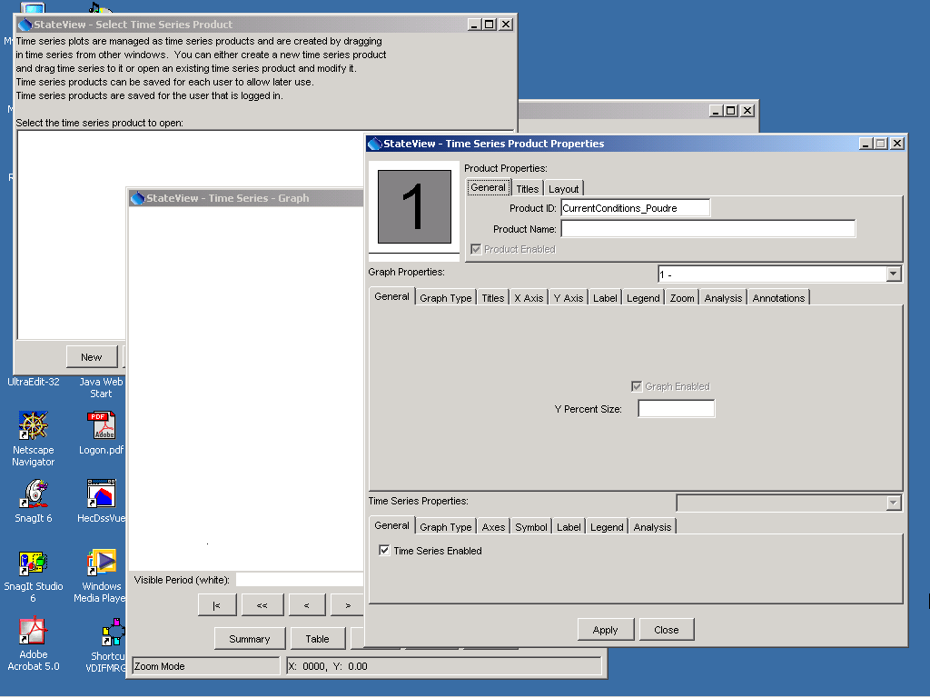
Tools_TSPlot_NewBlank

StateView/CWRAT tries to position the windows appropriately but you may need to move them around. The Time Series - Graph window (initially blank) displays the results of processing the time series product (in this case a graph) and the Time Series Product Properties window is used to configure the product (set titles, etc.). The properties window displays the time series product identifier at the top. It is suggested that you also enter a name, which will be used to list time series products during the initial selection/load.

The graph window is blank because no time series have been specified. To add time series, use the properties window layout area (the small graphic in the upper left that displays a large number for each graph on the page). Time series will be dragged from other StateView/CWRAT windows to this area, as described below.

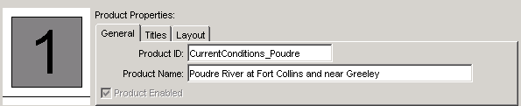
Tools_TSPlot_Layout

- Add time series to the time series product. The TSView Time Series Viewing Tools Appendix describes the functionality of the properties window. Within StateView/CWRAT, time series are added to a time series product by dragging the time series from Data menu display windows and dropping them onto the layout area. Time series to be added to the graph can be dragged to the layout window from the windows indicated below. To do so, select the indicated item and hold the mouse down while dragging the item – the cursor will change to a (although there is sometimes a delay). When the cursor is over the layout window (the area with a large 1 in the above figure), release the mouse and the time series will be added to the indicated graph. To display the data in the graph, a query will be performed, resulting in slight delay. The windows from which time series can be dragged are:

  - The Station Data window – perform a station query and then select and drag one row at a time from the time series list table. This allows all historical and real-time station data to be selected.
  - The structure Diversion Coding/Reservoir Release window – select and drag one row at a time from the list of available time series. This allows the major time series data for structures to be selected.
  - The Ground Water Data window for well level data – select and drag one row at a time from the list of available wells.

For example, use the Station Data window to select real-time data and drag onto the time series product, as follows:

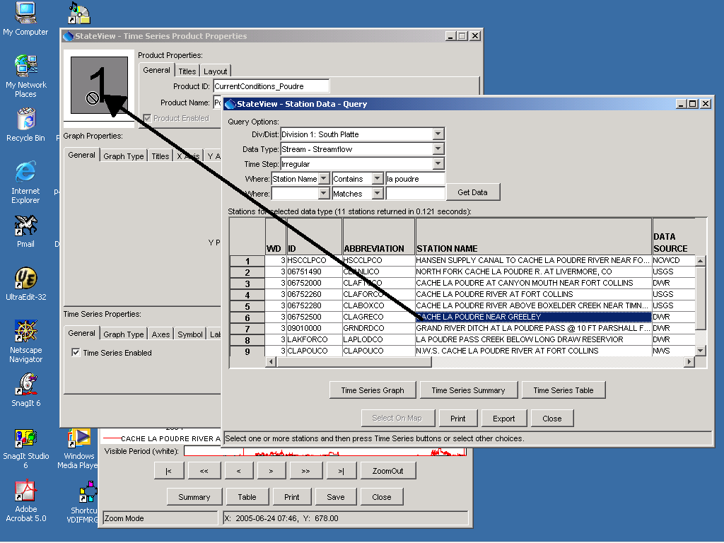
Tools_TSPlot_Drag
Example of Dragging a Time Series from a Display Window to the Time Series Product Layout

Note that only a single time series can be dragged at one time. Therefore, if multiple time series are to be displayed in the graph, each will need to be dragged separately.

After adding time series to the layout, the graph window will appear similar to the following:

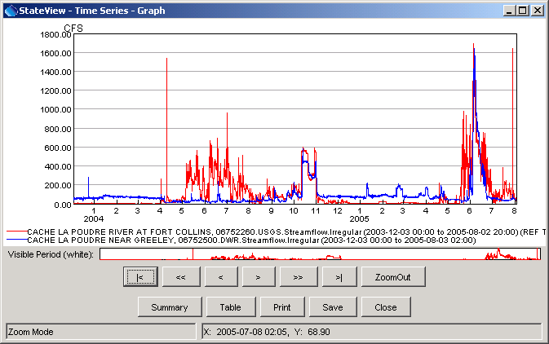
Tools_TSPlot_Graph1
Example Time Series Product Graph after Adding Time Series

Using the drag and drop approach allows the general plotting tools described in the TSView Time Series Viewing Tools Appendix to be used throughout StateView/CWRAT, while relying on existing Data displays to query data. Consequently, the Time Series Plots tool can focus on graphs and avoid duplicating query features.

- Configure the plot appearance using the Time Series Product Properties window. To configure the plot more specifically, set additional properties. The following figure illustrates the graph after setting titles and adding annotations. Press the Apply button in the properties window to redraw the graph.

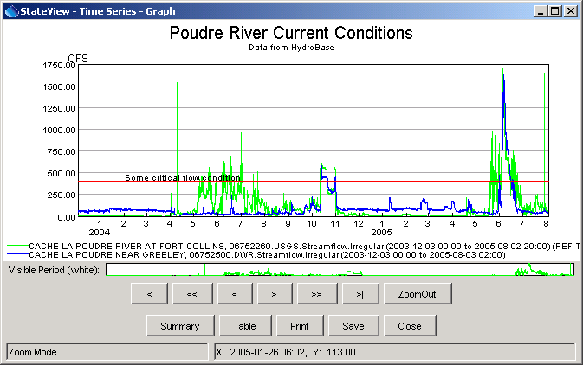
Tools_TSPlot_Graph2
Example Time Series Product Graph after Adding Titles and Annotations

This simple example illustrates the power and flexibility of time series products. If the existing features cannot create a product that is needed, enhancements can be made to add new properties for the graph. Refer to the TSView Time Series Viewing Tools Appendix for full details about configuring time series products.

- Save the time series product. After adding time series and setting graph properties, use the Save button on the bottom of the graph window to save the configuration to HydroBase. This will save the time series product identifier and name so that the product can be reused later (see Section 6.2.2 – Using an Existing Time Series Product below). Trying to close the graph without saving will display a warning to remind you to save. The time series product can be saved to HydroBase or a text time series product file, which can be used by TSTool. If using the SQL Server database, you will only be able to save a time series product if logged into someone other than guest.

All of the time series can be graphed independently in various display windows. Therefore, time series products should only be used where a complicated graph needs to be composed. It may be more efficient to use TSTool to create the plots and then import the time series products into StateView/CWRAT.

Note that when graphing time series, all available real-time data in the database are shown, which may result in a longer period than desired. This is generally not an issue because the real-time data tables in HydroBase are limited to a relatively short period and because the graphing tools allow zooming in to a shorter period.

6.2.2 Using an Existing Time Series Product

Using an existing time series product to display a graph involves the following steps:

- Select the Tools…Time Series Plots menu item.
- From the Select Time Series Product dialog, select a product that has been stored in HydroBase and, as shown in the following figure:

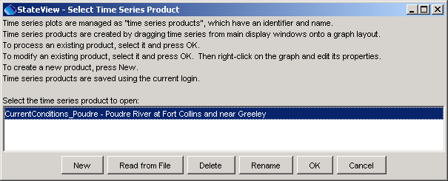
Tools_TSPlot_LoadExisting

- Press OK, or load a time series product file using Read from File. The graph will be displayed, as shown previously. A pause will occur as the database is queried for data. The size of the window will be the default graph size and may need to be changed for optimal viewing.

- If changes are desired, right-click on the graph and press the Properties menu choice. Set properties or drag new time series onto the graph as described in Section 6.2.1 – Create a New Time Series Product above. To save the changes over the existing time series product, use the Save button on the graph window.

6.3 Add Summary Layer to Map

The Tools…Add Summary Layer to Map menu allows data from a delimited file to be displayed on the map, by joining with spatial data. This tool is only available when the map display is shown and vertical scaled bars are the only symbols that are available. The current flow conditions map (see next section) uses this tool, internally handling all of the data preparation. The general tool is being provided to facilitate data viewing; however, some technical issues remain (e.g., optimizing the performance and performing joins on WDID locations, where one or two identifier fields may be provided for the join. See the Installation and Configuration Appendix for more information about configuring map data for use with StateView/CWRAT. Using this tool with many records (thousands) can be slow.

To add a summary layer to the map:

- Prepare a delimited input file. Typically this file should contain station identifiers and numerical data to display. For example, data from the normal structure and station tabular displays can be exported to a comma-delimited file, or a spreadsheet can be saved as a CSV file.
- Select the Tools…Add Summary Layer to Map menu and select the file from step 1.
- The input file will be read and the following dialog will be displayed, prompting for more information:

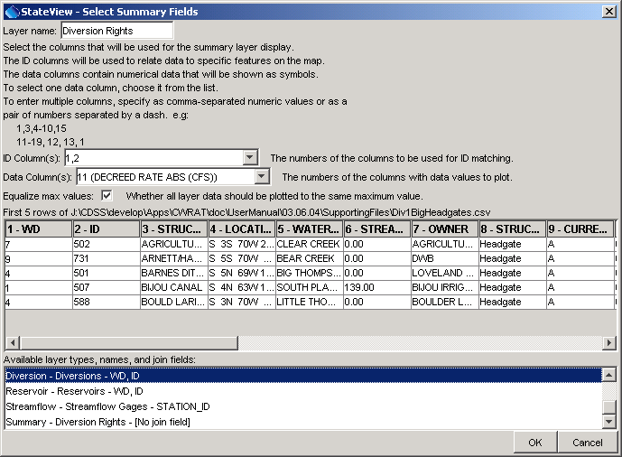
Tools_AddSummaryToMap_Select
Summary Map Layer Tool Interface

Provide the required information about the file, to allow the software to complete the display.

Layer Name |  | A name to be displayed in the map layer list (table of contents).
ID Column(s) |  | Indicate the column numbers for identifier information, to be used to match the data records with the spatial data features. The order of the columns should match the join fields shown for available layers at the bottom of the window.
Data Column(s) |  | One or more column numbers, for the columns to be displayed.
Equalize max values |  | If more than one column of data are used, selecting the checkbox will cause the maximum values for both data columns to be scaled to match on the map.

- Press OK to display the layer on the map. Warnings may result if locations on the map cannot be found – this is can usually be ignored. See the next section for an example display and information about labeling data.

6.4 Add Current Flow Conditions to Map

The Tools…Add Current Flow Conditions to Map menu will display the current flow conditions on the map. This tool is only available when the map display is shown and real-time data are available in HydroBase. The steps used to produce the map are as follows:

- HydroBase is queried to determine the real-time streamflow stations for the division that has been selected at login (the division selection controls the map that is displayed). Warning: the HydroBase design does not distinguish between real-time gages and monitored structures; therefore, some values that are displayed will not be natural stream channels.
- HydroBase is queried to read the real-time streamflow time series for DISCHRG data types. This is essentially the same action that is done from the Stations query when displaying real-time streamflow data. Data from the current time, minus one day is requested. During this step, it is possible that a warning will be displayed, indicating that time series for some real-time stations are not available. This warning can usually be ignored, especially if the number of stations with missing data is low.
- The time series data are examined and the most recent value is used to display on the map. The time for the observation is also saved for labeling the map (see below). Because a window of one day is allowed for data, it is possible that flow values across a region will not be for a single point in time. However, the pattern of flows will generally be reasonably accurate. Real-time stations that are not reporting will typically be delayed only by a short time or will not report for the full period being analyzed. See below for instructions for how to view the measurement times.
- The real-time station identifiers are compared with the identifiers for station layers on the map. It is possible that some stations will not have locations and a warning will be shown. This warning can usually be ignored, especially if the number of stations with missing data is low.
- A summary map layer is added to the map, using bars to indicate relative flow amounts. The map legend displays the maximum value displayed.

The following figure illustrates current flow conditions, indicated with vertical bars:

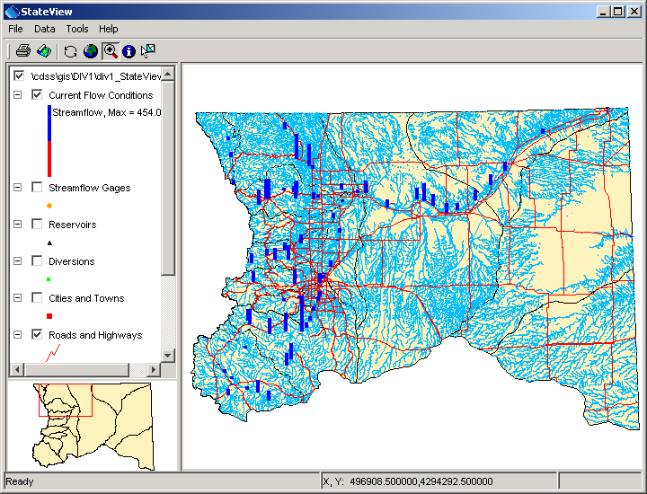
Tools_AddCurrentFlowToMap
Results of Using the Current Flow Conditions Tool (South Platte Basin)

By default, the flow values are not labeled because the display becomes too cluttered. An easy way to view the observation times is:

- Select the Current Flow Conditions layer in the layer list.
- Right-click, press View Attribute Table, and locate the station(s) of interest.

To label the observation times on the map when Current Flow Conditions has been selected:

- Right-click and press Properties, select the Label tab.
- Specify that the label should use the flow date and/or other information. See the GeoView Mapping Tools Appendix for more information.
- Zoom in to a smaller region to make the map labels more readable.

To remove the flow conditions from the map:

- Disable the Current Flow Conditions layer checkbox – this will cause the layer to not be drawn.
- Select the Current Flow Conditions, right-click, and press Remove Layer to remove from the map.

6.5 Options

The Tools...Options menu allows viewing and changing StateView/CWRAT configuration settings. Options are displayed in tabbed panels. Options are typically set for a user and are associated with the login that is being used. Guest users may be prevented from changing options, especially if a SQL Server database is used. The various tabs display different settings, as described in the following sections. Some options are independent of the Water Division that was selected at login. However, the Water District Filter and Map options are saved for each Water Division and for a default case to be used when no Water Division is selected at login.

6.5.1 Administration Options

Administration options are available only when running CWRAT and are used to control settings for the Edit Calls and Water Information Sheet features.

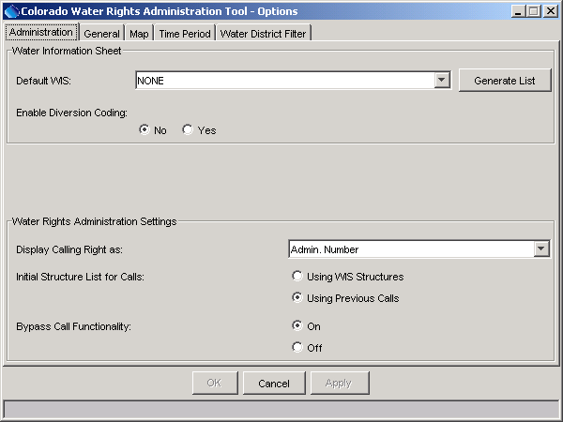
Tools_Options_Administration
Administration Options

Administration options are as follows:

Default WIS | Select a default Water Information Sheet to be highlighted for the Load WIS dialog, which is displayed when the Administration…Water Information Sheet menu item is selected. The sheets that are accessible are listed and the list can be regenerated if a new sheet is added elsewhere in the program.
Enable Diversion Coding | Enable/disable diversion coding features in the WIS (enabling diversion coding provides more WIS features but may not be desirable for all users). Using diversion coding allows diversion coding details to be stored as values are entered on the main WIS display.
Display Calling Right as | Sets the defaults for rights information display, in particular for the Administration...Edit Calls interface in CWRAT.
Initial Structure List for Calls | When setting a call with CWRAT, a list of structures is provided. This list, if taken from HydroBase, can be very long. Consequently, the initial list can be taken from available Water Information Sheets or previous calls (i.e., structures that are actually being administered using CWRAT).
Bypass Call Functionality | Enables or disables the bypass call functionality in the CWRAT Administration...Edit Calls interface (used by Division 1).

6.5.2 General Options

General options are used throughout StateView/CWRAT. The export format option that was available in previous versions of StateView/CWRAT is now provided in file choosers when an export occurs.

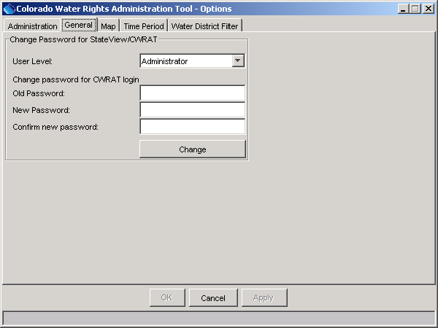
Tools_Options_General
General Options

General options are as follows:

User Level | The user level is used internally by the software to determine which software features to turn on. Choices are View Only, Advanced User, Administrator, and Other (used by developers). This feature is being evaluated.
Change Password | Use these fields to change the SQL Server HydroBase StateView/CWRAT password for the current login.

6.5.3 Map Options

Map options control the use of the map interface.

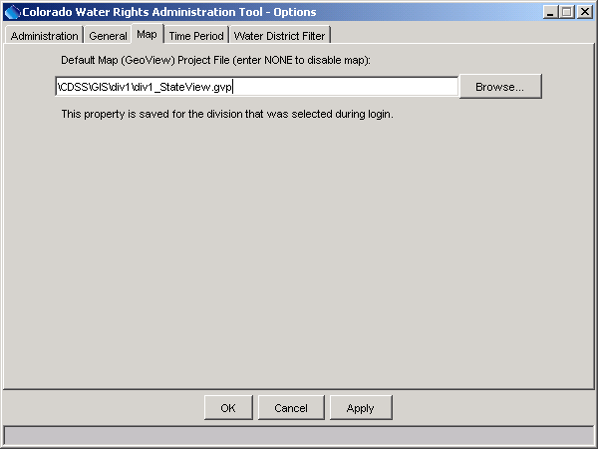
Tools_Options_Map
Map Options

Currently the only map option is the name of the GeoView project file (.gvp), which is used to define the map layers displayed in the main interface map. If NONE is specified, then no map interface will be used. If a path to a file is specified, an absolute path with or without a drive letter (as shown) can be given. The latter is more general but may not be explicit enough if StateView/CWRAT is run in a network environment from various drives.

See the GeoView Mapping Tools Appendix for information about the map interface. See also Chapter 7 - Examples of Use for information about using the map interface.

In many cases, the HydroBase database administrator will have configured the guest login so that the map interface is appropriate for the Water Division that is selected at login.

If CDSS software and data are pre-configured, the path to the .gvp file may not include a drive letter. This requires that the software be started from the same drive as the spatial data, in order to find the data. This is not usually a problem but refer to the Installation and Configuration Appendix if problems occur.

6.5.4 Time Period Options

The time period options indicate how to retrieve time-related data from HydroBase.

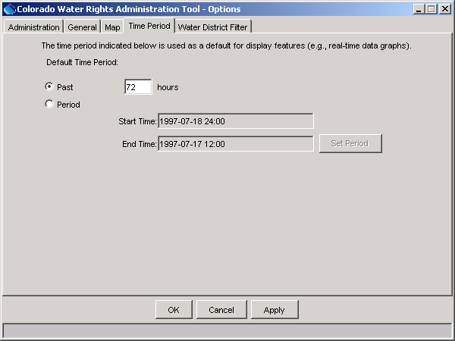
Tools_Options_Time
Time Period Options

Time period options indicate the default period for retrieving real-time data from the database (e.g., for Data...Call Chronology). The default period can be specified as a period extending back from the current time (Past), in which case the number of hours is required, or a fixed period (Period), in which case a specific period is required. In most cases, a recent period is desirable.

6.5.5 Water District Filter Options

The water district filter sets the water divisions and districts that are available in query display menus and lists.

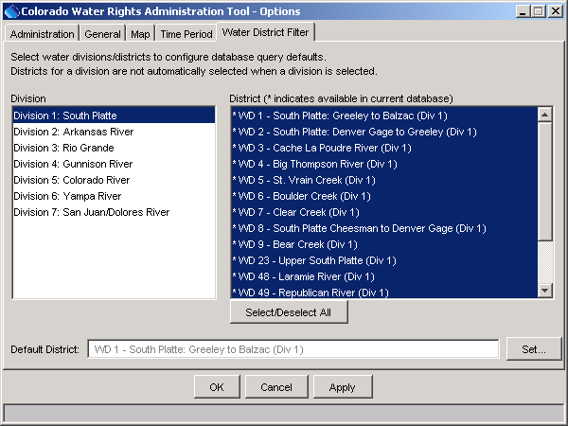
Tools_Options_WDFilter
Water District Filter Options

The water district filter is used to set reasonable defaults to limit query results. Highlighted water divisions and districts are displayed in query screens. If changes are made, visible display windows may need to be closed and reopened to activate the new settings. The districts that are available are controlled by the contents of the HydroBase database. In the above figure, the asterisks on the right indicate whether a district is available in the local database (determined by checking districts for structures that are available in HydroBase). You can also select the default district or division to be highlighted in query menus.

For State of Colorado water commissioners, a single water division and/or district may be used for most work. In this case, the filter can be constrained to only the division and/or district of interest. Doing so streamlines the use of the application by eliminating extra choices.

If you selected a Water Division when logging in to StateView/CWRAT, the setting will be saved for that Water Division. Selecting the same Water Division at the next login will then utilize the settings.

6.6 Diagnostics

Diagnostics features are useful for troubleshooting and are consistent among CDSS software, where possible. When an error occurs, a small warning dialog may be displayed, as shown in the following figure:

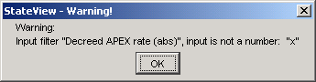
Diagnostics_Warning
Example Warning Message Dialog

If results are not as expected, also review the messages in the status bar at the bottom of the main or secondary windows.

6.6.1 Diagnostics Settings

The Tools…Diagnostics menu item displays the Diagnostics dialog, which is used to set message levels and view messages as the application runs. The Diagnostics dialog (see the following figure) can be used to evaluate a problem.

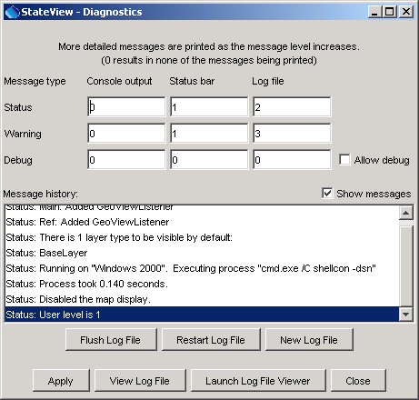
Diagnostics
Diagnostics Interface
The settings at the top of the dialog are used to specify the level of detail for messages printed to the console window, the status area at the bottom of the main window (and the Diagnostics dialog), and the log file. The log file contains warning, status, and debug messages, many of which are not normally displayed in the main interface. The log file is created in the logs directory under the installation directory (e.g., \cdss\logs\StateView_USER.log). The Diagnostics interface features are as follows:

Status, Warning, Debug |  | Enter integer values, with larger numbers resulting in more output and slower performance. Zero indicates no output. If troubleshooting, a good guideline is to set the debug level to 10 or 30 (and select the Allow Debug checkbox). The default settings are often enough for normal troubleshooting and result in good software performance.
Allow Debug |  | Select to enable debug messages. Turning on debug messages will significantly slow down the software.
Show Messages |  | Select to display messages in the Diagnostics window.
Flush Log File |  | Force messages to be written to the log file. Messages can be buffered in memory and may not otherwise immediately be written to the log file.
Restart Log File |  | Restart the log file. This is useful if a long session has occurred and troubleshooting will occur on new actions.
New Log File |  | Open a new log file, with a new name.
Apply |  | Apply the settings in the Diagnostics dialog.
View Log File |  | View the log file in an integrated window. The View Log File button will be enabled if the log file has been opened.
Launch Log File Viewer |  | View the log file using a viewer from the operating system. On Windows computers, Notepad will be used.
Close |  | Apply the settings in the Diagnostics dialog and close the window.

6.6.2 Diagnostics – View Log File

The Tools…Diagnostics – View Log File menu item displays the integrated log file viewer. Selecting this menu item is equivalent to selecting the View Log File button in the Diagnostics dialog. The log file viewer will be displayed in a window as shown in the following figure:

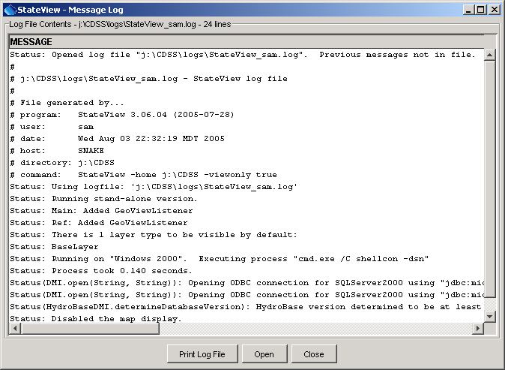
Diagnostics_ViewLog
Log File Viewer Window

The log file messages can be scrolled. To find a string in the log file, right-click and select the Find menu item. The information in the log file can also be copied and pasted into email, when contacting support.

