Appendix: StateView/CWRAT Installation and Configuration
Version 04.02.00, 2011-07-15

1. Overview

This appendix describes how to install StateView/CWRAT in the CDSS (Colorado’s Decision Support Systems) environment. StateView and CWRAT share the same software files. The main difference between the programs is that StateView does not display the Administration menu. Consequently, StateView is suitable for general users and CWRAT can be used by State of Colorado staff.

The StateView/CWRAT software can be installed on individual computers and on servers within the State of Colorado’s network for use by State of Colorado personnel.

2. File Locations

CDSS consists of the HydroBase database, modeling, and data viewing/editing software. StateView/CWRAT can be used with this system to view HydroBase data and edit administrative data.

Locations of StateView software files are as shown below (CWRAT files are similar). The _XXX notation indicates the JRE [Java Runtime Environment] version number (e.g., _16), which may change as upgrades to the system occur:

\CDSS\GIS\ |  | Geographic information system files, installed when software is installed from the HydroBase DVD (otherwise must be installed from the CDSS website).
\CDSS\StateView-Version |  | Top-level install directory.
bin\ |  | Software directory for .exe, and Java JAR files.
StateView.exe |  | StateView executable program that starts the JRE software.
StateView_XXX.jar |  | StateView main application package.
StateView.l4j.ini |  | Run-time configuration file.
HydroBaseDMI_XXX.jar |  | State of Colorado HydroBase database interface package.
sqljdbc4.jar |  | Microsoft SQL Server packages.
*.jar |  | Additional Java software packages.
doc\ |  | Main documentation directory for StateView.
UserManual\StateView.pdf |  | StateView documentation as PDF.
Training\\ |  | StateView training materials.
jre_XXX\ |  | Java Runtime Environment.
logs\ |  | Log files (should be writable).
system\ |  | Folder for system files.
CDSS.cfg |  | Configuration file for CDSS, including HydroBase connection information.
stateview.gif |  | Startup graphic for StateView.
DATAUNIT |  | Data units file.

3. Installing StateView/CWRAT

StateView/CWRAT can be installed either as part of the HydroBase Tools DVD installation, or as a separate installation. In both cases, is recommended that the default CDSS file structure be used.

3.1 Installing StateView from the HydroBase Tools DVD

If you have acquired a HydroBase DVD, StateView will be installed during the DVD install process. Refer to the installation instructions for that distribution.

3.2 Installing StateView/CWRAT from the Setup File

Use the following instructions to install StateView/CWRAT using the StateView_CDSS_Version_Setup.exe or CWRAT_CDSS_Version_Setup.exe installer program, for example if software was downloaded from the CDSS web site (http://cdss.state.co.us). The following example is for StateView, but installation is similar for CWRAT.

- Run the installer setup file by selecting from Windows Explorer or the run menu. The setup filename will include a version number (e.g., StateView_CDSS_04.02.00_Setup.exe).

You must be logged into the computer using an account with administrator privileges. If you have administrative privileges, the following welcome will be displayed, and the installation can continue:

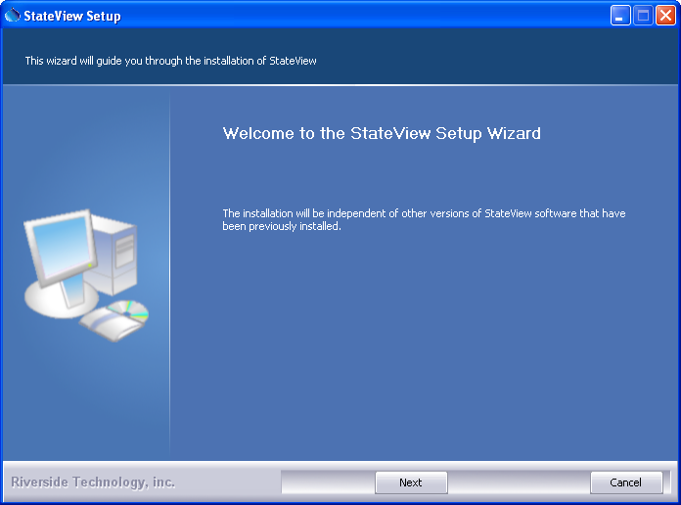
Install_Welcome

Press Next to continue with the installation.

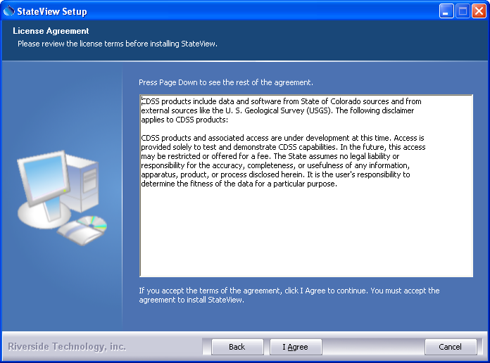
Install_Disclaimer

StateView is distributed with CDSS with no license restrictions. However the disclaimer must be acknowledged. Press I Agree to continue with the installation.

- Several components can be selected for the install as shown in the following dialog. Position the mouse over a component to see its description. It is recommended that the defaults are used.

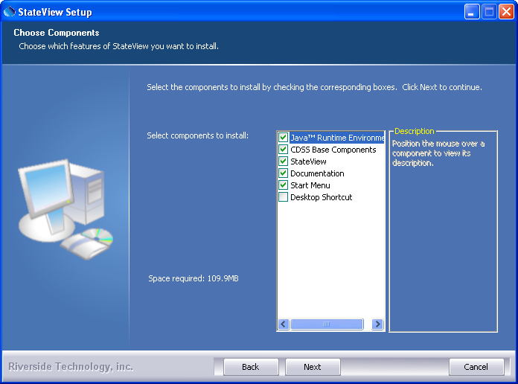
Install_SelectComponents

Select the components to install and press Next.

- The following dialog is then shown and is used to select the installation location for StateView/CWRAT. Multiple versions of StateView/CWRAT can be installed and there are no dependencies between the versions. It is recommenced that the default install location shown is used.

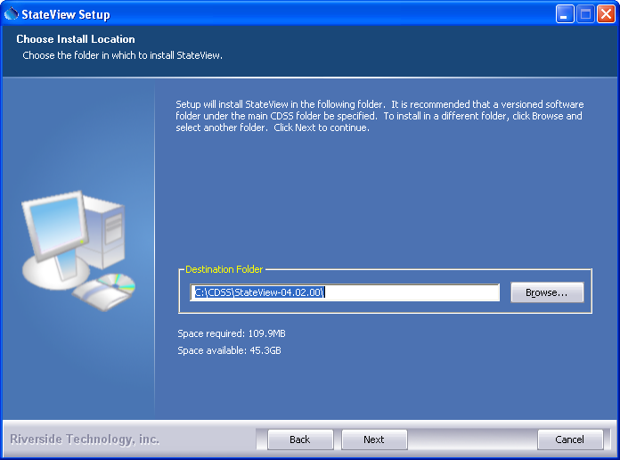
Install_SelectFolder

After selecting the install location, press Next.

Note that this location will be saved as a Windows registry setting (HKEY_LOCAL_MACHINE\Software\State of Colorado\StateView-Version\Path or HKEY_LOCAL_MACHINE\Software\State of Colorado\CWRAT-Version\Path) to allow future updates to check for and default to the same install location and to allow the standard software uninstall procedure to work correctly.

- The following dialog will be shown to select the menu for the software:

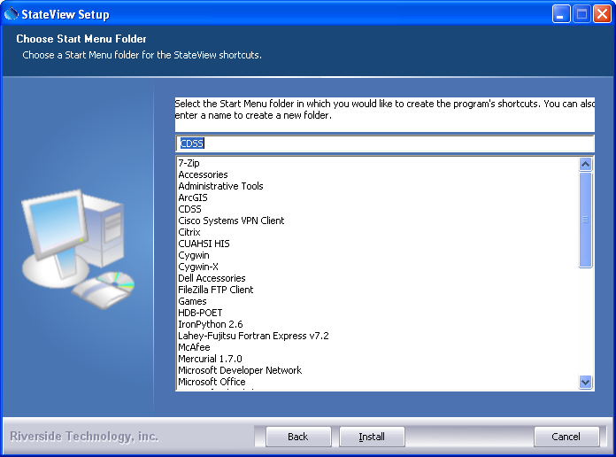
Install_StartMenuFolder

After selecting the folder, press Install.

- The following dialog will show the progress of the installation:

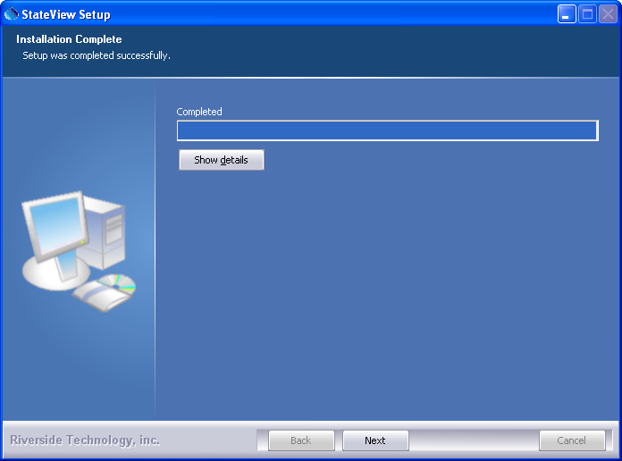
Install_Complete

Press Show details to see the files that were installed or press Next to continue.

- If the CDSS Base Components were selected for install, the following dialog will be displayed to allow further HydroBase configuration:

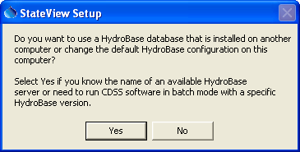
Install_HydroBaseQuestion

StateView/CWRAT and other CDSS software can utilize HydroBase running on the local computer as well as other computers. Press Yes if HydroBase has been installed on another computer in the network environment and may be used by the software (then continue to the next step). Otherwise, press No and skip to step 8.

- The following dialog allows additional HydroBase servers to be specified for use by CDSS software (the example below configures CDSS software to list the dwrappsdb HydroBase server in choices and defaults to HydroBase on the local computer).

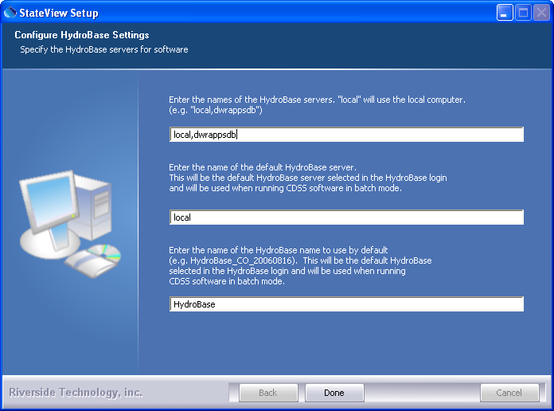
Install_HydroBaseConfiguration

After entering the name of a HydroBase server and the default server to use, press Done.

- The following dialog will then be shown asking whether the StateView/CWRAT software should be run:

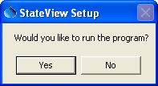
Install_RunStateViewQuestion

Press Yes to run the software or No to exit the installation procedure.

3.3 Installing StateView/CWRAT on a File Server

StateView/CWRAT can be installed on a file server, which allows software updates to be made in one location, thereby eliminating the need to install software on individual machines. For this type of installation, all computers that access the software and HydroBase must have similar network configurations so that servers can be found. The standard installer described in this documentation focuses on individual installs on user computers. To make StateView/CWRAT software installed on a server available to other computers, perform the following (this is typically performed by system administrators):

- Run the installer as described above. During installation specify the CDSS home using a drive letter and path for the server or specify a Universal Naming Convention (UNC) path (e.g., \\CDSSServer\CDSS). All computers that will use the software will need to have access to the server in a consistent way because the StateView/CWRAT software will expect the CDSS installation home at runtime to be that specified during the installation.

Another option is simply to copy the StateView-Version folder from a local computer to a server and then make a shortcut to the bin\StateView.exe program. The shortcut then can be copied onto local computers. Refer to the properties of the menus that start the applications to see the program that is being run, and the start location.
- The menus and shortcuts will only be configured for the computer from which the installation was run. Therefore, menus and shortcuts for other computers will need to be manually configured.
- If appropriate, edit the \system\CDSS.cfg file to include additional information.

If StateView/CWRAT has been installed on a local computer and it is also available on the network, the network version can be run by running the software in the NetworkStateViewInstallHome\bin folder. The software will expect that file locations use the same drives as when the software was installed.

4. Uninstalling StateView/CWRAT Software

To uninstall StateView/CWRAT software, select Start…Programs…CDSS…Uninstall…StateView-Version (and similar for CWRAT) and confirm the uninstall.

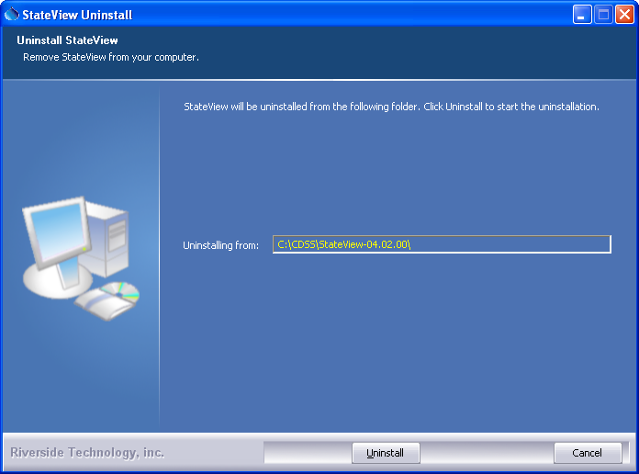
Uninstall_Intro

Press Uninstall to uninstall the software.

The following dialog shows the progress of the uninstall.

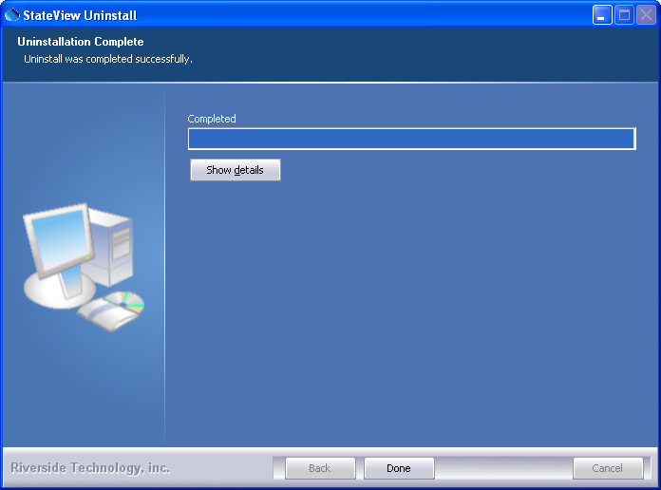
Uninstall_Complete

Press Show details to see the list of files that were removed. Press Done to exit the uninstall.

5. Running StateView/CWRAT

The Start…All Programs…CDSS…StateView-Version (or Start…Programs…CDSS…StateView-Version) menu can be used to start the StateView software. CWRAT can be run similarly.

6. StateView/CWRAT Configuration

StateView/CWRAT requires minimal configuration. This section describes the StateView/CWRAT configuration files that can be customized for a system. Installations on a server use one configuration for all users.

6.1 CDSS Configuration File

By default, StateView/CWRAT will automatically look for HydroBase databases on the current (local) machine and the State servers. State server databases are typically only accessible to State of Colorado computers. If SQL Server HydroBase versions have been installed on a different machine, the \CDSS\StateDMI-Version\system\CDSS.cfg file can be used to indicate the database servers. An example of the configuration file is as follows:

[HydroBase]

ServerNames="ServerName,local"
DefaultServerName="ServerName"
DefaultDatabaseName="HydroBase_CO_20080730"

The CDSS configuration properties are described in the following table:

CDSS HydroBase Database Configuration Properties

Property | Description | Default
ServerNames | A comma-separated list of server names to list in the HydroBase login dialog. | The state server is listed.
Default  ServerName | The default HydroBase server name to use. This allows the HydroBase login dialog to preselect a default that applies to most users in the system. | greenmtn.  state.co.us
Default  DatabaseName | The default HydroBase database name to use. This allows the HydroBase login dialog to preselect a default that applies to most users in the system.
Database  Engine | Reserved for internal use.
DatabaseName | The database name to use for the initial connection. This overrides the default server.
Database  Server | The server name to use for the initial connection. This overrides the default server.
SystemLogin | Reserved for internal use.
SystemPassword | Reserved for internal use.
UserLogin | Reserved for internal use.

6.2 Data Units File

The system\DATAUNIT file under the main installation directory contains data unit information that defines conversions and output precision. In most cases the default file can be used but additional units may need to be added for a user's needs (in this case please notify the developers so the units can be added to the default file distributed with installations). Currently, the data units file is the only source for units information – in the future units may be determined from HydroBase if available.

6.3 Map Configuration

The GeoView Mapping Tools Appendix describes mapping tools in detail. The StateView/CWRAT GeoView project files (typically available as \CDSS\GIS\divX\*.gvp) have been preconfigured and generally can be used without modification. The following table lists the GeoView project file AppLayerType properties, which allow StateView/CWRAT to know the spatial data layers that correspond to display features in the software. The AppLayerType values are reserved for use with StateView/CWRAT, although some data types do not currently have a link with spatial data (instream flow, water right, well permit), either because the data do not support the feature, or because StateView/CWRAT do not have an appropriate display.

AppLayerType Value | How Used in StateView/CWRAT
BaseLayer | Indicate base layers that can be ignored by specific displays.
Diversion | Used when displaying diversion structure information.
InstreamFlow | Used when displaying instream flow structure information.
Precipitation | Used when displaying precipitation station information.
Reservoir | Used when displaying reservoir structure information.
Streamflow | Used when displaying streamflow station information.
Temperature | Used when displaying temperature station information.
WaterRight | Used when displaying water right information.
Well | Used when displaying well structure information.
WellPermit | Used when displaying well permit data.

The AppLayerType values correspond to physical features, which are represented by the spatial data layers. However, some StateView/CWRAT displays focus on time series data types, which may not correspond one-to-one with physical features. For example, streamflow stations can have real-time and/or historical data using a variety of station identifiers and time intervals. Additional enhancements to HydroBase, spatial data, and/or software are needed to allow relating physical features to time series data types for all combinations.

6.4 Additional Configuration

To change the program configuration at run-time, use the Tools…Options menu. StateView/CWRAT will save changed configuration information to the HydroBase database so that the settings are active the next time that StateView/CWRAT is run. The guest login settings are only valid during the current session and cannot be saved to the database.

