Command Reference: ReadTableFromDBF()
Read a table from a dBASE file
Version 10.22.00, 2013-08-25

The ReadTableFromDBF() command reads a table from a dBASE file, such as the files used with ESRI GIS shapefiles. dBASE files are self-contained binary database files.

Handling of dBASE files is limited and support for newer features may not be included.

The following dialog is used to edit the command and illustrates the syntax for the command.

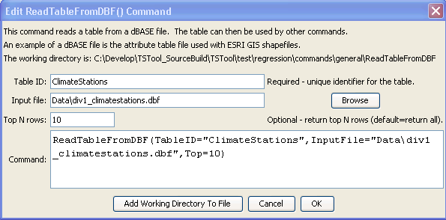
ReadTableFromDBF
ReadTableFromDBF() Command Editor

The command syntax is as follows:

ReadTableFromDBF(Parameter=Value,…)

Command Parameters

Parameter | Description | Default
TableID | Identifier to assign to the table that is read, which allows the table data to be used with other commands. | None – must be specified.
InputFile | The name of the file to read, as an absolute path or relative to the command file location. | None – must be specified.
Top | If specified, the top number of rows specified by the parameter will be returned. | Return all data.

