Command Reference: WriteTableToDataStore()
Write a table to a datastore
Version 10.18.00, 2013-03-03

This command is under development and has the following limitations:

- Although some error handling has been implemented, it is not very detailed. Improvements will be made in response to exercising the command functionality.
- Write statements are created for each row of the table being written. This is inefficient and slow. Improvements will be made in future updates.
- Functionality has been tested mainly with SQL Server.
- Handling of date objects has not been tested.
- Better handling of blank rows needs to be implemented.

The WriteTableToDataStore() command processes each row in a table and executes an SQL statement to insert the row into a database datastore. If database datastore support is not specifically provided by TSTool, a generic datastore can be used (see the Generic Database Datastore appendix). This command cannot be used with web service datastores and use with Excel datastores has not been tested. This command is useful in particular for bulk data loading such as for database initialization and when tight integration with TSTool is not required or has not been implemented. In the future additional command parameters may be added to limit the rows that are being written and allow update functionality.

General constraints on the query are as follows:

- the table or views being written must be writeable by the user specified for the database connection (some databases restrict direct access to data and require using stored procedures)
- the table column names must match the database table column names (in the future a command parameter may be added to allow column names to be mapped)
- data types for table columns must closely match the database:
  - internally an SQL statement is created in which data values are formatted as per the data type (e.g., strings are quoted); consequently column types must be appropriate to generate correct formatting
  - the full precision of floating point numbers is passed to the database (formatting for display will not apply to values written to the database)
  - null values in the table will transfer to null values in the database
  - date/time columns in the table will be represented as such in the database table; however, it may not be possible to limit the precision of the date/time (i.e., hours, minutes, and seconds may be shown with default zero values in output)
- the specified table columns are written (all are written by default)
  - primary keys in the database table do not need to be specified (their values will be assigned automatically)
  - table columns that correspond to related tables in the datastore table need to be mapped using the DataStoreRelatedColumnsMap command parameter

An example of column mapping to a related table is as follows, using the notation Table.Column to fully identify columns:

- the string TableID.DataType column is in the input data
- an integer database table TimeSeriesMeta.DataTypesID column is a foreign key to DataTypes.DataTypesID, and DataTypes.Abbreviation is the string data type – in other words, the datastore column being written does not match the string data type, but uses a relationship to match the integer data type in a separate table

To handle this relationship:

- Use the ColumnMap parameter to tell the command that the DataType column in input table maps to the DataTypesID column in the datastore table:

ColumnMap=”DataType:DataTypesID”

- Use the DataStoreRelatedColumnsMap parameter to tell the command that the DataTypesID column should be looked up the Abbreviation column, which is a second level of column mapping:

DataStoreRelatedColumnsMap=”DataTypesID:Abbreviation”

The following dialog is used to edit the command and illustrates the syntax for the command, in this case writing a table to a datastore that was defined as a GenericDatabaseDataStore.

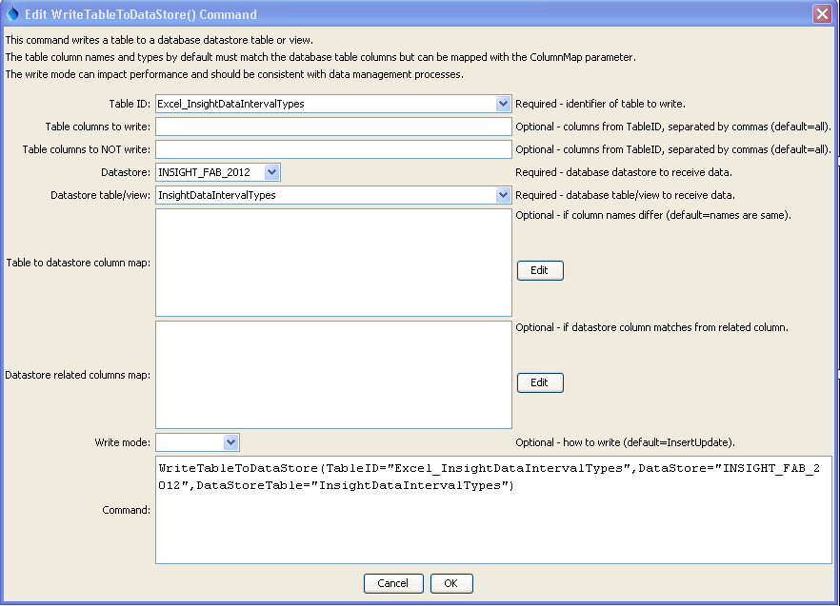
WriteTableToDataStore
WriteTableToDataStore() Command

The command syntax is as follows:

WriteTableToDataStore(Parameter=Value,…)

Command Parameters
Parameter | Description | Default
TableID | Identifier for table to write. | None – must be specified.
IncludeColumns | The names of the table columns to write, separated by commas. | All columns from TableID are written.
ExcludeColumns | The names of table columns NOT to write, separated by commas. This will override IncludeColumns. | All columns from TableID are written.
DataStore | The name of a database datastore to receive data. | None – must be specified.
DataStoreTable | The name of the database table or view to receive data. | None – must be specified.
ColumnMap | Indicate which columns in TableID have different names in DataStoreTable, using the syntax:  ColumnName:DatastoreTableName, ColumnName:DatastoreTableName, … | DataStore  TableName columns are assumed to match the column names in TableID
DataStoreRelated  ColumnsMap | Indicate datastore columns that need to match values in a related table in the datastore. For example, TableID may contain a column “Abbreviation” but the corresponding column in DataStoreTable may refer to a related table using a foreign key relationship (matching integer column in both tables). It is expected that the related table will have only one primary key column, which will be determined automatically. However, a column mapping must be provided to tell the command which DataStoreTable column should be matched with the related table. The syntax of the parameter is:  DataStoreTableKeyCol1:RelatedTableValueCol1,  DataStoreTableKeyCol2:RelatedTableValueCol2, …  The above assumes that foreign keys have been defined in the DataStoreTable columns. If the database does not explicitly define a foreign key relationship in the database design, then specify the right side of the map as: RelatedTable1.RelatedCol1. See the explanation below this table. | DataStore  TableName columns are assumed to match the column names in TableID, with no need to perform reference table value matching.
WriteMode | The method used to write data, recognizing the databases use insert and update SQL statements, one of:  - DeleteInsert – delete the data first and then insert (all values will need to be matched to delete)  - Insert – insert the data with no attempt to update if the insert fails  - InsertUpdate – try inserting the data first and if that fails try to update  - Update – update the data with no attempt to insert if the update fails  - UpdateInsert – try updating the data first and if that fails try to insert | InsertUpdate

To explain loading tables with foreign keys, consider the a definitions (lookup, reference) table:

DataTypes
DataTypesID | Integer autonumber primary key for this record
Abbreviation | Varchar – what the user sees and what is referenced in other data (e.g., “Streamflow”)
Name | Varchar
Definition | Varchar

Another table may use the above table with a relationship to the DataTypesID column, as follows:

TimeSeriesMeta
TimeSeriesMetaID | Integer autonumber primary key for this record.
DataTypesID | Foreign key to DataTypes.DataTypesID
Other ….

Time series being written to the TimeSeriesMeta table is specified with a data type of “Streamflow” and the internal database keys are opaque (meaning the values are not used directly by software user). If the TimeSeriesMeta table properties define the foreign key for TimeSeriesMeta.DataTypesID, then the TSTool software can automatically determine the table relationship. However, additional information is needed to indicate that the value for DataTypes.Abbreviation specified in the load data should be used to complete the relationship. Assume that the TSTool being written is as follows:

TimeSeriesMeta_TSTool
DataTypeAbbreviation | Foreign key to DataTypes.DataTypesID
Other ….

In this case, the following command parameters are required to complete the TSTool table to datastore table mapping:

TableID = “TimeSeriesMeta_TSTool”
IncludeColumns = “DataTypeAbbreviation” (or blank to write all TSTool table columns)
DataStore = as appropriate
DataStoreTable = “TimeSeriesMeta”
ColumnMap = “DataTypeAbbreviation:DataTypesID” (to indicate column in TimeSeriesMeta)
DataStoreRelatedColumnMap = “DataTypesID:Abbreviation” (to further indicate that the record in the related table matching the foreign key should use the DataTypes.Abbreviation column to look up the record to match the load data. This assumes that a foreign key relationship is defined, which while provide the foreign table. If a foreign key relationship is not defined, supply the foreign table, as in:
DataStoreRelatedColumnMap = “DataTypesID:DataTypes.Abbreviation”

