Command Reference: DeleteDataStoreTableRows()
Delete rows from a datastore table
Version 10.23.00, 2013-09-09

The DeleteDataStoreTableRows() command deletes rows from a database datastore table by using one of the following methods:

- Execute an SQL DELETE statement to delete all rows. Currently, only the ability to delete all rows is supported (see DeleteAllRows=True command parameter). In the future functionality will be implemented to delete specific rows using an SQL WHERE clause. See also the RunSql() command, which can be used to execute any SQL statement on a database datastore.
- Execute an SQL TRUNCATE statement (see DeleteAllRows=Truncate). Although database software varies, this typically has the effect of resetting auto-number counters.

If database datastore support is not specifically provided by TSTool, a generic datastore can be used (see the Generic Database DataStore appendix). This command cannot be used with web service datastores and use with Excel datastores has not been tested. This command is useful in particular for bulk data processing such as to delete records in a table before (re)loading in bulk (see WriteTableToDataStore() and WriteTimeSeriesToDataStore() commands).

General constraints are as follows:

- the table or views being processed must be writeable by the user specified for the database connection (some databases restrict direct access to data and/or require using stored procedures)

The following dialog is used to edit the command and illustrates the syntax for the command.

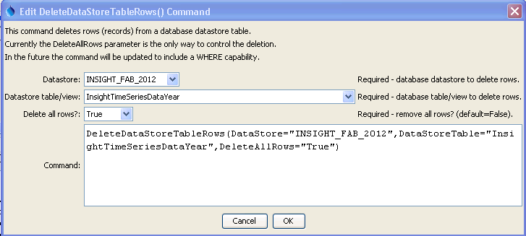
DeleteDataStoreTableRows
DeleteDataStoreTableRows() Command

The command syntax is as follows:

DeleteDataStoreTableRows(Parameter=Value,…)

Command Parameters
Parameter | Description | Default
DataStore | The name of a database datastore to process. | None – must be specified.
DataStoreTable | The name of the database table or view being processed. | None – must be specified.
DeleteAllRows | Indicate whether all rows should be deleted:  - False – currently a safeguard. A future enhancement will enable deleting only rows that match specified table rows via a constraint.  - True or – delete all rows using SQL DELETE statement  - Truncate – delete all rows using SQL TRUNCATE statement | False – consequently, because specific deletes are not enabled, this is a safeguard against any deletes

