Command Reference: TS Alias = ChangeInterval()
Create a new time series by changing a time series data interval
Version 09.05.00, 2009-04-27

A ChangeInterval() command creates a new time series by changing the data interval of an existing time series. The majority of the original header data (e.g., description, units) are copied to the new time series. Time series data values have a time scale of accumulated (e.g., volume), mean, or instantaneous. Changing the interval can also result in a change in the time scale (e.g., converting instantaneous values to a mean value). Currently, the time scale for input and output time series is NOT automatically determined from the data type and interval and must be specified as ACCM, MEAN, or INST. Instantaneous values are recorded at the date/time of the value and typically apply to small intervals (e.g. minute and hour). For mean and accumulated time series, the date/time for each value is at the end of the interval for which the value applies.

Irregular time series have a date/time precision and a scale appropriate for the data. For example, irregular minute time series may be used for instantaneous temperature or accumulated precipitation. Irregular day time series may be used for “instantaneous” reservoir level. For regular time series, the data intervals must align so that each larger interval aligns with the end-points of the corresponding smaller intervals (e.g., the ends of 6-hour intervals align with the daily interval).

The following conversions are currently supported, with a description of the conversion process.

Irregular Time Series to Regular Time Series

An irregular time series can be converted to a regular time series. The ability to change from an irregular or regular time series to an irregular time series is not currently implemented. Missing data is handled in different ways depending on the old and new time scales. Each of the follow examples demonstrates how missing data is interpreted.

The following conversion combinations are allowed.

Small Interval ACCM to Large Interval ACCM

When converting from small interval accumulated data to large interval accumulated data, values from the old time series are summed for the new interval-ending date/time from the values in the old intervals prior to this date/time.

The following illustrates the conversion from NHour to NHour (1Hour to 3Hour example):

Day 1,  Hour 0  (A) | Day 1,  Hour 1  (B) | Day 1,  Hour 2  (Missing) | Day 1,  Hour 3  (C) | Day 1,  Hour 4  (Missing) | Day 1,  Hour 5  (Missing) | Day 1,  Hour 6  (Missing)
Day 1,  Hour 0  =A | Day 1, Hour 3  =B+C |  |  | Day 1, Hour 6  = Missing

Large Interval ACCM to Small Interval ACCM

When converting from large interval accumulated data to small interval accumulated data, values from the old time series are equally divided by the number of intervals prior to this date/time in the new time series since the previous non-missing data.

The following illustrates the conversion from NHour to NHour (3Hour to 1Hour example):

Day 1,  Hour 0  (A) | Day 1, Hour 3  (B) |  |  | Day 1, Hour 6  (Missing) |  |  | Day 1, Hour 9  (C)
Day 1,  Hour 0  =A | Day 1,  Hour 1  =B/3 | Day 1,  Hour 2  =B/3 | Day 1,  Hour 3  =B/3 | Day 1,  Hour 4  =C/6 | Day 1,  Hour 5  =C/6 | Day 1,  Hour 6  =C/6 | Day 1,  Hour 7  =C/6 | Day 1,  Hour 8  =C/6 | Day 1,  Hour 9  =C/6

Small Interval MEAN or INST to Large Interval MEAN

When converting from instantaneous or mean data to mean data, mean values are calculated for the new interval-ending date/time from the values in the old intervals prior to this date/time.

The following illustrates the conversion from NHour to NHour (1Hour to 3Hour example):

Day 1,  Hour 0  (A) | Day 1,  Hour 1  (B) | Day 1,  Hour 2  (Missing) | Day 1,  Hour 3  (C) | Day 1,  Hour 4  (Missing) | Day 1,  Hour 5  (Missing) | Day 1,  Hour 6  (Missing)
Day 1,  Hour 0  =A | Day 1, Hour 3  =(B+C)/2 |  |  | Day 2, Hour 6  = Missing

Large Interval MEAN or INST to Small Interval MEAN

When converting from large interval mean or instantaneous data to small interval mean data, values from the old time series are copied to the new interval-ending date/time time series.

The following illustrates the conversion from NHour to NHour (3Hour to 1Hour example):

Day 1,  Hour 0  (A) | Day 1, Hour 3  (B) |  |  | Day 1, Hour 6  (Missing) |  |  | Day 1, Hour 9  (C)
Day 1,  Hour 0  =A | Day 1,  Hour 1  =B | Day 1,  Hour 2  =B | Day 1,  Hour 3  =B | Day 1,  Hour 4  =C | Day 1,  Hour 5  =C | Day 1,  Hour 6  =C | Day 1,  Hour 7  =C | Day 1,  Hour 8  =C | Day 1,  Hour 9  =C

Small Interval INST to Large Interval INST

When converting from small interval instantaneous data to large interval instantaneous data, the data is copied directly from the old time series when available. If the data is missing, the most recent previous valid data is used.

The following illustrates the conversion from NHour to NHour (1Hour to 3Hour example):

Day 1,  Hour 0  (A) | Day 1,  Hour 1  (B) | Day 1,  Hour 2  (Missing) | Day 1,  Hour 3  (C) | Day 1,  Hour 4  (Missing) | Day 1,  Hour 5  (D) | Day 1,  Hour 6  (Missing) | Day 1,  Hour 7  (E) | Day 1,  Hour 8  (F)
Day 1, Hour 0  =A |  |  | Day 1, Hour 3  =C |  |  | Day 1, Hour 6  =D

Large Interval INST to Small Interval INST

When converting from large interval instantaneous data to small interval instantaneous data, values from the old time series are linearly interpolated to calculate values for the new time series.

The following illustrates the conversion from NHour to NHour (3Hour to 1Hour example):

Day 1,  Hour 0  (A) | Day 1, Hour 3  (B) |  |  | Day 1, Hour 6  (Missing) |  |  | Day 1, Hour 9  (C)
Day 1,  Hour 0  =A | Day 1,  Hour 1  =A+  (B-A)*  (1/3) | Day 1,  Hour 2  =A+  (B-A)*  (2/3) | Day 1,  Hour 3  =B | Day 1,  Hour 4  =B+  (C-B)*  (1/6) | Day 1,  Hour 5  = B+  (C-B)*  (2/6) | Day 1,  Hour 6  = B+  (C-B)*  (3/6) | Day 1,  Hour 7  = B+  (C-B)*  (4/6) | Day 1,  Hour 8  = B+  (C-B)*  (5/6) | Day 1,  Hour 9  =C

Regular Time Series to Regular Time Series

ACCM (Accumulation) to ACCM (Accumulation)

Small Interval ACCM (Accumulation) to Large Interval ACCM (Accumulation)

Changing the interval for small interval accumulated data to large interval accumulated data involves summing the small interval data values for the period that overlaps the large interval.

Accumulated data have a timestamp corresponding to the interval-end for the accumulation. Conversions involving time intervals that have zero values (e.g., Hour 0, Minute 0) result in a perceived shift in time because the zero occurs on the boundary between larger intervals. The following examples illustrate the accumulation for common cases. In cases where an accumulation jumps over two or more interval categories (e.g., minute to day), the accumulation occurs as if the two intermediate accumulations occurred in succession. In the following examples, the general representation is shown first, followed by an example where appropriate.

The following illustrates the conversion from NHour to Day (6Hour to Day example, i equals the hour multiplier):

Day 1,  Hour 0 | Day 1,  Hour i | Day 1,  Hour 2i | Day 1,  Hour 3i | Day 2,  Hour 0
Day 1, Hour 0 | Day 1, Hour 6 (A) | Day 1,  Hour 12 (B) | Day 1,  Hour 18 (C) | Day 2, Hour 0 (D)
 | Day 1 accumulation (A+B+C+D)

The following illustrates the conversion from NDay to Month (example for a month with 30 days):

Month 1, Day 1 (A1) | … |  | … | Month 1, Day 30 (A30)
Month 1 accumulation (A1 + … + A30)

Large Interval ACCM (Accumulation) to Small Interval ACCM (Accumulation)

See Large Interval ACCM to Small Interval MEAN.

ACCM (Accumulation) to INST (Instantaneous)

Small Interval ACCM to Large Interval INST

Converting small interval accumulation data to larger interval instantaneous data is not supported.

Interval ACCM to Same Interval INST

Converting accumulation data to same interval instantaneous data is not supported.

Large Interval ACCM to Small Interval INST

See Large Interval MEAN to Small Interval INST (Instantaneous).

ACCM (Accumulation) to MEAN

Small Interval ACCM to Large Interval MEAN

See Small Interval INST (Instantaneous) to Large Interval MEAN.

Interval ACCM to Same Interval MEAN

Changing the interval from accumulation data to the same interval mean data involves copying the data from the old time series to the new time series (no changes to date values occur).

The following illustrates the conversion from 6Hour to 6Hour (6Hour to 6Hour example, i equals the hour multiplier):

Day 1,  Hour 0 | Day 1,  Hour i | Day 1,  Hour 2i | Day 1,  Hour 3i
Day 1, Hour 0 (A) | Day 1, Hour 6  (B) | Day 1, Hour 12  (C) | Day 1,  Hour 18  (D)
Day 1,  Hour 0  =A | Day 1,  Hour 6  =B | Day 1,  Hour 12  =C | Day 1,  Hour 18  =D

Large Interval ACCM to Small Interval MEAN

Changing from large interval accumulation data to small interval mean data involves dividing each accumulated value by the number of new values for that same period of record.

The following illustrates the conversion from Day to 6Hour (Day to 6Hour example, i equals the hour multiplier):

Day 1 accumulate (A)
Day 1,  Hour 0 | Day 1,  Hour i | Day 1,  Hour 2i | Day 1,  Hour 3i
Day 1, Hour 0 = A/4 | Day 1, Hour 6  = A/4 | Day 1, Hour 12  = A/4 | Day 1,  Hour 18  = A/4

INST (Instantaneous) to INST (Instantaneous)

Small Interval INST (Instantaneous) to Large Interval INST (Instantaneous)

Changing the interval for small interval instantaneous data to large interval instantaneous data involves assigning each date in the new time series a value from the corresponding date in the old time series. The HandleMissingInputHow parameter indicates how to interpret a missing value in the old time series. HandleMissingInputHow=KeepMissing will simply assign a missing value for that date/time. HandleMissingInputHow=SetToZero will set the value to 0. Repeat fills the date with data from the last non-missing value. Interpolation and using a non-missing future value may be added in the future.

The following illustrates the conversion from NHour to Day (6Hour to Day example where HandleMissingInputHow = Repeat, i equals the hour multiplier):

Day 1,  Hour 0 | Day 1,  Hour i | Day 1,  Hour 2i | Day 1,  Hour 3i | Day 1,  Hour 0 | Day 1,  Hour i | Day 1,  Hour 2i | Day 1,  Hour 3i
Day 1, Hour 0 (A) | Day 1, Hour 6 (B) | Day 1, Hour 12 (C) | Day 1, Hour 18  (D) | Missing data | Day 1, Hour 6 (E) | Day 1, Hour 12 (F) | Day 1, Hour 18 (G)
Day 1 instantaneous = A |  |  |  | Day 2 instantaneous = D

Large Interval INST (Instantaneous) to Small Interval INST (Instantaneous)

Small interval instantaneous data is created from larger interval instantaneous data by linearly interpolating between the previous and current large interval data to fill each value in the new time series during that same period of time. If the value in the old time series is missing, the method specified by the user in the HandleMissingInputHow parameter is used.

The following illustrates the conversion from Day to NHour (Day to 6Hour example, i equals the hour multiplier):

Day 1 instantaneous (A) |  |  |  | Day 2 instantaneous (B) |  |  |  | Day 3 …
Day 1,  Hour 0 | Day 1,  Hour i | Day 1,  Hour 2i | Day 1,  Hour 3i | Day 2,  Hour 0 | Day 2,  Hour i | Day 2,  Hour 2i | Day 2,  Hour 3i
Day 1, Hour 0  =A | Day 1, Hour 6  =A+  (B-A)*  (6/24) | Day 1, Hour 12  =A+  (B-A)*  (12/24) | Day 1,  Hour 18  =A+  (B-A)*  (18/24) | Day 2, Hour 0  =B | Day 2,  Hour 6  … | Day 2,  Hour 12  … | Day 2,  Hour 18  …
These values are an interpolated value between the Day 1 instantaneous value and the Day 2 instantaneous value using a time of 24 hours. |  |  |  | These values are an interpolated value between the Day 2 instantaneous value and the Day 3 instantaneous value using a time of 24 hours.

In the future, the ability to repeat input values may be added.

INST (Instantaneous) to ACCM (Accumulation)

Instantaneous to accumulated is not currently supported.

INST (Instantaneous) to MEAN

Small Interval INST (Instantaneous) to Large Interval MEAN

Changing from small interval instantaneous data to large interval mean data involves adding together all the values from the small interval time series over the larger interval for the corresponding time period and then dividing by the number of data values used within this calculation. As in other conversions, HandleMissingInputHow is first used to interpret missing data. If HandleEndpointHow = AverageEndpoints, the values at each end of the interval are averaged for minute and hour inputs (the parameter does not apply to day, month or year input).

The following illustrates the conversion from NHour to Day (6Hour to Day example with HandleEndpointHow = IncludeFirstOnly, i equals the hour multiplier):

Day 1,  Hour 0 | Day 1,  Hour i | Day 1,  Hour 2i | Day 1,  Hour 3i | Day 2,  Hour 0 | Day 2,  Hour i | Day 2,  Hour 2i | Day 2,  Hour 3i
Day 1, Hour 0 | Day 1, Hour 6 | Day 1, Hour 12 | Day 1, Hour 18 | Day 2,  Hour 0 | Day 2, Hour 6 | Day 2, Hour 12 | Day 2, Hour 18
Value A | B | C | D | E | F | G | H
Day 1 mean= (A+B+C+D)/4 |  |  |  | Day 2 mean=(E+F+G+H)/4

The following illustrates the conversion from NHour to Day (6Hour to Day example with HandleEndpointHow = AverageEndpoints, i equals the hour multiplier):

Day 1,  Hour 0 | Day 1,  Hour i | Day 1,  Hour 2i | Day 1,  Hour 3i | Day 2,  Hour 0 | Day 2,  Hour i | Day 2,  Hour 2i | Day 2,  Hour 3i
Day 1, Hour 0 | Day 1, Hour 6 | Day 1, Hour 12 | Day 1, Hour 18 | Day 2,  Hour 0 | Day 2, Hour 6 | Day 2, Hour 12 | Day 2, Hour 18
Value A | B | C | D | E | F | G | H | I
Day 1 mean= ((A+E)/2 +B+C+D) / 4 |  |  |  | Day 2 mean=((E+I)/2+F+G+H) / 4

Interval INST (Instantaneous) to Same Interval MEAN

If OutputFillMethod = Interpolate, see Large Interval INST (Instantaneous) to Small Interval INST (Instantaneous). Otherwise, the values are duplicated from the old time series directly to the new time series.

The following illustrates the conversion from 6Hour to 6Hour (6Hour to 6Hour example with OutputFillMethod = Repeat, i equals the hour multiplier):

Day 1,  Hour 0 | Day 1,  Hour i | Day 1,  Hour 2i | Day 1,  Hour 3i | Day 2,  Hour 0
Day 1, Hour 0  (A) | Day 1, Hour 6  (B) | Day 1, Hour 12  (Missing) | Day 1, Hour 18  (D) | Day 2, Hour 0  (E)
Day 1,  Hour 0  =A | Day 1,  Hour 6  =B | Day 1,  Hour 12  =B | Day 1  Hour 18  =D | Day 2,  Hour 0  =E

Large Interval INST (Instantaneous) to Small Interval MEAN

If the OutputFillMethod = Interpolate, see Large Interval INST (Instantaneous) to Small Interval INST (Instantaneous). The time series are handled in the same way. Otherwise, the values are duplicated from the old time series directly to the new time series.

The following illustrates the conversion from Day to 6Hour (Day to 6Hour example with OutputFillMethod = Repeat, i equals the hour multiplier):

Day 1 instantaneous = A
Day 1,  Hour 0 | Day 1,  Hour i | Day 1,  Hour 2i | Day 1,  Hour 3i
Day 1, Hour 0  =A | Day 1, Hour 6  =A | Day 1, Hour 12  =A | Day 1,  Hour 18  =A
Each of these values is equal to the instantaneous value for that day.

MEAN to MEAN

Small Interval MEAN to Large Interval MEAN

See Small Interval INST (Instantaneous) to Large Interval MEAN.

Large Interval MEAN to Small Interval MEAN

Changing from large interval mean data to small interval mean data involves copying values from the old time series into the new time series for that same period of record.

The following illustrates the conversion from Month to Day (Example for a month with 30):

Month Mean (A)
Day 1  =A | Day 2  =A | … | Day 30  =A

MEAN to ACCM (Accumulation)

Small Interval MEAN to Large Interval ACCM (Accumulation)

See Small Interval INST (Instantaneous) to Large Interval MEAN.

Interval MEAN to Same Interval ACCM (Accumulation)

See Interval ACCM to Same Interval MEAN.

Large Interval MEAN to Small Interval ACCM (Accumulation)

See Large Interval ACCM to Small Interval MEAN.

MEAN to INST (Instantaneous)

Small Interval MEAN to Large Interval INST (Instantaneous)

Not currently supported.

Interval MEAN to Same Interval INST (Instantaneous)

Not currently supported. The data can be treated equivalently by most commands.

Large Interval MEAN to Small Interval INST (Instantaneous)

Changing the interval for large interval mean to small interval instantaneous data involves calculating a value for each new interval based on trends found in the mean data. The following example demonstrates how the data is converted from the old interval to the new interval. A general representation is shown first followed by an example.

The following illustrates the conversion from Day to NHour (Day to 6Hour example, i equals the hour multiplier):

Day 1 mean
Day 1,  Hour 0 | Day 1,  Hour i | Day 1,  Hour 2i | Day 1,  Hour 3i
Day 1, Hour 0 | Day 1, Hour 6 | Day 1, Hour 12 | Day 1, Hour 18

The output instantaneous values for each input interval are computed using the current, next, and previous mean values. All three values are useful because together they indicate whether the current value is part of a continuous rise or fall, a peak or trough or simply a continuation of a steady value. These conditions are illustrated in the following figure.

The following set of rules are applied when converting from large interval mean to small interval instantaneous:
- Missing data is initially converted using the method specified by the user in the HandleMissingInputHow parameter.
- If the current input value is still missing, the instantaneous time series is also filled with missing data for each interval that falls in the larger interval.
- If the previous or next mean values are missing, the current mean value for that interval is copied directly to the instantaneous time series.
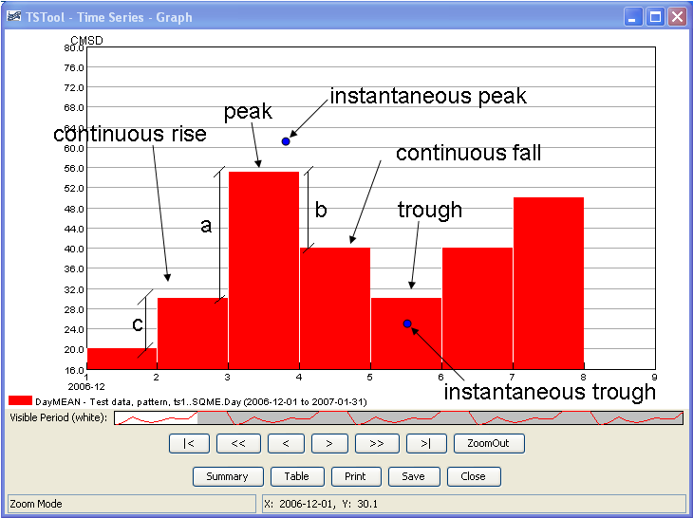
ChangeInterval_SQMEPic
Mean data illustration

- Another condition that may exist is a peak or trough. A peak exists when the current value is greater than the previous and next values. A trough is when the current value is less than the next and previous values.
  - In this case, an instantaneous peak (or trough) is calculated. Referring to the above illustration, the magnitude of the peak is calculated by adding (or subtracting for a trough) ¼ (a+b)/2 to the current mean.
  - The time of the instantaneous peak is initially set to the start date/time of the current interval then shifted forward in time using the following calculation. The number of instantaneous intervals per larger interval is multiplied by b/(a+b). That result is added to the start date/time. The value for the start of the interval is set to the current value minus ¼ a. The value for the end of the interval is set to the current value minus ¼ b.
  - The remaining instantaneous values for the interval are linearly interpolated between the peak (or trough) and both endpoints.
- A final condition that may exist is a continuous rise or fall. A continuous rise or fall exists when the current value is between the previous and next values.
- In this case, the instantaneous value at the start of the interval is set to the current value minus ¼ c (again using the above illustration).
- The instantaneous value at the end of the larger interval is set to the current value plus ¼ a.
- The difference between c and a is calculated. If c is less than a, then the simulated values are computed by adding small but increasing increments to the starting endpoint until the last point of the interval is reached. If a is less than c then the output values are computed by subtracting small but increasing increments to the last endpoint until the first point of the interval is reached.

After the instantaneous values are estimated using the above set of rules, they are adjusted so that the volume over each interval is within a specified tolerance of the input mean volume. This tolerance is specified with the Tolerance parameter. The volume for each interval uses the average of the first and last endpoint.

This approach has been adapted from the NWSRFS CHANGE-T operation (see http://www.nws.noaa.gov/oh/hrl/nwsrfs/users_manual/part5/_pdf/533changet.pdf).

The following dialog is used to edit the command and illustrates the syntax for the command. This example is converting from daily mean data to 6Hour instantaneous data. The new units are CMS. The tolerance is 0.025.

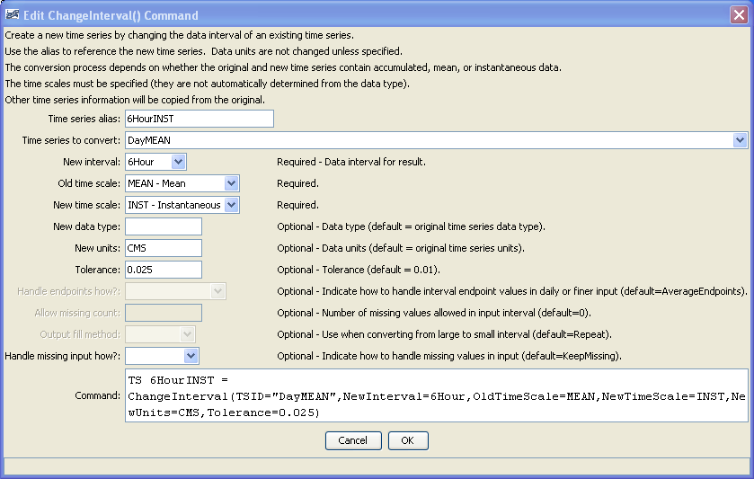
ChangeInterval
ChangeInterval() Command Editor

The command syntax is as follows:

TS Alias = ChangeInterval(Parameter=Value,…)

Command Parameters

Parameter | Description | Default
Alias | The alias to assign to the new time series. The time series identifier for the new time series will be the same as the original time series, with the new interval and optionally a new data type (see the NewDataType parameter). | None – must be specified.
TSID | The time series identifier or alias for the original (old) time series. | None – must be specified.
NewInterval | The data interval for the new time series, from the provided choices. For example: 6Hour, Day, Month, Year. | None – must be specified.
OldTimeScale | The time scale for the original time series, one of:  ACCM – accumulated data  INST – instantaneous data  MEAN – mean data  In the future, this parameter may be made optional if the time scale can be determined from the data type. | None – must be specified.
NewTimeScale | The time scale for the new time series (see OldTimeScale for possible values). In the future, this parameter may be made optional if the time scale can be determined from the data type. | None – must be specified.
NewDataType | The data type for the new time series. This will be set in the identifier of the new time series. | Use the data type from the original time series.
New Units | The units for the new time series. This will be set in the identifier of the new time series. | Use the units from the original time series.
Tolerance | Currently used when converting large interval MEAN data to small interval INST data. After the new time series is created, the volume of the new time series over each old interval is compared to the old time series for that same interval. If the difference between the two is outside the specified tolerance percentage, then each value in the new time series is adjusted so the totals will match. The endpoints are averaged for this comparison. Additionally, when the adjustment is made, the new starting value is averaged with the ending value of the previous interval so that the previous interval is not overly affected by this calculation. | 0.01
Handle EndpointsHow | When changing from small interval to larger interval, this indicates how the endpoints should be handled. This is only used when the new interval is daily or finer. One of:  AverageEndpoints – use both endpoint values for new single value  IncludeFirstOnly – only use earlier endpoint | Average Endpoints
AllowMissing  Count | The number of missing values allowed in the source interval(s) in order to produce a result. For example, if converting daily data to monthly, a value of 5 would allow <= 5 missing daily values and still compute the result. This capability should be used with care because it may result in data that are not representative of actual conditions. | 0 – do not allow any missing data in the source data when computing a result.
OutputFill  Method | Use to fill output when converting from large interval time series to small interval time series, one of:  Interpolate – linearly interpolate  Repeat – repeat values for the output | Interpolate
HandleMissing  InputHow | Indicate how to handle missing values in input, one of:  KeepMissing – leave data missing  Repeat – repeat last non-missing value  SetToZero – set values to 0  With the exception of irregular time series, the missing data is handled on input and the replacement value, if any, is used for calculations just as if it was the actual value. | Repeat

Several example command files follow.

0109.NOAA.Precip.Day~HydroBase
TS 0109Month = ChangeInterval(TSID="0109.NOAA.Precip.Day",NewInterval=Month,OldTimeScale=ACCM,NewTimeScale=ACCM)

TS DayMEAN = NewPatternTimeSeries(NewTSID="ts1..SQME.Day",Description="Test data",
SetStart="2006-12-01",SetEnd="2007-01-31",
Units="CMSD",PatternValues="20,30,55,40,30,40,50,45,45,80,80,80,80")

TS 6HourINST = ChangeInterval(TSID="DayMEAN",NewInterval=6Hour,OldTimeScale=MEAN,NewTimeScale=INST,
NewDataType=CMS)

TS 6HourInst = NewPatternTimeSeries(NewTSID="ts2..Flow.6Hour",IrregularInterval=6Hour,Description="Test data",SetStart="2006-12-15 12",SetEnd="2007-01-29 00",Units="CFS",PatternValues="20,23,56,62,35,42")

TS DayMean2 = ChangeInterval(TSID="6HourInst",NewInterval=Day,OldTimeScale=INST,NewTimeScale=MEAN,
HandleEndpointsHow=IncludeFirstOnly)

TS IrregularINST = NewPatternTimeSeries(NewTSID="ts1..Temp.Irregular",IrregularInterval=1Hour,Description="Test data",SetStart="2006-12-15 00",SetEnd="2007-01-31 23",Units="DEGF",
PatternValues="20,23,-999,45,-999,-999,56,62,0,-3")

TS 3HourINST = ChangeInterval(TSID="IrregularINST",NewInterval=3Hour,OldTimeScale=INST,NewTimeScale=INST)

This page is intentionally blank.

