Command Reference: TS Alias = ReadNwsrfsFS5Files()
Read a single time series from an NWSRFS FS5Files database
Version 08.16.04, 2008-09-09

The TS Alias = ReadNwsrfsFS5Files() command reads a single time series from an NWSRFS FS5Files database (see the NWSRFS FS5Files Input Type Appendix) and assigns an alias to the result.

The following dialog is used to edit the command and illustrates the syntax.

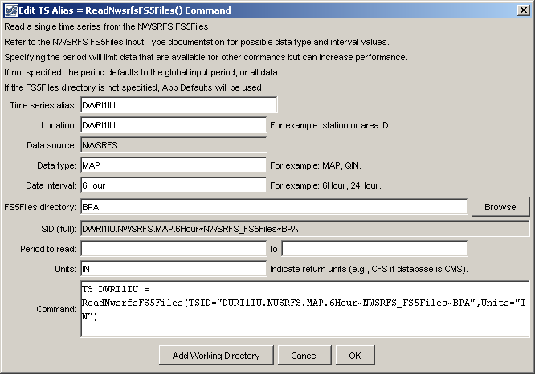
ReadNwsrfsFS5Files_Alias
TS Alias = ReadNwsrfsFS5Files() Command Editor

The command syntax is as follows:

TS Alias = ReadNwsrfsFS5Files (Parameter=Value…)

Command Parameters

Parameter | Description | Default
Alias | Alias for the new time series that is read from the file, which can be used instead of the TSID in other commands. | None – must be specified.
TSID | A time series identifier to read – see the NWSRFSFS5Files Input Type Appendix. The input name for the time series identifier will agree with how the NWSRFS FS5Files were specified. For example if Apps Defaults are used, the input name will be omitted. If a directory is specified, it can be an absolute path or can be relative to the working directory. | Currently ignored.
InputStart | The start of the period to read data – specify if the period should be different from the global query period. | Use the global query period.
InputEnd | The end of the period to read data – specify if the period should be different from the global query period. | Use the global query period.
Units | The data units to be returned. The units must be specified compatible with the database units to allow for the conversion. | Use the database units, which are typically SI units.

A sample command file is as follows:

TS x = ReadNwsrfsFS5Files(TSID="DWRI1IU.NWSRFS.MAP.6Hour~NWSRFS_FS5Files~
Data_BPA",Units="IN")

