Command Reference: ReadNrcsAwdb()
Read 1+ time series from the NRCS AWDB web service
Version 10.13.00, 2012-11-07

The ReadNrcsAwdb() command reads one or more time series from the Natural Resources Conservation Service (NRCS) Air and Water Database (AWDB) web service (see the NRCS AWDB Datastore Appendix), including SNOTEL and Snow Course data.

The NRCS AWDB web service allows station lists to be filtered, both as a convenience and to ensure reasonable web service performance. Many of the choices that are available for limiting queries allow 0+ values to be provided. For example, specifying no requested element (data type) will return all available elements for a location. Specifying a list of elements (separated by commas) will return only stations and time series that have data for the requested elements.

The following dialog is used to edit the command and illustrates the syntax. Some choices are provided as a convenience. However, full listing of choices (such as all the thousands of HUCs) is not provided due to performance issues. Additional query features will be enabled as web service integration is enhanced.

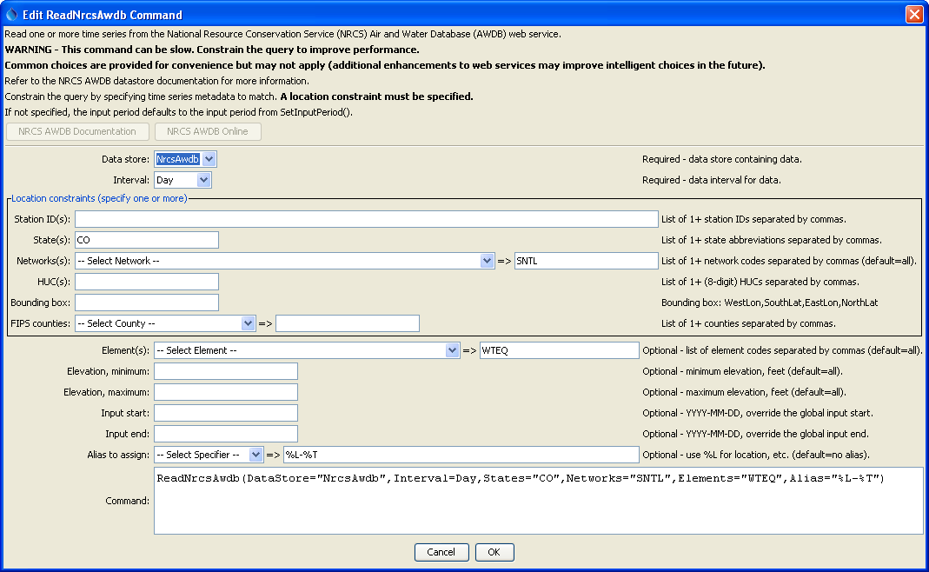
ReadNrcsAwdb
ReadNrcsAwdb() Command Editor

The command syntax is as follows:

ReadNrcsAwdb(Parameter=Value,…)

Command Parameters

Parameter | Description | Default
DataStore | The NRCS AWDB datastore to use for queries. | None – must be specified.
Interval | The data interval (“duration” in NRCS AWDB terms) to query. The Irregular interval is used for instantaneous data. | None – must be specified.
Stations | A list of station identifiers to read, separated by commas. | Do not limit the query to a station list.
States | A list of state codes (e.g., AL), separated by commas. | Do not limit the query to a state list.
Networks | A list of data network codes (e.g., SNTL), separated by commas. | Do not limit the query to a network list.
HUCs | A list of 8-digit hydrologic unit codes, separated by commas. | Do not limit the query to a HUC list.
BoundingBox | A bounding box consisting of west longitude, south latitude, east longitude, and north latitude, separated by spaces. Longitudes in the western hemisphere are negative. This feature is not finalized, pending resolution of a web service issue. | Do not limit the query to a bounding box.
Counties | A list of county names, separated by commas. The state must be specified. | Do not limit the query to a county list.
Elements | Data element codes for the stations (e.g., WTEQ for snow water equivalent), separated by commas. | All available elements are returned.
ElevationMin | Minimum station elevation, feet. | Do not limit the query based on elevation minimum.
ElevationMax | Maximum station elevation, feet. | Do not limit the query based on elevation maximum.
InputStart | The start of the period to read data – specify if the period should be different from the global query period. Specify to the precision of the data using the format YYYY-MM-DD hh:mm. | Use the global query period.
InputEnd | The end of the period to read data – specify if the period should be different from the global query period. Specify to the precision of the data using the format YYYY-MM-DD hh:mm. | Use the global query period.
Alias | The alias to assign to the time series, as a literal string or using the special formatting characters listed by the command editor. The alias is a short identifier used by other commands to locate time series for processing, as an alternative to the time series identifier (TSID). | None – must be specified.

