Command Reference: SetIgnoreLEZero()
Indicate whether time series data values <= zero should be ignored in historical averages
Version 08.16.00, 2008-07-09

The SetIgnoreLEZero() command sets the global property that indicates whether the computation of historical averages for time series should ignore values less than or equal to zero. By default, all values (other than the missing data placeholder) are used to compute averages. This command is useful when it is appropriate to ignore zero and negative values in averages, for example in cases where zero is assigned as an observation but may influence averages inappropriately. Commands that are concerned with this issue also typically provide a parameter and therefore using this global command may not be appropriate.

The following dialog is used to edit this command and illustrates the syntax of the command.

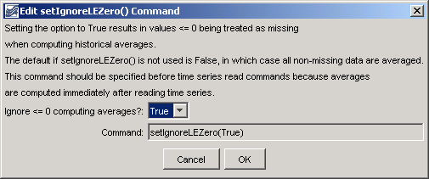
SetIgnoreLEZero
SetIgnoreLEZero() Command Editor

The command syntax is as follows:

SetIgnoreLEZero(Parameter=Value,…)

Command Parameters

Parameter | Description | Default
IgnoreLEZero | Indicates whether the computation of historical averages should ignore values less than or equal to zero, True or False. | If this command is not used, the default is False.

A sample command file is as follows:

SetIgnoreLEZero(IgnoreLEZero=True)

This page is intentionally blank.

