Command Reference: TS Alias = NewStatisticYearTS()
Create a new yearly time series containing a statistic determined from a time series
Version 08.15.00, 2008-05-04

The TS Alias = NewStatisticYearTS() command processes a time series and creates a new yearly time series, assigning the result an alias so that it can be more easily manipulated. Each yearly value in the resulting time series contains a statistic determined from the sample of points from the corresponding year in the original time series. For example, if the original time series has a daily time step, then the sample that is analyzed will be 365 or 366 values (depending on leap year). This command is useful because it operates on the raw time series data. Other commands (e.g., ChangeInterval() can produce a similar result, for example converting a daily time series to monthly average). The NewStatisticYearTS() command is being phased in, offering statistics that have been requested to meet a need. It is envisioned the list of statistics will increase over time and that additional optional parameters may be added (e.g., to indicate how to handle missing data in the sample).

The following dialog is used to edit the command and illustrates the syntax for the command.

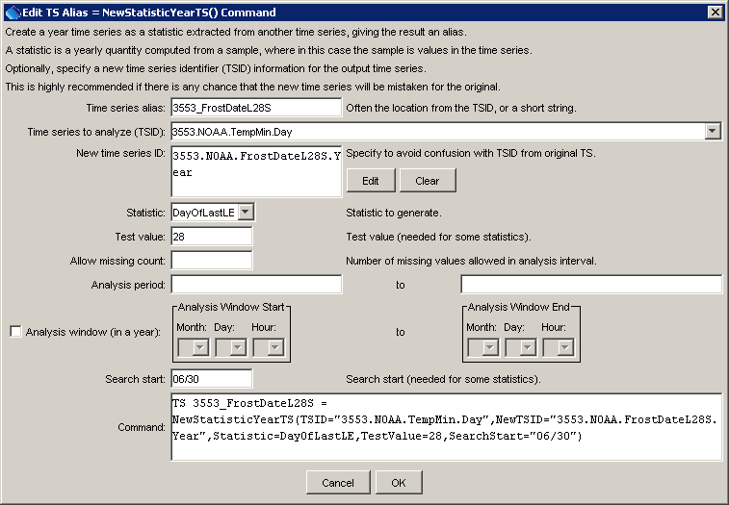
NewStatisticYearTS
TS Alias = NewStatisticYearTS() Command Editor

The command syntax is as follows:

TS Alias = NewStatisticYearTS(Parameter=value,…)

Command Parameters

Parameter | Description | Default
Alias | The alias of the new time series, which can be used instead of the TSID in other commands. | None – must be specified.
TSID | The time series identifier (or alias) of the time series to analyze. | None – must be specified.
NewTSID | The time series identifier to be assigned to the new time series, which is useful to avoid confusion with the original time series. | Use the same identifier as the original time series, with an interval of Year and a data type matching the statistic.
Statistic | See the Available Statistics table below. | None – must be specified.
TestValue | A test value used when analyzing the statistic. | This parameter is required for some statistics and not used for others.
Allow  Missing  Count | The number of missing values allowed in the source interval(s) in order to produce a result. This capability should be used with care because it may result in data that are not representative of actual conditions. | -1 – allow any number of missing values
TestStart | Specify the start in a year to apply the test, for example to limit the test to a season. | This parameter is planned for implementation in the future.
TestEnd | Specify the end in a year to apply the test, for example to limit the test to a season. | This parameter is planned for implementation in the future.
AnalysisStart | The date/time for the analysis start, using a precision that matches the original time series, and 9999 for year, for example 9999-01-01 00. | Analyze the full period.
AnalysisEnd | The date/time for the analysis start, using a precision that matches the original time series, and 9999 for year, for example 9999-10-31 00. | Analyze the full period.
SearchStart | The date/time to begin a data search when processing the statistic. For example, for the DayOfLastLE statistic applied to daily data, specify the MM/DD or MM-DD of the day to begin searching backwards in the year. | This parameter is optional for the DayOf statistics. By default, searches start on Jan 1 for forward searches and Dec 31 for backward searches.

Available Statistics

Statistic | Description | Limitations
CountOfGE | Count of values in a year >= TestValue. | Analysis is limited to daily data.
CountOfGT | Count of values in a year > TestValue. | Analysis is limited to daily data.
CountOfLE | Count of values in a year <= TestValue. | Analysis is limited to daily data.
CountOfLT | Count of values in a year < TestValue. | Analysis is limited to daily data.
DayOfFirstGE | Julian day of the year (1-366) for the first data value >= TestValue. Searches start at the start of the year and move forward (SearchStart will reset the search start). | Analysis is limited to daily data.
DayOfFirstGT | Similar to DayOfFirstGE, for values > TestValue. | Analysis is limited to daily data.
DayOfFirstLE | Similar to DayOfFirstGE, for values <= TestValue. | Analysis is limited to daily data.
DayOfFirstLT | Similar to DayOfFirstGE, for values < TestValue. | Analysis is limited to daily data.
DayOfLastGE | Julian day of the year (1-366) for the last data value >= TestValue. Searches start at the end of the year and move backward (SearchStart will reset the search start). | Analysis is limited to daily data.
DayOfLastGT | Similar to DayOfLastGE, for values > TestValue. | Analysis is limited to daily data.
DayOfLastLE | Similar to DayOfLastGE, for values <= TestValue. | Analysis is limited to daily data.
DayOfLastLT | Similar to DayOfLastGE, for values < TestValue. | Analysis is limited to daily data.
DayOfMax | Julian day of the year (1-366) for the maximum value in the time series. | Analysis is limited to daily data.
DayOfMin | Julian day of the year (1-366) for the minimum value in the time series. | Analysis is limited to daily data.
Max | Maximum value in a year. | Analysis is limited to daily data.
Min | Minimum value in a year. | Analysis is limited to daily data.

Handling of Missing Data at the End of the Period for DayOfXXXXxx Statistics with SearchStart

Day of year statistics that start the search on a given day in the year handle missing data at the start or end of the period as discussed in the following examples. For discussion purposes, SearchStart is June 30 for backward searches (to find the last occurrence in a year) and July 1 for forward searches (to find the first occurrence in a year).

Searching Forward with Gap at Start

Jun 30 | Jul 1 | Aug 1 Dec 31 | Jan 1 Jun 30 | Jul 1 Dec 31

In the above case, the period July 1 to July 31 would be treated as missing and the statistic would only be computed if AllowMissingCount is greater than the number of missing values in this initial period.

Searching Backward with Gap at Start

Jun 30 | Jul 1 | Aug 1 Dec 31 | Jan 1 Jun 30 | Jul 1 Dec 31

In the above case, the period on and before June 30 would be treated as missing and the statistic would not be computed in any case.

Searching Forward with Gap at End

Jul 1 Dec 31 | Jan 1 | Mar 15 Jun 30 | Jul 1

In the above, case the period on and after July 1 would be treated as missing and the statistic would not be computed in any case.

Searching Backward with Gap at End

Jul 1 Dec 31 | Jan 1 | Mar 15 Jun 30 | Jul 1

In the above case, the period between March 15 and June 30 would be treated as missing and the statistic would only be computed if AllowMissingCount is greater than the number of missing values in this initial period.

Examples

The following example commands file computes the last spring frost date for 28 degrees and 32 degrees, searching backwards from June 30 each year, and the first fall frost date for 32 and 28 degrees, searching forwards from July 1 each year:

StartLog(LogFile="FrostDates_HydroBase.log")
SetOutputPeriod(OutputStart="1950-01",OutputEnd="2004-12")
# 3553 - GREELEY UNC
3553.NOAA.TempMin.Day~HydroBase
TS 3553_FrostDateL28S = NewStatisticYearTS(TSID="3553.NOAA.TempMin.Day",
NewTSID="3553.NOAA.FrostDateL28S.Year",
Statistic=DayOfLastLE,TestValue=28,
SearchStart="06/30")
TS 3553_FrostDateL32S = NewStatisticYearTS(TSID="3553.NOAA.TempMin.Day",
NewTSID="3553.NOAA.FrostDateL32S.Year",
Statistic=DayOfLastLE,TestValue=32,
SearchStart="06/30")
TS 3553_FrostDateF32F = NewStatisticYearTS(TSID="3553.NOAA.TempMin.Day",
NewTSID="3553.NOAA.FrostDateF32F.Year",
Statistic=DayOfFirstLE,TestValue=32,
SearchStart="07/01")
TS 3553_FrostDateF28F = NewStatisticYearTS(TSID="3553.NOAA.TempMin.Day",
NewTSID="3553.NOAA.FrostDateF28F.Year",
Statistic=DayOfFirstLE,TestValue=28,
SearchStart="07/01")
Free(TSID="*.*.TempMin.*")
writeStateCU("Results/Test.FrostDates")

