Command Reference: ReadColoradoBNDSS()
Read time series from a Colorado BNDSS database
Version 9.09.01, 2010-10-18

The ReadColoradoBNDSS() command reads one or more time series from the Colorado BNDSS (Basin Needs Decision Support System) database (see the ColoradoBNDSS Data Store Appendix). It provides query criteria to process large numbers of time series in order to streamline computation of demand, supply, and water supply gap.

The following dialog is used to edit the command and illustrates the syntax for the command. Where criteria should be specified in sequential order without intervening blank selections. A Subject selection is required and changing this selection will refresh the choices in other lists; however, choices will not otherwise refresh based on a combination of the previous choices.

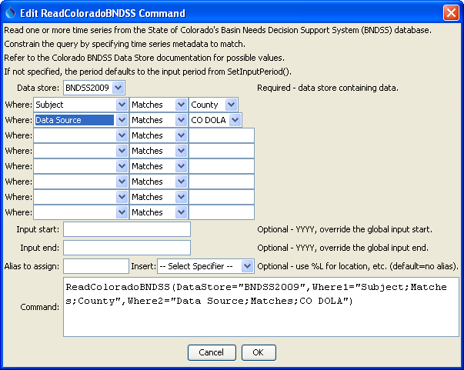
ReadColoradoBNDSS
ReadColoradoBNDSS() Command Editor

The command syntax is as follows:

ReadColoradoBNDSS(Parameter=Value,…)

Command Parameters

Parameter | Description | Default
DataStore | ColoradoBNDSS data store name indicating database from which to read time series. | None – must be specified.
WhereN | The “where” clauses to be applied when querying data, which match the values in the Where fields in the TSTool main interface. The parameters should be specified as Where1, Where2, etc., with no intervening gaps in numbering. All clauses are joined as “and” and are therefore cumulative in limiting the query. The format of each parameter value is:  “Item;Operator;Value”  Where Item indicates a data field to be filtered on, Operator is the type of constraint, and Value is the value to be checked when querying. | If not specified, the query will not be limited and very large numbers of time series may result from the query.
InputStart | Start of the period to query, specified as a 4-digit year. | Read all available data.
InputEnd | End of the period to query, specified as a 4-digit year. | Read all available data.
Alias | Indicate an alias to assign to time series, which can result in shorter identifiers for time series when referenced with other commands. | No alias is assigned.

