Command Reference: ReadPatternFile()
Read the pattern file to be used with FillPattern() commands
Version 08.16.04, 2008-09-19

The ReadPatternFile() command reads pattern time series to be used with FillPattern() commands (see the FillPattern() command for more information ). The patterns indicate whether a month is wet, dry, or average, although any number of characterizations can be used. One or more patterns can be included in each pattern file, similar to StateMod time series files (see the StateMod Input Type appendix), and multiple pattern files can be used, if appropriate. The following example illustrates the file format. See also the AnalyzePattern() command, which can be used to generate the file.

# Years Shown = Water Years
# Missing monthly data filled by the Mixed Station Method, USGS 1989
# Time series identifier = 09034500.CRDSS_USGS.QME.MONTH.1
# Description = COLORADO RIVER AT HOT SULPHUR SPRINGS, CO.
# -e-b----------eb------eb------eb------eb------eb------eb------eb------eb------eb------eb------eb------eb------eb--------e
10/1908 - 9/1996 ACFT WYR
1909 09034500 AVG AVG AVG WET WET AVG AVG AVG WET WET WET WET
1910 09034500 WET WET WET WET WET WET AVG AVG AVG AVG AVG AVG
1911 09034500 AVG AVG WET AVG AVG AVG AVG WET WET WET AVG WET
1912 09034500 WET WET WET WET WET AVG AVG WET WET WET WET WET
...ommitted...

The following dialog is used to edit the command and illustrates the command syntax.

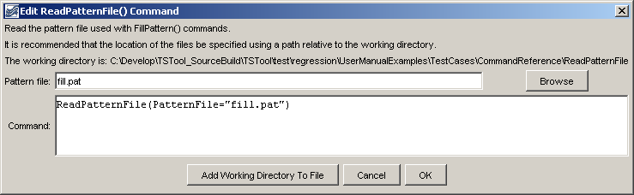
ReadPatternFile
ReadPatternFile() Command Editor

The command syntax is as follows:

ReadPatternFile(Parameter=Value,…)

Command Parameters

Parameter | Description | Default
PatternFile | The path to the pattern file, which can be absolute or relative to the working directory. | None – must be specified.

A sample command file is as follows:

ReadPatternFile(PatternFile="fill.pat")

This page is intentionally blank.

