Command Reference: CheckTimeSeriesStatistic()
Check time series statistic against criteria
Version 10.00.01, 2011-04-26

The CheckTimeSeriesStatistic() command checks a time series statistic against criteria, for example to perform quality control using full-period statistics. This command is essentially a combination of the CalculateTimeSeriesStatistic() command with features similar to the CheckTimeSeries() command; however, the latter checks individual data values and this command checks a statistic computed from the entire time series. The WriteCheckFile() command can be used to write a summary of the warnings.

The following dialog is used to edit the command and illustrates the command syntax.

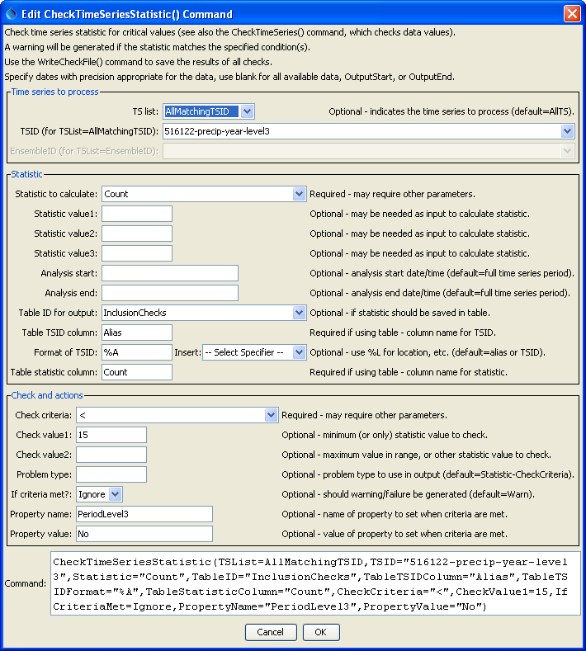
CheckTimeSeriesStatistic
CheckTimeSeriesStatistic() Command Editor

The command syntax is as follows:

CheckTimeSeriesStatistic(Parameter=Value,…)

Command Parameters

Parameter | Description | Default
TSList | Indicates the list of time series to be processed, one of:  - AllMatchingTSID – all time series that match the TSID (single TSID or TSID with wildcards) will be processed.  - AllTS – all time series before the command will be processed.  - EnsembleID – all time series in the ensemble will be processed.  - FirstMatchingTSID – the first time series that matches the TSID (single TSID or TSID with wildcards) will be processed.  - LastMatchingTSID – the last time series that matches the TSID (single TSID or TSID with wildcards) will be processed.  - SelectedTS – the time series selected with the SelectTimeSeries() command will be processed. | AllTS
TSID | The time series identifier or alias for the time series to be processed, using the * wildcard character to match multiple time series. | Required if TSList=*TSID.
EnsembleID | The ensemble to be modified, if processing an ensemble. | Required if TSList= EnsembleID.
Statistic | Statistic to compute. Refer to the CalculateTimeSeriesStatistic() command documentation. | None – must be specified.
StatisticValue1 | Input data required by the statistic. Currently the dialog does not check the value for correctness – it is checked when the statistic is computed. | See the Calculate TimeSeries Statistic() command documentation.
StatisticValue2 | Input data required by the statistic. Currently the dialog does not check the value for correctness – it is checked when the statistic is computed. | to the Calculate TimeSeries Statistic() command documentation.
StatisticValue3 | Input data required by the statistic. Currently the dialog does not check the value for correctness – it is checked when the statistic is computed. | to the Calculate TimeSeries Statistic() command documentation.
AnalysisStart | The date/time to start analyzing data. | Full period is analyzed.
AnalysisEnd | The date/time to end analyzing data. | Full period is analyzed.
TableID | Identifier for table that receives the statistic. | Optional – table output is not required.
TableTSIDColumn | Table column name that is used to look up the time series. If a matching TSID is not found, a row will be added to the table. If a TSID is found, the statistic cell value for the time series is modified. | Optional – table output is not required.
TableTSIDFormat | The specification to format the time series identifier to insert into the TSID column. Use the format choices and other characters to define a unique identifier. | Time series alias if available, or the time series identifier.
TableStatistic Column | Table column name to receive the statistic value. If not found in the table, a new column is added automatically. | Optional – table output is not required.
CheckCriteria | The criteria that is checked, one of:  - InRange – check for value >= Value1 and <= Value2.  - OutOfRange – check for value < Value1 or > Value2.  - < – check for values < CheckValue1.  - <= – check for values <= CheckValue1.  - > – check for values > CheckValue1.  - >= – check for values >= CheckValue1.  - == – check for values equal to CheckValue1. | None – must be specified.
CheckValue1 | A parameter that is used for specific CheckCriteria values.
CheckValue2 | A parameter that is used for specific CheckCriteria values, currently only needed for InRange and OutOfRange criteria.
ProblemType | The problem type that will be shown in warning messages. | Statistic-CheckCriteria
IfCriteriaMet | Indicate whether to set the command status if the statistic meets the criteria, one of:  - Ignore – do not set the command status  - Warn – set the command status to Warning  - Fail – set the command status to Failure | The command status will not be changed.
PropertyName | If the statistic meets the criteria, set the property identified by PropertyName to PropertyValue. | No property is set.
PropertyValue | If the statistic meets the criteria, set the property identified by PropertyName to PropertyValue. | No property is set.

