Command Reference: ComputeErrorTimeSeries()
Compute the error between time series and create new time series for the results
Version 10.00.01, 2011-05-12

The ComputeErrorTimeSeries() command computes the error between two time series as absolute value or percent, creating a new time series for each pair of time series that is compared. This is useful for comparing observed and simulated time series. The time series that are created have the simulated time series’ metadata but an alias can be assigned. The command can be used to process multiple pairs of time series, each determined using the appropriate *TSList parameter.

The following dialog is used to edit the command and illustrates the command syntax.

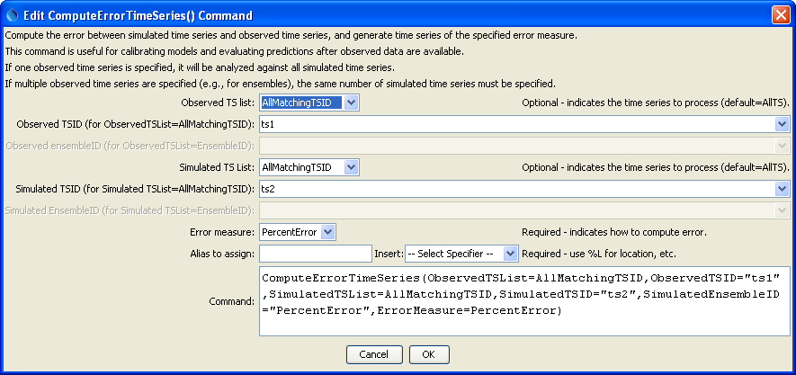
ComputeErrorTimeSeries
ComputeErrorTimeSeries() Command Editor

The command syntax is as follows:

ComputeErrorTimeSeries(Parameter=Value,…)

Command Parameters

Parameter | Description | Default
Observed  TSList | Indicates the list of observed time series to be processed, one of:  - AllMatchingTSID – all time series that match the TSID (single TSID or TSID with wildcards).  - AllTS – all time series before the command.  - EnsembleID – all time series in the ensemble.  - FirstMatchingTSID – the first time series that matches the TSID (single TSID or TSID with wildcards).  - LastMatchingTSID – the last time series that matches the TSID (single TSID or TSID with wildcards).  - SelectedTS – the time series are those selected with the SelectTimeSeries() command. | AllTS
Observed  TSID | The time series identifier or alias for the observed time series, using the * wildcard character to match multiple time series. | Use when ObservedTSList=  *MatchingTSID.
Observed  EnsembleID | The observed ensemble to be compared, if processing an ensemble. | Use when ObservedTSList=  EnsembleID.
Simulated  TSList | Indicates how to determine the list of simulated time series (see the explanation of ObservedTSList). | AllTS
Simulated  TSID | The time series identifier or alias for the simulated time series (see the explanation of ObservedTSID). | Use when SimulatedTSList=  *MatchingTSID.
Simulated  EnsembleID | The ensemble identifier for the simulated time series (see the explanation of SimulatedEnsembleID). | Use when SimulateddTSList=  EnsembleID
ErrorMeasure | The error measure to compute, one of:  - PercentError – Simulated minus observed, divided by observed.  - AbsoluteError – not yet implemented.
Alias | The alias to assign to the time series, as a literal string or using the special formatting characters listed by the command editor. The alias is a short identifier used by other commands to locate time series for processing, as an alternative to the time series identifier (TSID). | Alias will not be assigned.

A sample command file is as follows (in this case using contrived data):

RemoveFile(InputFile="Results\Test_ComputeErrorTimeSeries_1_out.dv",WarnIfMissing=False)
NewPatternTimeSeries(Alias=”ts1”,NewTSID="ts1..test.Day",Description="Test data",
SetStart="1950-01-01",SetEnd="1951-03-12",Units="CFS",PatternValues="5,10,12,13,75")
NewPatternTimeSeries(Alias=”ts2”,NewTSID="ts2..test.Day",Description="Test data",
SetStart="1950-01-01",SetEnd="1951-03-12",Units="CFS",PatternValues="6,12,14,11.5,80")
ComputeErrorTimeSeries(ObservedTSList=AllMatchingTSID,ObservedTSID="ts1",
SimulatedTSList=AllMatchingTSID,SimulatedTSID="ts2",ErrorMeasure=PercentError)
# Uncomment the following command to regenerate the expected results file.
# WriteDateValue(OutputFile="ExpectedResults\Test_ComputeErrorTimeSeries_1_out.dv")
WriteDateValue(OutputFile="Results\Test_ComputeErrorTimeSeries_1_out.dv")
CompareFiles(InputFile1="Results\Test_ComputeErrorTimeSeries_1_out.dv",
InputFile2="ExpectedResults\Test_ComputeErrorTimeSeries_1_out.dv",WarnIfDifferent=True)

