Command Reference: FillHistYearAverage()
Fill missing time series data using historical yearly average data
Version 10.00.01, 2011-05-12

The FillHistYearAverage() command fills missing data in yearly time series with the average annual value. The average values are computed using the available data period (or specified averaging period – see the SetAveragePeriod()command) immediately after the time series is read and are then applied when this command is encountered.

The following dialog is used to edit the command and illustrates the syntax of the command.

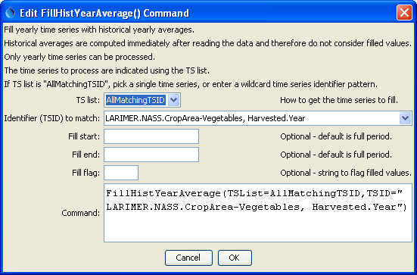
FillHistYearAverage
FillHistYearAverage() Command Editor

The command syntax is as follows:

FillHistYearAverage(Parameter=Value,…)

Command Parameters

Parameter | Description | Default
TSList | Indicate how to determine the list of time series to process, one of:  - AllMatchingTSID – process time series that have identifiers matching the TSID parameter.  - AllTS – process all the time series.  - SelectedTS – process the time series that are selected (see selectTimeSeries()). | None – must be specified.
TSID | Used if TSList=AllMatchingTSID to indicate the time series identifier or alias for the time series to be filled. Specify * to match all time series or use a wildcard for one or more identifier parts. | Required if TSList=AllMatchingTSID.
FillStart | Date/time indicating the start of filling, using a precision appropriate for the time series, or OutputStart. | Fill the entire time series.
FillEnd | Date/time indicating the end of filling, using a precision appropriate for the time series, or OutputEnd. | Fill the entire time series.
FillFlag | If specified as a single character, data flags will be enabled for the time series and each filled value will be tagged with the specified character. The flag can then be used later to label graphs, etc. The flag will be appended to existing flags if necessary. | No flag is assigned.

A sample command file to fill data from the State of Colorado’s HydroBase is as follows:

LARIMER.NASS.CropArea-Vegetables, Harvested.Year~HydroBase
FillHistYearAverage(TSList=AllMatchingTSID,
TSID="LARIMER.NASS.CropArea-Vegetables, Harvested.Year")

Time series data limits for the averages are printed to the log file, similar to the following example (note that the period for averaging is always shown and may be different than the output period).

Min: 95.0000 ACRE on 1954
Max: 2684.0000 ACRE on 1959
Sum: 11090.0000 ACRE
Mean: 1008.1818 ACRE
Number Missing: 42 (79.25%)
Number Not Missing: 11 (20.75%)
Total period: 1945 to 1997
Non-missing data period: 1945 to 1997

