Command Reference: FillMixedStation()
Fill missing data in dependent time series using the best fit from 1+ independent time series, using OLS regression or MOVE2, data transforms, one/monthly equations
Version 09.10.01, 2010-11-15

The FillMixedStation() command fills missing data in a time series where one or more independent time series is used to sequentially fill missing data. This approach has been developed to automate analysis of regression filling (see Mixed Station Analysis Tool below) and to facilitate batch filling of many related time series. This implementation is based on the Mixed Station Model implemented for Colorado’s Decision Support Systems (Ayres Associates, 2000), which was based on the similarly named approach implemented by the USGS (Alley and Burns, 1981).

The time series involved in the analysis are typically related, such as being from nearby locations in a region. The main uses of the command are:

- To automatically fill every time series in a data set, using other time series in the data set. For example, for hydrologic modeling natural flow time series may have been estimated by processing measured streamflow, diversion, and reservoir time series. The natural flow time series can be filled for use in modeling.
- To generate a report on relationships, so that the user can configure individual FillRegression() and FillMOVE2() commands in TSTool. This may be appropriate when using FillMixedStation() on a list of time series is inappropriate.

Important: TSTool does not automatically exclude time series that have been filled in previous steps. Consequently, care must be taken when specifying the list of independent time series to NOT use time series that were filled in a previous step.

For each dependent time series being filled, the Mixed Station Analysis (MSA) selects the independent time series and parameters that result in the best filling results, considering combinations of the following:

- The list of independent time series being considered can be constrained to a subset of available time series.
- Filling methods include ordinary least squares (OLS) regression (see the FillRegression() command for details) and MOVE2 (see the FillMOVE2() command for details).
- One equation or monthly equations can be used. However, both options cannot be evaluated together due to the complexity of ranking and reporting results.
- The data can be transformed using log₁₀, or no transformation can be applied.
- A minimum number of overlapping data points (N1) can be specified to indicate a valid relationship.
- A minimum correlation coefficient r can be specified to indicate a valid relationship.
- A minimum confidence level for the slope of the regression line can be specified (see T-Test discussion below).
- The best fit indicator can be the correlation coefficient (R), the standard error of prediction (SEP, described below), or SEPTransformed, which is the standard error of prediction on transformed data (can be specified if only transformed data are analyzed).

The interactive MSA tool is available to facilitate configuration of the FillMixedStation() command. The primary uses of the MSA tool and FillMixedStation() command are:

- Use the MSA tool to evaluate filling options before finalizing the fill commands. For example, run the MSA tool and review the output report to confirm the filling methodology and corresponding command parameters. A FillMixedStation() command can then be created and passed to the TSTool command list.
- If no evaluation is needed, use the FillMixedStation() command editor to create a single FillMixedStation() analysis command, which when run evaluates the best filling parameters for filling and also performs the filling. A single command can be used to fill many time series.

Because extensive analysis may be necessary to evaluate all the combinations of parameters, the FillMixedStation() command will be slower than other commands that specifically indicate how to perform the filling. Performance can be increased by using the Mixed Station Analysis tool to determine time series that result in the best fit, and excluding all other time series in the fill command. The number of combinations can also be limited by reducing the number of parameter options and using stricter limitations on the number of overlapping points and correlation coefficients that are required for a good regression result.

The full MSA process is as follows:

- For each dependent time series, perform a regression analysis using a unique combination of parameters (e.g., use an independent time series, OLS regression with one equation, no data transform). This results in 1+ regression results for each dependent time series.
- Qualifying results (those that meet the requirements of minimum number of overlapping points and correlation coefficient) are retained in a list for the dependent time series, for processing in the next step.
- The qualifying results are ranked according to the best fit indicator (e.g., R or standard error of prediction SEP, as described below). If a monthly analysis is performed, the results for each month are ranked.
- Missing data in the dependent time series are filled using the regression results. If missing values remain, the next highest ranking regression result is used until all missing values are filled (or no additional qualifying regression results are available). Monthly filling occurs on each of the 12 months.

Linear Relationship
Specifying the confidence level parameter indicates that the slope of the line from the regression relationship will be examined using the Student T-Test. The regression equation is given as:

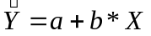

Where is the estimated flow at the dependent station, X is the actual flow at the independent station, and a and b are the linear regression parameters.

The test hypothesis for the test is formulated that there is no significant relationship between the dependent and the independent variable, which would require a value of b that is not significantly different from zero. The statistic for the Student T-test is given by:

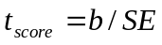

Where t_{score} is the test score, b is the slope of the regression equation, and SE is the Standard Error of the slope, calculated by:

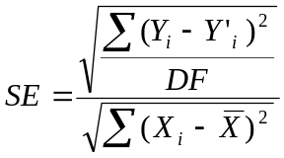

Were Y_{i} is the actual flow and 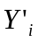is the estimated flow at the dependent station for month i. X_{i} is the actual flow at the independent station for month i, andis the mean flow at the independent station for the period or record. DF is the degrees of freedom.

TSTool determines the value of t_{test} for which the probability P(t_{test}|DF) matches the confidence level specified for the Student T-distribution with DF degrees of freedom. If t_{score} > t_{test}, the hypothesis can be rejected, indicating that there is a linear relationship between the dependent and the independent stations, and the independent station will be considered for filling data at the dependent station, as long as other criteria are also met.

Best Fit Indicators

Best fit indicators that are available include:

- Correlation coefficient, R, defined as:

R = 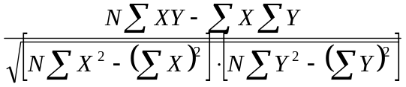

where X is the independent and Y is the dependent for all overlapping data points (values at the same time).

- Standard Error of Prediction (SEP) on a monthly basis, defined as:

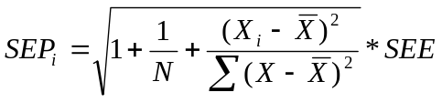

where X_{i} is the observed value at the independent station for month i, is the average flow at the independent station and SEE is the Standard Error of Estimate and is defined as:

SEE = 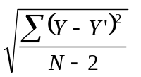

where Y is the observed value and Y’ and is the estimated value using the relationship determined for filling, for all original points in the dependent time series. If the data have been transformed to compute the regression relationship, the SEP is untransformed so that SEP is computed in the original data units.

- Standard Error of Prediction, transformed (SEPTransformed) is the standard error of prediction on a monthly basis described above where the data values have been transformed with log₁₀:

SEPTransformed = 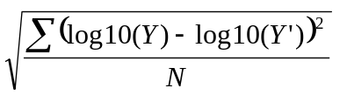

- SEPTotal is the same as SEP but includes all months of data in the year.
- SEPTransformedTotal is the same as SEPTransformed but includes all months of data in the year.

In the future, additional indicators may be added, such as the Nash-Sutcliffe efficiency coefficient.

Implementation in Colorado’s Decision Support Systems

The Mixed Station Model implemented for the State of Colorado typically used the following input:

- Log transform
- Monthly relationships
- Rank on SEP
- Ordinary lease squares regression
- Minimum concurrent values = 5
- Confidence level = 95%
- Fill all time series in data set

The original Mixed Station Model used several fixed format files during processing. In order to test the TSTool implementation, …. Steve is working on some scripts to automate the comparison. Because the original software checked SEP on the transformed data, the BestFitIndicator=SEPTransformed parameter must be used to produce the same results in TSTool.

Mixed Station Analysis Tool

The Mixed Station Analysis tool is started after time series results are generated in TSTool, for example as the result of reading a list of time series. The following dialog illustrates the parameters of the tool, which are essentially the same as for the FillMixedStation() command that is described in the next section.

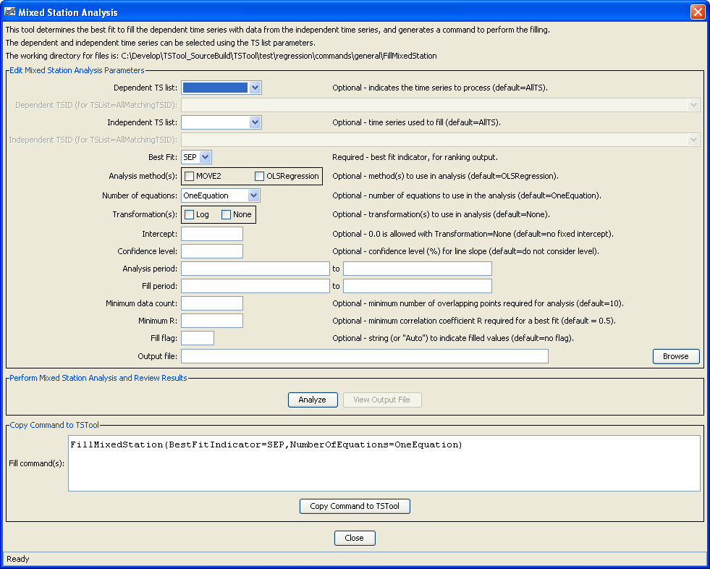
tool_MixedStationAnalysis
Mixed Station Analysis Tool after Initial Display

The MSA tool is used as follows:

- The tool will initially display default parameter values, but these values can be changed using the interface. Select parameters as appropriate for the analysis. The corresponding FillMixedStation() command is shown at the bottom of the window.
- Press the Analyze button to perform the analysis. The analysis may run for several minutes.
- When the analysis is complete, press the View Output File button to view the analysis results.
- If satisfied with the results, meaning that reasonable relationships have been determined, go to the following step. Otherwise adjust the analysis parameters and run the analysis again.
- Use the Copy Command to TSTool button to copy the FillMixedStation() command to TSTool. The command will be inserted as if it were inserted from the Commands menu.
- Another way to use the analysis results is to review the output report to evaluate filling options and then use TSTool to insert individual FillRegression() and FillMOVE2() commands. However, in this case, because each of these commands computes the regression equation at the time it is run, care must be taken to use independent time series that have not been filled by previous commands. The benefit of the FillMixedStation() command is that it computes all the relationships before filling.
- The MSA tool can then be closed and commands run as usual to automate data processing.

Subsequent edits of the command can occur using the normal command editor. The following section provides an example of the standard command editor and a description of all of the parameters.

Command Editing

The following dialog is used to edit the FillMixedStation() command and illustrates the syntax of the command:

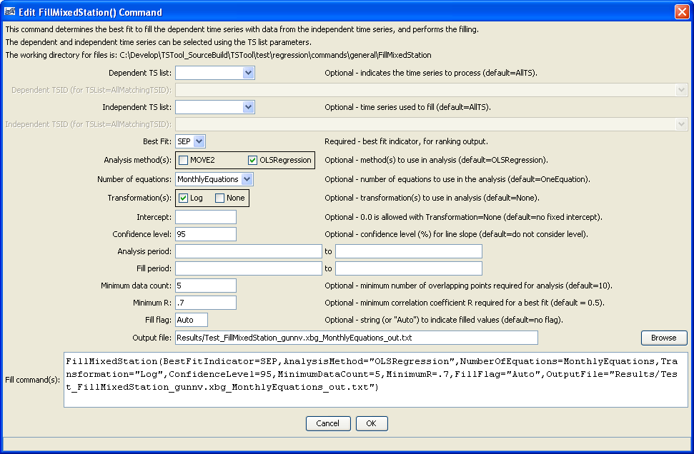
FillMixedStation
FillMixedStation() Command Editor
The command syntax is as follows:

FillMixedStation(Parameter=value,…)

Command Parameters

Parameter | Description | Default
DependentTSList | Indicates the list of independent time series to be processed, one of:  - AllMatchingTSID – all time series that match the TSID (single TSID or TSID with wildcards) will be processed.  - AllTS – all time series before the command will be processed.  - EnsembleID – all time series in the ensemble will be processed.  - FirstMatchingTSID – the first time series that matches the TSID (single TSID or TSID with wildcards) will be processed.  - LastMatchingTSID – the last time series that matches the TSID (single TSID or TSID with wildcards) will be processed.  - SelectedTS – the time series selected with the SelectTimeSeries() command will be processed. | None – must be specified.
DependentTSID | The time series identifier or alias for the dependent time series to be processed, using the * wildcard character to match multiple time series. | Required if DependentTSList= *TSID.
IndependentTSList | Indicates the list of independent time series to be considered for each dependent time series, one of:  - AllMatchingTSID – all time series that match the TSID (single TSID or TSID with wildcards) will be processed.  - AllTS – all time series before the command will be processed.  - EnsembleID – all time series in the ensemble will be processed.  - FirstMatchingTSID – the first time series that matches the TSID (single TSID or TSID with wildcards) will be processed.  - LastMatchingTSID – the last time series that matches the TSID (single TSID or TSID with wildcards) will be processed.  - SelectedTS – the time series selected with the SelectTimeSeries() command will be processed. | None – must be specified.
IndependentTSID | The time series identifier or alias for the independent time series to be compared, using the * wildcard character to match multiple time series. | Required if IndependentTSList= *TSID.
BestFitIndicator | Specifies the indicator to use when determining the best fit, one of:  - R – correlation coefficient  - SEP – Standard Error of Prediction, defined as the square root of the sum of differences between the known dependent value, and the value determined from the equation of best fit at the same point.  - SEPTransformedpoin – same as SEP; however the data values have first been transformed as per the Transformation parameter.  - SEPTotal, when used with one equation, it is the same as SEP. When used with monthly equations, it is the SEP considering all months.  - SEPTransformedTotal, when used with one equation, it is the same as SEPTransformed. When used with monthly equations, it is the SEPTransformed considering all months. | SEP
AnalysisMethod | Specify the method(s) to analyze the data, in order to determine the best fit, including OLSRegression and/or MOVE2. If multiple methods are specified, separate with commas and surround with double quotes. | OLSRegression
NumberOfEquations | The number of equations to use for the analysis: OneEquation or MonthlyEquations. Only one may be chosen. If necessary, use more than one command to use different parameter combinations for different groups of time series. | None – must be specified.
Transformation | Indicates how to transform the data before analyzing. Specify as None (no transformation) or Log (for Log₁₀). If the Log option is used, zero and negative values in data are set to .001. Missing data are ignored. If multiple values are selected, separate with a comma and surround with double quotes. | None (no transformation)
Intercept | Specify as 0 to force the intercept of the best-fit line through the origin. This is made available only for OLS regression analysis on untransformed data, to be consistent with the FillRegression() command. | Do not force the intercept through zero.
ConfidenceLevel | Required confidence level for the T-Test on the regression slope. Relationships not passing the test are not allowed for filling. | No limit on confidence level.
AnalysisStart | The date/time to start the analysis, to focus on a period appropriate for analysis. For example, specify the unregulated period for streamflow. | If blank, analyze the full period.
AnalysisEnd | The date/time to end the analysis. | If blank, analyze the full period.
FillStart | The date/time to start filling, if other than the full time series period. | If blank, fill the full period.
FillEnd | The date/time to end filling, if other than the full time series period. | If blank, fill the full period.
MinimumDataCount | The minimum number of overlapping data points that are required for a valid analysis (N1 in FillRegression() and FillMOVE2() documentation). If the minimum count is not met, then the independent time series is ignored for the specific combination of parameters. For example, if monthly equations are used, the independent time series may be ignored for the specific month; however, it may still be analyzed for other months. | 10
MinimumR | The minimum correlation coefficient required for a best fit. If the minimum is not met, then the results are not considered in the best fit ranking or filling. | 0.5
OutputFile | Output file for the results, either as a file name to be written to the working directory, or a full path. | If not specified, partial results of the analysis may be available in the log file.

The following example command file fills natural flow time series from a StaeMod file using one equation (not monthly):

# Test filling the gunnison monthly baseflow time series with
# Mixed Station Analysis (all combinations for one equation)
StartLog(LogFile="fill-baseflow.log")
ReadStateMod(InputFile="gunnv.xbg")
FillMixedStation(BestFitIndicator=SEP,AnalysisMethod="MOVE2,OLSRegression",
NumberOfEquations=OneEquation,
Transformation="Log,None",OutputFile="Results.txt")
# Check for missing data - all should be filled
CheckTimeSeries(CheckCriteria="Missing",MaxWarnings=10)
# Check for negative flows - should not be any
CheckTimeSeries(CheckCriteria="<",Value1=0,MaxWarnings=10)

This page is intentionally blank.

