Command Reference: AdjustExtremes()
Adjust the extreme values in time series data
Version 09.10.01, 2010-11-18

The AdjustExtremes()command adjusts extreme values in time series (e.g., to remove negative values from a time series that can only have values greater than or equal to zero), while preserving “mass”.

The following dialog is used to edit the command and illustrates the syntax of the command.

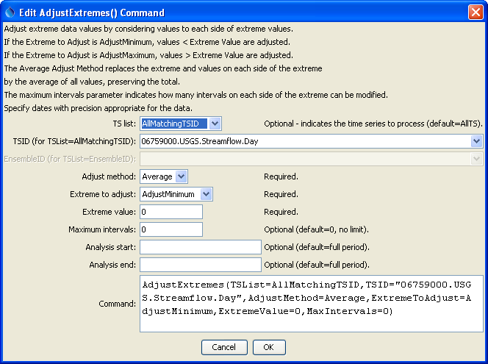
AdjustExtremes
AdjustExtremes() Command Editor

The command syntax is as follows:

AdjustExtremes(Parameter=Value,…)
Command Parameters

Parameter | Description | Default
TSList | Indicates the list of time series to be processed, one of:  - AllMatchingTSID – all time series that match the TSID (single TSID or TSID with wildcards) will be modified.  - AllTS – all time series before the command.  - EnsembleID – all time series in the ensemble will be modified.  - FirstMatchingTSID – the first time series that matches the TSID (single TSID or TSID with wildcards) will be modified.  - LastMatchingTSID – the last time series that matches the TSID (single TSID or TSID with wildcards) will be modified.  - SelectedTS – the time series are those selected with the SelectTimeSeries() command. | AllTS
TSID | The time series identifier or alias for the time series to be modified, using the * wildcard character to match multiple time series. | Required if TSList=  *TSID.
EnsembleID | The ensemble to be modified, if processing an ensemble. | Required if TSList=  EnsembleID.
AdjustMethod | Only the Average adjust method is implemented, in which adjusted data values are set to the average over the adjusted period, necessary to maintain the total/mass of the original values. This method adjusts extreme values by considering neighboring values equally on each side of the point in question. When adjusting minimum values, neighboring values are added until the average is above the allowed extreme value, and all values that make up the sum are then set to the average value. Missing values remain missing and therefore this command should only be applied to filled data. If a satisfactory result cannot be reached within this limit, then the original values are not changed. Changed values are listed in the time series history, which is viewed with the time series properties. Applying the command will result in the time series having periods of constant value, with the length of the period being controlled by the magnitude of the extreme value. | None – must be specified.
Extreme  ToAdjust | Indicate whether minimum (AdjustMinimum) or maximum (AdjustMaximum) values to be adjusted. | None – must be specified.
ExtremeValue | The extreme value that is the limit of acceptable values. | None – must be specified.
MaxIntervals | Indicates how many values on each side of a point are allowed to be examined. | 0, indicating no limit.
AnalysisStart | The date/time to start analyzing data. | Full period.
AnalysisEnd | The date/time to end analyzing data. | Full period.

A sample command file using data from the State of Colorado’s HydroBase is as follows:

# 06759000 - BIJOU CREEK NEAR WIGGINS, CO.
06759000.USGS.Streamflow.Day~HydroBase
AdjustExtremes(TSList=AllMatchingTSID,TSID="06759000.USGS.Streamflow.Day",
AdjustMethod=Average,ExtremeToAdjust=AdjustMinimum,ExtremeValue=0,MaxIntervals=0)

