Command Reference: CreateEnsembleFromOneTimeSeries()
Create a new ensemble from a single time series
Version 09.10.01, 2010-11-18

This command was previously named CreateEnsemble().

The CreateEnsembleFromOneTimeSeries() command creates an ensemble by splitting up a single time series into traces. For example, a historical time series can be split into 1-year overlapping traces that are shifted to start in the current year.

The following dialog is used to edit the command and illustrates the syntax for the command.

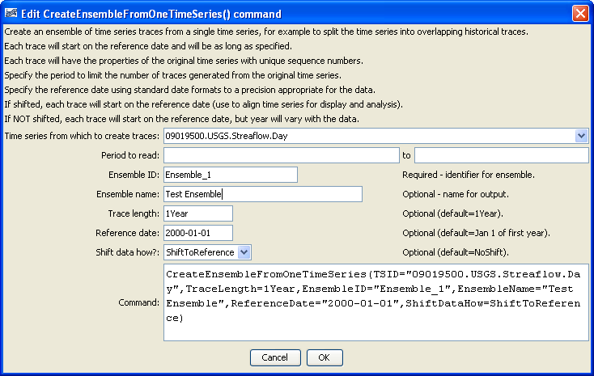
CreateEnsembleFromOneTimeSeries
CreateEnsembleFromOneTimeSeries() Command Editor

The command syntax is as follows:

CreateEnsembleFromOneTimeSeries(Parameter=Value,…)

Command Parameters

Parameter | Description | Default
TSID | The time series identifier or alias for the time series used to create the ensemble. | None – must be specified.
InputStart | The date/time to start transferring data from the time series. | Use all data.
InputEnd | The date/time to end transferring data from the time series. | Use all data.
EnsembleID | The new ensemble identifier. | None – must be specified.
EnsembleName | The name for the new ensemble. | Blank.
TraceLength | An interval for the trace length (e.g., 1Year, #Month or, #Day). | 1Year
ReferenceDate | The reference date indicates the starting date for each trace and should be left blank (resulting in a default of January 1 of the current year), or set to January 1 of a year of interest (use the format 01/01/YYYY or YYYY-MM-DD). Each trace can optionally be shifted (see ShiftDataHow). | January 1 of the first year in the source time series.
ShiftDataHow | Indicates whether the traces should be shifted. Possible values are:  - ShiftToReference – each trace will be shifted to the reference date, resulting in overlapping time series.  - NoShift – plotting the traces will result in a total line that matches the original time series, except that each trace can be manipulated individually. | NoShift

A sample command file to read a time series from the State of Colorado’s HydroBase and create an ensemble from the time series is as follows:

# 09019500 - COLORADO RIVER NEAR GRANBY
09019500.USGS.Streamflow.Day~HydroBase
CreateEnsembleFromOneTimeSeries(TSID="09019500.USGS.Streamflow.Day",
TraceLength=1Year,EnsembleID="Ensemble_1",EnsembleName="Test Ensemble",ReferenceDate="2008-01-01",ShiftDataHow=ShiftToReference)

