Command Reference: FTPGet()
Retrieve file(s) from a remote system using file transfer protocol (FTP)
Version 09.10.01, 2010-11-18

The FTPGet() command retrieves one or more files from a remote system using file transfer protocol (FTP). The retrieval is not recursive to child folders.

The following dialog is used to edit the command and illustrates the syntax for the command.

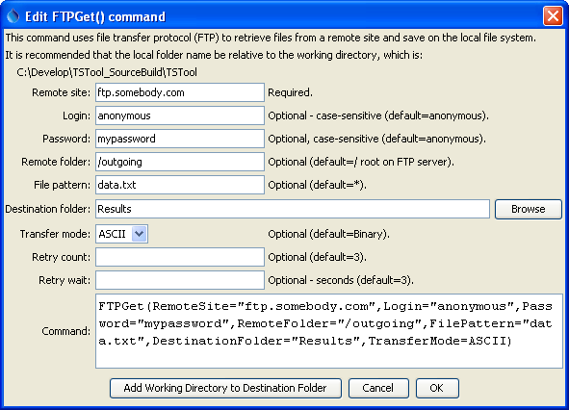
FTPGet
FTPGet() Command Editor

The command syntax is as follows:

FTPGet(Parameter=Value,…)

Command Parameters

Parameter | Description | Default
RemoteSite | The address of the remote site, for example: ftp.acme.com | None – must be specified.
Login | The FTP login to use. | anonymous
Password | The FTP password to use. | anonymous
RemoteFolder | The folder on the remote site, for example: /outgoing/data | Root folder (/).
FilePattern | The pattern to use to determine which files should be transferred. Simple patterns are used, where * is a wildcard. | Retrieve all files in the RemoteFolder.
DestinationFolder | The folder to receive the files, can be relative to the working directory. | None – must be specified.
TransferMode | The transfer mode:  - ASCII – for text files  - Binary – for binary files | Binary
RetryCount | The number of times to retry the login if it fails (e.g., due to busy site). | 3
RetryWait | The amount of time to wait between retries, seconds. | 3

