Command Reference: ReadStateMod()
Read all the time series from a StateMod time series file
Version 08.15.00, 2008-05-11

The ReadStateMod() command reads all the time series in a StateMod time series file (see the StateMod Input Type Appendix).

Water rights files also can be read and converted to time series – this is useful for visualization and is used to test well right processing. Considering all water rights for a location based on the administration number, results in a step function of decree over time. Monthly and yearly time series use calendar year and a right is active if it is turned on anywhere in the month or year. Free water rights (e.g., those having administration numbers > 90000.00000 are treated like other rights and therefore may not impact the results in the current period (additional parameters may be added in the future to allow more ways to process these rights). If processing well rights and multiple years of parcel data are processed, this command executes the same logic as the StateDMI MergeWellRights() command.

The following dialog is used to edit the command and illustrates the syntax for the command.

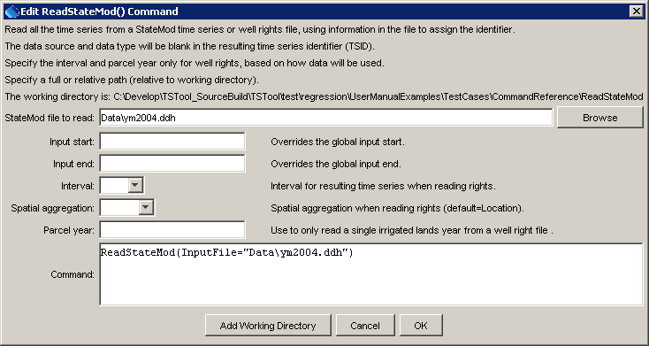
ReadStateMod
ReadStateMod() Command Editor

The command syntax is as follows:

ReadStateMod(Parameter=Value,…)

Command Parameters

Parameter | Description | Default
InputFile | The name of the StateMod time series file to read, surrounded by double quotes. The path to the file can be absolute or relative to the working directory. | None – must be specified.
InputStart | The start of the period to read data – specify if the period should be different from the global query period. Specify to a precision that matches the data. | Use the global query period or if not specified read all data.
InputEnd | The end of the period to read data – specify if the period should be different from the global query period. Specify to a precision that matches the data | Use the global query period or if not specified read all data.
Interval | When reading a water right file, specify the interval for the resulting time series, one of Day, Month, or Year. | None – must be specified.
SpatialAggregation | When reading a water right file, indicate how time series are to be aggregated spatially, one of:  - Location – aggregate by the station identifier.  - Parcel – (only used with well rights) aggregate based on the parcel number and parcel year.  - None – do not aggregate spatially, which will result in constant value time series for each water right. | Location
ParcelYear | When processing a well water right file, indicate the year of parcel data to process. Parcel configurations change from year to year, and a single year of parcel data can be processed if desired. | Process all parcel years.

A sample commands file is as follows:

ReadStateMod(InputFile="Data\ym2004.ddh")

